Registration page

Create a validation middleware to make sur­­e all the fields are filled up before sends the request to the server­­­­

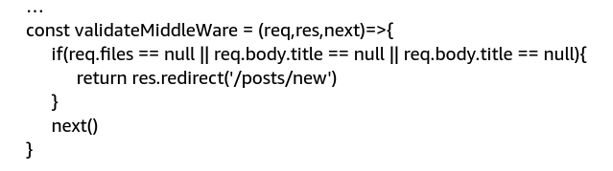

Use the middleware in index.js



If Express sees a request from a given url ‘/post/store’, then execute the middleware above

Create a storeUser.js for storeUserController

