**Supporting Information**

**TITLE: Host resistance diversity protects susceptible genotypes by restricting pathogen spread and evolution**

**Jack Common1, David Walker-Sünderhauf2, Stineke van Houte1, Edze R. Westra1**

**AFFILIATION**: 1ESI and CEC, Biosciences, University of Exeter, Cornwall Campus, Penryn TR10 9EZ, UK

2 European Centre for Environment and Human Health, University of Exeter Medical School, ESI, Cornwall Campus, Penryn TR10 9FE, UK

**CONTACT:** JC: jc860@exeter.ac.uk DWS: ds498@exeter.ac.uk SVH: c.van-houte@exeter.ac.uk ERW: E.R.Westra@exeter.ac.uk. Please address correspondence to Jack Common and Edze R. Westra

## **Supplementary Figures**

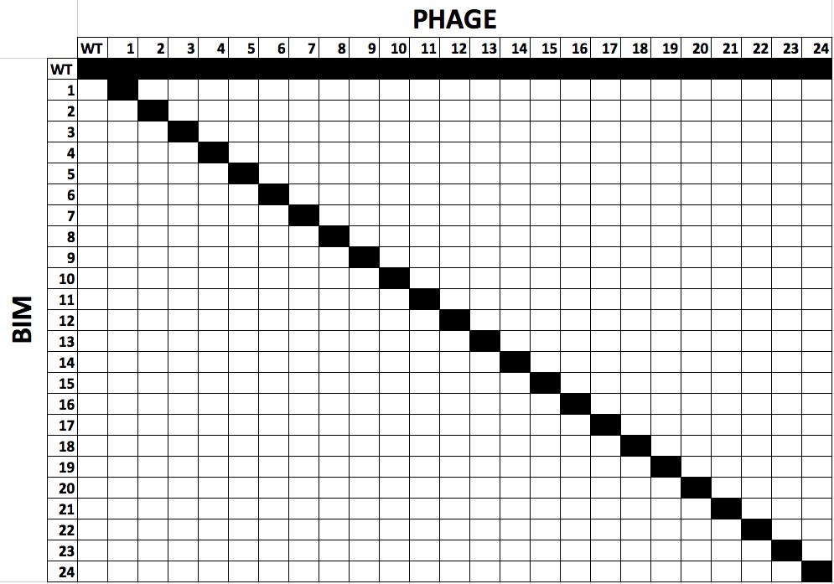

**Figure S1** Infectivity matrix of the library of BIMs and escape phages. The identity of BIMs and escape phage (1-24) are shown in the first row and column, respectively. Black squares represent infectivity, white indicates no infectivity. Infectivity of the wild-type DMS3vir is shown, as well as the infectivity of each escape phage on wild-type *P. aeruginosa* PA14.

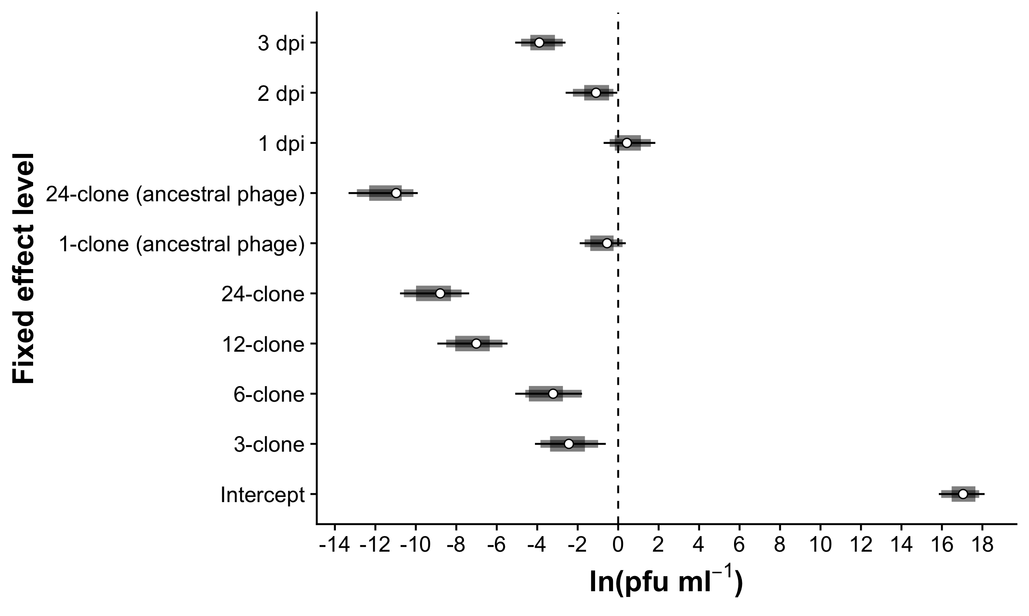

**Figure S2** Coefficients from a GLMM of the natural log of phage titre (plaque-forming units [pfu] ml-1), with CRISPR allele diversity treatment and days post-infection (dpi) as fixed effects. The intercept is the mean phage titre in the 1-clone treatment at 0 dpi. The *β* differences from the intercept are shown for the remaining levels of both fixed effects. The dotted line at zero indicates no difference from the intercept. Means are shown as white points with 67, 89% and 95% confidence intervals given in decreasing width.

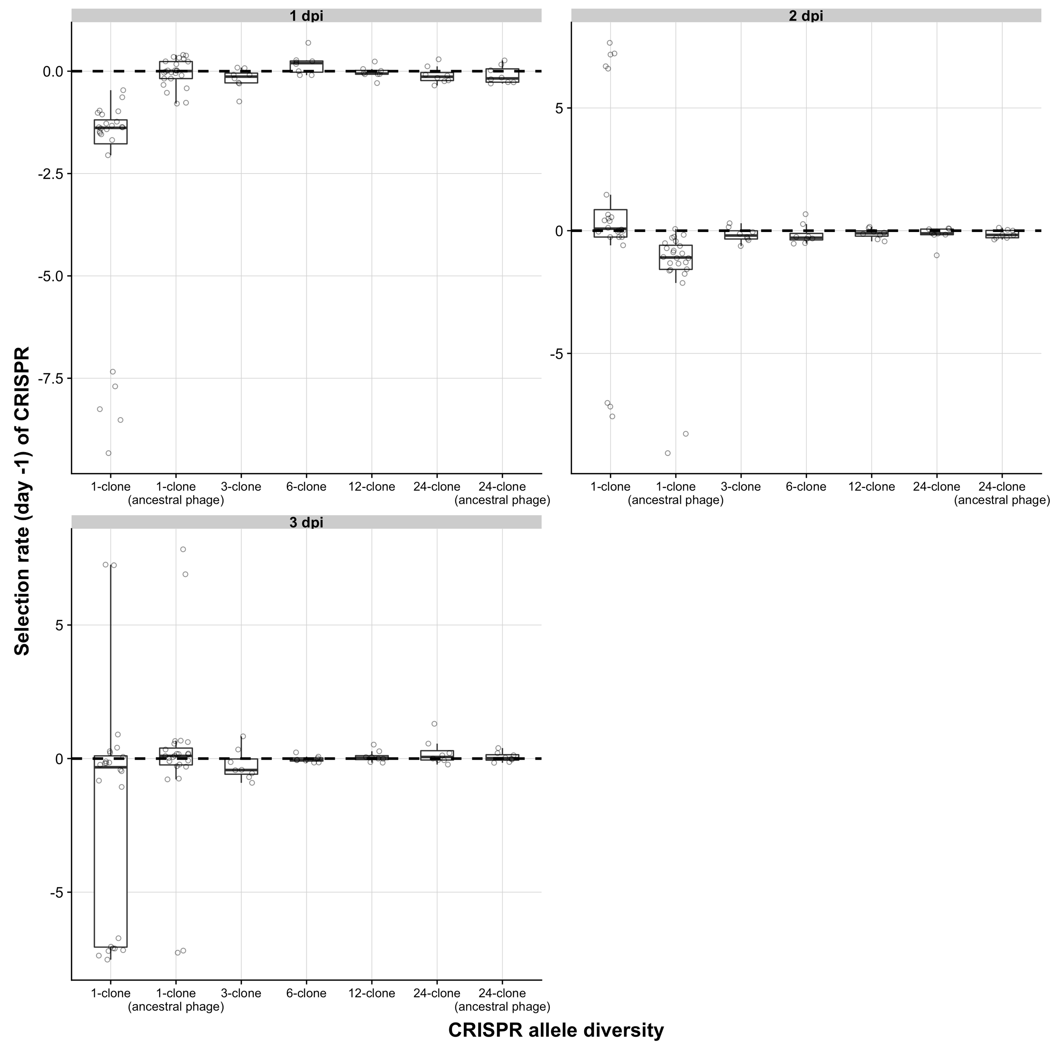

**Figure S3** Selection rate of CRISPR clones relative to a surface mutant (which does not encode CRISPR-based immunity) in each CRISPR allele diversity treatment at 1-3 days post-infection (dpi). Selection rate is the natural log of the relative change in density of one competitor against another. The dotted line at zero indicates no difference in density change i.e. both are equally fit. Boxplots show the median, 25th and 75th percentile, and the interquartile range. Residuals are shown as points. Note the different scaling of the y-axis in each panel.

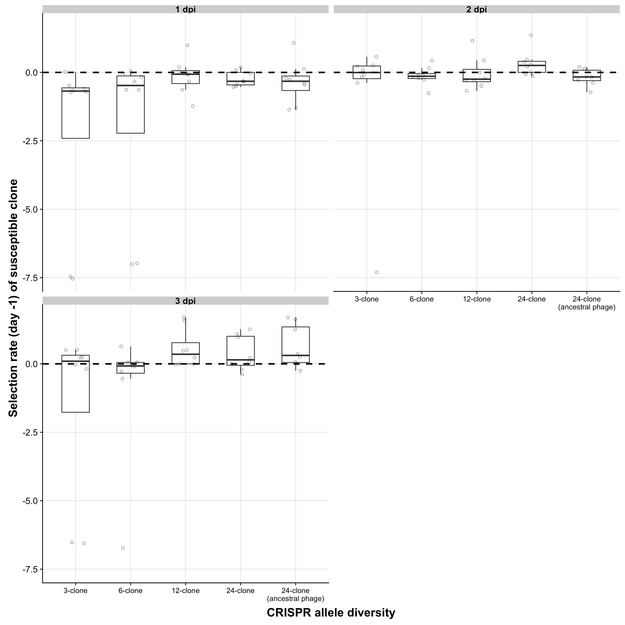

**Figure S4** Selection rate of susceptible hosts relative to other CRISPR clones in the population for each CRISPR allele diversity treatment at 1-3 days post-infection (dpi). Selection rate is the natural log of the relative change in density of one competitor against another. The dotted line at zero indicates no difference in density change i.e. both are equally fit. Boxplots show the median, 25th and 75th percentile, and the interquartile range. Residuals are shown as points. The 1-clone treatments, both with infective and ancestral phage, have been excluded because the whole CRISPR population was susceptible and can therefore be found in Figure S3.

# **Supplementary Tables**

**Table S1** Sequence of spacers in the CRISPR2 locus of each of the 24 bacteriophage-insensitive mutants (BIMs) used in the co-culture experiment. Clones transformed to carry a lacZ reporter gene using pBAM1(Gm)_lacZ are highlighted in blue.

|  |  |
| --- | --- |
| **BIM** | **Spacer sequence** |
| 1 | ATTTCAGTCCTTCCTGATCGCGTAGAGCCAAG |
| 2 | CATCTTCCCGCTCGATGGCGGTCAGCGTGCGC |
| 3 | CGCGTGAATGGCCCGGCGCTGAGCTGCGCTAT |
| 4 | AAGGGCATCAACCTGGCCGAAGGCGGCGCGCC |
| 5 | CGGTCGAACACGCCCTTATAGCGCTTCAGGCC |
| 6 | GATGTTCATCGCTGCCGGGCAGCGCGACATAC |
| 7 | AAACAGCGTCATGTCCAGGAGCTGCCGCTCGC |
| 8 | ACGGCAAGTTGAGTCTGGCCCTGGATGCTGAC |
| 9 | CCGGAAGTCCCGGCCGGTGTAGACGAGATAAA |
| 10 | GGCTCGACCAGGCGGCCCAGGGCGGCGTCGAT |
| 11 | TCAGGACCCCGACCAGATGGCGGCCGAAATGT |
| 12 | CGCCTGGAGACCCTGAAGGCCAATACCGAAAA |
| 13 | CCGAACGCATANANGGCGCANGGCACAGGGGT |
| 14 | ATGGGGATTCAGAGCTACGGCGATACCGCCCT |
| 15 | GAAATCGGCACCGCCACGAACCACCAGAACCT |
| 16 | GTCCAGCAGGATGCCGGCATCATCAACGAAAT |
| 17 | GGCAACGATCCCCACGAGCGGCTTTGGCACCT |
| 18 | CTCAACTCCGGCGCCGAAGACGTGATTGTCGA |
| 19 | GCGGGATCGCGGAGATAGCAGCTACGCTCGTA |
| 20 | ACTTTCACGACGACCCAGAAGCGTCGGCCGTT |
| 21 | GCGGCAGGAGCGGCAGCGGGCGGCGGCAGTT |
| 22 | GCGATCAGNTGCGGCCAATCCGTGGACTGGGT |
| 23 | GATGGCGTCAAACTCGGCCTCCAGGCGCAGCG |
| 24 | AACCTCGCGCAGTCGTTGTCCAGCGGCATCAT |

**Table S2** Plasmids, Primers, and Strains used for molecular cloning work.

|  |  |  |  |  |
| --- | --- | --- | --- | --- |
| **Plasmids** | | | | |
| **Plasmid** | **Reference** | | **Accession Number** | **Culture conditions** |
| pBAMD1-6 | (Martinez-Garcia *et al.* 2014) | | KM403115 | 100 μg/mL Ampicillin, 50 μg/mL Gentamicin, 0.3 mM diaminopimelic acid. Needs a *pir* strain to replicate. |
| pBAM1(Gm)_lacZ | This study | |  |
| **Primers** | | | | |
| **Primer** | **Sequence (5’ 🡪 3’)** | | | **Usage** |
| lacZ_amp_fw | TTACCATGGATGATTACGGAT TCACTGGCCGTCGT | | | Amplification of *lacZ* from PA14 *csy3:lacZ*. Adds NcoI and KpnI restriction sites onto amplicon. |
| lacZ_amp_rv | CAGGTACCTTATTTTTGACAC CAGACCAACTGGTAATGGT | | |
| **Bacterial Strains** | | | | |
| **Strain** | | **Reference/Supplier** | | **Usage** |
| *Pseudonomas aeruginosa* PA14 *csy3::lacZ* | | Zegans *et al.* 2009 | | Template for *lacZ* amplification. |
| *Escherichia coli* DH5α | | NEB | | Subcloning of *lacZ* behind P3 promoter. |
| *E. coli* CC18λpir | | NEB | | Cloning of promoter + *lacZ* onto pBAM1(Gm) |
| *E. coli* MFD*pir* | | (Ferrieres *et al.* 2010) | | Donor strain for pBAM1(Gm)_lacZ delivery |
| *P. aeruginosa* PA14 BIMs | | This study; Table S1 | | Recipients for pBAM1(Gm)_lacZ delivery |

**Table S3** Primers used to amplify and sequence the protospacers of interest of phage that were shown to have undergone host shift (lost infectivity to the original clone and could only infect a new clone) from the phenotypic assay. The first column indicates if the protospacer was the original pre-evolved or the new protospacer, with the identity of the protospacer shown in brackets. The primer sequence and binding direction are shown, and if the primer was used for PCR or sequencing reactions.

|  |  |  |  |
| --- | --- | --- | --- |
| **Phage** | **Sequence (5’- 3’)** | **Bind direction** | **Primer** |
| Original (7) | CCTGGACCTTCGCGCCGGAC | F | PCR |
| GAGGTGAGGTCTTCGCTTTC | R |
| GTCGCACGGAATGTTCAGCGAG | R | Sequencing |
| Original (13) | TCTGGCCAGGCGCTCACAAACAA | F | PCR |
| GAGCGGCTTTGGCACCTGGAAC | R |
| CCAAGTGTCGCTGCCGATCA | R | Sequencing |
| New (10) | AGCTGTCCACTGCGCTGGAC | F | PCR |
| CCGGAACAGATGATCCCGTT | R |
| AATGTCAGCGCGGCGGTTGC | R | Sequencing |
| New (21) | CAGCGGCATCATGGGGCTGTTTG | F | PCR |
| AGGTACTGAAGTTTTTGGAGGG | R |
| CCGCTGCTATCCAGACGGCC | F | Sequencing |

**Table S4** Protospacer sequences of evolved phage clones which showed host shift according to the phenotypic assay from replicate 3 of the 24-clone treatment at 1 day post-infection (dpi). The CRISPR-targeted protospacer and PAM sequences of the ancestral (WT) phage and of the pre-evolved phage are shown. Numbers 1-12 are separate phage isolates. The second column indicates if the protospacer was the original pre-evolved or the new protospacer, with the identity of the protospacer shown in brackets. Protospacer-adjacent motif (PAM) and protospacer sequences are shown separately. SNPs and deletions are highlighted in red.

|  |  |  |  |
| --- | --- | --- | --- |
| **24-clone, replicate 3, 1 dpi** | | | |
| Phage | Protospacer | PAM sequence | Protospacer sequence |
| WT DMSvir | Original (7) | GG | CGCTCGCCGTCGAGGACCTGTACTGCGACAAA |
| Pre-evolved protospacer 7 | **A**G | CGCTCGCCGTCGAGGACCTGTACTGCGACAAC |
| 1 | GG | CGCTCGCCGTCGAGGACCTGTACTGCGACAAA |
| 2 | GG | CGCTCGCCGTCGAGGACCTGTACTGCGACAAA |
| 3 | GG | CGCTCGCCGTCGAGGACCTGTACTGCGACAAA |
| 4 | GG | CGCTCGCCGTCGAGGACCTGTACTGCGACAAA |
| 5 | GG | CGCTCGCCGTCGAGGACCTGTACTGCGACAAA |
| 6 | GG | CGCTCGCCGTCGAGGACCTGTACTGCGACAAA |
| 7 | GG | CGCTCGCCGTCGAGGACCTGTACTGCGACAAA |
| 8 | GG | CGCTCGCCGTCGAGGACCTGTACTGCGACAAA |
| 9 | GG | CGCTCGCCGTCGAGGACCTGTACTGCGACAAA |
| 10 | GG | CGCTCGCCGTCGAGGACCTGTACTGCGACAAA |
| 11 | GG | CGCTCGCCGTCGAGGACCTGTACTGCGACAAA |
| 12 | GG | CGCTCGCCGTCGAGGACCTGTACTGCGACAAA |
| WT DMSvir | New (10) | GG | TAGCTGCGGCGGGACCCGGCGGACCAGCTCGG |
| Pre-evolved protospacer 7 | GG | TAGCTGCGGCGGGACCCGGCGGACCAGCTCGG |
| Pre-evolved protospacer 10 | GG | **C**AGCTGCGGCGGGACCCGGCGGACCAGCTCGG |
| 1 | GG | **C**AGCTGCGGCGGGACCCGGCGGACCAGCTCGG |
| 2 | GG | **C**AGCTGCGGCGGGACCCGGCGGACCAGCTCGG |
| 3 | GG | **C**AGCTGCGGCGGGACCCGGCGGACCAGCTCGG |
| 4 | GG | **C**AGCTGCGGCGGGACCCGGCGGACCAGCTCGG |
| 5 | GG | **C**AGCTGCGGCGGGACCCGGCGGACCAGCTCGG |
| 6 | GG | **C**AGCTGCGGCGGGACCCGGCGGACCAGCTCGG |
| 7 | GG | **C**AGCTGCGGCGGGACCCGGCGGACCAGCTCGG |
| 8 | GG | **C**AGCTGCGGCGGGACCCGGCGGACCAGCTCGG |
| 9 | GG | **C**AGCTGCGGCGGGACCCGGCGGACCAGCTCGG |
| 10 | GG | **C**AGCTGCGGCGGGACCCGGCGGACCAGCTCGG |
| 11 | GG | **C**AGCTGCGGCGGGACCCGGCGGACCAGCTCGG |
| 12 | GG | **C**ANCTGCGGCGGGACCCGGCGGACCAGCTCGG |

**Table S5** Protospacer sequences of evolved phage clones which showed host shift according to the phenotypic assay from replicate 5 of the 24-clone treatment at 2 days post-infection (dpi). The CRISPR-targeted protospacer and PAM sequences of the ancestral (WT) phage and of the pre-evolved phage are shown. Numbers 1-8 are separate phage isolates. The second column indicates if the protospacer was the original pre-evolved or the new protospacer, with the identity of the protospacer shown in brackets. Protospacer-adjacent motif (PAM) and protospacer sequences are shown separately. SNPs and deletions are highlighted in red.

|  |  |  |  |
| --- | --- | --- | --- |
| **24-clone, replicate 5, 2 dpi** | | | |
| Phage | Protospacer | PAM sequence | Protospacer sequence |
| WT DMSvir | Original (13) | GG | TGGGGACACGGGACGCGGTAGATACGCAAGCC |
| Pre-evolved protospacer 13 | G**A** | TGGGGACACGGGACGCGGTAGATACGCAAGCC |
| 1 | GG | TGGGGACACGGGACGCGGTAGATACGCAAGCC |
| 2 | GG | TGGGGACACGGGACGCGGTAGATACGCAAGCC |
| 3 | GG | TGGGGACACGGGACGCGGTAGATACGCAAGCC |
| 4 | GG | TGGGGACACGGGACGCGGTAGATACGCAAGCC |
| 5 | GG | TGGGGACACGGGACGCGGTAGATACGCAAGCC |
| 6 | GG | TGGGGACACGGGACNCGGTAGATACGC**T**AGCC |
| 7 | GG | TGGGGACACGGGACGCGGTAGATACGCAAGCN |
| 8 | GG | TGGGGACACGGGACGNGGTAGATACGCAAGCC |
| WT DMSvir | New (21) | GG | TGCGGCAGGAGCGGCAGCGGGCGGCGGCAGTT |
| Pre-evolved protospacer 13 | GG | TGCGGCAGGAGCGGCAGCGGGCGGCGGCAGTT |
| Pre-evolved protospacer 21 | GG | TGCGGCAG**--------------------**CGGGCGGNGGCAGTT |
| 1 | GG | T**--------------------**GCGGCAGCGGGCGGCGGCAGTT |
| 2 | GG | T**--------------------**GCGGCAGCGGGCGGCGGCAGTT |
| 3 | GG | T**--------------------**GCGGCAGCGGGCGGCGGCAGTT |
| 4 | GG | T**--------------------**GCGGCAGCGGGCGGCGGCAGTT |
| 5 | GG | T**--------------------**GCGGCAGCGGGCGGCGGCAGTT |
| 6 | GG | T**--------------------**GCGGCAGCGGGCGGCGGCAGTT |
| 7 | GG | T**--------------------**GCGGCAGCGGGCGGCGGCAGTT |
| 8 | GG | T**--------------------**GCGGCAGCGGGCGGCGGCAGTT |