# Appendix

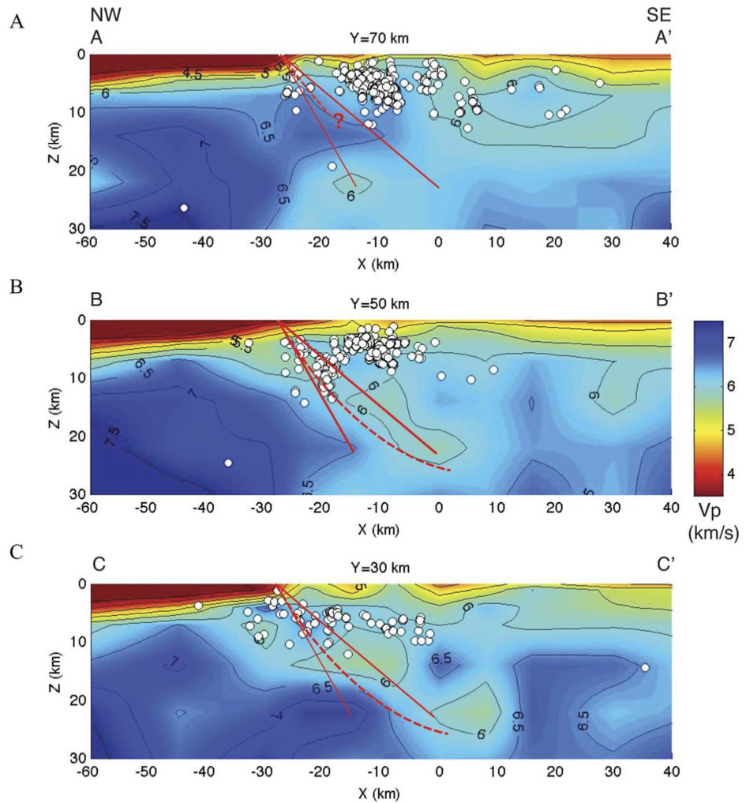

Figure A1. Cross-sections through the 3D VP model for the central part of the study area at (A) Y = 70 km, (B) Y = 50 km (Whataroa), and (C) Y = 30 km from Feenstra et al. (2016), their Figure 4. Earthquakes with hypocenters within 5 km of each cross-section are plotted as circles. Solid red lines indicate plausible range of AF dip (40° and 60°) based on geologic information. The red dashed line in (C) is the interpreted geometry of the Alpine Fault based on the structure and seismicity. P-wave velocity in km/s. Feenstra et al. (2016) used the same coordinate system as that in this manuscript.

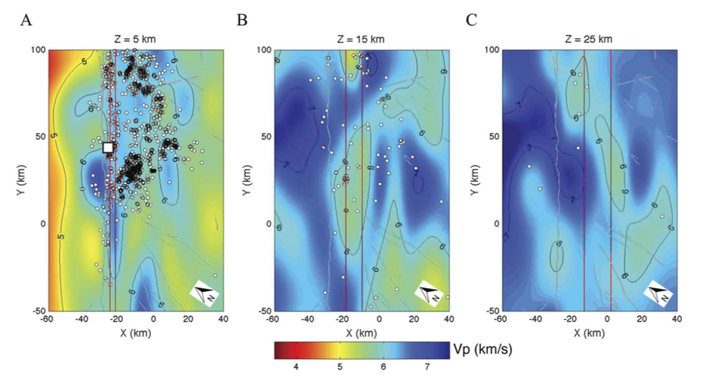

Figure A2. Three map-view slices of P-wave velocity (in km/s) from Feenstra et al. (2016) (their Figure 3). Depths are below sea level. Earthquakes with hypocenters within 5 km of each slice are plotted as circles. Solid red lines indicate plausible range of AF dip (40° and 60°) based on geologic information. Grey lines are mapped faults. White square is the DFDP-2 site.

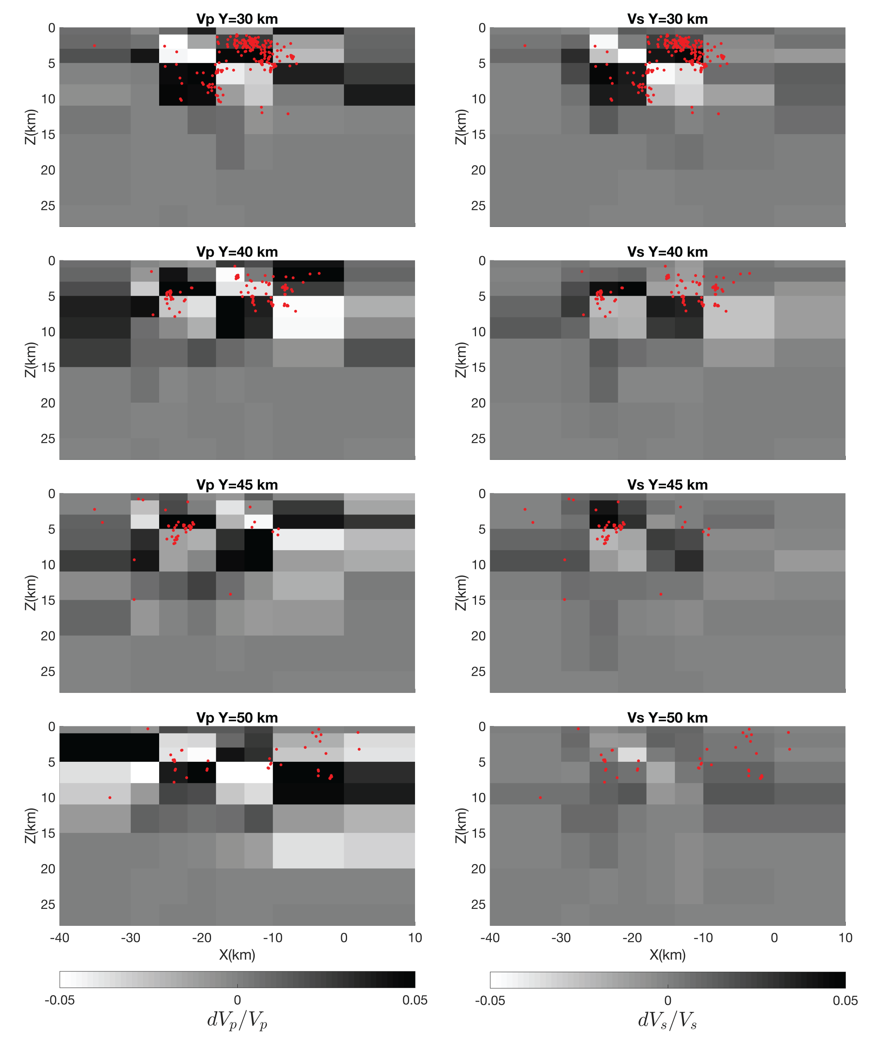

Figure A3. Checkerboard test results using data from Feenstra et al. 2016. Left column are VP results and right column are VS results. Red dots are earthquake locations within 2.5 km distance in the Y direction from the cross-section.