Data-Flow Map
Phase 0B · task 9 · from the code at base commit 4f261ac · feeds the cross-border question in spec 18.5 and the counsel questions in 05a and 05b
How this was made
Read from the code only: wrangler.toml, the migrations, the controllers and libraries that call outside services. Countries are listed only where the code or config shows them. In practice none do, so the country column mostly says so. Section 4 lists what could not be determined.

1. Diagram
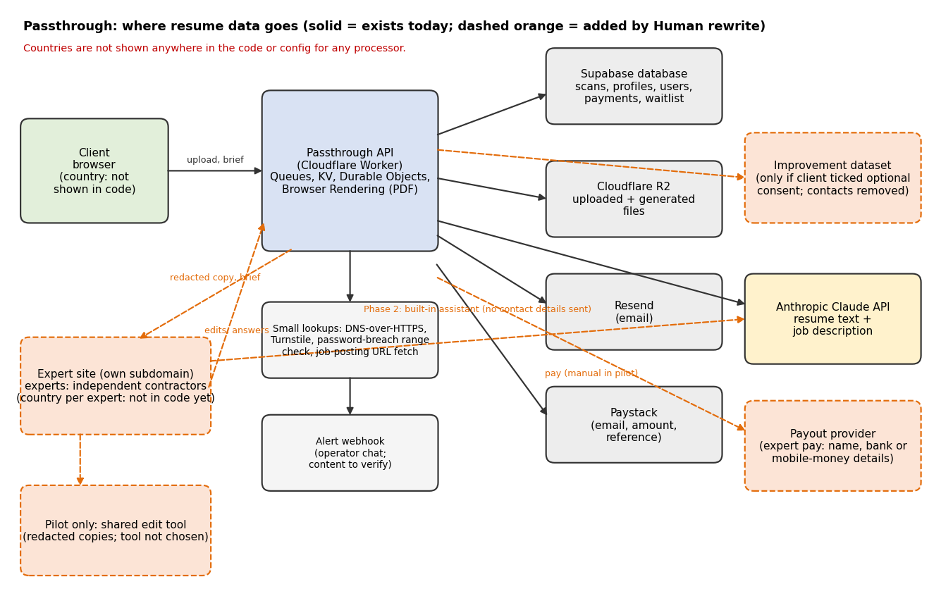

2. Flows that exist today
ID | Flow | Data | To | Country shown in code | Evidence
E1 | Client uploads or pastes a resume and a job description or URL | Resume file or text, job description, anti-bot token | Passthrough API (Cloudflare Worker) | Not shown in code or config | src/controllers/scan.controller.js; src/lib/turnstile.js
E2 | Files stored | Uploaded resume file; generated Word and PDF files | Cloudflare R2 bucket "passthrough-resumes" (binding RESUMES_BUCKET) | No location or jurisdiction set in wrangler.toml | scan.controller.js (RESUMES_BUCKET.put); wrangler.toml
E3 | Structured data stored | scans.original_resume_data and rewritten_resume_data (JSON of the resume); saved profiles; users; payments; email logs | Supabase database | Not shown in code or config (SUPABASE_URL is a secret) | supabase/migrations/0003, 0022, 0025, 0026
E4 | AI rewrite, scoring, structuring, cover letters | Resume content and job description text | Anthropic Claude API (api.anthropic.com) | Not shown in code or config | src/services/claude.service.js
E5 | PDF rendering | Resume content rendered to PDF | Cloudflare Browser Rendering (binding BROWSER) | Not shown in code or config. PDF styling may load web fonts from a font host: to verify. | wrangler.toml [browser]
E6 | Payment | Email, amount, reference. No card data and no resume. | Paystack | Account country not shown in code or config. PAYSTACK_CURRENCY is USD. | src/services/paystack.service.js
E7 | Transactional email | Recipient address, subject and body of verification, delivery and receipt emails. Whether files are attached: to verify. | Resend | Not shown in code or config | src/services/email.service.js
E8 | Job-posting fetch | The job URL the client supplies, and a DNS lookup of its host | Third-party sites; Cloudflare DNS-over-HTTPS (cloudflare-dns.com) | Not shown in code or config | src/lib/ssrfGuard.js
E9 | Password breach check | A short hash prefix of the password at registration | api.pwnedpasswords.com (range check) | Not shown in code or config | src/lib/pwned.js
E10 | Anti-bot check | Challenge token and IP | Cloudflare Turnstile | Not shown in code or config | src/lib/turnstile.js
E11 | Operator alerts | Alert subject and message. Whether any resume content can appear: to verify. | A chat webhook the operator sets (Slack, Teams, Mattermost or Discord) | Depends on the webhook; not shown in code or config | src/lib/alertWebhook.js
E12 | Internal queues and limits | Scan or job identifiers; rate-limit counters | Cloudflare Queues, KV, Durable Objects | Not shown in code or config | wrangler.toml
E13 | Demand test (Phase 0A) | Email or user id, tier, price variant, quoted amounts, contact consent, anonymous visitor id. No resume. | Supabase tables human_demand_events and human_demand_waitlist | Not shown in code or config | supabase/migrations/0119_human_demand_test.sql
E14 | Public verification page | Score, status, first name unless hidden, file fingerprints | Anyone with the link | n/a | Privacy section 6

3. New flows that Human rewrite adds
ID | Flow | Data | To | Country | Source
N1 | Frozen resume copy at payment | Full resume, scan result, AI draft | Human job tables (pilot or expert realm) | Not built yet | Spec 9.2, 22 (Phase 1 scope)
N2 | Redacted copy to the expert | Resume text with contact details replaced by markers; brief; job description with company name masked | Expert via the workbench, or in the pilot a shared edit tool | Expert's country: not recorded yet. The spec stores countries per expert and an allowed-region check per job (10.1). | Spec 18.1, Phase 1
N3 | Supporting materials | Up to three files, 5 MB each, plus links (older resume, reviews, portfolio) | Private storage, then the expert | Not built | Spec 6.3, 27
N4 | Questions and answers | Free-text questions and client answers (scanned for contact details) | Expert and client through the platform or the operator | Expert's country | Spec 18.2
N5 | Built-in assistant (Phase 2) | Resume text without locked contact fields or third-party data | The existing AI provider | As E4 | Spec 18.6
N6 | Improvement data | AI draft and expert final pair with contact details removed | Internal test sets only, and only if the client ticked the optional consent | Not built | Spec 6.2
N7 | Delivery and notices | Word and PDF files, change summary, confirmation items | Client by email through the app, or by hand in the pilot | Operator's email provider in the pilot: to verify | Spec 6.5, F.2
N8 | Expert payment | Expert name, bank or mobile-money details, tax information, payout amounts | A payout provider, or manual bank payment | Expert's country | Spec 17
N9 | Review and grading | Sampled jobs shown to a reviewer | Reviewer, who is another expert or the operator | Reviewer's country | Spec 13
N10 | Audit log and ledger | Identifiers, times, amounts. No resume text. | Supabase (expert realm) | As E3 | Spec 18.2

4. What could not be determined
Unknowns (each needs an answer before the privacy policy and counsel questions are final)
1. Region of the Supabase project, the R2 bucket, the Resend account, and the Anthropic API calls: nothing in the code or config sets or shows them.
2. Country of the Paystack business account (this also decides whether Paystack Transfers can be used for expert pay).
3. Whether delivery emails attach files or only link to them.
4. Whether any alert message can contain resume content.
5. Whether the PDF renderer fetches fonts from an outside host, and what is sent.
6. Whether the Anthropic account is configured so that API data is not used for training or is retained for a stated period. Spec 18.5 says to check the provider's terms.
7. R2 and database retention timings for resumes. A retention service exists (src/services/retention.service.js); I did not read its schedule in detail.
8. The countries where the pilot experts live and work, and the countries clients buy from.
9. The shared edit tool for the pilot (not chosen).
10. Whether the operator's own email and storage, used for the pilot by hand, count as another processor.

5. Reading for counsel
- The new recipient category is experts (independent contractors, possibly in other countries). They see resume content with contact details hidden.
- The new data subjects are experts themselves (payout details, tax and identity information).
- Items E2 and E3 hold resumes for as long as accounts exist. Human jobs add a shorter expert-accessible retention, which is not defined yet (spec Appendix E proposes 90 days; spec section 27 says 30 to 90).
- Nothing in the code today limits which country can see a resume, because there is no expert access yet. The allowed-region check is a Phase 1 or 2 build item.

