Game Planning: Four Corners
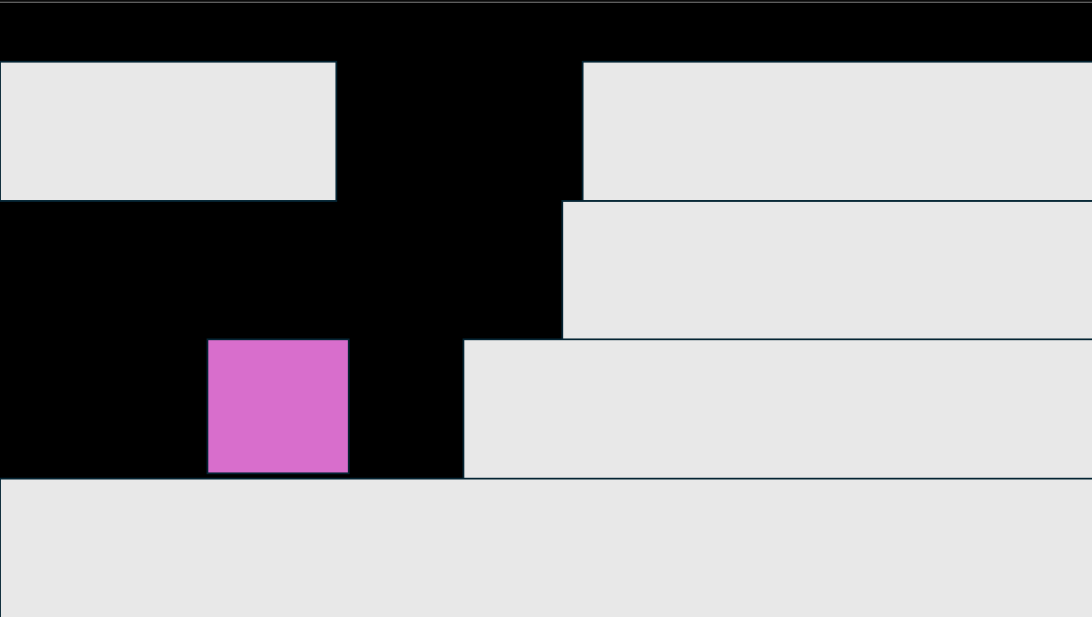
Project Design
Player Experience: player plays as a square that must jump up difficult terrain to get to the top of the mountain and move onto the next level. Timer that your times your run.

Core Mechanic: moving left and right. Jumping. Levels that get harder. Slippery terrain. Occasionally spikes that make the player restart when touched.

Core Game Loop: wanting to get a better score and move onto the next level.
Game Screen (draw an image of your game)

Game Flow and Screens Overview (flowchart)
The player opens the game and is greeted with a menu a play button. Once you press the play button a level selection screen comes up but you can only choose level one for now. When level 1 loads you must climb up the mountain to move onto the next level. When you beat the level you go back to selection screen but now you can select level 2.
Game Theme (including Story and Setting)
Mountain climbing no story just climbing up a mountain

