Life In West Hartford

Tracey M. Wilson

# Preface



This book-in-progress was last updated on: 2018-06-24

short description here

## Introduction

Who tells our stories? And what do these stories tell about what we value?

For 15 years, I wrote local history essays for the magazine, West Hartford Life. I’m not sure how I wrote more than 130 essays, each at least 1,000 words, while I was raising a family and teaching high school history full time. These monthly articles continually put me in the position of my Conard High School history students - a deadline, a topic, establishing a context, evidence, and ferreting out cause and effect. This work helped make me a better teacher and community member. I was able use my historian skills at the local level to help community members examine who we are as a town.

As I wrote these articles, and as you read them, individually, and as a whole, think about how they define what we value as a community. What events included all types of people? Which events excluded people? Which reinforced who had power and which gave power to those who didn’t have it before? Whose voices were heard? What documents can give us a window into the past? Is the story about an individual or is it more about the context in which this individual lived? How do present day issues help to define what we want to know about the past?

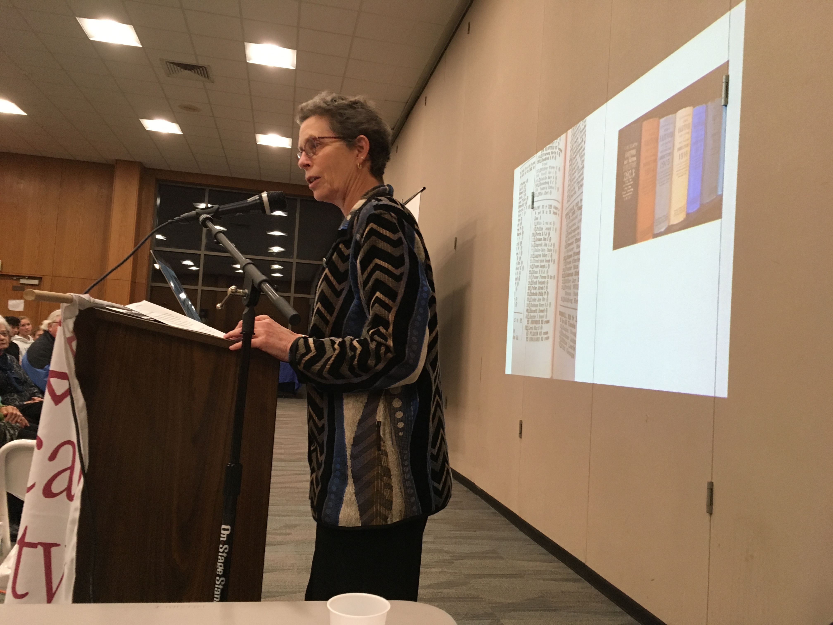

Author Tracey Wilson. Photo by Jack Dougherty

My love for this town comes from the involvement of so many citizens in striving to build a better community: a place based on justice, equal opportunity, a desire to join together to attack problems, and a love for those who live here. That is not to say that our actions in this town are always just, or that there is equal opportunity for all. Not everyone is a joiner, and not everyone is loved. But I dare say that many in this town make it their work to move toward those noble goals. You will read here about equality and differences. For example, you’ll read about our first meeting house, Lemuel Haynes, Amos Beman, Thomas Barrows, when we became our own town, Edith Beach, Susie Butler Andrews, Dr. Caroline Hamilton, the League of Women Voters, attempts to build affordable housing, Korczak Ziolkowski, Soviet Jewish emigres, school Superintendents, people who died in the many wars, and about pioneer Olivia Shelton.

Former Connecticut State Historian Chris Collier argued that he could teach United States History by teaching Connecticut history. There is much to be said for that sentiment. For the stories here about West Hartford teach us about equality, democracy, justice, rights and rebellion. Local history, too, can teach U.S. History.

## Acknowledgements

So many people have helped me become the historian and community member that led to this book. I think of my high school history teacher, Pete Lynch from Granby Memorial High School, college professors Jim Miller, Kim Steele, and Joan Hedrick from Trinity College. Graduate school professors Mari Jo Buhle and Joan Scott each helped me find my voice.

As a teacher, my department supervisors at Conard encouraged and supported me in teaching a Local History course, and did so for over 20 years. My students taught me much about what mattered and what stories had staying power. Thanks too, to the Town of West Hartford, and Mayor Jonathan Harris for naming me Town Historian in 2004.

[West Hartford Life](http://www.turleyct.com/west-hartford-life.html) provided a motivation and venue for my work. Thanks to Mark Jahne and others who encouraged me. And thanks to TurleyCT Community Publications for permission to publish the over 140 articles that first appeared in their magazine.

I especially want to thank Prof. Jack Dougherty, who, when I was at a very low point, came to me asking if I would be interested in making the articles into an online book. Jack made things happen. His intern and my former Trinity student Vianna Iorio did much of the legwork to help me get the articles in order and provide searchable words, a short synopsis and a means to organize them. What a treat to have them both help me through a difficult time and keep me motivated. Thanks for their friendship and professional help, especially when I needed it most.

Thank you to the Noah Webster House and West Hartford Historical Society, especially Jenn DiCola Matos and Sheila Daley. Sheila had the knowledge and the skills to help me find the primary sources which appear throughout the book. And she helped me find the illustrations and embedded them in the text, no small task.

Thanks to the West Hartford Public Library, and especially to Martha Church who always encouraged me in my study of Local History. Her knowledge of the town is vast and she has documents at her fingertips. Their Local History Room keeps the power of local history alive.

Thanks on a personal level to Liz Devine. We taught together for 37 years at opposite ends of town, for most of it, and then we retired together. We continue to talk history and teaching as we write curriculum and train young teachers. She is as good a friend as you’d ever find!

And finally, my family - Peter, Adam, Brittany, Caroline and Billie - who delight in my love of history and find ways to keep me guessing. And, to Beth, who is the best partner a person could ever have and my best editor. She is supportive, fun, and curious, and she knows what I love.

*- Tracey Wilson, June 2018*

# Colonial Life

* by Tracey M. Wilson *

## Equality and Difference in Colonial West Hartford

*Originally appeared in West Hartford Life, November 2000*

“All men are created equal.” This grand statement appears in the Declaration of Independence written in 1776. Since the writing of the Declaration, Americans have thought a lot about the issue of equality in political, economic and social terms.

Was there equality in the West Division of Hartford (as West Hartford was called before independence in 1854) by 1776? And, did colonial residents recognize economic and social differences?

Landholding is one place to look for differences in wealth. When the proprietors divided the West Division land into long lots in 1671, they distributed it according to how much land each man owned in Hartford. Those who had large lots in Hartford received large ones here. There was no attempt in the move west to equalize fortunes; instead this land division reinforced the economic hierarchy that existed.

At the same time, more Americans had the chance to own land than in England. Proprietors divided the abundant land among all sons in the New World, as opposed to only the first son in England.

A look at colonial homes still standing in town gives a glimpse at the range of house sizes and thus the resources of individual families. A middling farmer built the Noah Webster House at 227 South Main. Built around 1748, the house originally had four rooms built around a center chimney. The Benjamin Colton House (c. 1770) at 25 Sedgwick Road and the John Wells Jr. House (c. 1766) at 505 Mountain Road both are substantially larger than the Webster House. They have five windows in front and two on each side, while the Webster House has three windows across the front and one on each side.

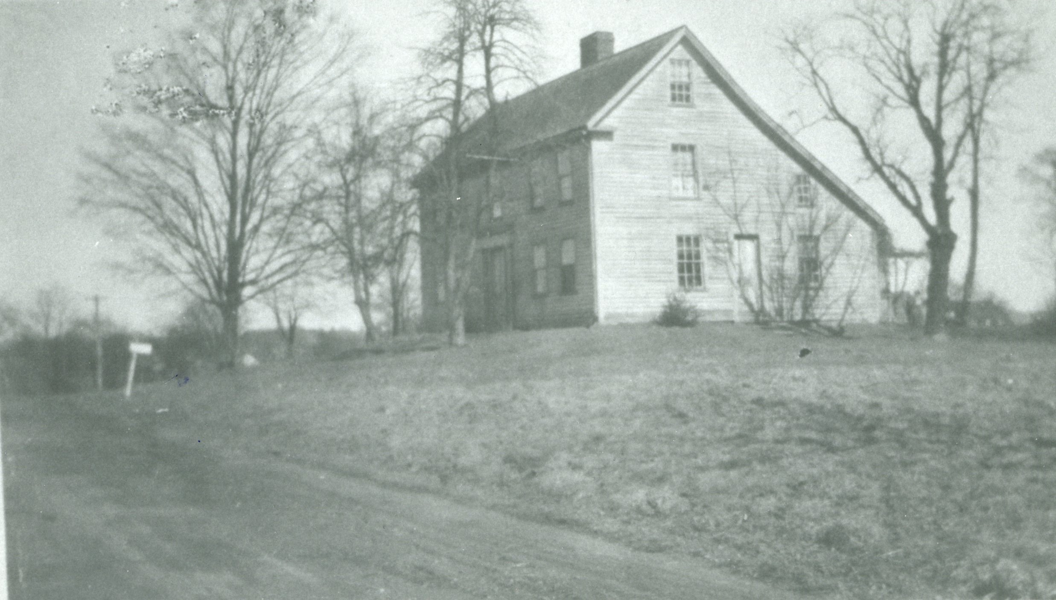

The Gillet house, at 202 South Main Street is one of 18 remaining colonial homes in town. It was built by Asa Gillet, a grandson of Joseph Gillett, one of the first proprietors of the town in 1694. Asa Gillett farmed both sides of Main Street in the late 18th century and he traded with the merchant Joseph Webb in Wethersfield. Source: Noah Webster House & West Hartford Historical Society.

This comparison tells us only so much, however. The houses of the poorest residents did not survive. Those who had not reached the middle-class status of the Websters might have lived in a cellar with a roof, or in a shack that did not withstand more than a few winters. Archaeologists in other New England towns have found the remains of such buildings. We have no sites or artifacts here because larger homes were built over these original, simpler structures. But we can hypothesize that the difference between rich and poor housing was greater than the examples left standing.

Inventories taken at the time of a man’s death, are another way to assess the difference in wealth among West Division residents. Designated townspeople went into the deceased person’s home and listed everything found in each room. Today these inventories can be found at the Connecticut State Library. In the 1770s , the total value of the inventories of eight different West Division families (featured in Noah Webster House educational programs) ranged from about 300 pounds to 1,300 pounds.

The types of goods owned by these farmers did not vary greatly. Most families had a Bible and perhaps one other book in their inventory. Wealthier families had more clothing, more looking glasses and more books. The biggest difference in wealth was the amount of land an individual owned.

The Rev. Nathaniel Hooker, the second minister in town (1738-1770) who died at the early age of 32, had a list of books and drugs appended to his inventory, showing his educational background as both a minister and doctor. Though his estate was worth only about 550 pounds, Reverend Hooker had the most social prestige in the town because of his education and his position as minister.

The presence of slavery in the West Division was a clear sign of inequality. At least 15 families owned people of African heritage between 1738 and 1827. We have the names of more than 40 people who were owned. Some bought their freedom, some were freed by the 1784 gradual emancipation law, and some died in slavery. Reverend Benjamin Colton owned what he named a “negro servant,” and Reverend Nathanael Hooker owned a man, a woman, and a child.

Finally, the use of church records can tell something of the social structure within the town. In the late 18th century, there was but one church in town: the Fourth Congregational Church of Hartford. All townspeople had to belong to the church and paid taxes for its upkeep and the upkeep of the town. These records reside in the John P. Webster Library in the First Church (so-called after West Hartford became an independent town in 1854).

In a First Congregational Church booklet from 1913 commemorating the 200th anniversary of the church, there is a description from the 1760s about how people were seated in the church. A church committee assigned those with the highest social, political and economic standing to the pews in the front. Church leaders designated a pew for “old maids” in the back of the church. African-Americans like Page and Lew and the widow of Jude (listed as Negro) were members in full communion of the church. They also sat in the back.

People knew where they ranked by their seating in church.

In a list of “Members in Full Communion” in December of 1764 from the Fourth Church, the only church in town, there is a clear differentiation between people by sex, race, marital status and social status. Titles such as captain, lieutenant and colonel distinguished military men. Leaders of the church were denoted as deacons. That Page and Lew were considered members in full communion at the church, however, is evidence that everyone could be full members of the church.

Gender defined social status as well. Married women, like “Stephen Sedgwick’s wife” were listed as wives, not by their own names. Women considered “old maids,” such as Lydia Smith, were listed with their given name and surname, but many widows were noted as Widow Gillet, without the use of a given name. Where you sat in the pews each Sunday reminded those church goers of the social and economic hierarchy of the church members.

In the 1770s, West Divisions residents saw the difference between rich and poor all around them. But the gap, in a small town like the West Division, was nowhere near as wide as it is today, where multi-million-dollar homes exist not too far from one-bedroom apartments. Yet the abundance of land gave more people the chance to be independent farmers and the chance at a higher standard of living than they would have in England.

And, even with the distinctions between classes, there was a sense of equality of access. All residents had to attend the Fourth Church. All of them traded with John Whitman and Zaccheus Butler. While they were reminded of their social standing in church every Sunday, they all shared the right to vote on church matters, and those who owned land voted on town matters. All West Division residents had certain basic inalienable rights, but they clearly knew their place within the established hierarchy of their small New England town.

# Noah Webster

* by Tracey M. Wilson *

# The Market Revolution

* by Tracey M. Wilson *

# An Independent Town

* by Tracey M. Wilson *

# A Growing Suburb

* by Tracey M. Wilson *

# World War I Era

* by Tracey M. Wilson *

# Development and Reform

* by Tracey M. Wilson *

# World War II Era

* by Tracey M. Wilson*

# Post-World War II Era

* by Tracey M. Wilson*

# Inner Ring Suburb

* by Tracey M. Wilson*

# The Fight for Justice

* by Tracey M. Wilson*

# Afterword

* by Tracey M. Wilson*

**Speech delivered at Ceremony for Dedication of Tracey’s Tree, October 9, 2017**

This speech tells much about my work as Town Historian and the power of history in our lives. Delivered at Burgoyne Park in Elmwood on the occasion of planting an elm tree, now known as Tracey’s Tree. See local news: <http://we-ha.com/traceys-tree-dedicated-honor-west-hartford-historian-retired-teacher-dr-tracey-wilson/>

Good Afternoon!

Thank you so much for this ceremony. I am humbled and honored to have this elm tree planted in my name. Who gets to have something like this?. . .and especially when I can appreciate it. In these days of consciously thinking about who should be commemorated and what statues can stand, I feel even more honored that there was consensus that I’m one for the ages.

First I want to thank Rick Liftig who was the mastermind of this whole thing – and then Jenn DiCola Matos and Pam and Charlie Hilborn who helped carry out the plan. Thanks too, to the Governor’s Foot Guard - which was formed in 1771 and joined the march to the Battle of Saratoga in 1777, for adding to this celebration. And all of you who came - family Beth and Adam and Peter (and Brittany Caroline and Billie who couldn’t be here) and my brother Dave, friends, teacher colleagues, and particularly my retiree partner Liz Devine, former students, the Solidarity Sisters, Katherine who helped me pick the apples yesterday, elected officials and those of you running for elected office and members of the Universalist Church all members of this community for whom I am so grateful to be a part.

Many of you gave money in my name to benefit two of my favorite non-profits – the Noah Webster House and Knox, Inc. - history and gardens are two of my favorite things! Thank you.

To me, the planting of this elm tree represents

* a symbol in history,
* a community event, and
* a tool for educating us about liberty in a democracy.

You see, trees have special significance

* in our environment and also
* as symbols – Marcus Garvey, the great black nationalist, proclaimed 100 years ago,

A people without the knowledge of their past history, origin, and culture, is like a tree without roots.

He knew the power that history can have in people’s lives - that knowing our history cannot only keep us rooted, but history can also give us a firm footing to branch out - to give shade, to reach the sky. And as we are seeing in Puerto Rico, even as soon as a week after the hurricane, those trees whose roots held, already have leaves sprouting.

Our celebration today is about history and it coincides with the day 240 years ago in Saratoga, when American General Benedict Arnold’s troops repulsed British General Johnny Burgoyne’s troops in the Second Battle at Saratoga. This battle turned out to be a turning point in the Revolutionary War. Ten days later, General Burgoyne surrendered 5,000 British and Hessian troops to American General Horatio Gates.

This battle reverberated in France, when the French told American envoy Benjamin Franklin that they would become an ally to the Americans in their fight for independence against the British.

When word got back to the West Division of Hartford, Ebenezer Faxon whose homestead was on this corner, planted a small grove of elms right here, on the corner of Quaker Lane - then known as East Street and New Britain Avenue, then known as South Street. They grew and became a town landmark known as the Burgoyne Elms – properly known as the Victory over Burgoyne Elms.

The idea of a regular everyday tree being a symbol is powerful. I dare say that most of us like trees – they give shade and sometimes fruit, they produce beauty when their leaves change, and they help turn carbon dioxide into oxygen. Yet these elm trees became much more.

The history of the elm as a liberty tree began in 1765 as a protest to the British-imposed Stamp Act. In 1765, when the British Parliament passed the Stamp Act, Boston Patriots hung a British tax collector in effigy from an elm tree. This Stamp Act put taxes on newspapers, printed materials and college diplomas - so the protest of hanging the tax collector in effigy symbolized a desire of these Patriots for access to information, access to an education, rule by law, and individual liberty. Most historians argue that the protest was not so much about the tax, but it was more about having representation in a government that raised that tax. And I agree.

So, this Liberty Tree had branches which could be used for political purposes or some might say for social change. This idea of a tree representing liberty, representing a fight against tyranny and oppression, led Faxon to plant them here on this plot of land, in what for over 200 years has been known as – Victory over Burgoyne Park.

That protest demonstrated support for liberty - that we define in two ways:

1. liberty from government tyranny and coercion
2. liberty to participate in government

I want you to try, like the Governor’s Foot Guard must every time they put on their uniforms, to think back 240 years and wonder

* What did liberty mean to the people who lived here 240 years ago?
* Was it so different from what we yearn for today?
* Would we understand each other’s ideal?

**COMMUNITY**

These elm trees represent these historical questions and they represent the kind of community in which we live.

Faxon planted elm trees and we plant elm trees as a symbol of liberty and also a way to gather our community, to remind us that we are not just 63,000 individuals, living out our daily lives in isolation, but that our lives are made better by living in community - and by celebrating and enjoying the community in which we live.

In a lot of ways a community - like Elmwood, like West Hartford - is a covenant. It is an agreement to live together – and in a covenantal relationship we ask, not what we get, but what we can give. Here many of you have given time to set up this ceremony, given money to these two great organizations, Knox and Noah Webster. I have worked to give back to the community through the writing of its history, through many years of Empty Bowls banquets, my work with the Noah Webster House, and through my leadership in the Universalist Church on Fern Street.

The second definition of liberty - is the liberty to participate in government. I urge you to get involved in public service – this could mean, like my wife Beth, that you run and serve in elective office. Though politicians are criticized continuously, they are who translate and safeguard and put these ideas of liberty into action. They represent us as we relay our ideas to them for what we want government to do. Beth would tell you that as a Senator from West Hartford, she gets 2 to 3 times as many calls from constituents than other Senators. Our community’s hyper-engagement helps define our aspirations through peaceful civic engagement. That is one of the reasons we love this community so much - because its citizenry is enfranchised and empowered to make government work, something for which the Patriots fought.

Being civically involved also means getting involved in organizations like the Noah Webster House and Knox Inc., the Elmwood Business Association, and the Black Lives Matter Movement. It could also mean being on the Library Board, coaching a youth sports league, advocating, like Mary Ellen Thibodeau does for safer streets for bicyclists and pedestrians, or organizing a block party in your neighborhood, or helping to organize hurricane relief for Puerto Rico.

And in Elmwood and West Hartford, we celebrate this engagement. The names of our schools honor local heroes who were involved in our community. This park is now known as Blanchfield Park as a tribute to Bill Blanchfield who worked in this community and came here everyday to raise the flag. Behind us is the former Talcott Jr. High, named after James A. Talcott, a businessman who donated money and books to start our town library in 1897. Conard High School was named after Frederick U. Conard, President of Niles-Bement-Pond in Elmwood and the Chair of our Board of Education.

So, I challenge you,

* How do you participate in your community? Not just in the past, but also today.
* What is your covenant with this town, your town?
* How do you help people make connections and build local institutions and get involved in civic life like this tree planting ceremony is doing today?

**EDUCATION**

And finally, this elm tree, I hope can be a symbol for the importance of education in our community that helps students understand what liberty is.

I’d like all the teachers who are here to raise their hands and stand. I believe it is the teachers who keep our country safe, who protect our democracy, and are our biggest defenders of liberty. All teachers are models for democracy, civic discourse and critical thinking by the way they model those values in their classrooms, regardless of subject matter. And, when our Social Studies teachers teach our history and the principles of American government, students learn what freedom is. Please give them a round of applause.

I feel so lucky to have had the chance to be your colleague and to serve this community as a teacher, starting right here at Talcott Jr. High in 1977 and then at Conard until 2015.

As you know, I love **history**. I studied women’s history, African American History and Labor History in school. What all those fields have in common is that they are not the people who “won” and often their voices were not heard in the standard narrative of US History. My job, I thought, was to make their stories come alive – to give a voice to the voiceless and to try to complicate a narrative that mostly focused on men and political history.

As teachers, we tell local and national stories that help us get at the historian’s enterprise:

* What causes change?
* How does an event compare to what happened in another time and place?
* What is the context of the event? and
* What changes and what remains the same?

West Hartford has stories: of the Beach sisters, Bristow, Luna Park, and World War II housing, and an individual teacher’s vision all help define a community

* where the Beach sisters could be leaders and drive their own cars as early as 1905,
* where an enslaved man who bought his freedom, right before these elms were planted could get a school, Bristow, named after him in 2004,
* where people came by trolley to Luna Park for manufactured fun in a city of lights,
* where Frederick Duffy, the head of the housing authority successfully banned African Americans from living in federal housing built right near here during World War II, ironically, our 20th century fight for democracy;
* where in the 1970s and 80s, a school teacher, Eve Soumerai, who survived the Holocaust, even before there was Unified Theater, integrated students with disabilities into her musical theater productions.

Each of these stories helps us understand the texture of our town today - and provides multiple narratives that continue in this complex inner ring suburb that we call home.

These stories themselves become symbols, like this tree, of values that matter to our community. They are a way to break into student’s certainty of a single narrative, and to raise questions about who had power, and finally I hope they help give agency and voice to those who study the past.

I like to think that I have lived up to the aspirations of Ebenezer Faxon, 240 years ago when he showed with his action of planting elm trees, that they would be a symbol to safeguard liberty. I believe safeguarding liberty happens in the political realm, and in our schools. I take pride in former students who chose to run for elected office including State Rep Joe Verrengia, Town Councillors Dallas Dodge and Chris Williams - and Ryan Langan who is running for office. And, when I find out one of my former students has become a teacher my heart jumps. I think of Katy Worth McCarthy, Kevin Liftig, Diana Coyne, Melissa Behrens, Anne McKernan, Leslie Hadra, Steve O’Meara, Emily Goetz, Kelly McCormick Brouse, Anna Bennett, Michael Bennett, Ebony Jones, Morgan Reed, big Carl Johnson, and many more. This job of teaching students how to live an examined life is passed from one generation to the next. Like the idea of liberty embodied in these elm trees, our teaching reverberates beyond our classroom.

So thanks once again for this great honor. I am so happy to have moved to this community 40 years ago and today to feel rooted in this place – You have allowed me to branch out, to plant seeds, and to provide shade for students and people who needed it. And in this past year and a half as I have had to learn to live with cancer, I have been so grateful to my family, friends, and this community for your support. Without you, I don’t think I’d be here today, basking in this day, on this busy corner, just aching to get to the apples and doughnut holes!

Thank you!