Part 2B:

Supplemental Charts on School Finance and Demographics
for Metropolitan Milwaukee and Federal Aid

While researching this report, I did my best to collect reliable school finance data and search for meaningful patterns to supplement the narrative. But since the data are a mess, and also because I’m not very confident with what I’ve found, this information should be treated as a tentative supplement to the full report.

The Metropolitan Milwaukee School District Revenue Data here come from two major sources:

a) from 1955 to 1980, I relied upon the annual fiscal reports by the metropolitan “good government” watchdog group, the Citizens’ Governmental Research Bureau (today known as the Public Policy Forum). To my knowledge, they were the only source at the time which collected detailed school financial data for the entire Metro Milwaukee area (not just the city. However, their reports relied upon budgets, rather than actual expenditures, since they were trying to warn the public about finance issues before they happened.

b) After 1980, the WI Department of Public Instruction began to publish some reliable data on district-level revenue sources, enrollment, etc, in the series titled “Basic Facts about Wisconsin Elementary and Secondary Schools.” During this period, the CGRB/PPF didn’t publish as many bulletins as they used to do.

To cover the entire 1955-1996 period, I had to draw upon both CGRB and WI DPI sources, thus merging different sources of data. Therefore, pre-80 and post-80 data may not be perfectly comparable, but I think they’re pretty close.

In my files, I have lots of other notes about limitations in the data, due to CGRB/PPF reporting formats that differed from year to year.

Different systems gave different dates, depending upon “year beginning” or “year ending”. I tried to keep track of this in my spreadsheet, but there may be mistakes.

Overall, I decided to trace patterns among four metro Milw school districts:
a) Milw Public Schools - the big one in the city
b and c) Shorewood and Whitefish Bay - two wealthy northshore suburbs
d) Cudahy - a lower-income, industrial suburb on the far southside

Typically, data on federal and state revenues did not appear in CGRB reports until the late 1960s, because it was not a major player. Perhaps the most important finding is the public controversy over federal aid was disproportionately high with respect to the relative amount of funding.

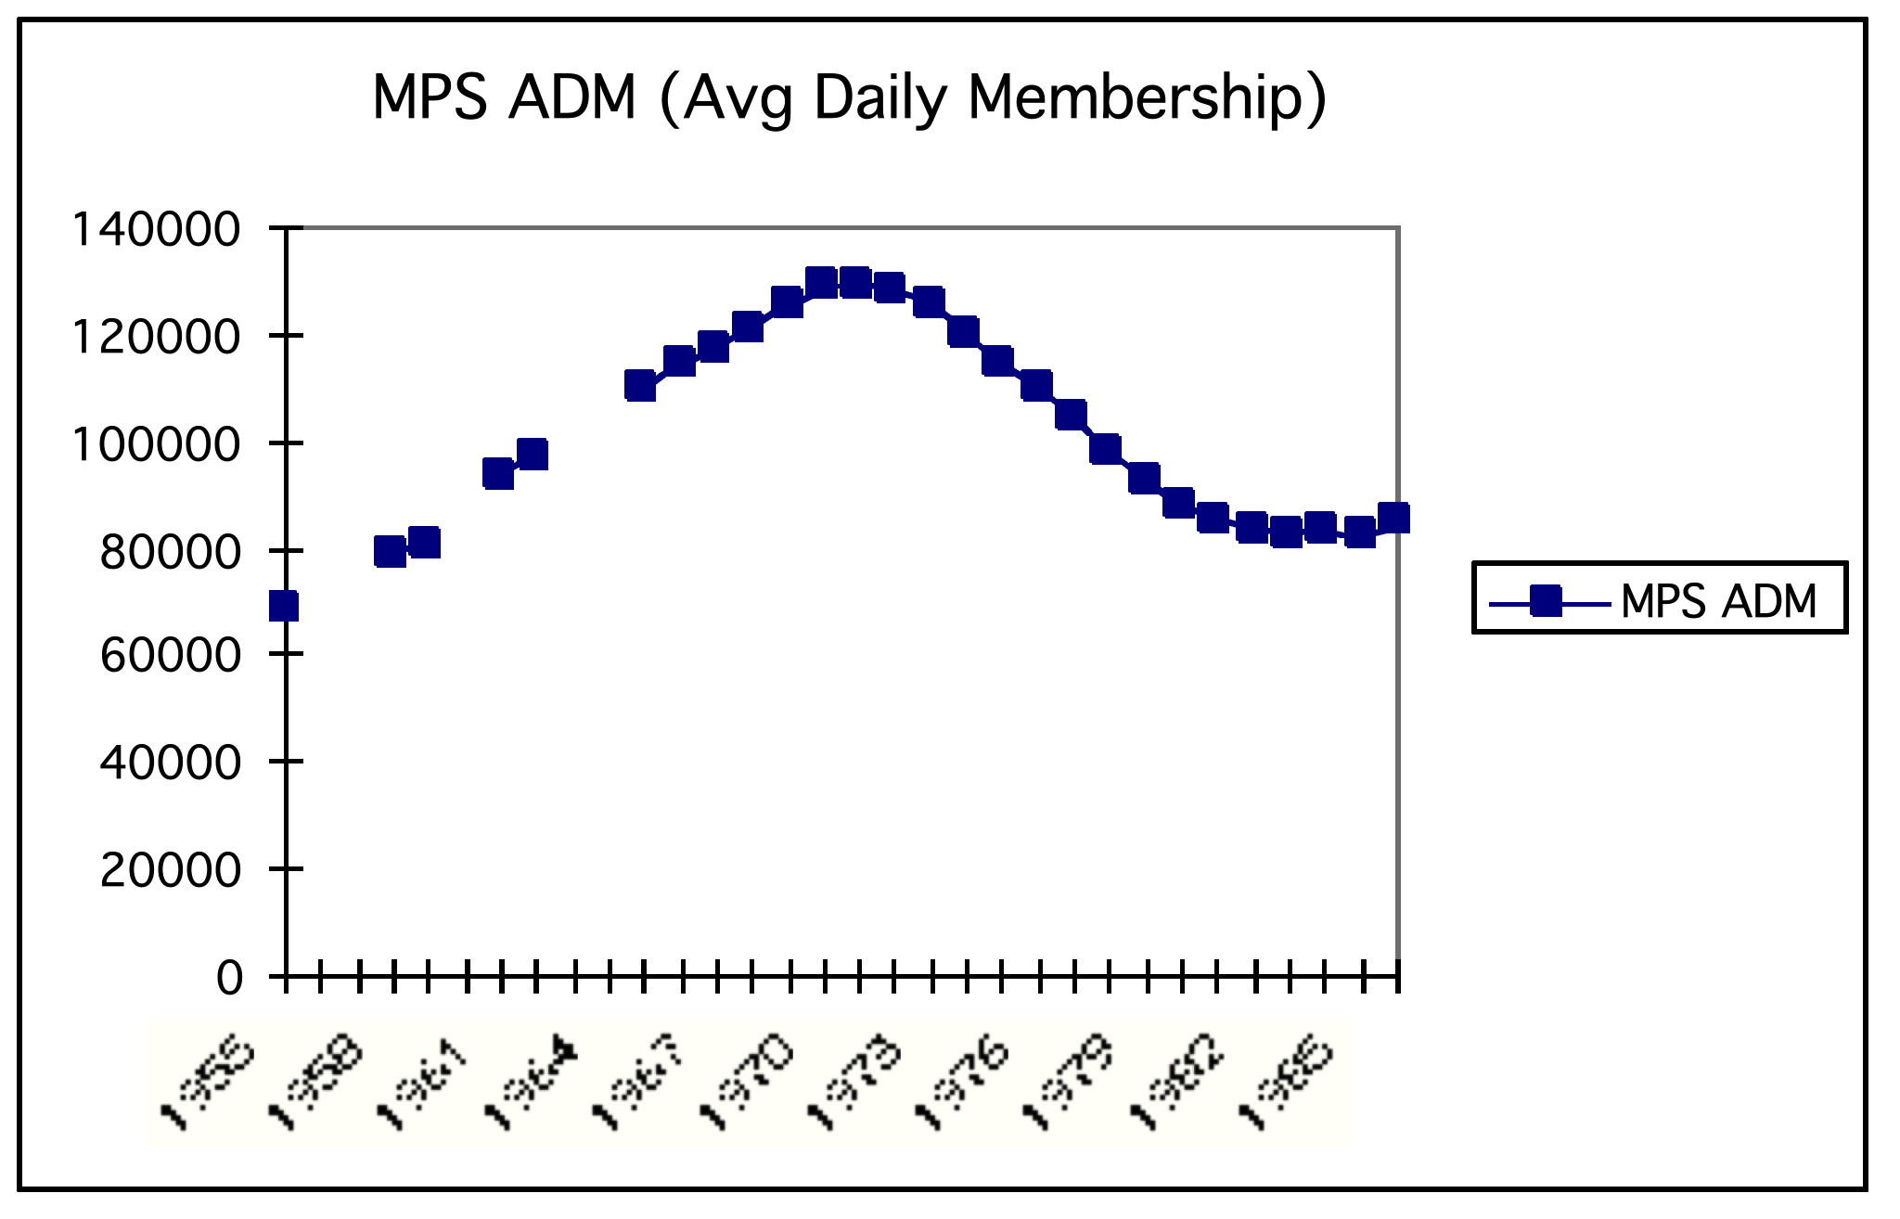

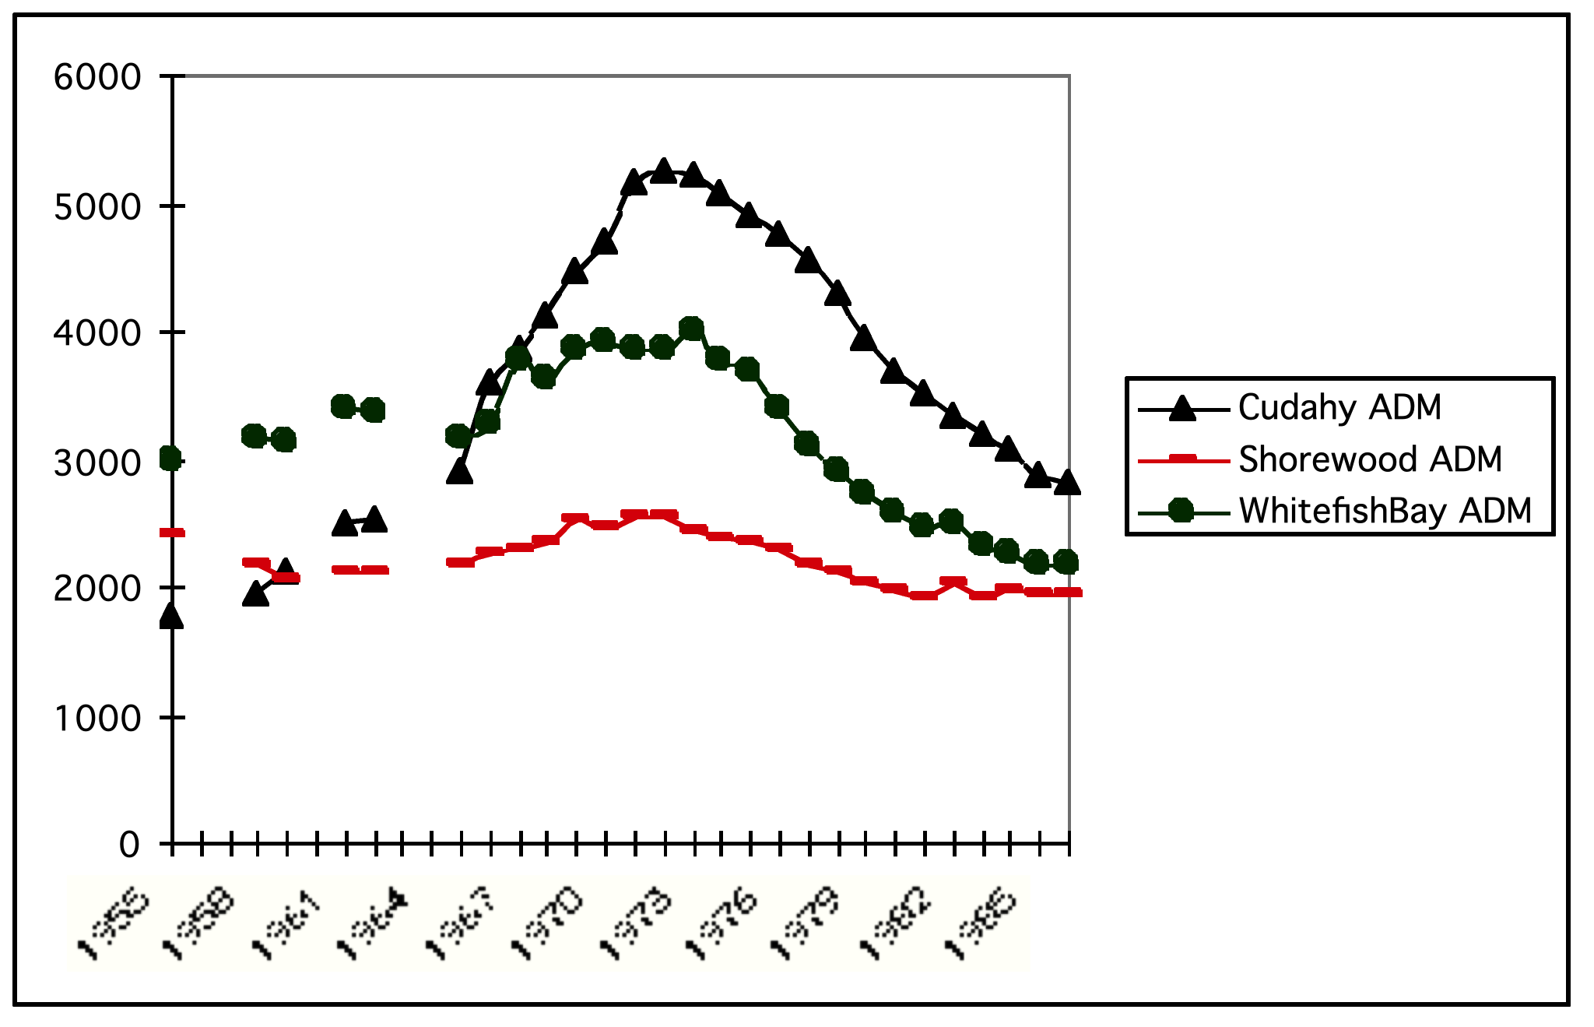

ADM, or Average Daily Membership (standardized enrollment numbers) show all four districts rising and falling in student population, with the peak around 1971. Shorewood and WBay were less affected by enrollment changes than the other two districts. (I split MPS from the suburb data because the scales were so different; MPS is always higher than 80,000, while suburbs never top 6,000.

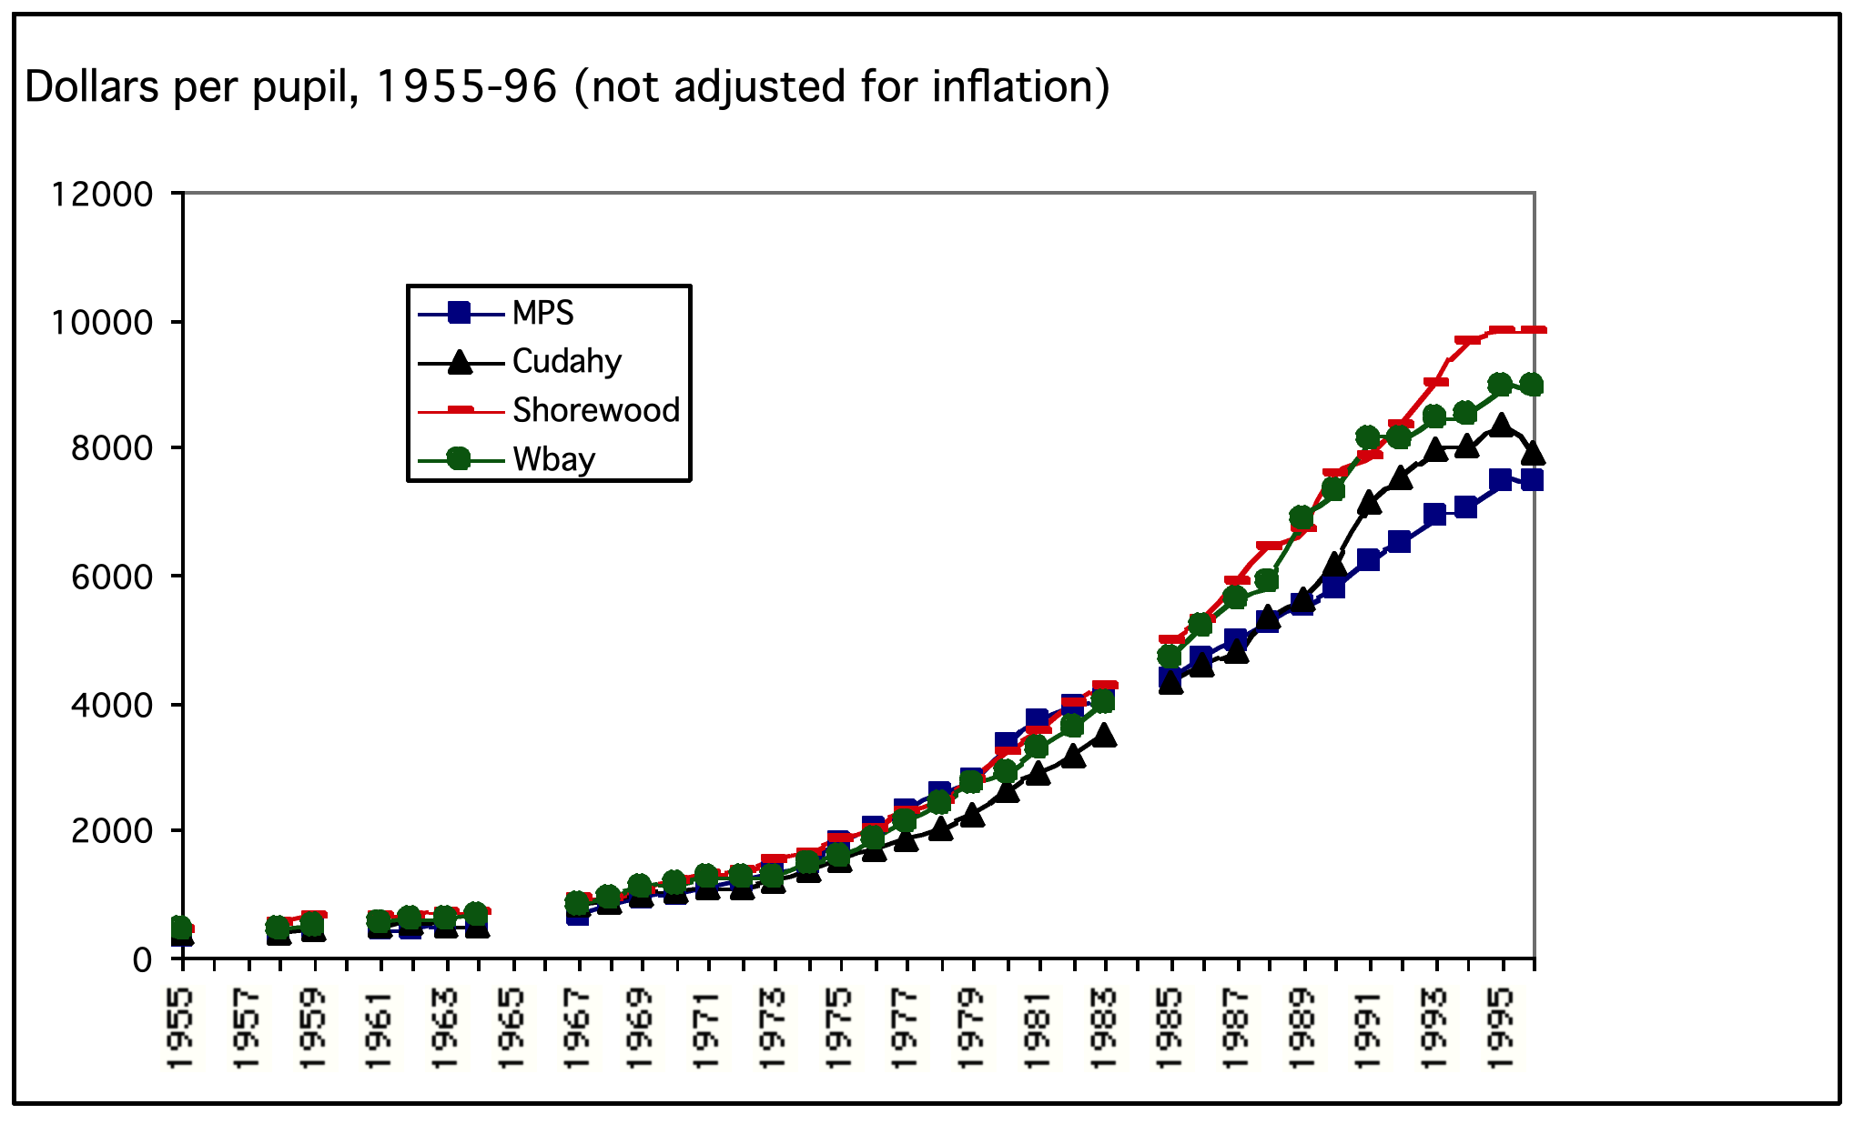

This chart shows spending per pupil rising steadily (though not adjusted for inflation). It’s difficult to see significant differences here due to the wide scale. A close-up view of two periods sheds more light on the picture. See next page.

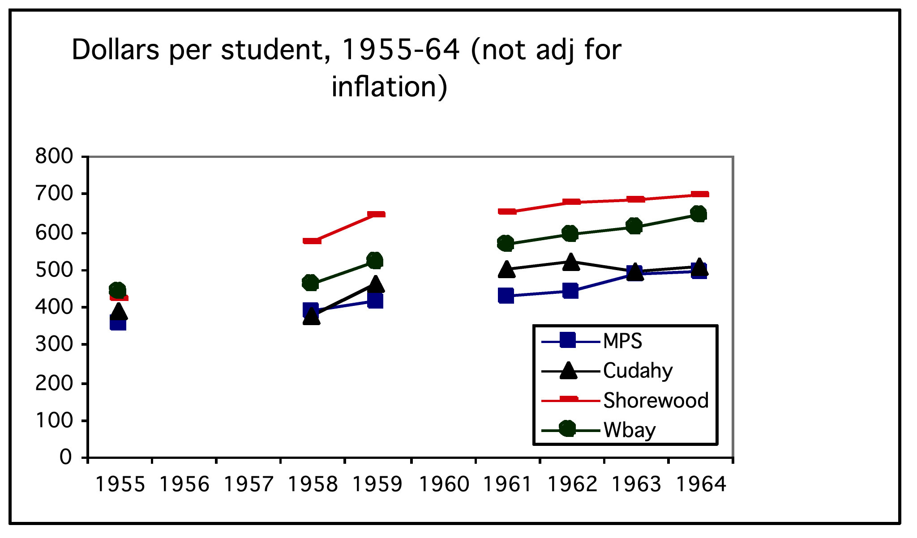
During the pre-1967 years of significant ESEA aid, MPS spent much less per pupil than did the suburbs. The numbers alone do not explain why, but the most common interpretation is the economies of scale which large cities enjoyed over small village districts at the time.

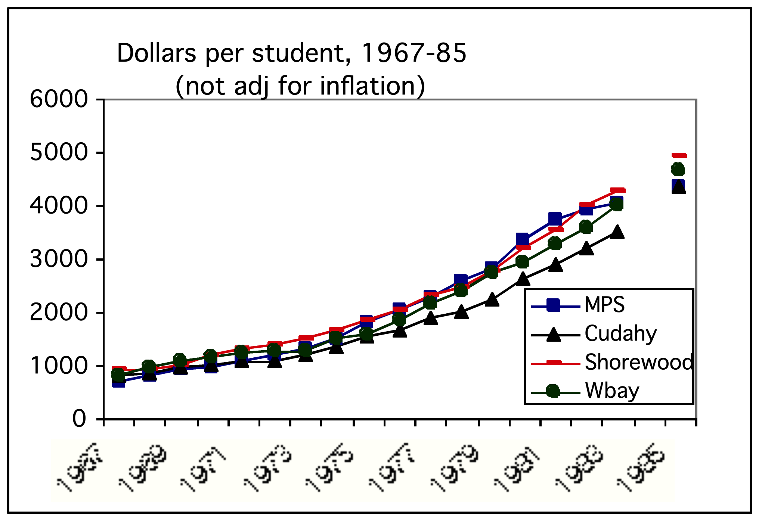
From 1967-85, MPS began spending more per pupil than the typical suburbs, surpassing them in the late 1970s. Again, the numbers alone do not explain why, but closer study of the data may show a linkage with federal aid (especially ESEA and ESAA for desegregation in the late 70s). When MPS received large amounts of federal aid, they had to spend it, which is one factor that raises the level of dollars spent per student.

In the mid-1980s, MPS spending per student drops below the suburbs. This happens to correspond with a drop in federal aid in the Reagan ECIA years, but it also may be traced to state aid, local property tax values, etc.

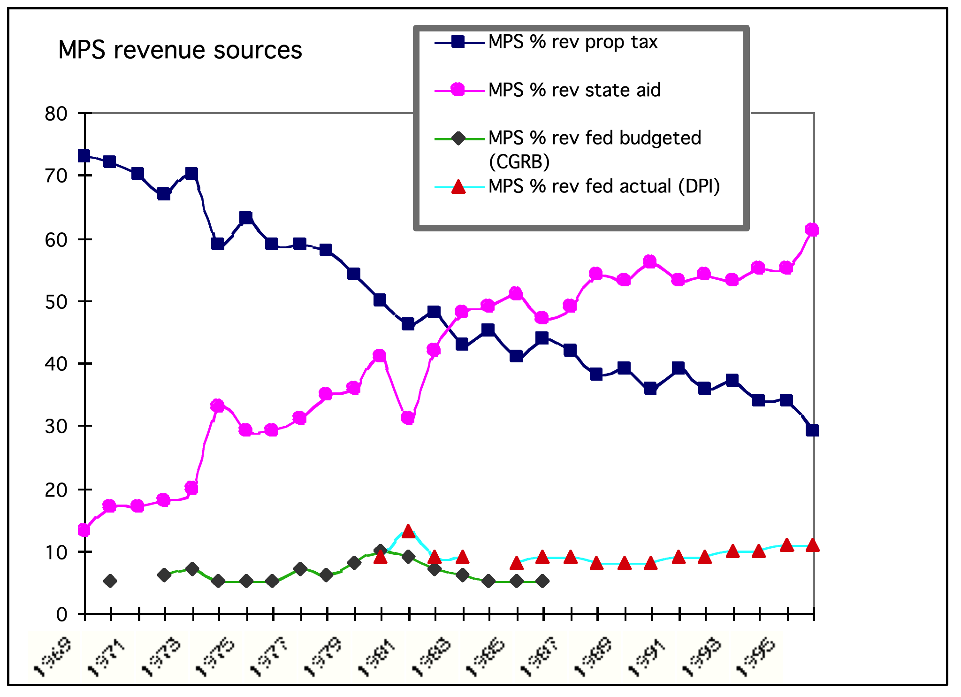

This chart shows that MPS grew more dependent upon state aid and less upon property taxes over time. The switchover occurs around 1982, in the middle of the chart.

Along the bottom, federal aid hovers around 5 to 10% of the MPS budget. I had to use two sets of data to represent the early 1980s, because budgeted federal aid estimates (from CGRB) tended to be lower than actual federal aid revenues (from the DPI data). At first glance, it appears that the “draconian” budget cuts of 1981-83 weren’t that bad, but it’s important to remember that even a 1% cut in a major city school budget during times of social and economic stress is a major event.

Once again, one interpretation of this chart is that federal aid attracted a disproportionately high level of public controversy in comparison to its relative level of funding.

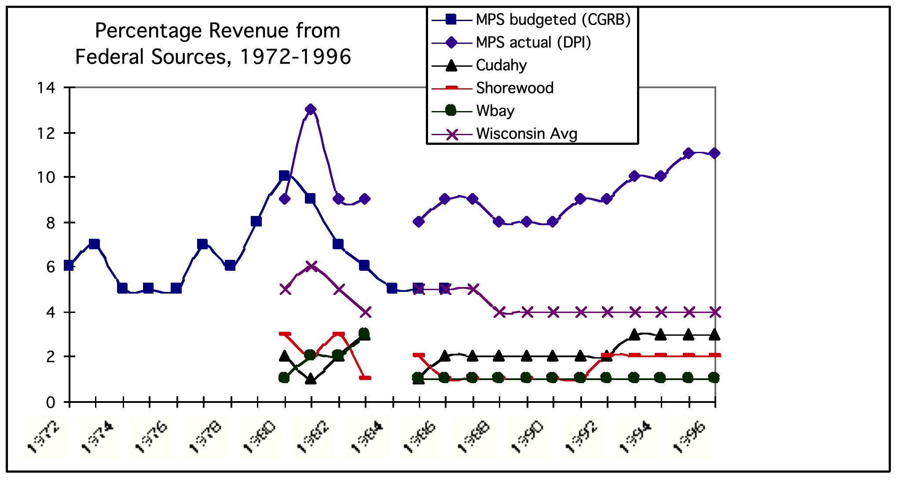

This chart tries to compare the percentage of school budget revenues from Federal aid, but there’s lots of gaps in the data, so it looks very odd. Overall, WBay, Shorewood, and Cudahy float along the bottom, usually receiving no more than 2 or 3% of their annual budget from the feds. The Wisconsin state average is in the middle, around 4 to 5%. At the top are MPS budgeted (CGRB) and MPS actual (DPI) numbers, ranging anywhere from 5 to 13%. As we know, there’s a big dip in 1980 due to the cuts of ESAA and the beginning of ECIA, but I had great difficulty in finding accurate, trustworthy numbers, partly because announced budgets did not correspond neatly with actual amounts received.

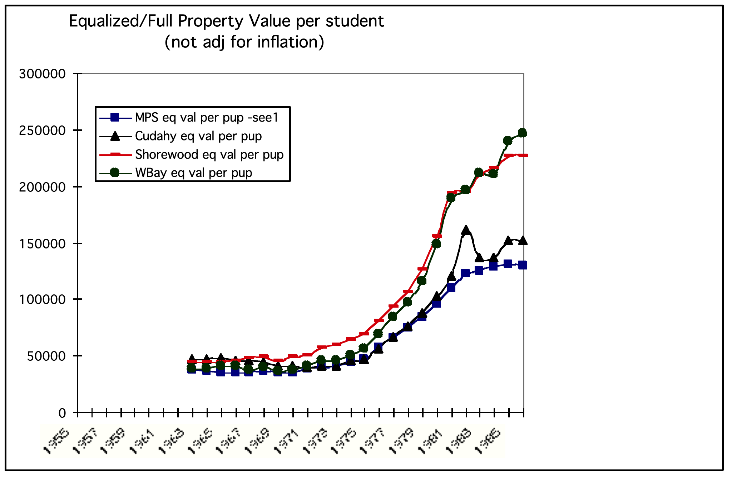

This chart attempts to show Property Tax Value per Student in each district. It doesn’t say anything about federal involvement directly, but does tell us more about the context of the times. Until 1970, all four districts were “relatively” equal in the amount of taxable property per student, but that rapidly changes when Shorewood and WBay values skyrocket compared to MPS (remember - not adjusted for inflation). In other words, MPS (and Cudahy) had much less of a property tax base per student to draw upon during the post-70 era, and thus were more likely to be dependent upon state and federal aid.

CAUTION: Once again, I’m not an expert on school finance data, and I don’t fully understand an important difference in how the data was reported over time. Prior to 1964, I believe that CGRB listed “full value per pupil,” and then it appears that Wisconsin began to recognize equity issues and began listing “equalized value per pupil.” I don’t know how this latter category was calculated, which could strongly discount how I’m interpreting the data here.

