|  |
| --- |
|  |
| **Lab Report** |
| COURSE: Cyber 262  Lab : Lab 1 - Orientation  Submitted BY: Jack Morgan  Date: 01/18/2022  Instructor: Hozza |
| *By submitting this report I certify that this is my work and was not copied from other sources. Any use of public materials is cited.* |

# SCREEN CAPTURES

***Question 1:***

For practice labs, help can be found in a few locations. First, we can email the TA’s in case we have an issue that needs to be resolved. We can also click the question mark in the top left corner of Practice Labs for support videos and documentation.

***Figure (3.1):***

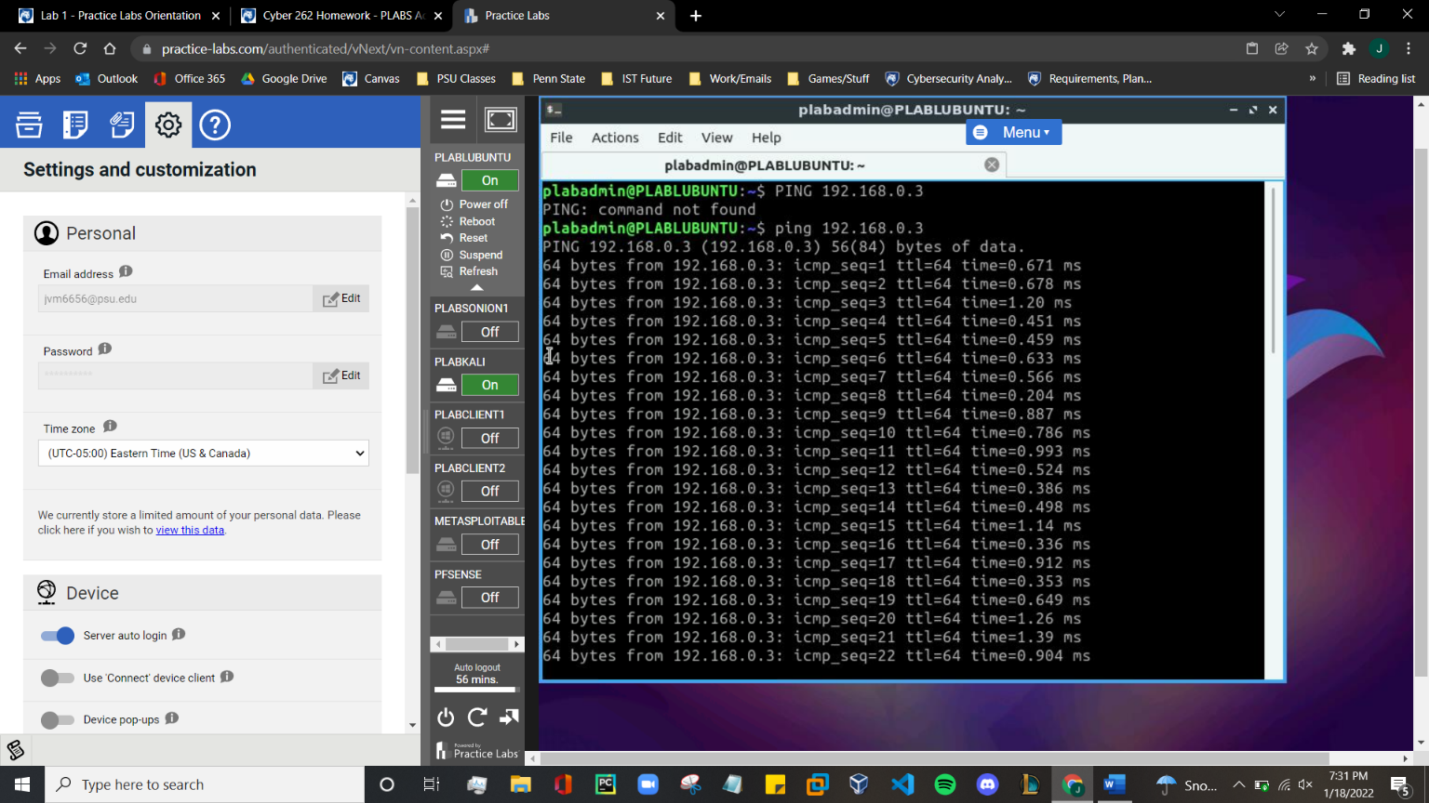

***Question/Answer (3.2):***

Currently I have no issues with Practice Labs or anything in relation to Practice Labs. The Ping command never finished; however I don’t know if this is how the command is supposed to function.