MATH 1350 | Statistics for Information Technology

Lab # 1 – Exploratory Data Analysis With Python

Answer/Grading Sheet

Step: | Answer | Mark
5 | server 1 & server 2 histograms (Insert Picture in Word)  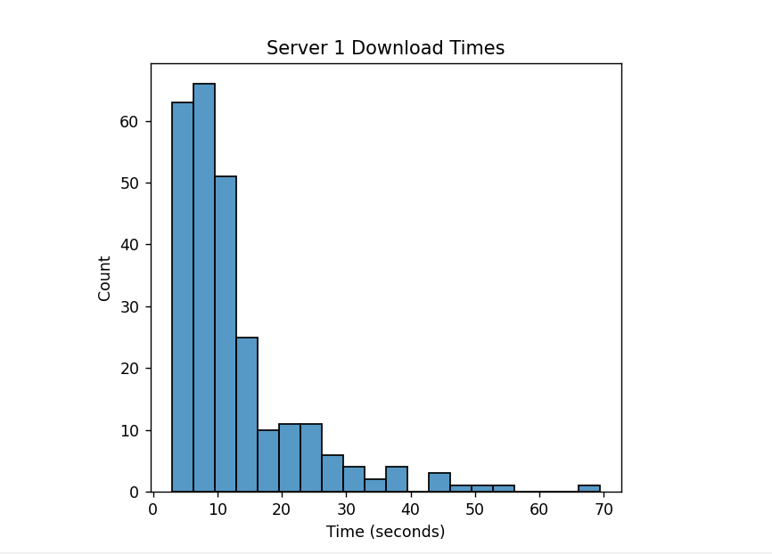  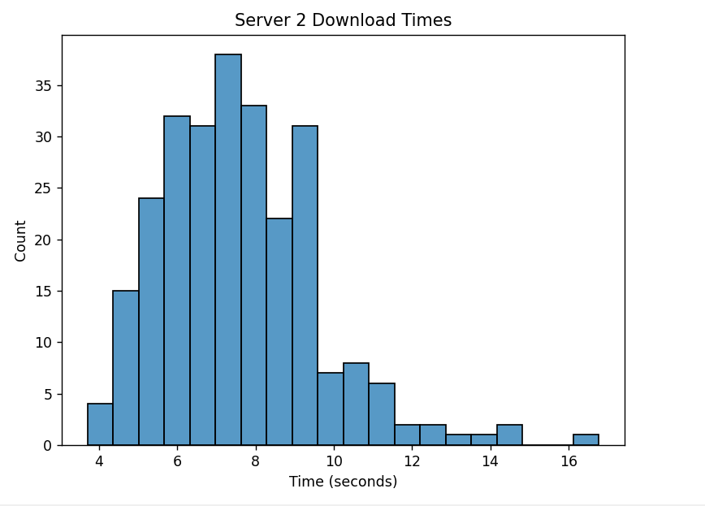  Answer to Question 1:  Server one is skewed right a lot more than server two. Server, one has greater values in count than Server two. The two graphs use different magnitudes of measurements than one another.  Answer to Question 2:  They would most likely experience much faster times from Server two as the graphs show that Server one has much higher count above 10 seconds.
6 | mean time for server 1 & server 2: (type them in here)  Server 1 mean: 12.69 seconds  Server 2 mean: 7.58 seconds  Answer to Question 3:  They are measuring the values of the mean of the upload speed in time(seconds). This is where the data centered around.  Answer to Question 4:  Yes the speed of the seconds server is faster than the other by an average of 5.11 seconds.
7 | Did you find the mentioned python commands? [YES] or NO
8 | Paste your Python code here.  It should contain all the commands you used to complete the lab.  import pandas as pd  import numpy as np  import matplotlib.pyplot as plt  import seaborn as sns  def serv1():  s1 = pd.read_csv(  'Server1Data.txt',  sep='\t',  skiprows=3  )  return s1  def serv2():  s2 = pd.read_csv( 'Server2Data.txt', sep='\t', skiprows=3)  return s2  print(serv1().head())  print(serv2().head())  def create_histogram(server1, server2):  plt.figure(figsize=(12,5))  plt.subplot(1,2,1)  sns.histplot(server1['Time'], bins=20)  plt.title('Server 1 Download Times')  plt.xlabel('Time (seconds)')  plt.figure(figsize=(12,5))  plt.subplot(1,2,1)  sns.histplot(server2['Time'], bins=20)  plt.title('Server 2 Download Times')  plt.xlabel('Time (seconds)')  plt.tight_layout()  plt.show()  def compute_mean(server1, server2):  mean1 = server1['Time'].mean()  mean2 = server2['Time'].mean()  print(f'Server 1 mean: {mean1:.2f} seconds \nServer 2 mean: {mean2:.2f} seconds')  create_histogram(serv1(), serv2())  print(compute_mean(serv1(), serv2()))

