MATH 1350 | Statistics for Information Technology

Lab # 2 – Descriptive Statistics II

Answer/Grading Sheet

Step: | Answer | Mark
2 | Table to be filled:
  57.96 | 60.5 | 10.227
  104.611 | 45 | 24.5
3 | Table to be filled:  Answer to Question 1:  Using python and the pandas library, we gathered the mean, median, standard deviation, variance, range, and Interquartile range from sets 1 and 2. The analysis helps us identify patterns in the data, for example Set 2 has the highest frequency of test scores within the 60-65 range which is why the median is 61. There are ~8 occurrences of test scores around the 60-65 score range within the standard deviation. Furthermore, set 1 has a higher standard deviation (11.649) meaning the test scores will be further away mean than in set 2.  Answer to Question 2:  Set 1 generally has higher scores. It has a slightly greater mean which is more reliable than median when calculated test scores, it also has a higher IQR which means that the 25th and 75th percentile are greater in number when subtracted from each other. They are almost equal, however set 1 has a slightly higher average (mean).  Answer to Question 3:  Set 1 has more variable exam scores. This is because the standard of deviation and variance are higher than set 2, also set 1 has a higher range than set 2 further supporting that the data is spread further apart. Set 1’s standard deviation, 11.649, from the mean 58.04 means that the standard of test scores will be within 11.649 points of the mean. Set 2 has a mean of 57.88 and a standard deviation of 8.823.
  Set | mean | median | Standard deviation | Variance | Range | IQR
  1 | 58.04 | 59 | 11.649 | 135.706 | 42 | 16
  2 | 57.88 | 61 | 8.823 | 77.86 | 36 | 8
4 | Histogram plot  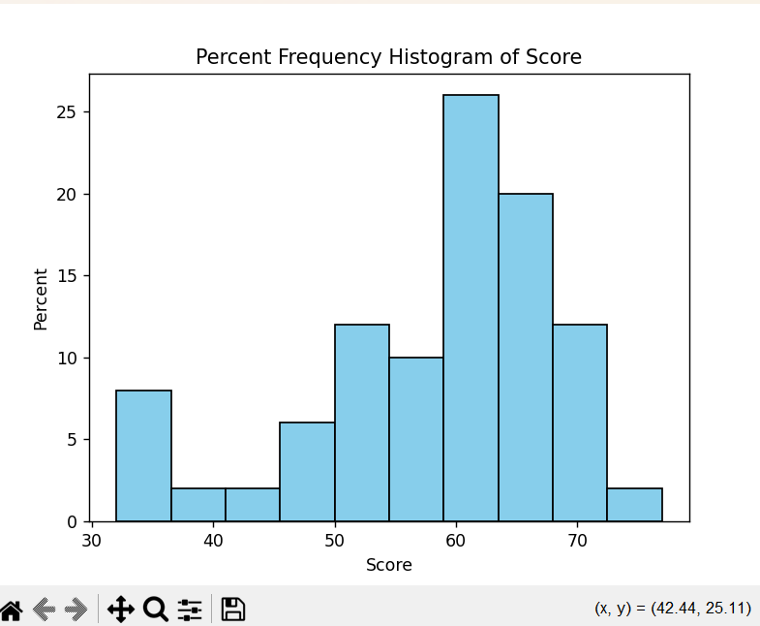
5 | Side-by-side histogram  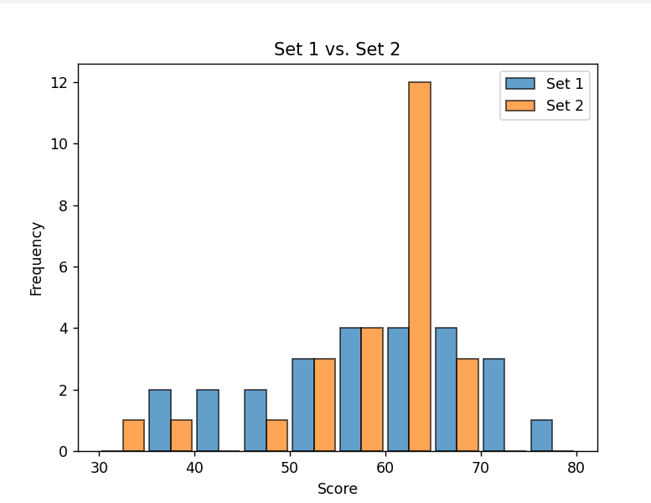  Comment on distribution of exam scores in the two sets:  We can learn that set one has a higher deviation and variance as the scores are more widely spread with less consistency towards the middle of the graph. Set 2 has a high frequency of test scores in the near 65. Set 2 performed more consistently than Set 1, however set 1 had better overall scores as they have 3 scores above 70 whereas set 2 does not.
6 | Boxplots  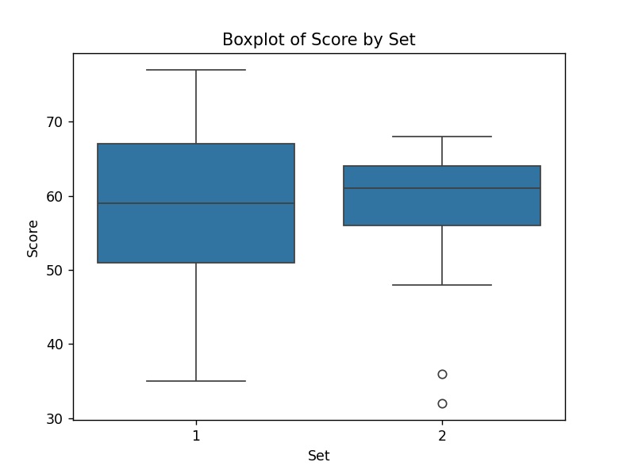
7 | Did you find the mentioned python commands? [YES] NO
8 | Paste your Python code here.  It should contain all the commands you used to complete the lab.  import pandas as pd  import matplotlib.pyplot as plt  import seaborn as sns  import numpy as np  #Load dataset  data = pd.read_csv('Lab2.txt', sep='\t')  def mean(data):  return data['Score'].mean()  def median(data):  return data['Score'].median()  def std_dev(data):  return data['Score'].std()  def variance(data):  return data['Score'].var()  def rnge(data):  return data['Score'].max() - data['Score'].min()  def intquart(data):  q_one = data.quantile(0.25)  q_three = data.quantile(0.75)  return q_three - q_one  def set1(data):  print("Set 1")  scores = data[data['Set'] == 1]['Score']  print(f"{scores.mean()}")  print(f"{scores.median()}")  print(f"{scores.std()}")  print(f"{scores.var()}")  print(f"{scores.max() - scores.min()}")  def set2(data):  print("Set 2")  scores = data[data['Set'] == 2]['Score']  print(f"{scores.mean()}")  print(f"{scores.median()}")  print(f"{scores.std()}")  print(f"{scores.var()}")  print(f"{scores.max() - scores.min()}")  def quart_set1(data):  scores = data[data['Set'] == 1]['Score']  q_one = scores.quantile(0.25)  q_three = scores.quantile(0.75)  return q_three - q_one  def quart_set2(data):  scores = data[data['Set'] == 2]['Score']  q_one = scores.quantile(0.25)  q_three = scores.quantile(0.75)  return q_three - q_one  def side_by_side(set1, set2):  bins = range(30, 81, 5)  plt.hist([set1, set2], bins=bins,  label=['Set 1', 'Set 2'],  edgecolor='black',  alpha=0.7,  histtype='bar',  rwidth=0.9)  plt.xlabel('Score')  plt.ylabel('Frequency')  plt.title('Set 1 vs. Set 2')  plt.legend()  plt.show()  sns.boxplot(x='Set', y='Score', data=data)  plt.title('Boxplot of Score by Set')  plt.show()  print(f"The mean score is: {mean(data)}")  print(f"The median score is: {median(data)}")  print(f"The standard deviation is: {std_dev(data)}")  print(f"The variance of the scores is: {variance(data)}")  print(f"The range of the scores is: {rnge(data)}")  print(f"The interquartile range of the data is: {intquart(data)}")  set1(data)  set2(data)  print(f"Quantile Set 1: {quart_set1(data)}")  print(f"Quantile Set 2: {quart_set2(data)}")  side_by_side(data[data['Set'] == 1]['Score'], data[data['Set'] == 2]['Score'])  plt.hist(  data['Score'],  bins=10,  weights=np.ones_like(data['Score']) / len(data['Score'])*100,  color='skyblue',  edgecolor='black'  )  plt.title('Percent Frequency Histogram of Score')  plt.xlabel('Score')  plt.ylabel('Percent')  plt.show()

