# CAB202 Assignment:

Student Name: Jack Gate-Leven

Student Number: n1046123

TinkerCAD Link: <https://www.tinkercad.com/things/b2zf1cgDlOn>

Video Demonstration Link: <https://connectqutedu-my.sharepoint.com/:v:/g/personal/n10464123_qut_edu_au/EbS4lG5WoiRHhfMsJm_DfAQBRVMgvdKwiecaSM_wL8xYgQ?e=N0ksX7>

## Introduction

|  |  |
| --- | --- |
| Digital I/O - Switch | The Device button will be used to control the selected device within the home automation system. It will allow the user to control separate peripherals through the Arduino. Also, the on/off slide switch will allow the user to control the state of a given device. |
| Digital I/O – Debouncing | The device button will make use of debouncing for the user to accurately and smoothly control the system through buttons. A time delay debounce was used as the interrupt-based technique couldn’t be achieved fully but it was setup and attempted. |
| Digital I/O – LED | The On/Off LED will display the status of the selected device. The light bulb will symbolise a light within the home, however it would be undervoltage in a real home, and would require a relay. Through the timers, potentiometer and LCD, the user can control the intensity of the light. |
| Analog Input – ADC | The potentiometer will allow the user to control the device’s settings, light intensity and fan speed. This will grant the user control over their home appliances more so than just on/off. |
| Analog Output – PWM | The motor will be mimicking a fan motor and was meant to use PWM to allow control from the potentiometer. However, PWM was attempted but was not implemented and so the fan and lightbulb just go on and off. |
| Serial I/O – UART | The Arduino will send and receive messages from/to the serial monitor. The user can set a turn off timer for all connected devices. This will benefit the user as a night time turn off timer, or for when they are leaving the house. |
| LCD | The LCD will display an introduction message, the current device and setting selected. Users can choose between devices that they wish to control. |
| Timers (other than debouncing or PWM) | The timer is being used for the system turn off functionality which the user can set through UART communication with the program. |

## Schematic

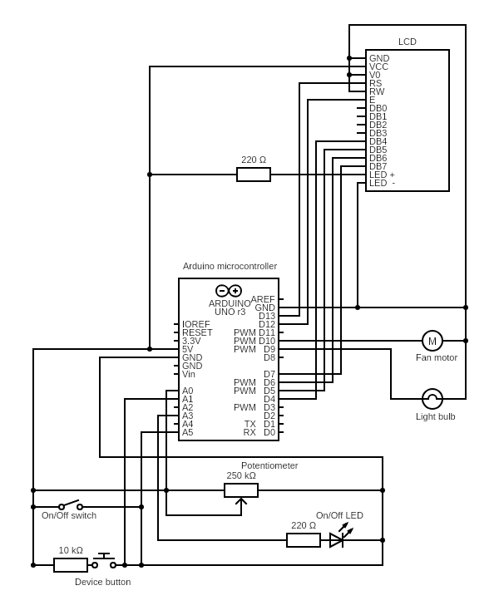

|  |  |  |
| --- | --- | --- |
| **Label/Labels** | **Component** | **Value** |
| Arduino microcontroller | Arduino Uno R3 | ATmega328 |
| LCD | LCD | 16x2 |
| On/Off LED | Red LED |  |
| Fan motor | DC Motor |  |
| Light bulb | Light Bulb |  |
| Potentiometer | Potentiometer | 250k Ohm |
| On/Off switch | Slide switch |  |
| Device button | Pushbutton |  |
| Resistor | resistor | 10k Ohm |
| Resistor | 2 x Resistor | 220 Ohm |
| Breadboard | Breadboard | Small (10x30) |
| Wire | Wire |  |

## Wiring Instructions

Power rails:

* Connect the 5V pin on the Arduino to the left most point on the bottom power rail of the large breadboard; connect the ground pin on the Arduino to the left most point on the bottom ground rail of the large breadboard; connect the bottom and top 5V power rails on the large breadboard by connecting a wire between the right most bottom and top power rail points; connect the bottom and top ground rails on the large breadboard by connecting a wire between the right most bottom and top ground points.

Controls:

* Connect Potentiometer on the large breadboard at 7g,8g,9g; connect the left most terminal 2 to 5V power rail directly above; connect the middle wiper pin to the 14 (PC0) pin on the Arduino; connect the right most pin, terminal 1, to the ground rail directly above on the large breadboard.
* Connect On/Off switch on the large breadboard at 11h, 12h, 13h; connect the left most terminal 1 to the 5V power rail directly above on the large breadboard; connect the middle common pin to the 19 (PC5) pin on the Arduino.
* Connect Device Button to the large breadboard at pins 14f, 16f, 14e and 16e with the common b terminals both on the top side of the button; connect terminal 1b to the 15 (PC1) pin on the Arduino; connect a 10000 Ohm resistor to the points 16a and the 5V power rail directly below.

LCD:

* Connect the ground, contrast, read/write and LED cathode pins of the LCD to a common ground on the Arduino; connect the power pin on the LCD to the 5V power rail on the top of the breadboard; connect the register select pin on the LCD to the 13 (PB5) pin on the Arduino; connect the enable pin on the LCD to the 4 (PB4) pin on the Arduino; connect the DB4 pin on the LCD to the 12 (PD4) pin on the Arduino; connect the DB5 pin on the LCD to the 5 (PD5) pin on the Arduino; connect the PB6 pin on the LCD to the 6 (PD6) pin on the Arduino; connect the PB7 pin on the LCD to the 7 (PD7) pin on the Arduino; connect the LED anode pin on the LCD to a 220 Ohm resistor and connect that resistor into the top 5V power rail on the large breadboard.

Peripherals:

* Connect the right terminal of the Light bulb to the right most pin of the top ground rail on the large breadboard; connect the left terminal to the 9 (PB1) pin on the Arduino.
* Connect the left terminal 1 ground pin of the Fan motor to top ground rail of the large breadboard; connect the right 5V terminal 2 pin of the motor to the 10 (PB2) pin of the Arduino.
* Connect the anode of the On/Off LED to F1 and the cathode to F2 of the breadboard; connect a wire from pin 17(PC3) to a 220 Ohm resistor and connect that resistor into G1.