CHICAGO BEARS
MEDIA CLIPS

TUESDAY,
FEBRUARY 17th
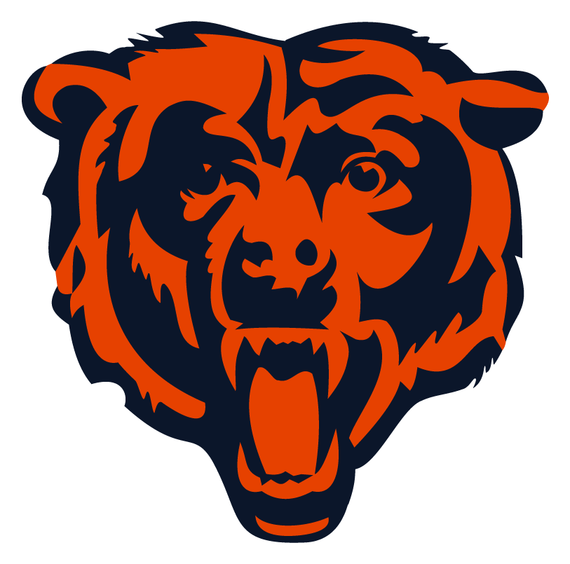

ChicagoBears.com – Tuesday, February 17, 2026

Bears 2025 position review: Defensive line
By Gabby Hajduk, Chicagobears.com Page 1 of 4

While the Bears defensive line dealt with myriad injuries throughout the season, several players stepped up, particularly late in the year.
Montez Sweat led the group with 10.0 sacks, 18 quarterback hits, 13 tackles-for-loss and three forced fumbles, which equaled his career best. It marked the second time Sweat reached double-digit sacks in his career (2023), and his first time doing so with one team.
The majority of Sweat's production occurred after the bye week, something coach Ben Johnson repeatedly discussed as a difference maker for the Bears defense.
"He's a guy that we count on," Johnson said late in the season. "I know the sack numbers is what everybody looks at when it comes to edge rushers, and he's at double digits. He's played really good football in that regard, but as I've told him, as the year has gone along, for me it's not just the sacks, it's also the pressures and the quarterback hits.
"When you're watching from the sideline and you're feeling him affecting the quarterback, a different type of way I do think that's really important. He's stepped up. I've felt like that since the bye week. He's playing really good in the running game – that gets overlooked – but also in the passing game. I felt him get after the quarterback a little bit more."
Sweat recorded his best performance Nov. 23 in a 31-28 win over Pittsburgh. Heading into the Week 12 game, the veteran had recorded a sack in four of the previous five contests and tallied two more against the Steelers, including a strip-sack which he recovered himself.
Sweat also made an impact in the Bears' two playoff games, playing a season-high 82.1% of snaps against the Rams and 80.3% of snaps, his third highest, against the Packers. In the Wild Card Round, he recorded three quarterback hits and a batted pass and registered a sack of Los Angeles quarterback Matthew Stafford in the Divisional Round.
"I thought Sweat did a good job this year," general manager Ryan Poles said. "I think sometimes we get hung up on sacks, and sacks are important. He did get into double digits, but I think his all-around game was good. The way he defended the run, defended the perimeter, as well as applied pressure, was good. We need him to continue to get better, too."
In the first half of the season, veteran Dayo Odeyingbo played opposite Sweat and recorded 21 tackles, 1.0 sack and four QB hits before suffering an Achilles injury against the Bengals Nov. 2 that sidelines him for the remainder of the season.
Odeyingbo's last game of the season was the first action for Austin Booker after the second-year pro started the season on injured reserve. Booker had shown promise in the preseason, leading the league with 4.0 sacks, but sustained a knee injury and was placed on injured reserve to start the season.
After recording his first sack of the season in Cincinnati, Booker started the remaining nine regular-season games and two postseason contests, totaling 5.5 sacks and 14 QB hits in 12 games and routinely playing the most snaps of any player on the defensive line. The Kansas product came alive late in the year, starting with a two-sack performance against the Browns Dec. 14.
"I think [Booker] continues to get better each and every week," defensive coordinator Dennis Allen said late in the season. "I know I've said this before, but the thing that I like about that player is his toughness, his grittiness, his tenacity. He plays extremely hard on every single play. And I think that's what allows him to be effective."
Booker was also instrumental in the Bears' regular-season and playoff wins over Green Bay, totaling 13 tackles, 1.5 sacks and three QB hits between the two contests.
The Bears also had saw contributions from veteran edge rushers Dominque Robinson, Joe Tryon-Shoyinka and Daniel Hardy.
Veterans Grady Jarrett and Andrew Billings, as well as third-year pro Gervon Dexter Sr., manned the interior defensive line for the majority of the season. Both Billings and Dexter appeared in all 17 games, while Jarrett missed just three due to injury.
Dexter led the group of defensive tackles with 44 tackles, 6.0 sacks, 11 quarterback hits, two fumble recoveries and tied Billings with six tackles-for-loss. Jarrett and Billings combined for 13 quarterback hits and 2.5 sacks.
Rookie defensive lineman Shemar Turner contributed in five games before suffering a season-ending ACL injury in Baltimore Oct. 26. At his end-of-season press conference, general manager Ryan Poles told reporters he expects both Odeyingbo and Turner back in some capacity during the offseason program.
"There's a lot going on there just in terms of we had some injuries going on that you have to overcome," Poles said. "I think that's an area where we can continue to press and get better. I look forward to Shemar getting back and Dayo getting back."

Chicago Sun-Times – Tuesday, February 17, 2026

Bears RB D'Andre Swift hopes he convinced team to keep him heading into last year of contract
By Jason Lieser, chicago sun-times Page 3 of 4

A do-it-all running back is an essential for the Bears in coach Ben Johnson’s offense, and they might already have one in D’Andre Swift.
He completely flipped the outlook on whether he’s a good fit with a renewed north-south running style and a 1,000-yard season after a disappointing 2024 and now, rather than eying the relatively cheap $1.3 million out on his contract this offseason, the Bears have him on board at an affordable $8.8 million this season.
Swift knows there’s some uncertainty, but made a strong case to stay with a career-high 1,087 yards and nine touchdowns.
“I have no idea, but hopefully I did enough for them to want me back because I know I don’t want to go anywhere else,” he told the Sun-Times. “I hope it plays itself out that way. I love the city, I love the coaching staff and the men that I work with. That’s out of my control, but if I had it my way, I’d be back. I don’t want to play nowhere else.”
Johnson played a major part in Swift’s success and his desire to remain with the Bears, which was interesting given their history. While Johnson has maintained he has always seen high potential in Swift, he was part of the Lions’ coaching staff when they traded him to the Eagles for a fourth-round pick in 2023.
In Swift’s first season with the Bears, albeit amid dysfunction in coach Matt Eberflus’ staff and with a struggling offensive line, he often seemed too reliant on running laterally to look for big gains rather than hitting the holes quickly. Swift has said he didn’t change his running style at all this season, but his yards per carry jumped from 3.8 to 4.9 in a more effective system and with a significantly upgraded offensive line.
“First of all, Ben always believed in me as a player, so just him giving me opportunities was great,” Swift said. “The more opportunities I’m given, the more I can make stuff happen.”
It’s hard to deny the impact of former running backs coach Eric Bieniemy as well, and Swift said he was “sad to see him leave” for the Chiefs as offensive coordinator. The Bears have agreed to hire veteran coach Eric Studesville to replace him, and Swift was “excited for this new relationship.”
Bieniemy helped the Bears establish a surprisingly solid backfield tandem with Swift and rookie Kyle Monangai. Going into the season there were doubts from the outside on whether either was what the Bears needed, but those two led the way as the team finished third in the NFL in rushing at 144.5 yards per game.
Swift finished 12th in the league in rushing, and Monangai, a seventh-round pick, ran for 783 yards — fifth in his draft class and 24th in the NFL.
The upside for Swift, who is still in the ideal window for a running back after turning 27 last month, is he believes he can produce even more in Johnson’s offense than he showed last season. He caught a career-low 34 passes for 299 yards and a touchdown, and when playing for Johnson in 2021, he put up 452 yards and two touchdowns on 62 catches. The Lions targeted him 78 times that season.
“I can do more,” he said. “I wish I would’ve been able to contribute a little more in the passing game. We’ve got so many pass-catchers on the field, so whenever it does come up, I try to make something happen with it, but I do know I could do more.”

Daily Herald – Tuesday, February 17, 2026

Bears face big free agent decisions
By Michal dwojak, daily herald Page 4 of 4

It’s time for the Bears to move on.
Head coach Ben Johnson and general manager Ryan Poles will spend the offseason looking to make moves to help the Bears take another big step next season.
Some of the key decisions will be what to do with the free agents on their roster. The Bears will likely have to make some tough salary cap decisions and won’t franchise tag any of their free agents.
Teams can start negotiating with unrestricted free agents on March 9 and officially sign players on March 11 when the new league starts. Here’s a look at three key players on the Bears’ roster who are set to become free agents next month.
Kevin Byard
Byard was one of four safeties on the Bears roster who entered 2025 on the last year of their contract with something to prove. He did so and more as Byard showed he can be an impact player even as he entered the second half of his career.
Byard was a leader for a secondary that helped the defense lead the league in takeaways and interceptions. He led the NFL with a career-high seven interceptions while playing at 32 years old. That strong play earned Byard his third All-Pro and Pro Bowl honors.
It happened as Byard invested time in the film room to create those turnovers. Byard studied quarterbacks’ tendencies to make up for any physical parts of his games that might’ve slowed down.
Now the Bears need to decide whether to bring back Byard. There likely won’t be a top-dollar market even after Byard’s career year because of his age. Both parties were open to a reunion at the end of the season and both would likely be open to a return if it made sense for both sides.
Nahshon Wright
Not much was expected when the Bears signed Wright to a one-year contract last offseason. Chicago was Wright’s third team in five years and he came to the team because of a previous relationship with Bears defensive backs/passing game coordinator Al Harris.
But Wright stepped in when the Bears needed him to and lived up to his potential when he started in place for injured Jaylon Johnson for most of the season. His length helped him haul in a career-high five interceptions, which tied for second in the NFL. Wright also forced two fumbles, none more memorable than against the Philadelphia Eagles on a “tush push” play. He earned his first Pro Bowl honor.
It will be interesting to see what Wright’s market looks like in free agency. Wright finally showed that he could create turnovers, but opponents also picked on him at times in coverage for big gains.
Even with that, Wright is likely in store for a big payday in free agency. Given what the Bears have with the return of Jaylon Johnson and Tyrique Stevenson, along with the uncertainty of Zah Frazier, who missed his entire rookie season for personal reasons, it seems unlikely the Bears would pay up to keep Wright.
Jaquan Brisker
Brisker was another Bears safety who had something to prove in a contract year. His was for a different reason, though.
The major question heading into the season for Brisker was whether he could play an entire season. Brisker failed to do so during his first two seasons and then missed the last 12 games of 2024 because of a concussion. It was the latest in a few diagnosed concussions Brisker suffered during his career.
Brisker proved he could stay on the field by playing in every game for the first time in his career. He flashed the potential of his draft status as a former second-round pick. Brisker finished the season with one interception and sack, ending the year with his best game in the NFC divisional round.
Those flashes could price Brisker out of the Bears’ offseason budget. Brisker said he was open to returning. But if another team pays into Brisker’s upside, it might be too much for the Bears to afford given their other roster needs.

