**CSE 212 – Programming with Data Structures**

**W01 Prove – Response Document**

|  |  |
| --- | --- |
| **Name:** | Jack Hammond |
| **Date:** | 04/30/2024 |
| **Teacher:** | Brother Comeau |

*It is a violation of BYU-Idaho Honor Code to post or share this document with others or to post it online. Storage into a personal and private repository (e.g. private GitHub repository, unshared Google Drive folder) is acceptable.*

**Question 1: For the rotate right problem, provide a description of how you solved the problem.**

I created a temporary new list that is empty. I used AddRange to add the elements from data with GetRange starting at the (length – amount) index and going for amount number of elements. Then I added the rest of the data list by AddRange with data.GetRange from the first element to the (length- amount) number of elements. Finally, I iterate through the new list and replace each element of data with the temporary list.

**Question 2: For the rotate right problem, draw a picture of how you solved the problem.**

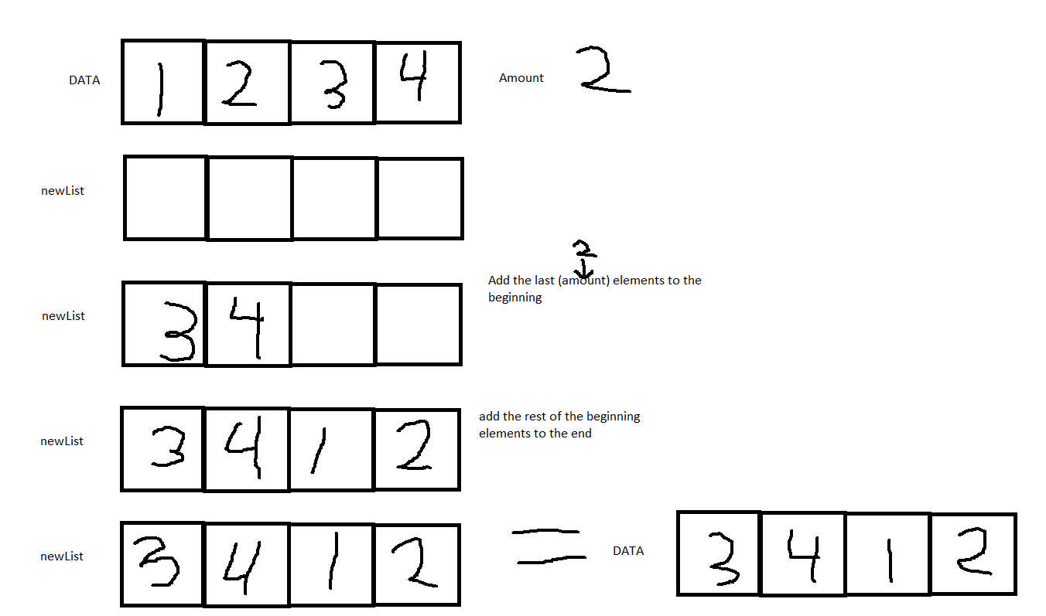

Remember: You need to commit all the changes to the prove-01-<username> repository along with this document. Then submit a link to the repository in I-Learn.