Just a friendly reminder,
Tri-Creaser Fast-Fit
Have you forgotten just how easy these tools are to sell, remind your customers of the benefits of the Tri-Creaser Fast Fit, let them see the difference, once they see the results they will be converted and you will have a customer for life.

We manufacture the Tri-Creaser Fast-Fit for many folding machines so if you have a customer that has a folding machine then the chances of us having a device to fit that machine is high.

Try something different. Contact your customer offer them a solution to their cracking problems with NO RISK TO THEM, the reaction we usually get is “great show me how” this is when we introduce them to the Tri-Creaser Fast-Fit. Offer your customer ‘A Full Money Back Guarantee’; at Tech-ni-Fold we take this risk every time we send a product because we believe that our tools are the best. Try it and see the results for yourself, I think you will be surprised at the response you get from your customers.
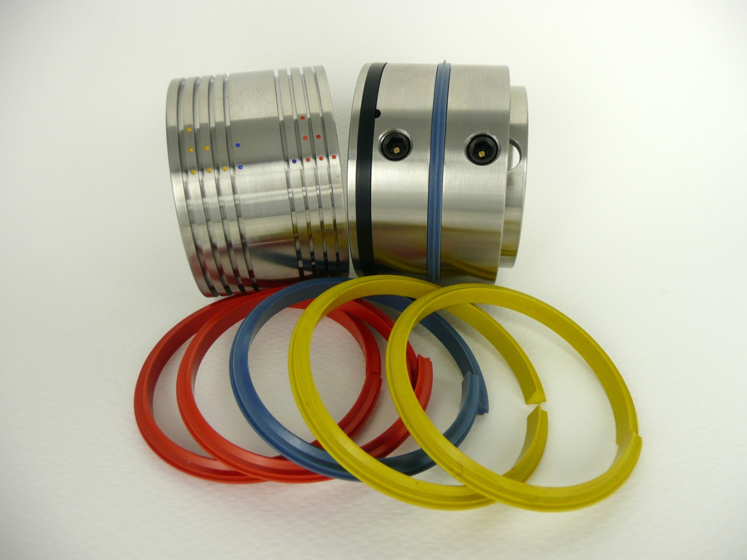
The Tri-Creaser Fast-Fit will retail at 1400 Euro’s but to you it will only cost 690 Euro’s!
Think of the profit that could be made with this unique product, it is effective, reliable and performs to the highest standard; no other tool can eliminate cracking like the Fast-Fit.
Do you need any further information? Contact me with any question you may have, I am only too willing to help, you can reach me on +44 (0) 1455 554491 or email Vivienne.Edwards@Technifold.co.uk

