Just a friendly reminder,
Tech-ni-Fold Micro-Perforator
Perforate first and Print second or Print first and Perforate second it makes no difference as it still produces a perfect perforation every time. The choice of TPI ranges from 8 to 72 on a 35mm shaft and a minimum of 17 to 52 TPI on most other shaft sizes.
See how our method compares to the triditional methods, this is how we can acheive near invisible Micro-Perforations. No more ragged edges, No more broken blades if you use the Tech-ni-Fold solution!
Traditional Method of Perforating Tech-ni-Fold Method of Perforating

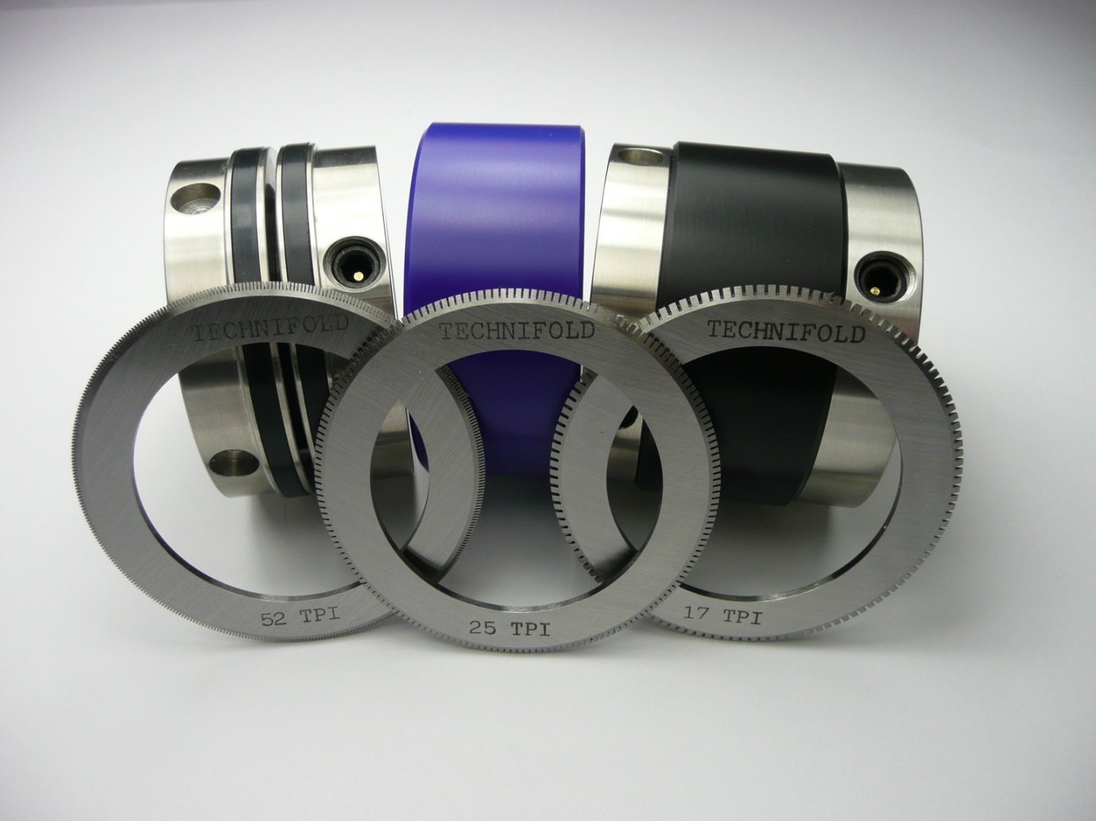
We manufacture a Micro-Perforation Tool for many folding machines so if you have a customer that has a folding machine then the chances of us having a device to fit that machine is high.
Think of the profit that could be made, this unique product is effective, reliable and performs to the highest standard; No more broken blades, Runs as fast as your folding machine will go,
Contact your customers and offer them a solution to their Perforating problems, the reaction we usually get is “great show me how” this is when we introduce them to the Tech-ni-Fold Micro-Perforation Tool
Do you need any further information? Contact me with any question you may have, I am only too willing to help, you can reach me on +44 (0) 1455 554491 or email Vivienne.Edwards@Technifold.co.uk

