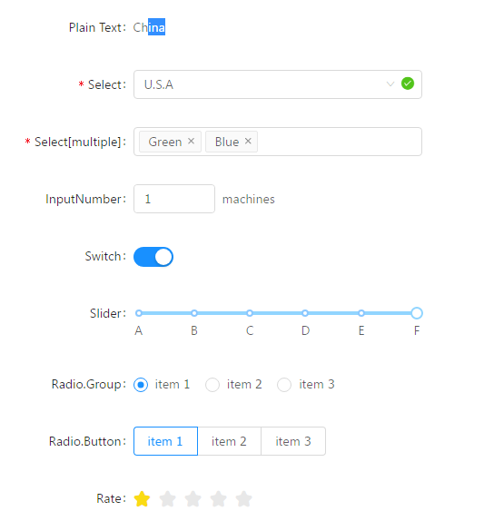

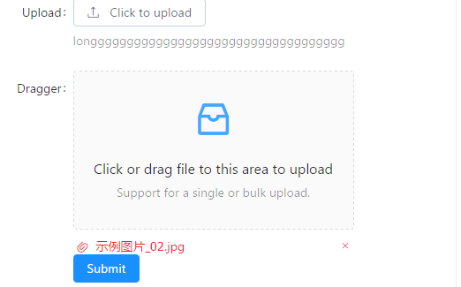

|  |  |  |
| --- | --- | --- |
|  |  |  |
| import {  Form, Select, InputNumber, Switch, Radio,  Slider, Button, Upload, Icon, Rate,  } from 'antd';  const FormItem = Form.Item;  const Option = Select.Option;  const RadioButton = Radio.Button;  const RadioGroup = Radio.Group;  class Demo extends React.Component {  handleSubmit = (e) => {  e.preventDefault();  this.props.form.validateFields((err, values) => {  if (!err) {  console.log('Received values of form: ', values);  }  });  }  normFile = (e) => {  console.log('Upload event:', e);  if (Array.isArray(e)) {  return e;  }  return e && e.fileList;  }  render() {  const { getFieldDecorator } = this.props.form;  const formItemLayout = {  labelCol: { span: 6 },  wrapperCol: { span: 14 },  };  return (  <Form onSubmit={this.handleSubmit}>  <FormItem  {...formItemLayout}  label="Plain Text"  >  <span className="ant-form-text">China</span>  </FormItem>  <FormItem  {...formItemLayout}  label="Select"  hasFeedback  >  {getFieldDecorator('select', {  rules: [  { required: true, message: 'Please select your country!' },  ],  })(  <Select placeholder="Please select a country">  <Option value="china">China</Option>  <Option value="use">U.S.A</Option>  </Select>  )}  </FormItem>  <FormItem  {...formItemLayout}  label="Select[multiple]"  >  {getFieldDecorator('select-multiple', {  rules: [  { required: true, message: 'Please select your favourite colors!', type: 'array' },  ],  })(  <Select mode="multiple" placeholder="Please select favourite colors">  <Option value="red">Red</Option>  <Option value="green">Green</Option>  <Option value="blue">Blue</Option>  </Select>  )}  </FormItem>  <FormItem  {...formItemLayout}  label="InputNumber"  >  {getFieldDecorator('input-number', { initialValue: 3 })(  <InputNumber min={1} max={10} />  )}  <span className="ant-form-text"> machines</span>  </FormItem>  <FormItem  {...formItemLayout}  label="Switch"  >  {getFieldDecorator('switch', { valuePropName: 'checked' })(  <Switch />  )}  </FormItem>  <FormItem  {...formItemLayout}  label="Slider"  >  {getFieldDecorator('slider')(  <Slider marks={{ 0: 'A', 20: 'B', 40: 'C', 60: 'D', 80: 'E', 100: 'F' }} />  )}  </FormItem>  <FormItem  {...formItemLayout}  label="Radio.Group"  >  {getFieldDecorator('radio-group')(  <RadioGroup>  <Radio value="a">item 1</Radio>  <Radio value="b">item 2</Radio>  <Radio value="c">item 3</Radio>  </RadioGroup>  )}  </FormItem>  <FormItem  {...formItemLayout}  label="Radio.Button"  >  {getFieldDecorator('radio-button')(  <RadioGroup>  <RadioButton value="a">item 1</RadioButton>  <RadioButton value="b">item 2</RadioButton>  <RadioButton value="c">item 3</RadioButton>  </RadioGroup>  )}  </FormItem>  <FormItem  {...formItemLayout}  label="Rate"  >  {getFieldDecorator('rate', {  initialValue: 3.5,  })(  <Rate />  )}  </FormItem>  <FormItem  {...formItemLayout}  label="Upload"  extra="longgggggggggggggggggggggggggggggggggg"  >  {getFieldDecorator('upload', {  valuePropName: 'fileList',  getValueFromEvent: this.normFile,  })(  <Upload name="logo" action="/upload.do" listType="picture">  <Button>  <Icon type="upload" /> Click to upload  </Button>  </Upload>  )}  </FormItem>  <FormItem  {...formItemLayout}  label="Dragger"  >  <div className="dropbox">  {getFieldDecorator('dragger', {  valuePropName: 'fileList',  getValueFromEvent: this.normFile,  })(  <Upload.Dragger name="files" action="/upload.do">  <p className="ant-upload-drag-icon">  <Icon type="inbox" />  </p>  <p className="ant-upload-text">Click or drag file to this area to upload</p>  <p className="ant-upload-hint">Support for a single or bulk upload.</p>  </Upload.Dragger>  )}  </div>  </FormItem>  <FormItem  wrapperCol={{ span: 12, offset: 6 }}  >  <Button type="primary" htmlType="submit">Submit</Button>  </FormItem>  </Form>  );  }  }  const WrappedDemo = Form.create()(Demo);  ReactDOM.render(<WrappedDemo />, mountNode); | <Select placeholder="Please select a country">  <Option value="china">China</Option>  <Option value="use">U.S.A</Option>  </Select>    <Select mode="multiple" placeholder="Please select favourite colors">  <Option value="red">Red</Option>  <Option value="green">Green</Option>  <Option value="blue">Blue</Option>  </Select>    <InputNumber min={1} max={10} />    <Switch />    <Slider marks={{ 0: 'A', 20: 'B', 40: 'C', 60: 'D', 80: 'E', 100: 'F' }} />    <RadioGroup>  <Radio value="a">item 1</Radio>  <Radio value="b">item 2</Radio>  <Radio value="c">item 3</Radio>  </RadioGroup>    <RadioGroup>  <RadioButton value="a">item 1</RadioButton>  <RadioButton value="b">item 2</RadioButton>  <RadioButton value="c">item 3</RadioButton>  </RadioGroup>    initialValue: 3.5,  <Rate />    <Upload name="logo" action="/upload.do" listType="picture">      <Upload.Dragger name="files" action="/upload.do"> | |