A Comparative Study and Embedded Implementation of SOC Estimation Methods for Lithium-ion Batteries

Ta-Chia Hung, Wei-Kai Cheng
Department of Information and Computer Engineering
Chung Yuan Christian University, Taoyuan City, Taiwan
g11277602@cycu.edu.tw, wkcheng@cycu.edu.tw

Abstract
State of Charge (SOC) estimation is a core function of a battery management system, yet existing method comparisons are mostly performed offline using a single accuracy metric and rarely quantify, on the resource-constrained microcontroller where the algorithm is actually deployed, both accuracy and resource cost; differing cells, protocols and hardware further prevent a fair baseline. This work builds an automated multi-round test platform that keeps the cell, the test protocol and the microcontroller identical across methods, and implements Coulomb counting, an Extended Kalman Filter (EKF) and a dynamic-impedance method on the same STM32 under a unified firmware specification. Full-round on-board measurements show that the EKF attains a root-mean-square error below 1% (0.22-0.90%) at all four discharge rates - the best of the three - while Coulomb counting yields 1.7-2.0% and impedance-only online inversion is ill-posed (23-31%) for this flat Z-SOC cell. The EKF costs about 50x the compute of Coulomb counting yet consumes only 0.024% of the 1-second update budget at 64 MHz. We further show that measurement-domain consistency dominates algorithm choice: parameters and look-up tables built in a different measurement domain than deployment cause systematic error regardless of algorithm correctness.
Keywords: lithium-ion battery, state of charge estimation, Coulomb counting, extended Kalman filter, dynamic impedance, embedded systems
- Introduction
Driven by decarbonization and the electrification of transport, lithium-ion batteries have become the dominant energy-storage element in electric vehicles, portable electronics and grid storage. The battery management system (BMS) is therefore indispensable, and among its functions the State of Charge (SOC) - the ratio of remaining to rated capacity - plays the role of a fuel gauge for range prediction, energy scheduling and over-charge/over-discharge protection. SOC is an internal state that cannot be sensed directly; it can only be inferred from terminal voltage, current and temperature of a highly nonlinear, time-varying electrochemical cell [1], [4].
Although comparisons of SOC estimation methods are abundant, two gaps remain insufficiently addressed. The first is evaluation-environment distortion. Most comparisons are conducted on a PC or in MATLAB and report the root-mean-square error (RMSE) as almost the only metric, whereas the real deployment target is a resource-constrained microcontroller unit (MCU). How much Flash and RAM a method occupies after porting, how many CPU cycles each update costs, and how much accuracy is lost after fixed-point implementation are seldom quantified. Notably, commercial BMS ICs generally adopt Coulomb counting with OCV correction rather than the theoretically more accurate Extended Kalman Filter (EKF) [5] - an engineering trade-off among memory, computation and cost that is rarely presented with measured data.
The second gap is unfair benchmarking. Existing cross-method comparisons often use different cells, protocols and hardware, so the reported accuracies share no common baseline. The dynamic-impedance method [1], for instance, claims to need no initial value and to suit embedded use, yet it has never been placed on the same MCU, the same cell and the same protocol as an EKF for an equal resource-versus-accuracy comparison.
To address both gaps, this work builds a “same cell, same protocol, same MCU” fair-comparison platform and quantifies the accuracy-cost trade-off of embedded SOC estimation. Its contributions are: (1) an automated, long-term unattended cross-round test platform integrating an STM32, a programmable DC supply, a programmable electronic load and a high-accuracy current/voltage sensor with an automation scheduler; (2) an implementation of Coulomb counting, the EKF and the dynamic-impedance method on one STM32 under a unified firmware specification; and (3) an equal, reproducible comparison of accuracy, robustness and embedded resource cost, from which we derive both a method-selection guide and a key finding that measurement-domain consistency dominates algorithm choice.
- Background and Related Work
  - Equivalent-circuit model
A first-order RC (Thevenin) equivalent-circuit model is adopted as the cell model: an open-circuit-voltage source V_OC(SOC) in series with an ohmic resistance R0 and one parallel RC branch (R1, C1) that captures polarization. The terminal voltage is given by (1), where V1 is the RC-branch voltage. This structure balances fidelity and identifiability for embedded use [6], and the nonlinear V_OC(SOC) relation is obtained by a pseudo-OCV table [5].
V_t = V_OC(SOC) - I·R0 - V1 (1)
  - SOC estimation methods
Coulomb counting integrates current to accumulate charge; it is simple and model-free but has no self-correction and accumulates drift [4]. OCV look-up maps a rested open-circuit voltage to SOC but requires long relaxation. Model-based methods, dominated by the Kalman-filter family (KF/EKF/UKF), fuse current integration with a voltage measurement to correct the estimate and can recover from a wrong initial value [2], [3], [7], [9]. The dynamic-impedance method [1] estimates SOC from the instantaneous voltage-to-current ratio during operation, avoiding both an initial value and long rest, and online impedance has also been used for low-complexity modeling and aging indication [8]. Commercial ICs nonetheless favor Coulomb counting with OCV correction for resource reasons [5], a trade-off this work quantifies on real hardware.
- Test Platform and Estimator Implementation
  - System architecture
The platform plays two roles simultaneously: an excitation-and-ground-truth rig and an embedded estimation target. A programmable DC supply (ITECH IT6302, CC-CV) and electronic load (ITECH IT8512A+, CC) apply controlled charge/discharge to a single device-under-test (DUT), while an STM32G071 with an INA226 current/voltage sensor runs the estimators. Both roles share the same cell and the same high-power loop, so the instrument ground truth and the MCU estimate can be aligned point-by-point. Sensing uses a four-wire Kelvin connection across a 10 mOhm shunt; charge and discharge are two independent paths, of which only one is energized at a time. The architecture is shown in Fig. 1.
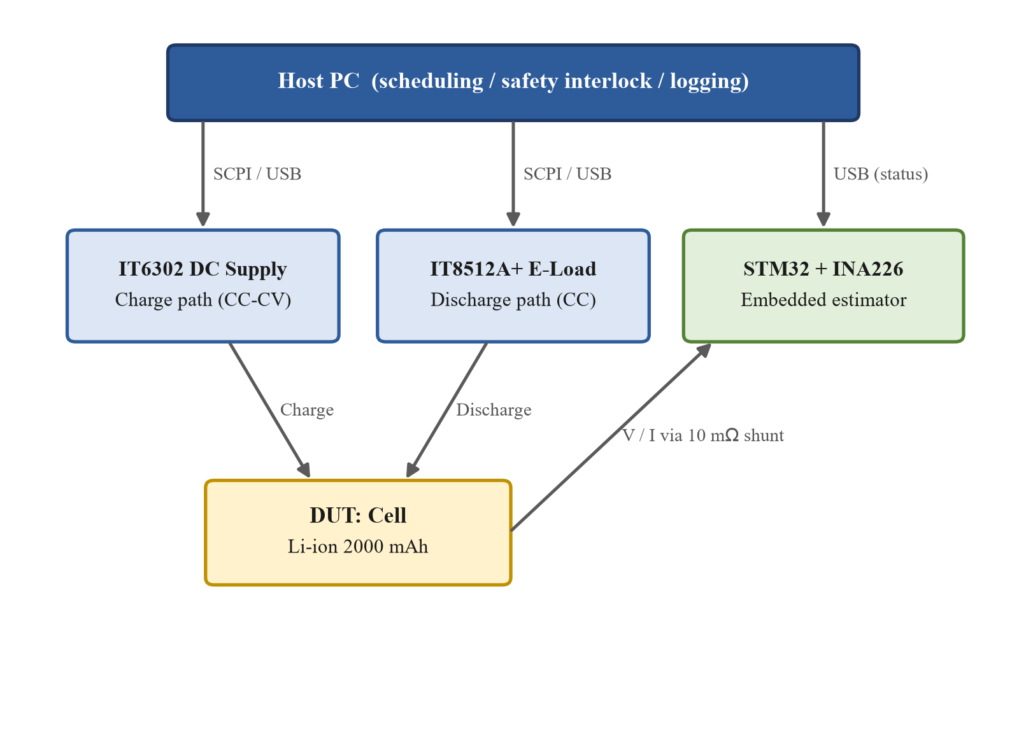
- Test-platform system architecture.
  - Current calibration
Because every method rests on current integration, current accuracy is the foundation of the platform. The raw INA226 reading was systematically about 15.8% high (mainly shunt tolerance and ADC offset). A 14-point piecewise-linear look-up table (seven charge and seven discharge points from 0 to 2 A) was built using the instruments as reference. Validated against four independent currents not in the table, the full-range error is below 0.21 mA, i.e. 0.012% at 1.75 A, down from the +13-16% raw bias.
  - Cross-round test protocol
One round comprises four “charge - rest - discharge - rest” groups; charging is always 0.5C, and the four discharge rates are 0.5C, 1.0C, 1.5C and 2.0C (1C = 2 A). A dV/dI perturbation is injected every 60 s during discharge - a brief step down to 0.2C - to serve the dynamic-impedance method, and Coulomb counting covers the perturbation seconds. Records persist across runs. The cell is a custom lithium-ion unit (2000 mAh, V_cv = 4.2 V, V_cut = 2.5 V); its rate capability is very flat, with discharge capacity dropping only about 1% from 0.5C to 2.0C and good round-to-round repeatability, providing a favorable and stable basis for the comparison.
  - The three estimators
All three run on a common firmware skeleton at a 1 Hz update; only the core estimation module is swapped, keeping the measurement path, timebase and I/O identical for fairness.
Coulomb counting recursively integrates the calibrated current as in (2), and also serves as the per-cycle ground truth after normalization by the measured full-discharge capacity q_full.
SOC(t) = SOC(t0) - (1 / C_rated) ∫ I(τ) dτ (2)
Extended Kalman Filter. With state x = [SOC, V1] and the first-order RC model, the observation is nonlinear only through V_OC(SOC), read from a 21-point GITT pseudo-OCV table refined to a 1% grid so its slope (the Jacobian) is continuous. Because there are two states and one scalar observation, the gain needs only a scalar division - no matrix inversion - which is the key to real-time operation on the MCU. Model parameters, identified by least squares from GITT relaxation pulses, are R0 = 51.9 mOhm (cell-terminal domain), R1 = 21.3 mOhm and tau_1 = 177.5 s.
Dynamic impedance. The instantaneous impedance Z = ΔV/ΔI from each perturbation is fit against SOC by the quadratic of (3), whose inverse yields SOC (with a branch selection because the parabola is symmetric). The combined fit is a = 20.2, b = -21.6, c = 63.6 mOhm with a minimum near 53% SOC, consistent with the literature [1].
Z = ΔV / ΔI = a·SOC² + b·SOC + c (3)
- Experimental Results
  - Accuracy
On one round of four discharge cycles, the three methods are scored against the per-cycle re-anchored Coulomb ground truth (Table I); Fig. 2 overlays the trajectories. The EKF tracks the truth almost exactly, with RMSE below 1% at every rate - the best of the three. Coulomb counting is a stable 1.7-2.0% with a small constant negative bias that traces to a scale difference between the board and bench current chains, not to the algorithm. Impedance-only online inversion is ill-posed for this flat-curve cell (23-31%): the whole Z-SOC curve spans only about 6 mOhm while single-event measurement noise is about 2 mOhm, so mid-SOC branch selection is nearly random. Under the idealized assumption of always choosing the correct branch, the offline RMSE is 6-10%, an upper bound not available online.
- Accuracy of the three methods (Round 41 board measurement; dynamic-impedance offline over rounds 1-3)
Method | RMSE (%) | MAE (%) | e_max (%) | Note
Coulomb (board) | 1.7-2.0 | 1.5-1.7 | 3.0-3.5 | measurement-chain bias
EKF (board) | 0.22-0.90 | 0.20-0.76 | 0.6-1.9 | best; <1% all rates
Dyn. imp. (online) | 23-31 | - | ~96 | inversion ill-posed
Dyn. imp. (offline) | 6-10 | 5-8 | ~20 | oracle-branch bound

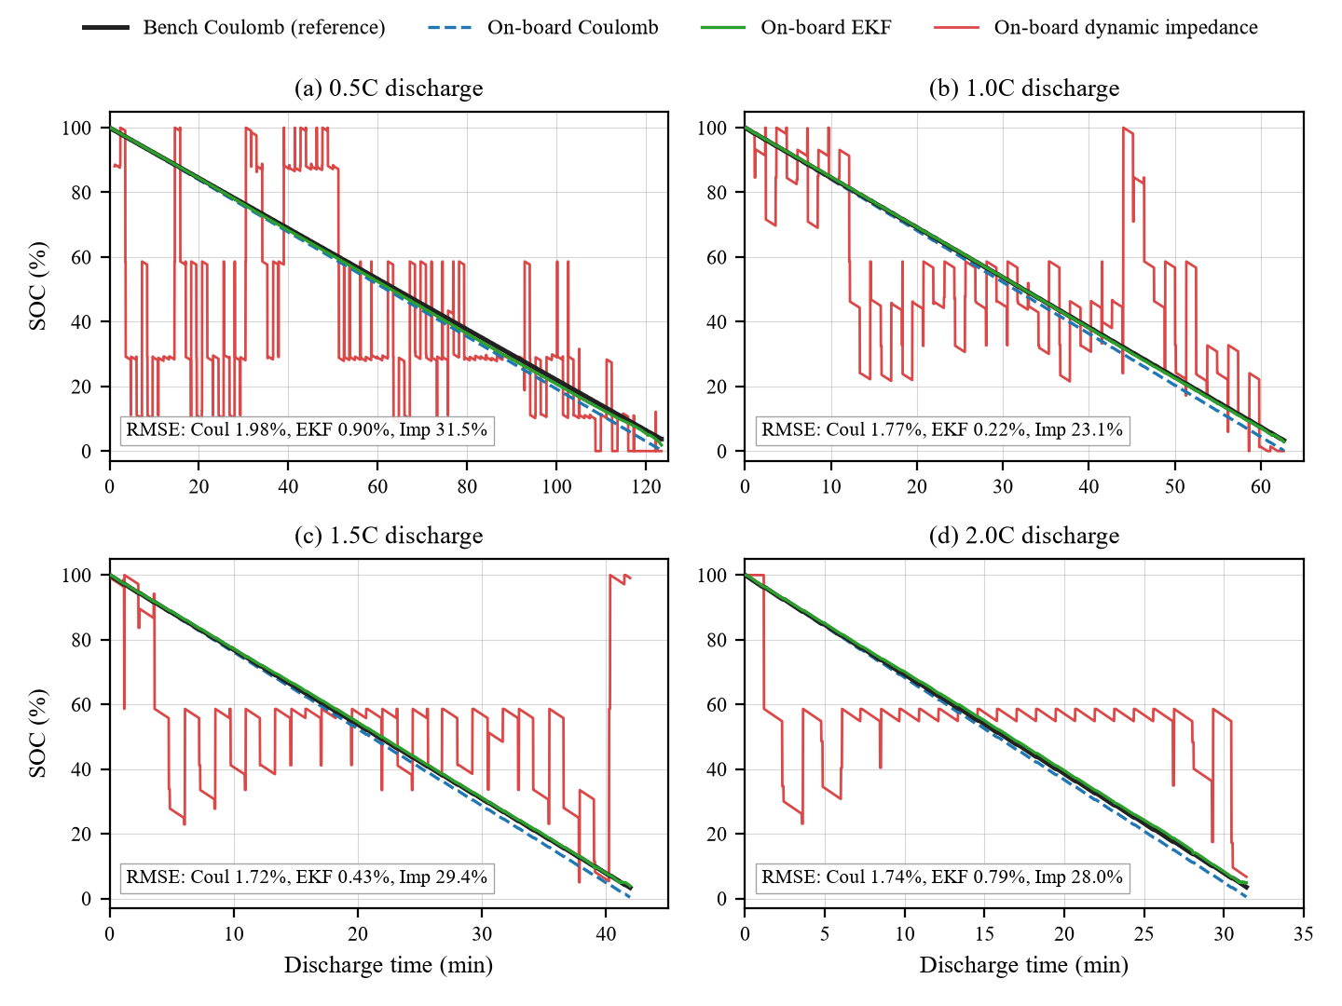
- On-board SOC trajectories of the three methods versus the bench Coulomb ground truth (Round 41, four discharge rates; each panel annotates RMSE against the bench truth).
  - Measurement-domain consistency (key finding)
Before correction (Round 40) the EKF showed a rate-dependent positive bias (RMSE 0.87-4.48%). The cause was a measurement-domain mismatch: R0 had been identified from the load-terminal voltage, which includes about 24 mOhm of wiring and contact resistance, whereas the board EKF uses the INA226 voltage at the cell terminals. Re-referencing R0 to the cell domain (51.9 mOhm) drove all four rates below 1% and removed the rate-dependent bias entirely (Round 41). The dynamic-impedance method exposes the same root cause more starkly: the bench-domain parabola minimum (57.9 mOhm) lies above every board measurement, so the discriminant has no real root and the whole table fails. Between the two domains only the constant term c shifts by about 24 mOhm - the quadratic and linear terms, set by the cell electrochemistry, are essentially unchanged [8]. The engineering lesson is that parameters and look-up tables must be built in the same measurement domain as deployment; otherwise a correct algorithm still fails systematically. This is a concrete instance of the evaluation-versus-deployment distortion raised in Section I.
  - Robustness
Three stress tests (Table II) compare the methods. On a wrong initial value, Coulomb counting never recovers (mitigated here by an automatic full-charge re-anchor), the EKF is pulled back within a single measurement update, and dynamic impedance re-estimates at the first event. Under C-rate stepping the EKF absorbs the transient in its RC branch, whereas dynamic impedance mistakes the step for a perturbation event. Under injected sensor noise, Coulomb counting and the EKF stay bounded while impedance inversion flips branches catastrophically - confirming the ill-posedness is mathematical, not a sensor-quality issue.
- Robustness comparison (initial-value and C-rate rows are board measurements; noise row is a PC replay with injected Gaussian noise)
Stress test | Coulomb | EKF | Dynamic impedance
Wrong initial value | no recovery | single-step pull-back | re-estimate <=60 s
C-rate switch peak | <=0.21% | <=0.48% | 10-48%
SOC jitter under noise | <=0.054% | <=0.27% (bounded) | ~53% (branch flip)
  - Embedded footprint
Table III reports the extra Flash, RAM and per-update cycles each method adds over the shared skeleton on an STM32G071 at 64 MHz (-Og, software floating point). The EKF costs about 50x the compute of Coulomb counting, yet at 237 us its update is only 0.024% of the 1-second budget. Thus “EKF is too heavy” does not hold at this MCU tier; the resource argument only becomes decisive on lower-end platforms or at much higher update rates.
- Embedded resource cost, measured as the difference against the shared firmware skeleton (medians over ~159,300 updates)
Method | Flash (B) | RAM (B) | Cycles/update | FPU
Coulomb | +1,892 | +24 | 305 (4.8 us) | no
EKF | +2,336 | +40 | 15,187 (237 us) | soft
Dyn. imp. (no event) | +1,540 | +48 | 442 (6.9 us) | soft
Dyn. imp. (event) | same | same | 6,525 (102 us) | soft
- Conclusions
On a single embedded platform with identical cell, protocol and MCU, this work implemented and fairly compared three SOC estimation methods. Three findings stand out. First, the EKF is the most accurate (0.22-0.90%, below 1% at all rates), Coulomb counting is a stable middle (1.7-2.0%), and impedance-only online inversion is infeasible (23-31%) for a flat Z-SOC cell; the accuracy ordering spans an order of magnitude and every error source is traced. Second, the resource ladder is quantified: the EKF costs about 50x Coulomb counting but still only 237 us per update, so it is not “too heavy” at this tier. Third, and most important, measurement-domain consistency dominates algorithm choice - parameters and tables built in a domain different from deployment fail systematically, as proven by the independent re-measurement that took the EKF from 4.48% to below 1%. Dynamic impedance remaining infeasible even after domain correction further shows that feasibility is set jointly by cell characteristics and the measurement chain, not by the algorithm alone. The reproducible fair-comparison platform is the main contribution; future work extends it to SOH estimation, temperature compensation [10] and LFP hysteresis [11].

References
- C.-H. Lin, C.-M. Wang, and C.-Y. Ho, “Implementation of state-of-charge and state-of-health estimation for lithium-ion batteries,” in Proc. IECON 2016, Florence, Italy, Oct. 2016, pp. 18-24.
- A. Hasan, M. Skriver, and T. A. Johansen, “eXogenous Kalman filter for lithium-ion batteries state-of-charge estimation in electric vehicles,” in Proc. IEEE Conf. Control Technol. Appl. (CCTA), Copenhagen, Denmark, Aug. 2018, pp. 1403-1408.
- A. Barros, P.-J. Kirsch, and J. Sun, “Adaptive extended Kalman filtering for battery state of charge estimation on STM32,” IEEE Embedded Syst. Lett., vol. 17, no. 3, pp. 121-124, 2025.
- K. Movassagh, A. Raihan, B. Balasingam, and K. Pattipati, “A critical look at Coulomb counting approach for state of charge estimation in batteries,” Energies, vol. 14, no. 14, art. 4074, 2021.
- I. Baccouche, S. Jemmali, B. Manai, N. Omar, and N. E. B. Amara, “Implementation of an improved Coulomb-counting algorithm based on a piecewise SOC-OCV relationship for SOC estimation of Li-ion battery,” Int. J. Renew. Energy Res., vol. 8, no. 1, 2018.
- S. Zhao and D. A. Howey, “Global sensitivity analysis of battery equivalent circuit model parameters,” in Proc. IEEE Veh. Power Propulsion Conf. (VPPC), Hangzhou, China, Oct. 2016, pp. 1-4.
- L. D. Couto and M. Kinnaert, “Partition-based unscented Kalman filter for reconfigurable battery pack state estimation using an electrochemical model,” in Proc. Amer. Control Conf. (ACC), Milwaukee, WI, USA, Jun. 2018, pp. 3122-3127.
- A. Kulkarni, A. Barai, and J. Marco, “Novel low-complexity model development for Li-ion cells using online impedance measurement,” J. Energy Storage, vol. 91, art. 112034, 2024.
- J. Knox, M. Blyth, and A. Hales, “Advancing state estimation for lithium-ion batteries with hysteresis: systematic extended Kalman filter tuning,” Sci. Rep., vol. 14, art. 12472, 2024.
- Y. Qin, S. Adams, and C. Yuen, “A transfer learning-based state of charge estimation for lithium-ion battery at varying ambient temperatures,” IEEE Trans. Ind. Informat., vol. 17, no. 11, pp. 7304-7315, Nov. 2021.
- B. Yi, X. Du, J. Zhang, X. Wu, and Q. Hu, “Bias-compensated state of charge and state of health joint estimation for lithium iron phosphate batteries,” IEEE Trans. Transport. Electrific., early access, 2024.

