|  |
| --- |
| kNIght’s leaf Incoprated |
| The Mimicry Project Look & Feel |
| A Knight’s Leaf Product |
|  |
| **Justin Fern & Brandon Olson** |
| **5/30/2015** |

|  |
| --- |
|  |

**Application Details and Appearance**

Login Screens

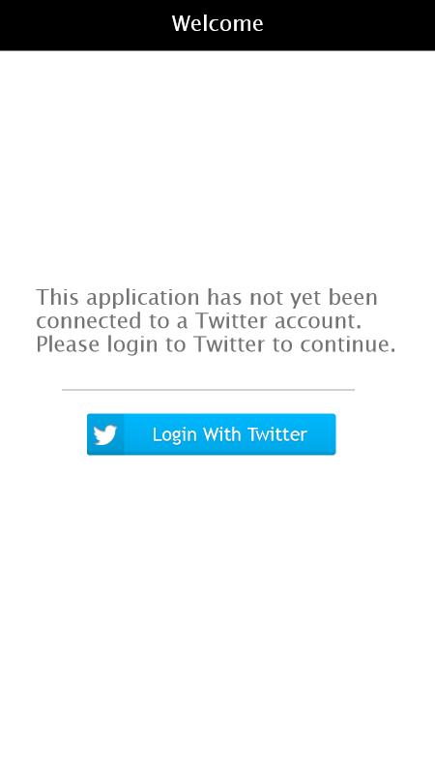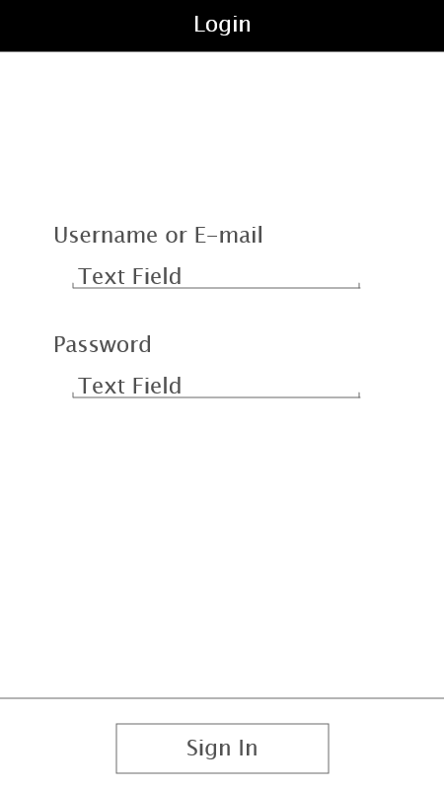

Upon opening the app, if this is the very first time the app has been opened, the user will be prompted to connect with a Twitter account. The first page will inform the user of such and, upon tapping the “Login With Twitter” button, the application will direct them to a page containing a Username text field, a Password text field, and a Sign In button. This page intuitively tells the user they must first enter their Twitter username and their Twitter password before tapping the Sign In button.

Impersonator Creation

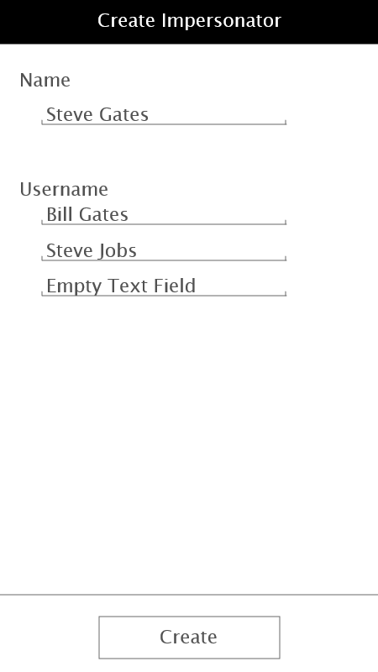

Immediately after connecting their Twitter account to the application, the user will be prompted to create an ‘Impersonator.’ An Impersonator has a name (this is chosen by the user) and one or more Twitter accounts. These Twitter accounts do not require a password, as the user will not be making any changes to these accounts, but merely reading from the posts these accounts have made. This page is once again simplistic and intuitive in look and feel. Starting from the top of the page, this page has a Name text field, Username text fields (more will continue to generate after entering a username), and a Create button. The Name text field, after being tapped by the user, will allow the user to type in any arbitrary name. This does not change how the app operates and simply assigns a name to the ‘Impersonator’ for easy access later. The username fields, after being tapped by the user, will allow the user to type in any pre-existing Twitter accounts. The tweets made by these accounts are what the application will scrape to build content for the user. After the user has entered a name and at least one username, the user must tap the Create button in order to proceed to the next page.

Impersonator Posting

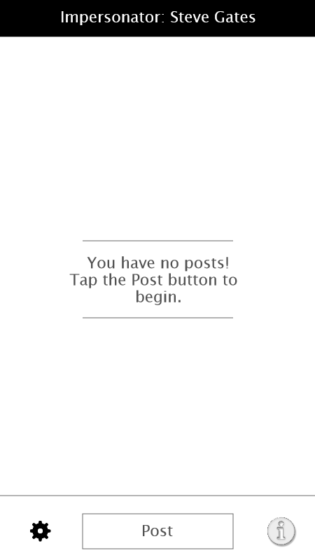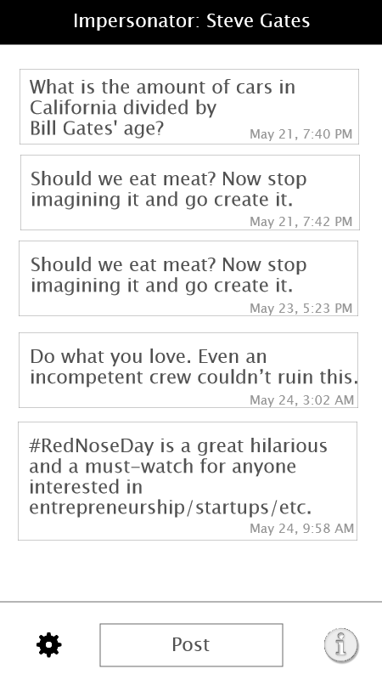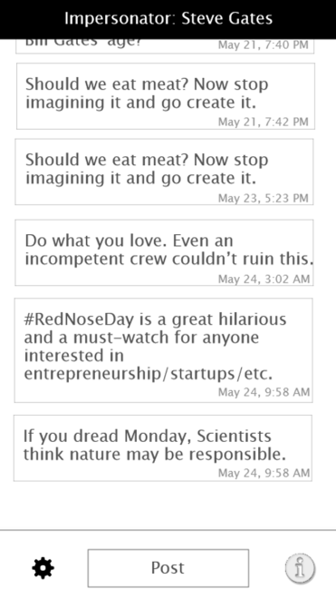

If the user has just finished creating their ‘Impersonator’ they will see an empty screen simply reading, “You have no posts! Tap the Post button to begin.” This text is centered in the screen and draws the user’s attention, alerting them on what action to take. After tapping the Post button, the application will generate a new post. Tapping the post button again will move the queue of generated posts down, placing the new post on the top of the screen. At the bottom of the screen, on both sides of the Post button, are two buttons: Settings and Information. The Settings button will lead the user to the Settings page. The Information button will lead the user to the Information page. Neither of these pages have been conceptualized fully at this point.Post Features

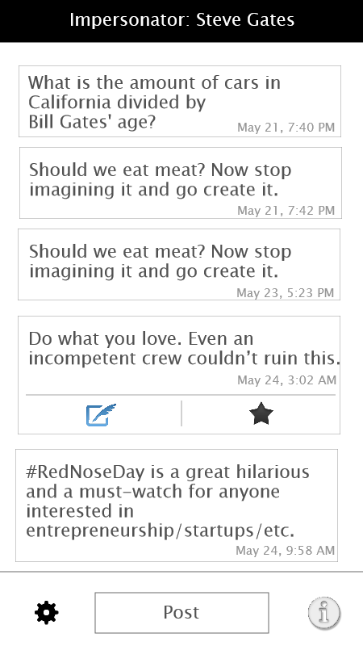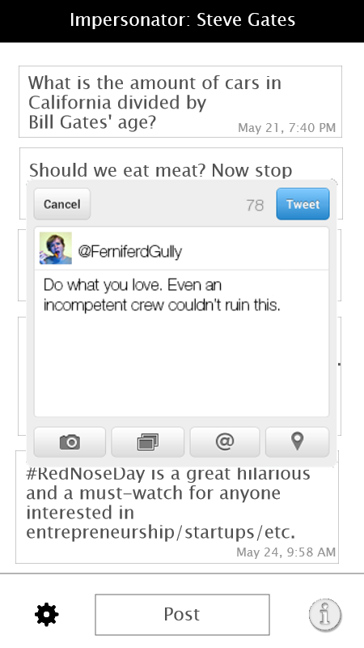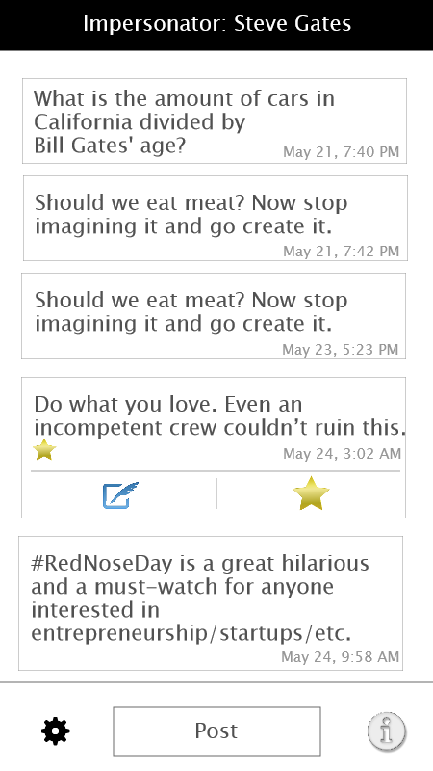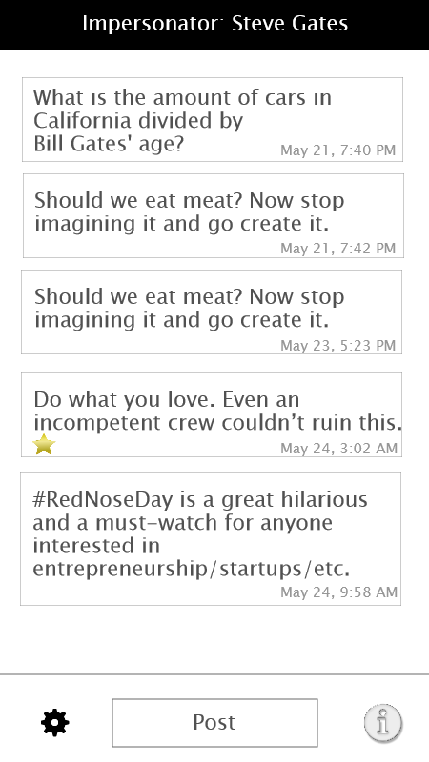

Tapping a post will show the hidden drop-down menu associated with each post. This menu will allow the user two options: tweeting that post to the user’s personal Twitter account and favoriting the post for viewing pleasure at a later date. If the user chooses to tweet the post, a tweet navigation menu will overlay the posts. In the navigation menu, the user has the option to edit the post, whether it be the wording of the post, or to add extra content at the end. After pressing the Tweet button will tweet the text to the user’s personal Twitter account. After doing so, the post will continue to display the dropdown menu. The user has the option to once-again tweet the post or favorite the post. If the user decides to favorite the post, the favorite button will change colors from black to gold. A golden star will also be displayed in the bottom-left corner of the post. Favoriting a post will add it to the list of favorites. Favorited posts will not be automatically deleted by the application, unlike posts that have not been favorited. After favoriting a post, the dropdown menu will continue to be displayed. Tapping a post will toggle showing and hiding of the dropdown menu. If a post’s dropdown menu is open, scrolling through posts will close the dropdown menu.