Pre-posed Design Specification
Jack Magee-Tollerton | 40482879

Scenario overview
The pre-posed system is a web-based database application to help the Council for the Curriculum, Examinations & Assessments (CCEA), CCEA is Northern Ireland’s qualifications regulator, established in 1994 and sponsored by the department of education NI, it develops the NI curriculum, sets and awards different qualifications such as GCSE’s, A-Levels and AS-Level qualifications, CCEA also regulates access arrangements that allow candidates with disabilities or learning needs to sit examinations fairly.
The proposed system would provide a web-based interface though which school staff can report, maintain and query the disability support arrangements in place for students, enabling a consistent form of access arrangements during exams and clear visibility of support across the school.
The system supports co-ordination between SENCO staff, subject teachers and exam officers along side reporting on differences between supported and non-supported students.

Real world challenge
Recent data has shown that one out of four students receive extra time on there GCSE and A-Level exams, each arrangement must be approved in advanced for a selected student, but this needs to be applied consistently across every test and final exam. Information can easily be fragmented through files, individual teacher plans, paper records from external sources or examination officer spreadsheets.
This fragmentation of data creates real opportunity risks for students, as they could possibly have missing arrangements they’re entitled to, teachers lacking the visibility of what support is in place and evidence being hard to produce for inspections that the support is there. As well, schools expected to monitor outcomes for this, are students with support achieving comparable results to non-supported students? Without consistent and valid data, It makes this almost impossible.
The challenge is therefore one of co-ordination and evidence, centralising fragmented data into a single query of truth.

SDG Alignment
This system would align with SDG target 4: “ensure inclusive and equitable quality education and promote lifelong learning opportunities for all”, diving deeper, the system would mainly target SDG target 4.5: “eliminate gender disparities in education and ensure equal access to all levels of education and vocational training for the vulnerable, including persons with disabilities, indigenous peoples and children in vulnerable situations”, by enabling schools to compare outcomes between supported and non-supported students, the system would give schools the data needed to evidence inclusive practice, and identify where support is falling short

Proposed system and Key users
The proposed system provide a web-based interface for managing students, disabilities, assistance, classes and tests. Three possible user groups that would interact with it:
- Learning support staff: Could create and update student disability records and assign assistance and review reports across the school
- Subject teachers and exam officers: review the disability and assistance profile of students in their classes, could possibly create test records for students.
- Senior leadership: review reports on gaps between supported and non-supported students, filter by year group, to overall create new possible outcomes / strategies

Data sources and Evidence base
The design is formed from three public sources which are:
- CCEA’s Access Arrangements guidance: This is what will shape how assistance is done
- JCQ AARA 25-26 regulations: CCEA themselves follow, which inform the modelling of specific assistance types such as (Extra time 25%, Reader, Scribe)
- CCEA’s SEN and inclusion resources: Which help distinguish disability category structure ( Learning, Physical, Mental Health, etc)

Initial ER diagram model
The ER diagram below shows the key entities of the proposed system and their relationships, Many -to- many relationships are solved through linking tables, the most prominent table being the ternary relationship of the Student_Disability_Assistance table, this allows one student to have multiple disabilities with different assistance for each.

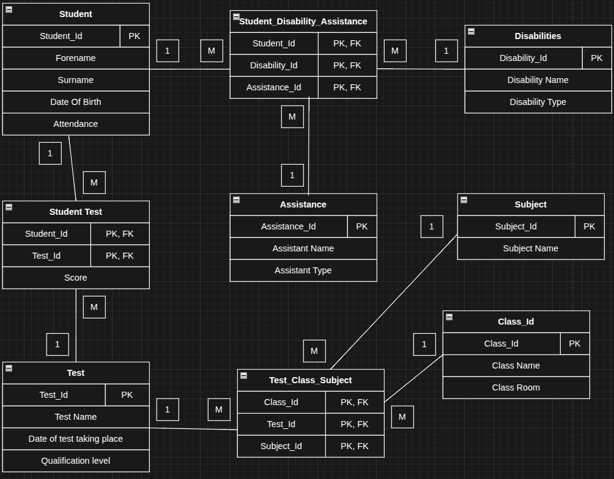

Key CRUD functionality:
Create
- Add student and there details such as Name and DOB to the system
- Allow adding disabilities and assistance to be added to a student
- The ability to add test results to a student
Edit
- Allow to edit a students details
- Edit a students assistance
Delete
- The ability to delete the a student from the system
- Delete a test result of a student from the Student_Test records

Data Integrity and Security Considerations
- NOT NULL constraints on identifying fields (names, DOB) and on all foreign keys in linking tables
- Composite primary keys on linking tables (e.g. Test_Class_Subject uses all three foreign keys) to prevent duplicate support records
- Foreign key constraints to maintain referential integrity — for example, a Test cannot reference a non-existent Subject ID
- Client-side validation aligned with database constraints (valid date ranges)

