

Computer Games Development CW208
Software Functional Specification
Year IV

Jack Malone
C00236428

[Date of Submission]

[Declaration form to be attached]

Functional Specification 2
Main game functionality 2
Reinforcement learning algorithms 4
Data Viewing 4

Project Description
The final application that I decided on was a main application that where I could test out both the Monte Carlo Tree search algorithm and the Alpha Beta Tree search as well as being able to store this data in a database so that it would be easy to compare the two algorithms. I was successful in implementing the main parts of the project when I first started the project. I switched part of the smaller area of the project towards the end as I thought that trying to implement reinforcement learning would be a better way to further compare all of the algorithms instead of trying to extend the algorithms that were already implemented as this would not give as much information compared to adding in more algorithms to be able to compare against. The main way to be able to run the project is to use either python in a command prompt or to use an anaconda prompt and then installing the necessary packages such as pygame an thorpy for the main project and tensorflow for the reinforcement learning. This allows the project to be easily able to run on different platforms as all of these packages can be installed on any operating system that is able to install python.
The main game allows for setting either of the two players (black and white) to both of the main algorithms as well as being able to play as a human player if you want to try and play against them yourself to see how they react to an actual player. There is also the ability to set a time limit for both of the algorithms which limits how long both of them have to be able to figure out what their next move should be. This is more useful for the bigger board sizes as the alpha beta tree search specifically can start taking a long time to be able to fully evaluate a specific move which would take a long time to be able to go through a full game. The monte carlo algorithm also takes more time on these bigger board sizes but it is not as slow as the other algorithm. The final option that you are able to change is what board size you want them to play on. Setting this to a smaller board size will result in faster games as it both takes the algorithms a shorter amount of time to figure out a move as well as reducing the amount of moves that it takes to fully finish the game. I also included the full size 19x19 board to show how they work on the proper board where the monte carlo tree search is fairly well able to still make a decent move on this board, however the alpha beta search is not able to play well on this board.
The game will then automatically export all of the data that was captured during the game to a data base file. I have two different databases that store both all of the moves and then a description of how the entire game went, including the number of captures and territories for both players and then a unique identifier. To be able to load these into the jupyter notebook to be able to look at the differences between the two algorithm, I used the sqlite database browser which can be downloaded for free. This then gives you the option to export the database files as excel files. This excel file can then be copied over to the jupyter notebook folder which includes the actual ipynb file for the notebook. Once you open this notebook by running jupyter notebook inside of a command prompt assuming that you have python and jupyter notebook installed correctly, you will be able to open the python file included in this notebook. Running all of the cells inside of this file will generate all of the graphs that show the moves calculated as well as the difference at the end of each of the games.
The final part of the project that I created was the two different reinforcement learning models using an open ai gym environment. This environment can be found inside of the GymGo folder of my project. I have slightly altered the environment to suit my project by updating the environment and the game to have better reward models. I also have created python files that allow you to run the learning for both of the models as well as seeing how well both of the models are able to play. To be able to run these files, I created a tensorflow environment inside of an anaconda prompt and installing python and then running the install instructions from the gym environment which can be found here: https://github.com/aigagror/GymGo .

Main game functionality

The main menu will have options to customise what size board you want to play on using a slider to choose the size or a set of buttons. You will also be able to choose if you want to play as black or as white using a checkbox for each colour or if you want the ai to play against itself. To be able to choose each player, there will be 3 choices for each player for either a human player, the Monte Carlo algorithm or the Alpha Beta algorithm. There will then be a title above each of the choices to give the user an idea for which player each choice is for. There will also be a time limit choice that will allow you to set how long each ai has to play a move, there will be 3 choices, 5, 10 or 30 seconds. Once the time limit runs out then the ai will have to stop calculating their moves and then pick the best move that they have found so far. The time limit will not apply to the actual player just to make it easier for a player to figure out a move.

Example layout of main menu display.
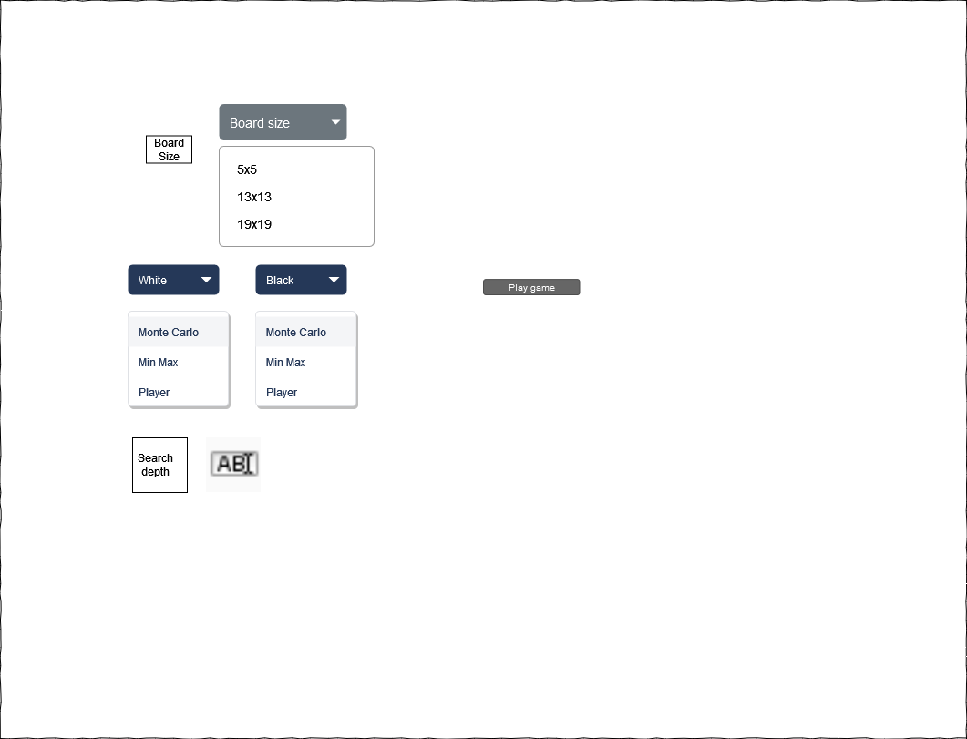
After the user presses play on the main menu screen then they should be brought to the main play screen of the game where they can see the algorithm in action. If they selected to have the AI play both sides of the game then the user should not have to interact with the application as the game should be played out by the algorithm. Once the game is over in this case, they will be able to see which colour won the game which can be used to determine which algorithms are better than each other. The user can also decide to play against the AI themselves if they want to focus on looking at how the algorithm tries to play certain types of positions in the game. The game-play screen will have the board displayed in the centre of the screen as well as displaying what colours turn it is as well as what algorithm is playing that colour or if it is the actual player. Once the game is over, the colour that won the game will be displayed in the centre of the screen. To be able to interact with the board if you decide to play the game yourself, you have to left mouse click on the position on the board that you want to play at when it is your turn.
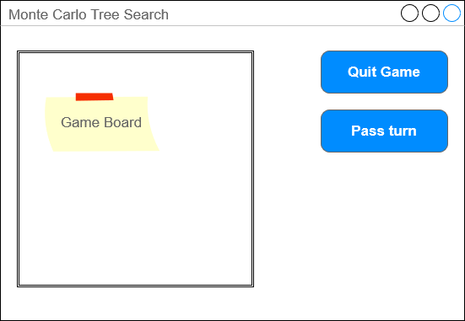

Reinforcement learning algorithms
There will also be an environment for the reinforcement learning algorithms to be able to train in. I am using this environment that I found online that already implements the game of go and the environment necessary to train the AI: https://github.com/aigagror/GymGo. The AI can then be run by using an Anaconda prompt inside of the folder that contains both the environment as well as the specific scripts for training and for loading. A virtual tensorflow environment was also used to be able to make sure that the environment is loaded correctly. Instructions on how to set up this can be found in the ReadMe on my Github page. There are also two forms of rendering. The ai uses a terminal view when it is training as this ignores user interaction but there is also a more visual version that opens up a window that renders the board as well if you want to play against the ai. Once the ai has finished learning, they will then use the terminal again to play the game if it is going to play against another ai. The environment has also been set up so that you are able to play against the ai using a visual rendering method.

Data Viewing
I will be setting up a jupyter notebook to be able to view the data that I will be sending from my main project. I will be focusing on capturing data from the Monte Carlo Tree search and alpha beta algorithm. I will be using a sqlite database to store all of the information and then I will use the sqlite database explorer to export this to an excel file so that it is able to be opened in the jupyter notebook. To be able to use the jupyter notebook, you will need a command prompt that has python installed so that you are able to run the jupyter notebook command where the notebook is saved to open it in your browser. This will then let you run the code in the notebook and view the graphs that I have created.

Setting up the project
How to run this project
The project files can be downloaded from here: https://github.com/JackMalone1/Final-Year-Project . There are 3 main folders in here that contain the main pieces of code. The code folder contains the main game that has the Monte Carlo Tree Search as well as the Alpha Beta algorithm. The GymGo folder contains the training files for both of the reinforcement learning models as well as files to run these algorithms. I have also included my own version of the environment that I used for creating the two algorithms. This is nearly the same as the regular environment however I have updated it for my project so if you install the environment from here: https://github.com/aigagror/GymGo there may be some differences between the two. To run both of these I used the anaconda command prompt which can be downloaded from here: https://www.anaconda.com/. Once you have this command prompt installed, you will have to install pygame by opening the command prompt and then running the command: pip install pygame. The Ui library Thorpy will then have to be installed, which can then be installed using the command, pip install thorpy. Once you have these installed, you can then use the anaconda prompt to go into the code folder by using cd foldername until you are inside the folder. Then run this command:
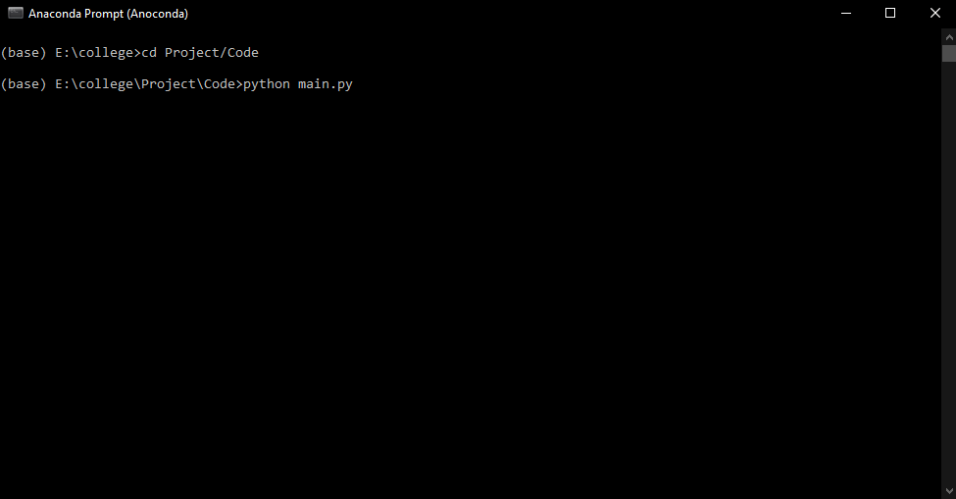
Running this command should open the game on the main menu with these options:
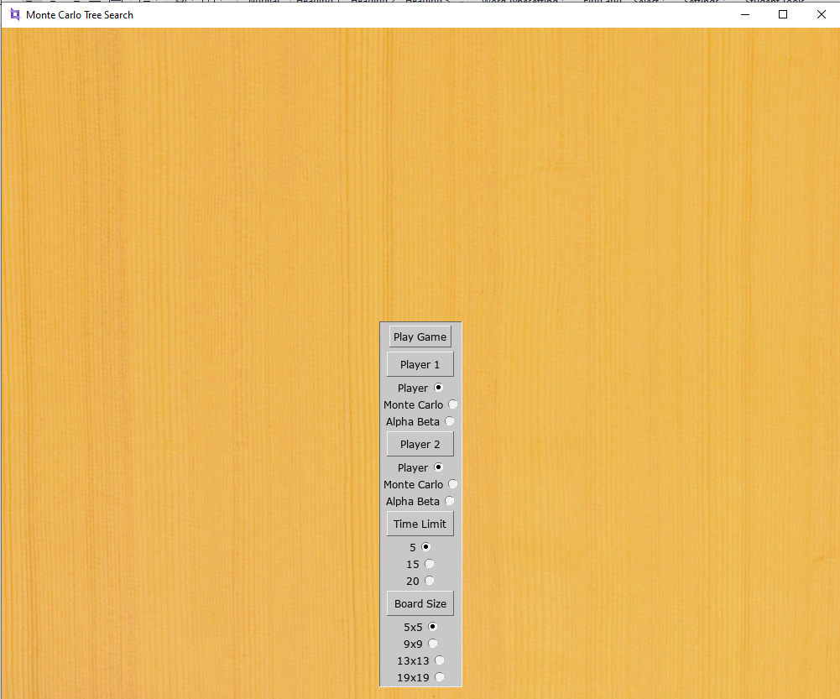
If for some reason you are not able to run the game because you are missing some python libraries you should be able to run pip install missingLibrary to get any libraries that you are missing and then you should be able to rerun the game. You are then able to switch from player1 and player2 from using an actual player, to using whatever algorithm you want to play first and second. The time limit is the amount of time in seconds that each algorithm has per second to play a move, this is to make sure that it does not take too long to complete a game on the larger boards. I would recommend to leave it on either 5 or 15 seconds if you are switching the board size to one of the larger boards as these games can take some time to run.
Once you finish playing a game, you should have a game database, if you did not have it before the game was run there are files to be able to create these databases before running them as these are needed for storing the database. These database files will be located inside of the code folder. You are able to use the sqlite db browser to look at the tables inside of the database by opening the database and then opening the browse data tab:
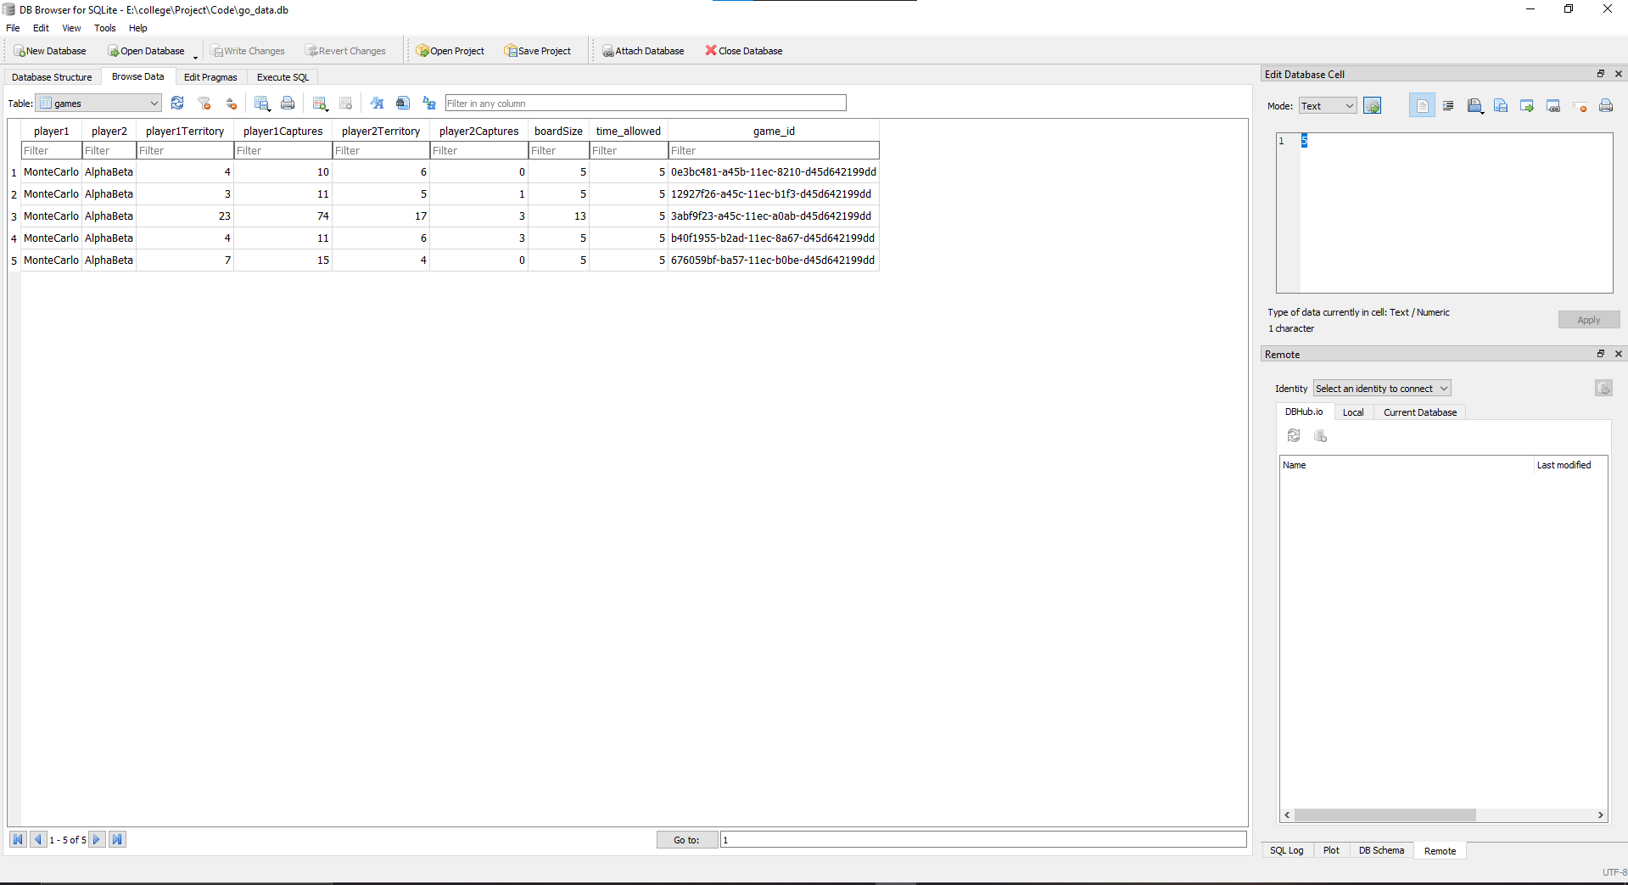
This can be downloaded from here: https://sqlitebrowser.org/. You can then export this database to a csv file by opening file at the top left and clicking this option:
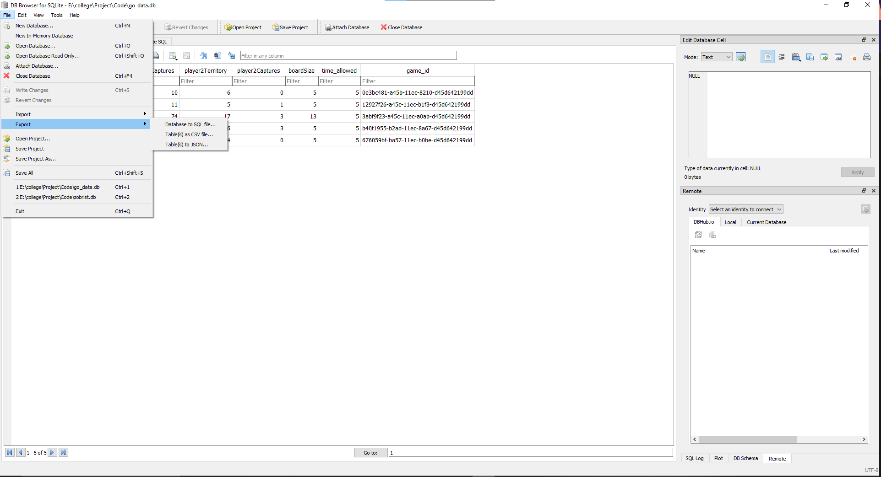
You then want to select both tables and leave the rest of the options as normal:
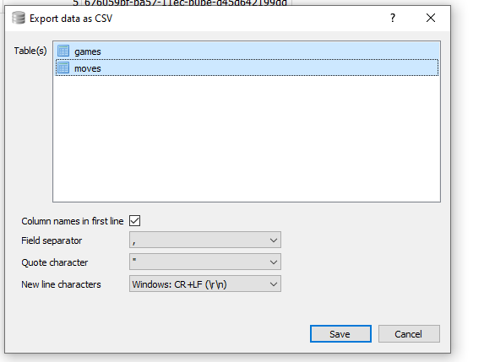
Then save the file inside of the Jupyter notebook folder inside of the project. Then cd into the Jupyter Notebook folder and run the following command:
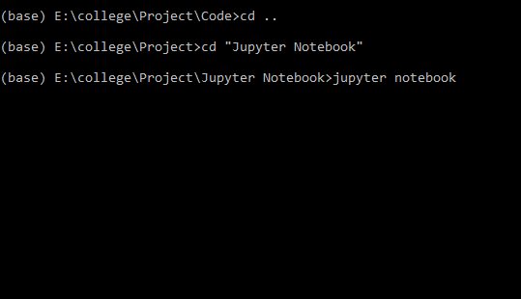
A webpage will then automatically be opened with the following contents:
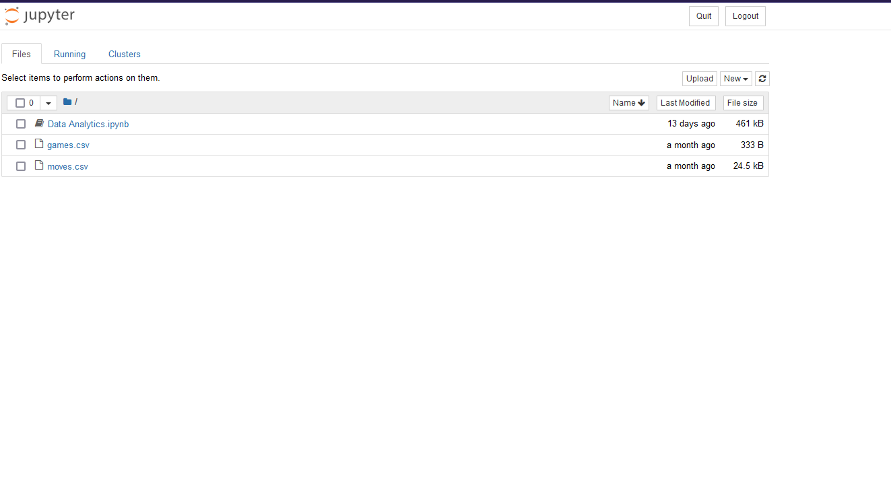
You then want to open the ipynb file and run all cells which can be done here:
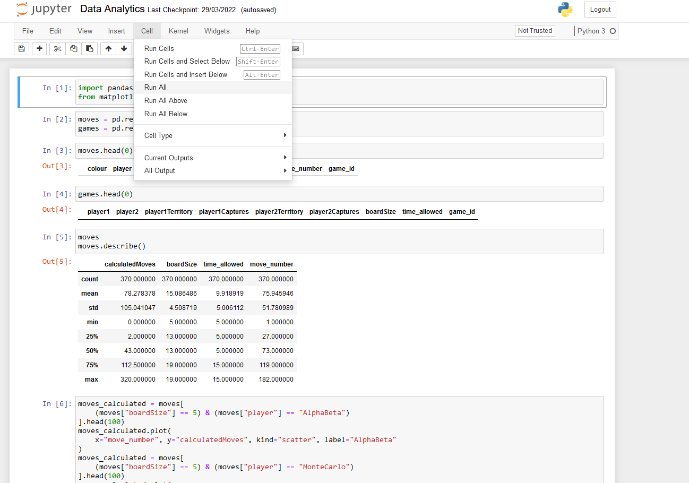
This should then automatically run all cells and you will be able to read through all of the graphs.
To run the Reinforcement Learning models cd into the GymGo folder using the anaconda prompt. Then run the following commands.
conda create -n tensorflow python=3.7
conda activate tensorflow
conda install python=3.6.5
pip install tensorflow==2.2.0
pip install -e .
pip install stable_baselines3[extra]
The 4 files that I created for the reinforcement learning are model_playing.py, ppo_load_model.py, proximal_policy_optimisation.py and training.py which you can run by using the command python followed by the name of the file that you want to run.

Is there a precedent for this project
The precedent behind this was project was that I became interested in being able to create an artificial intelligence that would be able to play some kind of board game. I became interested in creating a reinforcement learning approach to solving a board game after using similar approaches in college.
I also became interested in creating it for go specifically after watching the documentary on the go ai that was able to beat a world champion. I knew that I would not be able to create anything that was anywhere near as complex, but I thought that it would be interesting and a challenge to at least try and make a few basic algorithms that could play the game at a fairly basic level.

Metrics
What can I keep track of.

Milestones

Review and conclusions
Compared to Alpha Beta Tree Search, the Monte Carlo Tree search is a great improvement in terms of calculation time as well as moves calculated and the quality of the move generated. In a time constrained or memory constrained environment, Monte Carlo Tree Search can far outperform Alpha Beta for environments where there is a large search space. This is as a result of the amount of processing that the algorithm needs compared to Alpha Beta to get a similar result but without having to search the entire tree to find the best possible move, instead it is focused on finding a move that is the best from what it has found so far. The algorithm also works better when it is cut off early as a result of time constraints, even if the algorithm was not able to be run to conclusion, it is still able to produce a reasonable result, even if it is not the best possible. When Alpha Beta is completed early however, we do not have a guarantee on whether or not it has found a good move as it is limited to linearly searching through the search space.

The reinforcement learning models that I used in my research, were able to reproduce similar results as the other algorithms, but with the added benefit as that as they are playing they use up a lot less time in calculating a move as well as not having to use as much computer resources. Hopefully in the future, the deep q learning model that I created can be extended to improve its decision making to be able to choose more valid moves as well as being able to make human like moves if supervised learning was also used to create a model instead of only using reinforcement learning.
Overall, the deep q learning was not able to learn to be able to make legal moves in the starting setups for the game, this may be able to be changed if it was given a lot more games to be able to train in the game, but this would result in having to let the model train for several days, weeks and may not see great improvements. A better solution would likely to be to reduce the action space that the model was given so that it could only choose between the valid moves in the position. This would improve it dramatically in the algorithm being able to pick only valid moves but this might require changing how it is given the state when actually playing to only include valid moves which may retract from it learning to play valid moves on its own.
The proximal policy optimisation algorithm(PPO) was able to start making valid moves fairly quickly and was given approximately 200,000 timesteps to train. This algorithm was able to pick valid moves a lot better than the deep q learning but it will probably need a lot more training to be able to reach a good level of playing against actual players. It was able to play similarly to how the Monte Carlo tree search played or how the alpha beta algorithm would be able to play given enough time, however once the PPO algorithm and deep q learning are trained they are able to give moves instantly instead of requiring time to figure them out.
One next step could be to further compare different types of machine learning against each other for trying to solve the game of go. One area that would probably be best to focus on would be supervised learning. A component ai could be created given a good data set to train the model on, however this could take a while to train the agent so some way of speeding this training up using multiple pcs or a different technique to use alongside the supervised learning would be needed. This would be similar to some of the ai that AlphaGo created as they were creating their neural network where they used a large number of professional games to try and create an ai that could play the game as well. Other games could also be chosen to see how these algorithms could be used in those games. Chess may be an easier game to create an AI for as the search space is a lot smaller, however it could take a bit longer to actually implement the game itself into an environment that you could use unless you use a pre-made one as the rules of Go are not as complex. For my implementation of the model, I did not use any external data apart from training it on playing the actual game, so giving the ai an opening book as well as puzzles as part of some kind of Supervised learning could improve the skill level of the ai that are generated as the skill level of the ai that I generated is not that high, especially for the larger boards as this is a much harder problem to solve, so someone could first try to make a good ai for the smaller boards and then work up to creating an ai that can play reasonably well compared to a human beginner at the game. There is also a book that shows you how deep learning can be used to solve the game which can be found here https://www.manning.com/books/deep-learning-and-the-game-of-go.

Incorporating with different implementations
My game was created without being able to also be used to play against ai created by other players. There is a standardised format for playing moves on a board as well as a way to format boards that could be used to also incorporate other ai into the game which could then be used to compare the ai against already created ai if needed.

