

Computer Games Development CW208
Technical Design Document
Year IV

Jack Malone
C00236428

28/04/2022

Contents

Technical Design 2
References 2

Algorithm Design

Monte Carlo Tree Search
Monte Carlo Tree Search has two fundamental ideas: that the actual value of an action can be approximated using random simulation and that these values may be used efficiently to adjust the policy towards a best first strategy. The algorithm slowly builds up a partial game tree (incomplete tree), using the results of having previously explored the tree. The tree estimates the values of moves and this becomes more accurate as it explores more of the tree and more of the tree is built up. The algorithm consists of continually building the search tree until a time limit has been reached or there is some other memory or number of iterations constraint. Once the limit has been reached the algorithm returns the best move that it was able to find in that time. Each node of the tree represents a specific board state.
The algorithm is split up into 4 different stages.
- Selection: in this step, a tree policy is used to construct a path from the root node to the most promising leaf node. A leaf node is a node that has unexplored child nodes. The tree policy is an informed policy used for node selection in the explored part of the game tree. In this stage the algorithm also has to consider exploration vs.exploitation, which is the balancing between looking at a specific move and exploring the search tree to look for other possibly better moves. The uct algorithm is used to solve this. The algorithm keeps on selecting child nodes recursively until the most urgent expandable node is reached. A node is expandable if it is not a final game state and it has unvisited child nodes.
- Expansion: in this step, one or more child nodes are added to expand the tree randomly, depending on what legal moves are available.
- Simulation/Roll-out:in this step, a simulation is run from the new nodes with reward accumulated for each simulation. Roll out policy is normally simple evaluation or pure random such that it is fast to execute. A win could give a reward of +1, a draw 0 and a loss -1. A simulation is just playing random legal moves to simulate an actual game being played.
- Back propagation: in this step, the simulation result is backed up through the selected nodes to update their statistics. The back propagatino step does not use a policy itself, but updates node statistics that inform future tree policy decisions. The value of nodes are not updated during the roll out step because we need to focus on the vicinity of the root node, based on which we need to make decisions of next moves.

Pseudo-code

Class Node:
Def __init__(self,m,p):
Self.move,self.parent,self.children=m,p,[]
Self.wins,self.visits = 0,0
Def expand_node(self,state):
If not terminal(state):
For each legal move m of state:
Nc = Node(m,self)
Self.children.append(nc)
Def update(self,r):
Self.visits += 1
If r == win:
Self.wins += 1
Def is_leaf(self):
Return len(self.children)==0
Def has_parent(self):
Return self.parent is not none
Def mcts(state):
Root_node = Node(none,none)
While time_remains:
N,s = root_node, copy.deep_copy(state)
While not n.is_leaf():
N = tree_policy_child(n)
- add_move(n.move)
- expand_node(s)
N = tree_policy_child(n)

Implementation

While not terminal(s):
S = simulation_policy_child(s)
Result = evaluate(s)
While n.has_parent():
n.update(result)
N = n.parent
Return best_move(tree)

Implementation

For my actual implementation, I decided to follow a fairly similar approach to what is in the pseudocode, I use a class the contains all of the information for the algorithm to generate a move and to store other information that I use later to send to the database. I also use nodes to store specific states in the game, which start off with a root node which I set to have a parent of None. I also set the current best move to none before I start the algorithm so that when I do go to start looking for what the best move was, it will decide to use the first one available. The root node also randomly chooses a move from the available moves in the position to start the algorithm off with having a default move to start off with. I then loop through how many times I set it to explore, which for my game I set to 320, as this will be the max number of moves on a 19x19 board so that it will try to go through as many moves as possible. I also decided to use a time limit for the algorithm as this was the easiest limit to implement and it also meant that it was easier to get it to stop when I wanted it to. For each of the children I give them a copy of the state so that none of them interfer with each other and I also add them to the list of the roots children so that it can keep track of all of the nodes.
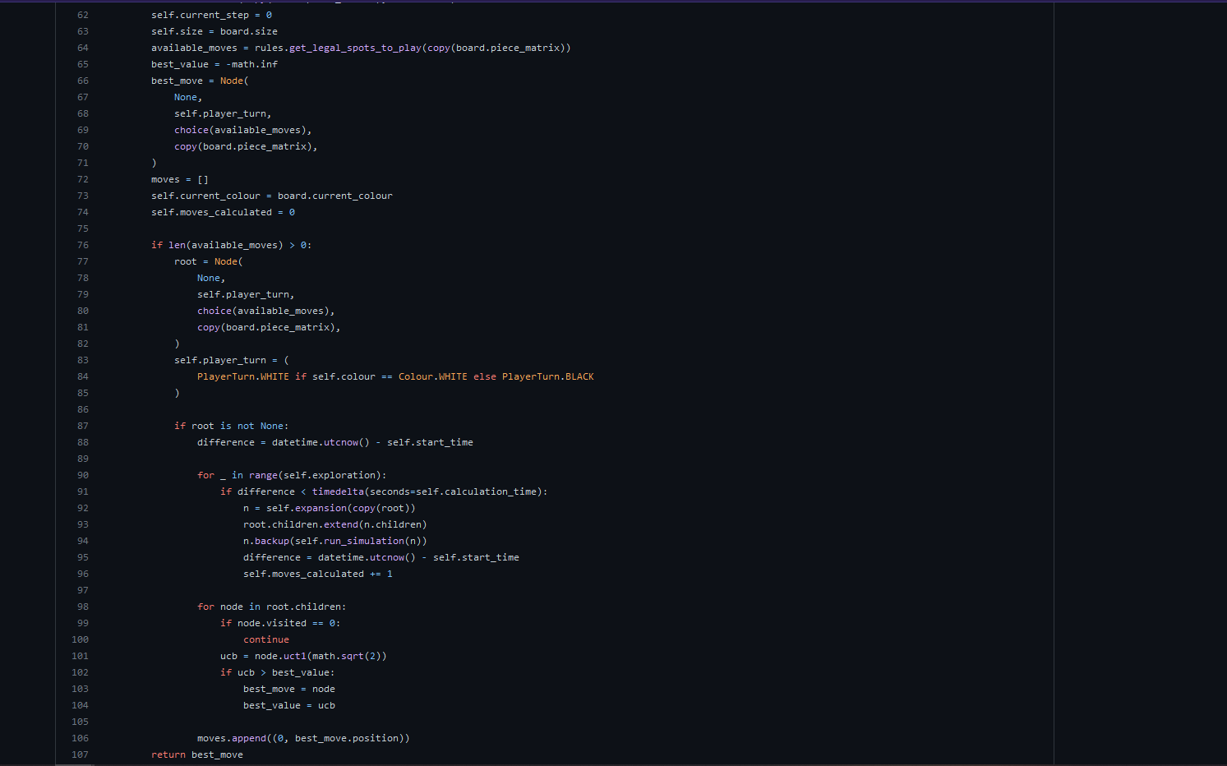
Once either the time limit has been reached or it has gone through all available moves, I go through all of the nodes that have at least been visited once to make sure to pick somewhat looked at moves, I check their ucb value and if it’s higher than the last highest I set them as the next best move. I use an exploration parameter of the square root of 2 as this seemed to be an excepted upon good value for the constant.
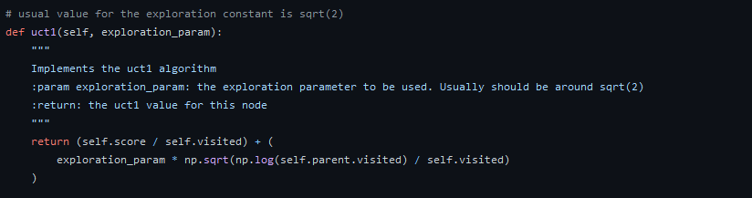

For each node that I do an expansion on, I get all legal moves at the current position for that node and then I loop through until I reach no legal moves left. This is to make sure that I explore as many different moves as possible. I also make sure that each of the moves get played and then after each of these I use the expand function on each of the nodes. When I go to actually simulate the game which happens right after I expand a node in the expansion step of the algorithm, I make sure to place as many nides randomly as possible (the random playout section of the algorithm) until I reach a terminal state where there is no legal spots to play left, and then I let the rules evaluate the board position. I did it this way both to decrease the complexity of the algorithm trying to figure out whether black or white won the game and then to give a score based on that and to make sure that both the monte carlo tree search and the alpha beta algorithm were using the same evaluate function if they were both using the same class to get the score. I decided to implement it this way so that it would be fair between the two algorithms that one of them would not have a way better way of evaluating a position which could give them an edge and win and instead left it to actually how many moves they were able to calculate and the overall set up of the two algorithms.
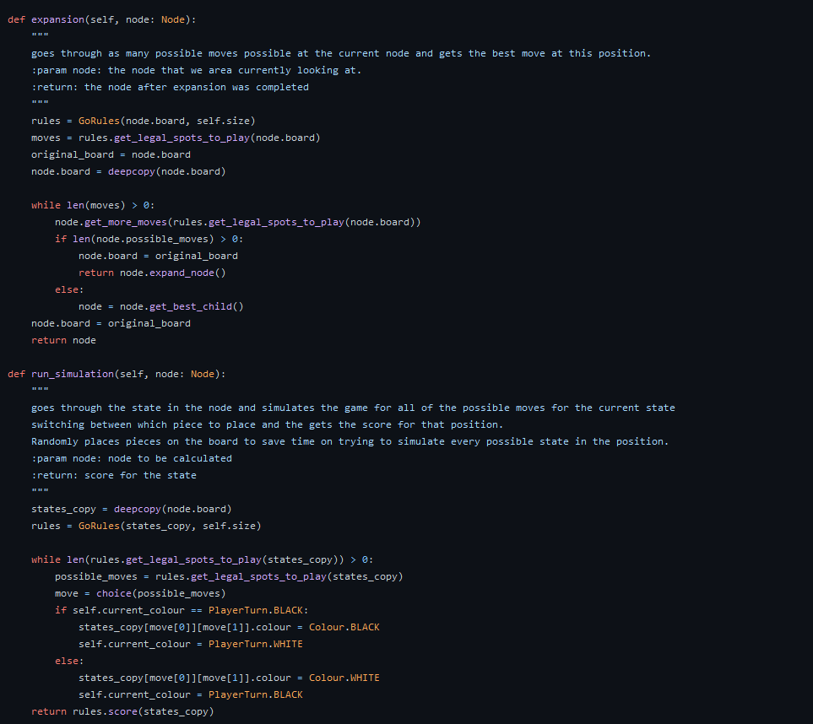

I decided to use the backup function alongside the simulation so that whenever a node would simulate the game and then end up with a final score for the game, they would get the score themselves but they would also back-propagate this score back up all the way through each of the parent nodes. This means that whenever I get a score for a particular game that this does not get lost in a node somewhere further down the tree. I also increase the visited count as a simulation was run at this level and this ensures that the node is looked at properly at the end of the algorithm.

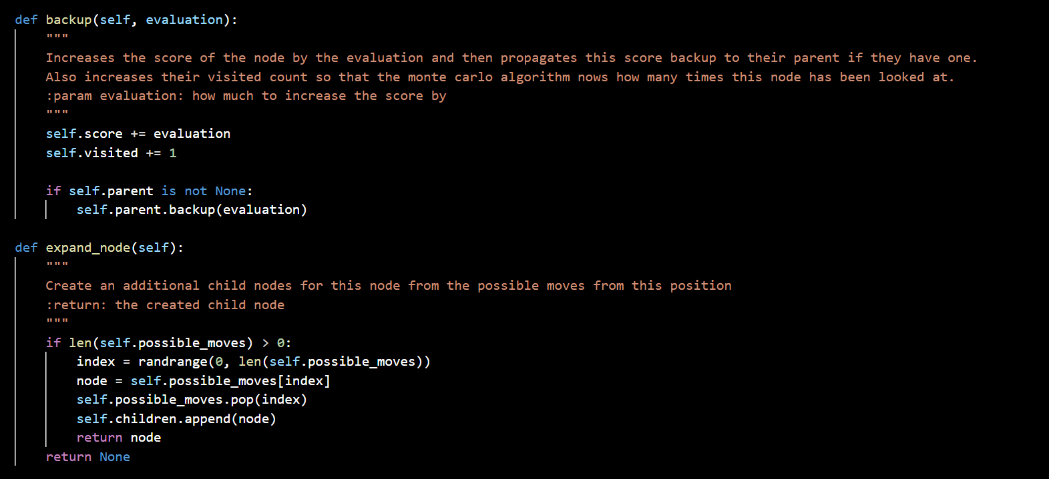
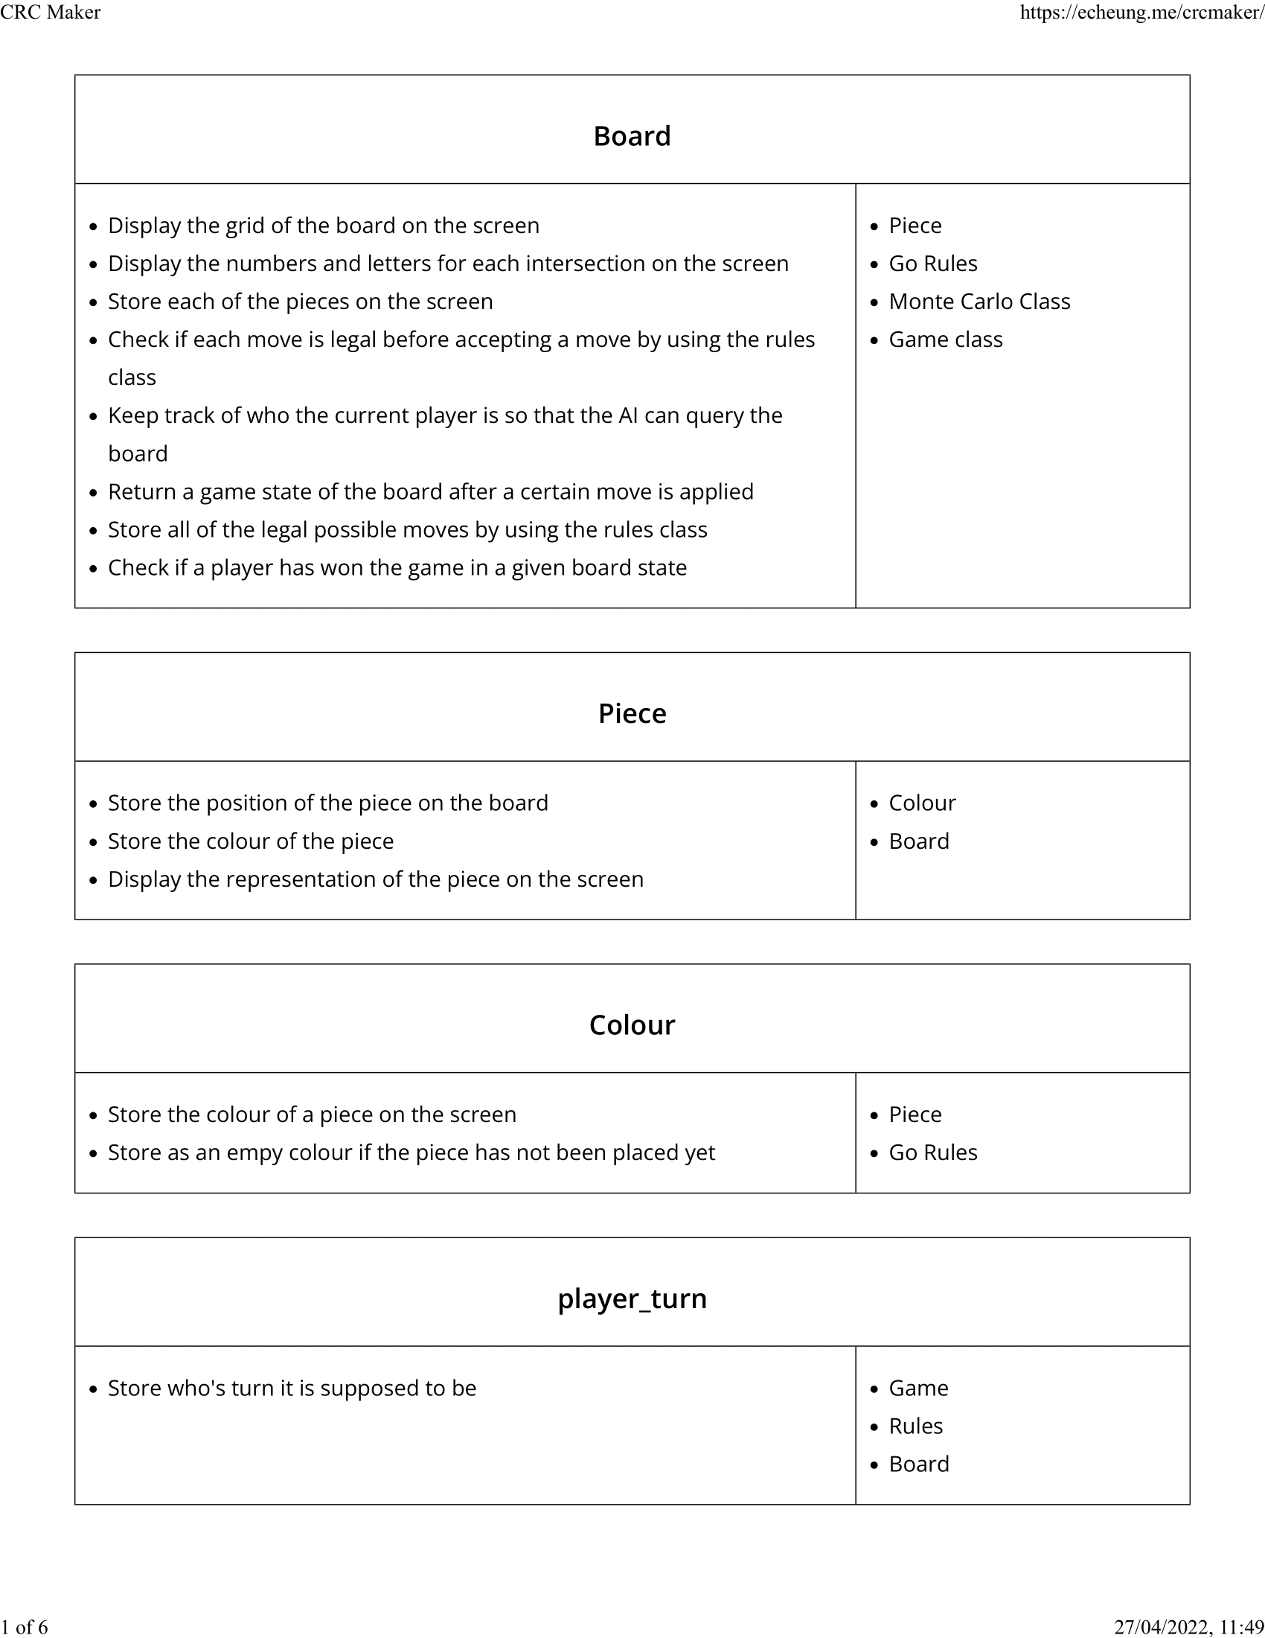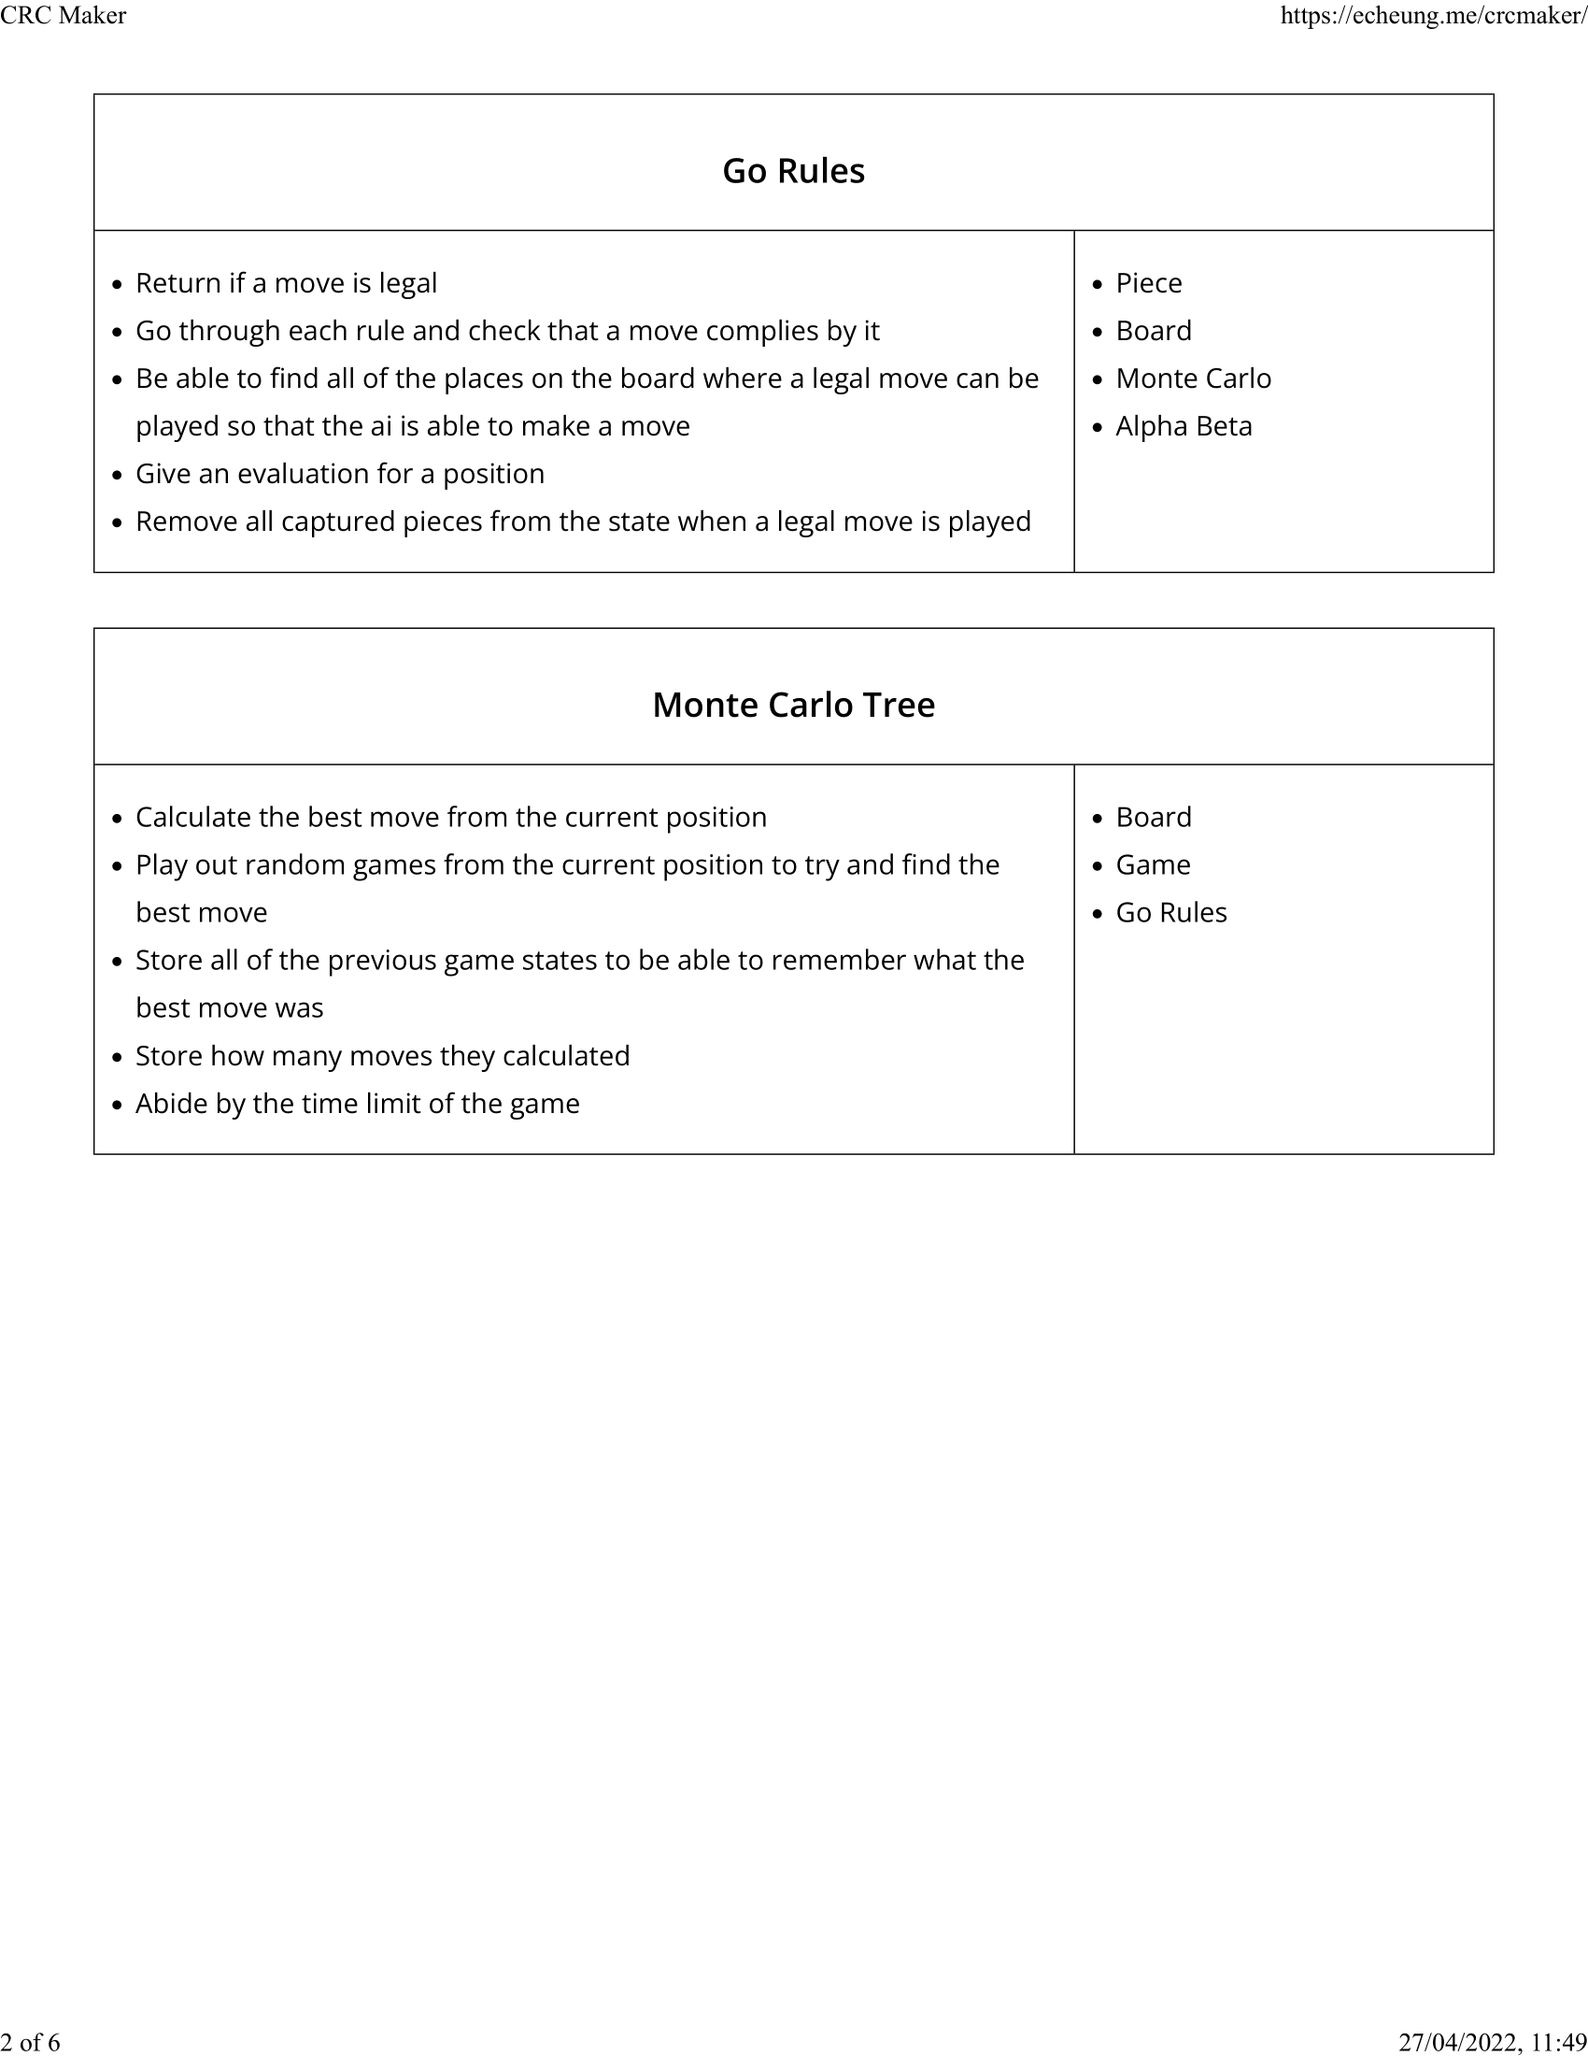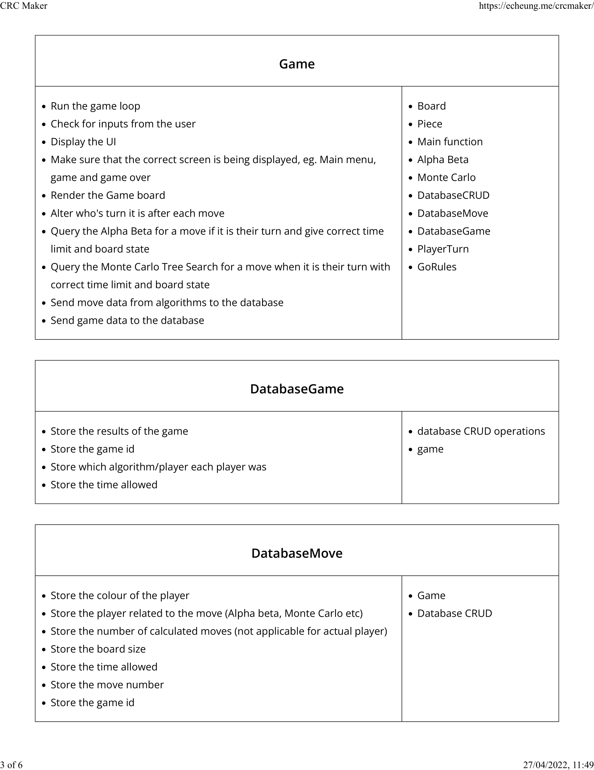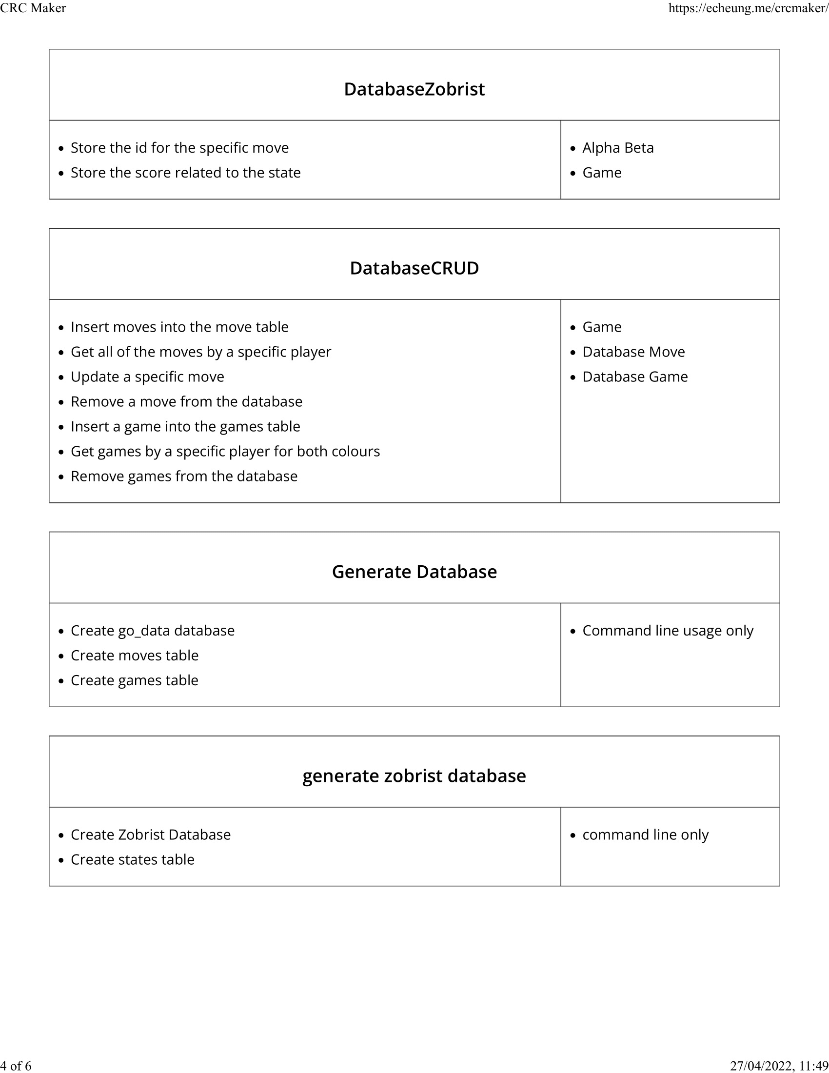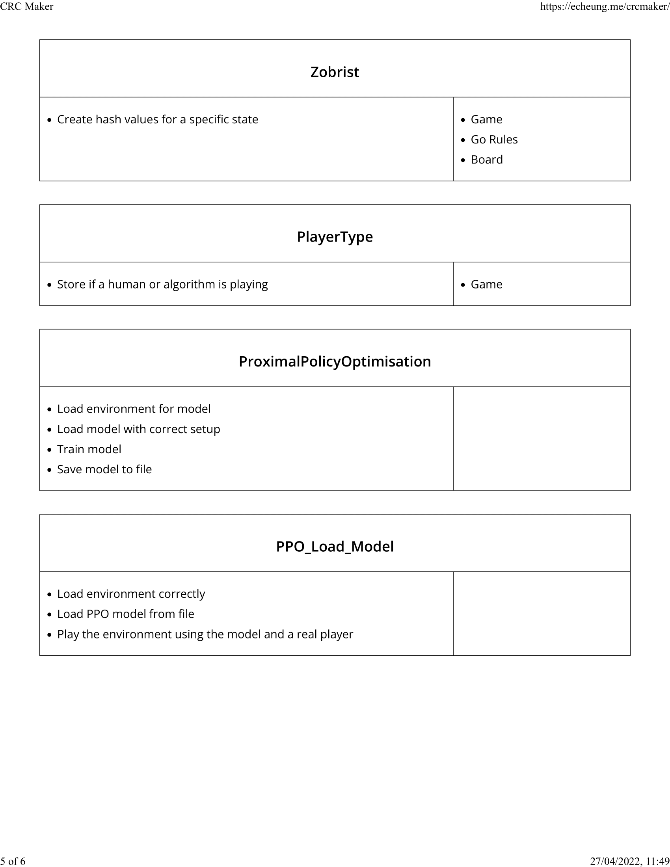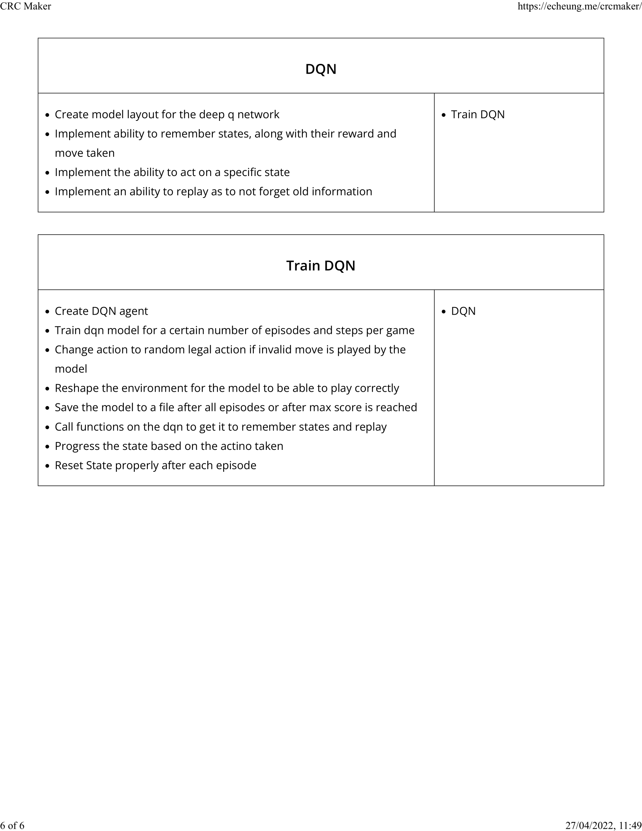

UML Diagrams
The UML diagrams that I created were made using draw.io. The images placed into the document might be a bit difficult to properly read so I have also included the draw.io files. To use these files, you can go to this website: https://app.diagrams.net/ or search for draw.io online and then import the files and the diagrams will be at their original quality.
