# Documentation

## Environment

The program is written in Python. To execute the program, the following environment configuration is necessary: Anaconda can be installed from the official website (https://www.anaconda.com) for utilizing Python.

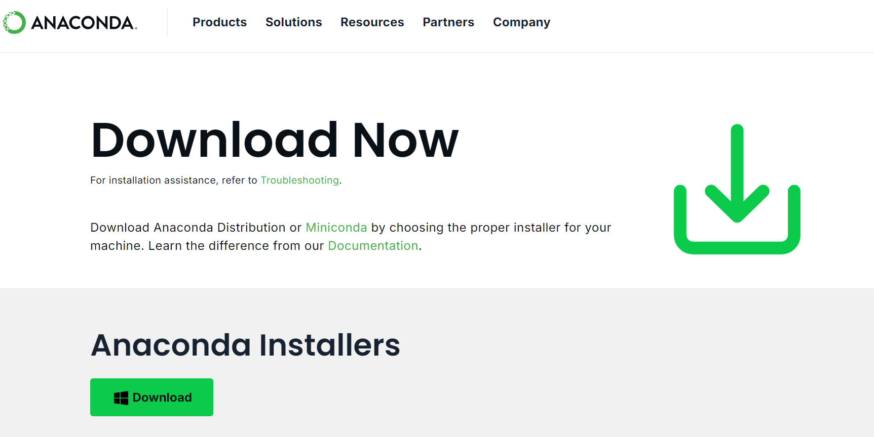

## Data

We will integrate the regional data into the program and retrieve the gathered data from Excel using the third-party library "pandas".

## Run

If you are familiar with PyCharm, you can import the directory as a project into the IDE. Within the IDE, you will have a clear view of the project structure. After making modifications to the code related to file reading paths, you can execute the program file following the experimental process.

## Result

After the program has completed its execution, all results can be found in the "/result" directory. It is essential to rely on your expertise to adjust the file names or modify the directory for ensuring accurate selection of results.

## Others

During the running process, changes in model or algorithm parameters may lead to bias in the final optimization result. Therefore, it may be necessary to conduct multiple experiments on model parameters for comparison.