**Homework 8. Selection of a Sample Design**

**MSDS 6370**

**Due 3/12 or 3/13 2018**

*A custom shoe manufacturer wants to track its shipping costs of shoes each business day. Each shipment can be classified into intrastate, interstate, and international categories. It would be too time consuming to track each shipping cost every day so the manufacturer decides to take a sample of two days a month of shipping costs in the three categories. The sample design randomly picks two days out of twenty business days each month and records the total number of shipments in each category.*

***Ex1****: Match each of the following sampling concepts with its realization type in this application. Note not all the items in the realization column may have corresponding concepts. Enter your answers in the table below:*

|  |  |
| --- | --- |
| **Concept Number** | **Concept** |
| 1 | Population |
| 2 | Cluster |
| 3 | Sampling frame |
| 4 | Parameter of interest |
| 5 | Sample design |

|  |  |
| --- | --- |
| **Realization** | **Corresponding Concept Number** |
| All working days in a month | 3 |
| All shipments in a month | 1 |
| All shipments in day | 2 |
| Stratified sample | 5 |
| Cluster sample | 5 |
| Proportional sample | 5 |
| Standard deviation | 4 |
| Mean | 4 |

***Ex2****: The manufacturer found it was too costly to examine all shipments on the selected days, so it decided to randomly sample the shipments. Two sampling designs were considered.*

Design A: Randomly sample 2 working days per month. Select every 10th shipment (by time sent ) on each day, after selecting one of the first 10 randomly.

Design B: Randomly sample 2 working days per month. Randomly select 100 shipments sent on each day.

*For each design, answer the following questions.*

*1. What is the probability of selection for an order in a month with 20 working days if 500*

*shipments occur each day?*

Design A: $π_{A}=\left(\frac{n_{working days}}{N_{working days}}\right)\left(\frac{n_{cluster}}{N_{cluster}}\right)\left(\frac{n_{shipment}}{N_{shipments}}\right)=\left(\frac{2}{20}\right)\left(\frac{10}{50}\right)\left(\frac{1}{10}\right)=\frac{1}{500}$

Design B: $π_{B}=\left(\frac{n_{working days}}{N_{working days}}\right)\left(\frac{n_{shipment}}{N_{shipments}}\right)=\left(\frac{2}{20}\right)\left(\frac{100}{500}\right)=\frac{1}{50}$

*2. What is the weight for an order in a month with 20 working days if 500 shipments occur each day?*

Design A: $w_{A}=\frac{1}{π_{A}}=500$

Design B: $w_{B}=\frac{1}{π_{B}}=50$

*3. Is each design an EPSEM (equal probability of selection) design? Why or why not?*

Yes, the first design is a two-stage design where the first stage days are randomly sampled. The second stage is sampled systematically which is still considered EPSEM because the probability within each cluster of 10 has the same probability of selection. The second design is a two-stage design where the first stage days are randomly sampled and of those days, shipments are randomly sampled. The consistency of SRS design makes it EPSEM.

***Ex3****: Because of staffing limitations, the manufacturer decides it will randomly select 2 out of 20 days a month and randomly sample 100 shipments on the first day selected and 50 shipments on the second day. The manufacturer knows that the cost of each category of shipment is as show in the table below:*

|  |  |
| --- | --- |
| **Type of Shipment** | **Cost per Shipment** |
| Intrastate | $20 |
| Interstate | $25 |
| International | $50 |

*If the total number of shipments on the first day sampled is 508 and 516 on the second day, answer the following questions:*

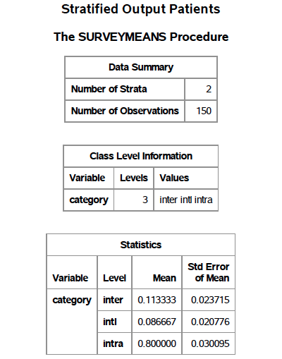

*1. What is a population estimate for the mean cost of a shipment based on the sample information given in the file hw8Data.xlsx? (Hint: Use sample strata proportions as estimates of population proportions.)*

$$\overline{c}=\sum{c_{i}{\overline{p}}_{i}}=\left(0.113333∙\$25\right)+\left(0.086667∙\$50\right)+\left(0.8∙\$20\right)=\$23.17$$

*2. What is a population estimate for the total daily costs using the shipments in the two days sampled?*

$${\overline{C}}_{day avg.}={\overline{N}}_{avg.}∙\overline{c}=\frac{508+516}{2}∙\$23.17=\$11,863.04$$