

Computer Games Development CW208
TDD
Year IV

Jack Nulty
C00273123

11/05/2025

Extermination Protocol Technical Design Document
Architecture Overview:
The project was developed in C++ using the SFML graphics library. No other external libraries were used to build the game. I used Visual Studio 2022 as my IDE to build the game.
The architecture of the game follows an object-oriented design to make objects reusable and have a plug and play type experience. For the gameplay this is managed by a central Game class which runs the main loop for the gameplay scene. Players also interact with polymorphic systems such as the Weapon class and the Enemy class for modular behaviours.
UML Diagram:
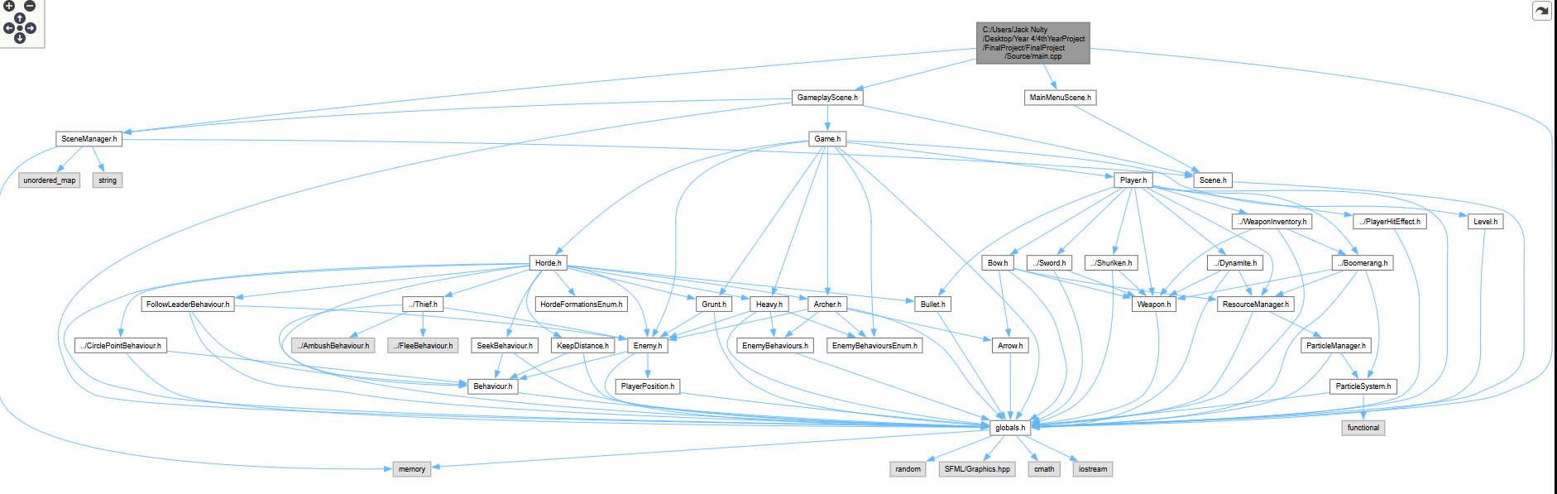

Classes:
I will explain the main classes in the game and the important functions that these classes carry.
Game:
The game controls the main game loop in the gameplay scene and is the main interface for the game. It handles window updates and delegates out the logic to other classes by calling all of their update, fixedUpdate and render calls.
handleEvents()- Handles events like moving to the previous scene back to the menu on escape.
fixedUpdate()- Handles all updates that must be done at a 60fps timer as to not speed up or slow down depending on the speed of the hardware available on the machine that is being used to play the game.
update()- Handles all updates for the game that don’t rely on 60 fps updates.
render()- Creates the draw order and calls all render functions for the rest of the objects in the game scene and this order then decides what draws on top of what which can be a difference maker in terms of gameplay.
cameraUpdate()- updates the position of the cameraView based on the position of the player in the game world and also checks if the camera shake has been activated by the player being hit and then adds that effect to the camera if needed. It is done by adding an offset to the x and the y of the camera using a shakeMagnitude and then setting the centre based on this offset.

All collision functions – The collision functions such as handleBoomerangCollisions() work by at the beginning of the function the selected weapon is checked dynamically to only run the collision function for the weapon that is currently active to not have any unnecessary looping through the horde vector of enemies. This weapon check is done by dynamic casting the weapon type to a variable and then returning from the function if it is not the current selected weapon.
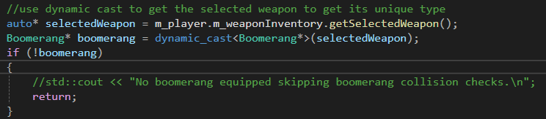
updateMap()- updateMap is used to update the tiles being drawn on screen at any given time, I do it in this way as I was having memory usage issues and lag issues when not done with the efficiency concerns considered. The way it is done is that I have a sf::VertexArray m_tileVertices to store all the points that need to be assigned and drawn on screen to make up the background. Then in the function I have a check to see if it is the firstRun of the game and if so, I need to set the type of VertexArray I will be using which is a sf::Quads to store the 4 vectors needed per tile. Then I calculate the points for the position and texture coordinates in the tileset I have given and then this is added to the VertexArray. I do this to then make sure I only have 1 draw function in the render function to decrease the number of draw calls in my game as they are a very expensive function.
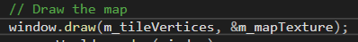
Player:
The player handles all aspects of player control, health and weapon management. The player class contains the weapon inventory and controls the switching and checking the events for firing and attacking. It also controls the animations for the player character and UI overlays for health as well as the effects when hit.
Update() – updates the variables and functions that once again do not require the 60fps update speed such as the UI position of the lives in the top left of the screen and runs through all weapons and updates them and runs the handleWeaponSwitch function.
fixedUpdate() – runs all functions that need to be set to 60fps such as the playerAnimations and the playerMovement.
render() – this render function handles all needed rendering for the player after the RenderWindow has been passed in from the Game class by reference, the things rendered are objects such as the m_hitEffects and the m_playerSprite
removeLife() – this function removes a life from the player and also runs off a cooldown and creates a new hit effect to show the player they have taken a hit and also activates a bool isShaking to being the screen shake effect.
playerMovement() – uses sf::Keyboard events to check if the correct keys have been pressed and update movement based on which key is pressed by using sf::move to move the sprite by a m_speed and deltaTime.
playerAnimations() – updates player animations by updating the textureRect of the player sprite using my spritesheet by calculating the size of the sprite using a counter for the number of frames per each animation and the size of the frame.
handleWeaponSwitch() – updates the current weapon by tracking a sf::Keyboard event once again to then set the newWeaponIndex to a number 0-4 and that then sets the weaponInventory selectedWeapon variable to the newWeaponIndex number.
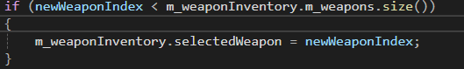
updateHitEffects() – goes through the vector of PlayerHitEffect objects and update it and then if it comes back as finished erase the effect from the vector.
initWeaponInventory() – initialise all weapons to the m_weaponInventory as unique pointers.
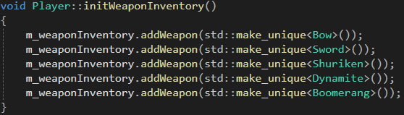

Weapon Inventory system:
The weapon inventory system handles the change and storage of an array of abstract base weapon types so here I will cover both the WeaponInventory and base Weapon class. I will also mention any important or technical parts of certain weapons as Each subclass implements attack logic, cooldowns, and special effects.
WeaponInventory:
addWeapon() – adds a weapon that is passed through into this function like addWeapon(std::make_unique<Bow>()) and then checks if the inventory is full and if not a new weapon is pushed back to the vector of type weapon
render() – the render function for this class does slightly more as each of the inventory slots are updated here to be drawn all in a line and draw the specific icon sprite for each weapon onto the box in the inventory. This is where the check for the boomerang is as there was a mismatch in size for the sprite causing some graphical errors which are sorting by checking a dynamic cast to draw the boomerang icon sprite slightly smaller.
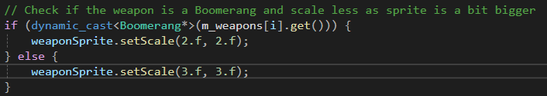
I also use this function to highlight the selected box by drawing a sf::RectangleShape outline around the slot sprites.
Weapon:
Update() – virtual update function
fixedUpdate() – virtual fixed update function for 60fps cap
render() – virtual render function
fire() – virtual fire function to allow each weapon to have a unique attack
setActive() – sets the weapon as active used as a utility to help the weaponInventory.
Unique fire() for each weapon:
Bow:
Fire() – gets a direction based on the player position and the mouse position then creates an object of type Arrow to be added to a vector to then be moved by the arrow’s update function which moves the arrow in the given direction vector that is calculated by the player pos and mouse pos, there is also a trail effect used that is created by the fire effect.
RotateAroundPlayer() – the bow also rotates around the player by once again using the direction vector and calculating the magnitude of the of the direction and getting the angle of this and setting the rotation of the bow sprite to give a visual representation of the way the player is aiming.
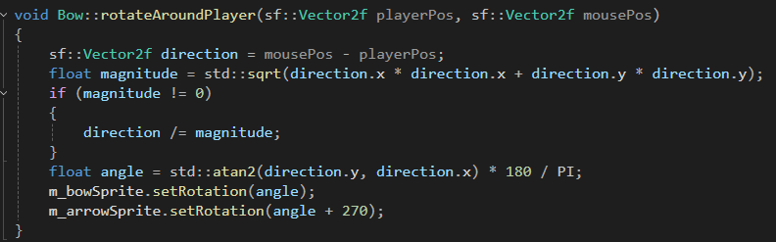
Shuriken:
Fire() – the shuriken unique fire function involves the object being fired in the direction of the mouse again but has a unique feature where it can ricochet across multiple enemies so this weapon must keep track of how many enemies it has ricocheted off. This is done in the ricochet function where it tracks the hitCount and then using this and a cooldown it creates a new direction to go to and then sends the weapon in that direction.
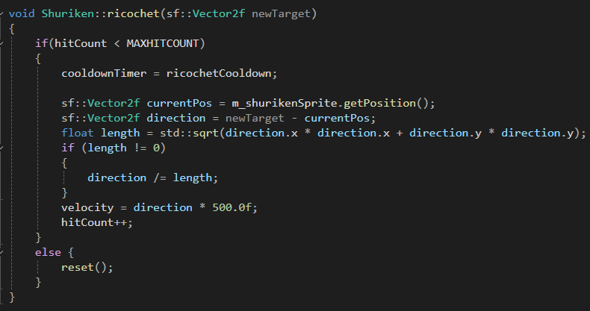
Dymanite:
Fire() – the dynamite fire function is different from the others not in the way it is shot by the player but by the way the distance that it goes is effected by how far away the mouse is from the player using a clampedLength to give it a more dynamic feel. Drag is also applied to the dynamite so that it stops in place to being its explosion. The explosion spawns a sf::circleShape that is responsible for giving visual aid for the player to see the explosion radius as it expands from the point that the dynamite explosion goes off. One of my particle systems is also created to enhance the effect.
Boomerang:
Fire() – boomerang fire acts the same again where the boomerang is sent in the direction of the mouse and I make use of a bool for isFlying to check if the boomerang is in the air then there is an updated for when it moves too far away it begins to move back towards the player this is done by taking the current position of the boomerang and then using the same functionality then getting a direction vector to then normalise and send in the direction of the player rather than the mouse. There is also a trail effect present that is updated using my particle system and manager.
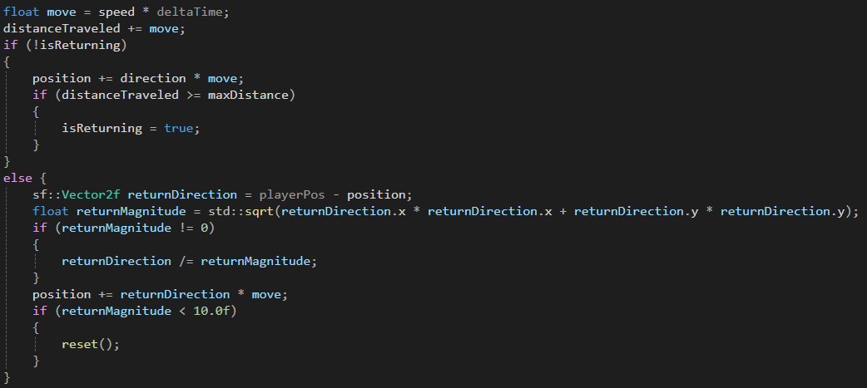

Horde and Enemy Systems:
The horde class manages the spawning, formation and lifecycle of enemies. Enemies are grouped under horde instances and include all 4 types of enemies Archer, Heavy, Grunt and Thief. There are multiple formation types such as Wall, Grid, Circle, Cluster and Claw. There is dynamic leadership among the enemies in each horde that is updated upon the death of the current leader.
Horde:
Update() – runs update functions for all enemies in the horde
fixedUpdate() – responsible for after 5 seconds for each horde to updated the fixed update for all enemies in the horde. The fixed update is also responsible for checking each of the bool values that check what formation is active and then depending on of the enemies are in the positions for that horde or not make sure the correct behaviour is assigned a behaviour by dynamic casting a behaviour and if it is the right behaviour set the target for that behaviour and else it is to create a new behaviour and setting the new behaviour to that enemy.
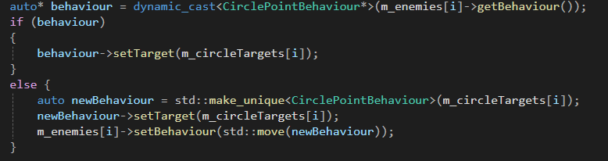
It also checks if the horde is in place then it updates the behaviour of the enemies to the new behaviour. It also runs all the main update functions for each of these formations.
render() – calls all enemy render functions
generateFormation()- runs a the beginning of the game to generate the points of each enemy in the horde by creating a vector of points spread out in a way that is dynamic depending on the size of the enemy.
separation() – checks all enemies in the horde against each other to make sure they are not colliding or overlapping and creating a force that pushes enemies away from each other to stop the look of static enemies. I do this by looping through all the enemies and checking they are not colliding and then check to make sure its not checking itself and then get the vector and distance between the current enemy and get the separation force of them, then I normalise the separation force of each enemy and multiply it and then add the separation force to each enemies velocity.
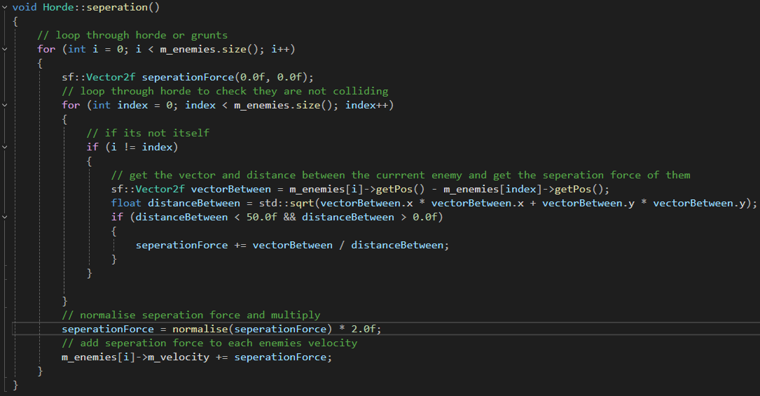
assignLeader() – loops through all enemies to update the leader when the current leader dies as the new leader is assigned as the front of the enemy vector. There is also checks for if the enemy type is a thief a different behaviour is assigned as the thief using the ambush and flee behaviour set to give a different experience to the player. The enemies that are not the leader are then assigned the FollowLeaderBehaviour to give the feel of a group attack rather than a horde of individual enemies.
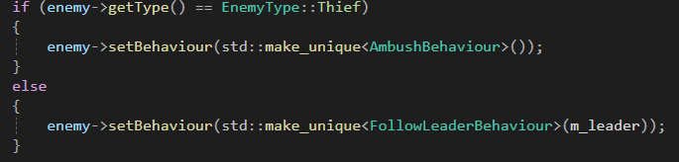
update formation types – I will do a deep dive into each formation update as they are major parts of my game. There is an enum class for each behaviour to manage the states of each beahviour so each of these functions is designed as a mini state-machine to handle each state of the enemy horde formation.
UpdateCircleFormation() –
The purpose of this function is to form a circle around the player. There is multiple states that are managed ClosingIn, Idle and MovingToPositions. If the horde is only MovingToPositions then the circleTargets are recalculated every frame based on the number of enemies, radius of the wanted circle and the position of the player. When the enemies are in position and ClosingIn is active then the points are recalculated to shrink towards the player using linear interpolation with deltaTime and shrinkSpeed and also the positioning of the points is calculated equally using angleDivider = 2PI / count and the position is calculated using polar to Cartesian conversion.
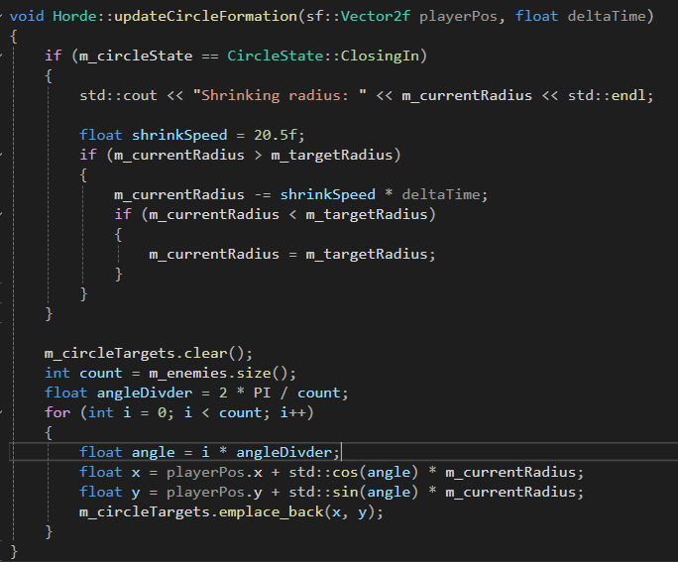
updateConvergingFormation() –
The purpose of this function is to move enemies into cluster formations and then transition the enemies to engage the player. The states that are managed are MovingToClusters and Engaging. When in the MovingToClusters the function creates 3 clusters of points evenly in a circle around the player with enemies distributed evenly through all the points and each enemy has a random offset in each cluster to avoid overlap. This is done by using the main cluster point as a centre point and then randomly assigning an offset to each other point depending on how many enemies in the cluster which is 1/3rd usually.
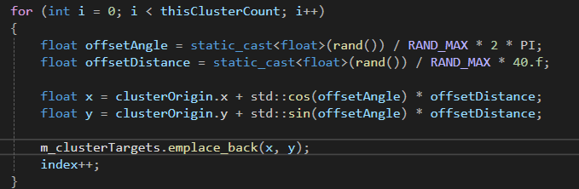
Once the enemies have seeked to the points in the cluster using the CirclePointBehaviour that I am reusing for all point searching in formations then the state moves to the Engaging state to move the cluster points towards the player so the player can be attacked from all sides. This is done by for each cluster point create a target vector then using the playerPos I can set the behaviour target to this point and using a shrinkSpeed again I can move it closer to the player. I then check if the player has moved to far away from the clusters then they move back to their leader behaviour types to begin to chase down the player again. This is done by checking the distance between the player and the closest cluster and if that distance is greater than 200 then the player has moved too far away and the fallback behaviours are activated for the whole horde.
UpdateWallFormation() –
The purpose of this function is to align enemies into a horizontal wall formation relative to the player position and then move towards the player position before moving into a circle formation when close enough to the player. The 2 states that are managed in this are the MovingToWall and EngagingWall states. While in the MovingToWall state the enemies are set to move to the wall points which are calculated by first checking which side left or right is closest to the player and then fill a vector of points along a horizontal line. These points are recalculated every frame relative to the players position and once the enemies reach their points they move to the EngagingWall state and this is when the wall points are all moved closer to the player the same way the other formation points are moved by uniform linear motion rather than linear interpolation. Once the wall is within a 100 distance of the player the wall then moves into the circle state and a circle begins to form around the player the wall handles the first point of this change to limit the jitter of enemies when moving to the circle so in the wall I calculate the first point of the circle and assign a new radius and set the circleFormation back to true.
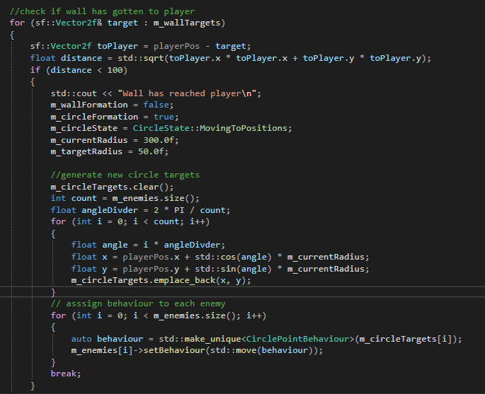
updateClawFormation() –
The purpose of this function is to position enemies into a claw or pincer-style formation that surrounds the player from both sides, creating a flanking threat. This function handles two states: MovingToClaw and EngagingClaw. In the MovingToClaw state, enemies are divided into two groups (left and right), and target positions are generated using coordinates to form two arcs, one on each side of the player. The left arc uses angles from PI to 2PI, and the right arc uses mirrored angles in the negative direction, with positions spaced evenly along those arcs using trigonometric functions.
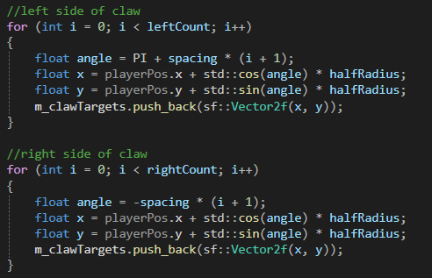
These points are recalculated every frame relative to the players current position. Once the claw positions are established, the system transitions to the EngagingClaw state, where each claw point moves toward the player using uniform linear motion—this means each point moves at a constant speed in the direction of the player, rather than using classic linear interpolation. If the player moves too far (300 units) from the closest claw target during this state, the formation is broken, and enemies move back to their leader behaviour types to begin to chase down the player again. Thief enemies go into ambush mode, the leader switches to seeking, and all others follow the leader.
Enemy Types:
Enemy:
Attack() – virtual function where each enemy has a unique attack
setBehaviour() – takes in a std::unique_ptr<Behaviour> newBehaviour to set as the new behaviour for the enemy
Grunt:
Derived from the abstract enemy class and is the most simple of the 4 enemy types it is a basic AI with no ranged attacks and the behaviour logic is purely dictated by the external behaviour classes that is assigned to it. Has animations for movement and death that are calculated from a sprite sheet for the enemy.
Heavy:
The heavy is a tank like enemy and the only enemy with a health value that is self-managed as it is higher than 1 so the dealDamage() function doesn’t just kill it, it can also trigger a damage animation. The Heavy also has a attack state to swing a hammer down on the player to deal damage and uses checkPlayerPosition to determine direction of the animation. All movement behaviours are also managed by the external behaviour classes as I wanted a behaviour tree like effect that is solely managed by the base enemy class by assigning behaviours to each enemy as a horde and not managing them internally on the enemy types.
Archer:
The archer is the ranged enemy of my enemy selection. The archer attacks by firing arrows towards the player when the canAttack() returns true. The archer also maintains an internal vector of arrows m_arrowVector to store the arrows for each archer and each of these active arrows are updated every frame by the archer. These arrows are instantiated in the shootArrow() function, and the MAX_ARROWS caps the number of arrows for each archer.
Archers also rely on the external enemy behaviour assigned to it by the horde.
Thief:
The thief is the most in depth enemy type as it is a fast ambush type enemy that uses adaptive behaviours by fleeing after attacking and ambushing the player. With the behaviour switching the thief starts aggressive with the Ambush behaviour and running up and attacking the player from behind and then after completing the attack animation it switches to the FleeBehaviour and flees 1000 units away from the player before returning for another attack run.
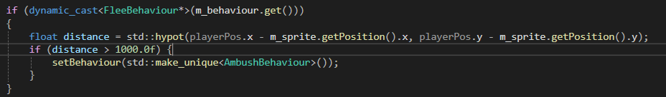
Behaviours:
Each of these behaviours can be assigned to any enemy using the setBehaviour(std::unique_ptr<Behaviour> newBehaviour) function. All AI behaviours inherit from the Behaviour interface. Each behaviour overrides update(Enemy&, sf::Vector2f) and updates the enemy’s m_velocity to produce intelligent movement based on the player’s position and game logic. Behaviours are designed to be modular and swappable.
Ambush Behaviour:
This behaviour positions enemies behind the players direction of attention based on the mouse position to simulate the dynamic ambush of the player. It does this by capturing the direction from the player to the mouse and then normalise this vector behind the player and then make the enemy approach this position by applying velocity to the enemy.
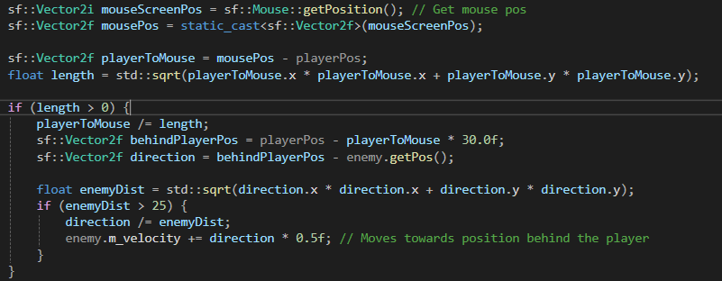
Circle Point Behaviour:
This directs enemies to a given target point (is named poorly due to originally being used for only the hordes circle formation and then reused as more formations were added). This keeps the enemies in a tactical pattern and is mainly used for the formation of formations in the horde. It works by targeting a given point and then calculating a normalised direction towards the target and adds velocity to the enemy.
Flee Behaviour:
Allows enemies to escape from the player after an attack is made and works by calculating direction from the player to the enemy and then normalising it and applying velocity to rapidly move the enemy away from the player and if the enemy is too close to the player this does not happen to avoid erratic / jittery behaviour.
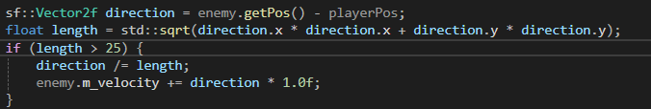
Follow Leader Behaviour:
This causes an enemy to follow another enemy that is assigned to be the leader at a loose distance to keep the enemies as a group. This is done by setting the enemy to move towards the leaders position and increase the velocity scaled a bit lower to facilitate a gentler trailing behind the leader enemy.
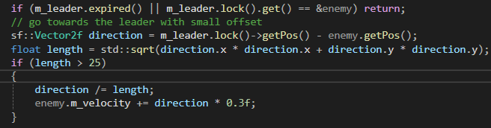

Keep Distance Behaviour:
This behaviour allows enemies to maintain a 200 unit distance from the player and creates a balance between attacking and fleeing. This is done by checking the distance to the player and depending on how close to the player less than 200 units means that it moves away with velocity += 0.5f * direction and if it is more than 200 units away it moves closer with velocity -= 0.5f * direction. When it is at the optimal distance the velocity is then dampened to keep the enemy in place.
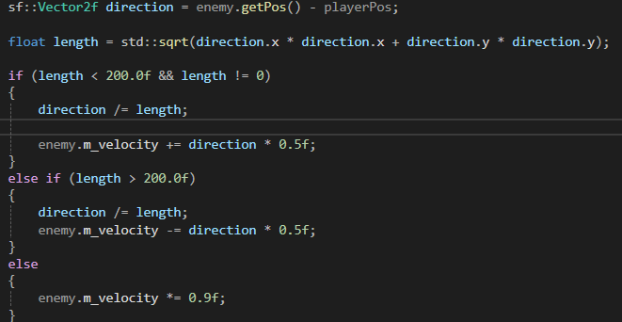
Seek Behaviour:
This is the most aggressive pursuit of the player that an enemy can do which directly moves the enemy towards the player. This is done by getting a vector to the player and then normalising and applying the velocity.

Particle System:
The particle system is a runtime-managed system built to store and manage particles to be dynamically rendered in the game environment. It is designed to be highly configurable for performance and per-effect customisation using ownership-based registry using my ResourceManager to globally access the singleton instance ParticleManager which means this is integrated into gameplay fluidly as all classes and objects can create particle effects.
The system is made of 2 major components ParticleSystem and ParticleManager. The ParticleSystem handles rendering the particles and choosing the correct emission type whereas the ParticleManager is responsible for being the centralised system for spawning, updating and destroying all ParticleSystem instances.
Particle System:
This encapsulates all logic for emitting, updating and rendering particles.
Update() – the update function for the particle system handles subtracting time from each particles lifetime, moving particles using velocity, removing dead particles, emitting new particles based on the emission mode and deactivates systems if no particles remain before they are deleted in the ParticleManager.
emitParticles() – This is responsible for emitting m_maxparticles number of particles while using the specific m_id of the system to apply angle, velocity, jitter and size variation with the current supported ids being grunt_hit, arrow_trail_, dynamite_explosion and boomerang_trail. There is also a check for if the current id supports constant emission like the boomerang_trail effect.
Render() – this draws all sf::CircleShape particles
Conifigure() – sets the dynamic parameters for each system
The ParticleSystem also contains a lightweight structure for representing a single particle that is used to build up the particle systems.
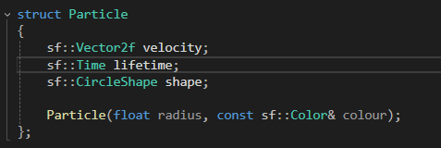
Particle Manager:
The particle manager manages the lifecycle of all active particle systems in the game. It does this by maintaining a registry of active systems.
It also handles preventing duplication by using the id system and automatically destroying systems when they are inactive, it also provides access to systems using getParticleSystem.
addParticleSystem() – this function creates and registers a new system in the map and returns a shared pointer for configuration of the system.
Update() – this function iterates through all systems and updates them and removes inactive systems that are empty.
Render() – draws all active systems particles.
Due to the high computational cost of draw calls I have taken more performance considerations for the particle system such as auto cleanup of the systems as dead systems are removed each frame. There is also no heap churn as particle vectors are reused and shared pointers only control system ownership I also handle emission throttling to make sure particles are not created for trail effect every frame and are capped due to emissionCooldown.

Usage example:
Here is a usage example for creating a particle system to have an effect spawn when a grunt is hit by the player.
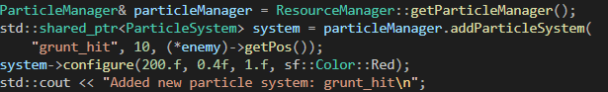
This is a very modular and configurable system that is used throughout the games codebase.

