Dev Blog 1 – 11/10/13 – It's About Time

Time to get this site rolling, I have been pushing it off for the pass two months. So to start it off I guess I should say a little about myself. My name is Jack Storm and I am studying Game Programming at Champlain College in Burlington, Vermont. Currently, I am taking Graphics I and working on the final. The purpose of the final is to demonstrate our understanding of what we have learned in the class. So we need to make a polished 2D game that shows off animation, depth, particles, and pixel shaders. Sounds simple enough.
My friends and I at ACPC Productions have been toying around with a simple idea for a game that boils down to two sides firing at each other with cannons through out different eras. I have decided for my final to take one of these eras and flesh it out. The result is Missile Drizzle: Wimbledon (Tentative Title). Take a tennis themed arena and put players with cannons in it. It is this project that I will be blogging about for the next couple of weeks. I will be doing all of the programming for this assignment and my friend, Brook Chipman, will be helping out with the art.

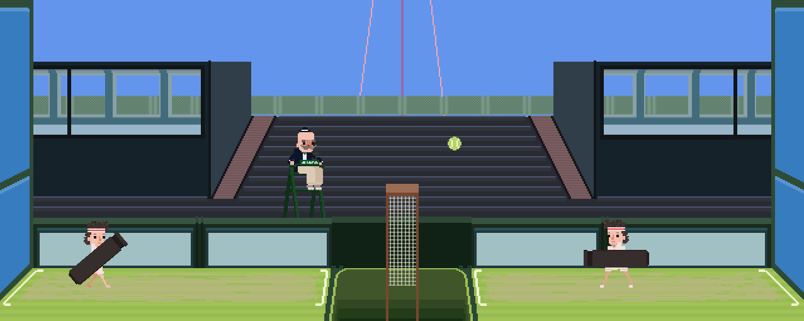
For the first week, we needed to provide a proof of concept, so a simple demo was made. Two players were added, each being able to move around, jump and fire their cannons.

Next Week: Recycling Particles and Bullet Manager

Dev Blog 2 – 11/10/13 – Technical Design and Milestone - Week 1

Hello everyone,
Normally I would not post a blog post so soon, but my blog posts are slightly behind the current progress of my game. This post is an effort to update the progress of what I have accomplished for the first full week of the project.

In order to help all of us get a grasp on what we wished to accomplish for the rest of the semester, our professor had us create a simple Technical Design Document along with milestones of what we aim to accomplish for each week. The Technical Design Document itself had four sections along with the milestones tacked on at the end. The four sections consisted of Game Overview, Need to Implement, Extras, and Risk analysis.

The Game Overview section consists of a four quick points that describe the basis of the game:
- Fire Cannons at each other over a pit
- Themed after Tennis/Wimbledon
- Matches are best of seven rounds
- Rounds last up to one minute or until one side is defeated

The Need to implement section contains a list of components that need to be implement for the game to be considered “complete” for the final project:
- Dynamic Camera System that zooms based on player locations
- Refined particle system that recycles and has a capped limit
- Parallax Background Scrolling
- Sepia Film Grain Shader
- Bloom Shader on the explosions
- 2 Player Mode
- Content Editor
As stated in the previous blog post, the primary goal of this project is to show off our knowledge of Depth, Particles, Animation, and Pixel Shaders. My animation requirement is fulfilled by the player sprites that run around on the court. Depth in my game will be shown off by the parallax scrolling that will take place in the background. I hope to show off shaders by putting bloom on the explosions and adding a film-grainy sepia overlay that can be toggle on and off. The base game needs to have a 2 player mode.

Beyond the needed are stretch goals that, if I have time, I hope to implement:
- Changing the particle cap based on Xbox or PC
- Music and Sound
- Animated Particles
- 4 Player mode

Finally, before we get to the milestones, we have the Risk Analysis. This section I rate the components I need to implement based on either High Risk or Low Risk. Or how hard I think each section will be for me.
- Dynamic Camera – High Risk
- Recycling Particle System – Low Risk
- Bullet Class Manager – Low Risk
- Sepia Filter – Low Risk
- Multipass Shader – High Risk
- Film Grain and Bloom - High Risk
- 2 Player Mode - Low Risk
- Parallax Background – Low Risk
Sections labeled with low risk are concepts that I have a good idea on how to implement. Sections labeled High Risk are sections where I little to no idea on how to do it. It will require some research for me to implement them correctly.

Milestones:
For Week 1, which lasted from October 30th to November 6th, my goal was to have four main things accomplished. First, I need to get my InputManager class to be able to work for multiple players. Second, I needed to refine the original particle system that I had made earlier this semester so that it recycles particles and set a cap on the number of effects and particles generated. Third, I started working on a bullet manager class, which similar to the new particle system, recycles the bullets/cannon balls. Fourth and final, make a blog post.

The Input Manager goal was accomplished by having multiple instances of the class running. When an instance of the class is created, a PlayerIndex is passed in, so that each instance of InputManager is associated with a player. Ideally, the controls and InputManager works best on gamepads for multiplayer, but I was able to configure the class so the players also have keyboard input.

The particle system and the bullet manager I have group together, since the main goal for this week was to have them recycle particles and bullets respectively. Originally, the particle system I had would create a brand new effect when the addEffect(0 function was called. This would create the effect and have it start updating each frame for a set amount of time. One of the problems with this was when effect needed particles to generate the desired effect, it had to create new ones each time. This puts a toll on the processor, since each update it needs to allocate memory for the new particle. The way around this is generating all the particles needed at the beginning of the game, and recycle them as needed. I went about it was creating an array of particles that the effects could draw upon. When the effect needs a particle it searches through the array for one that is “dead” and configures it for the effect. The effects themselves are also reused now in a similar way with an array.

As for the Bullet Manager class, there is an array that stores the maximum number of bullets allowed onscreen, as well as references to the player locations. When the player presses the action button, the fire event in the manger is called. This takes into account which player hit the fire button and pulls a bullet from the array, setting the correct velocity for the bullet. If the bullet is active the manager calls the update and draw functions.

Next Week: Basic Camera and Parallax

DevBlog 3 11/16/13 Matrix Camera and Parallax

