**Final Report Content**

* Initial Design (Ibrahim)
* Revised Design (Jack)
* Features and brief implementation (including 3rd party libraries/tools used)
  + Overall language, IDE used, framework (Jack)
  + Dev Phase 1 (Jack)
  + Dev Phase 2 (Matthew)
  + Dev Phase 3 (Ibrahim)
* Use one or more of the testing methods of the UCD methodology to evaluate the usability of your application. In particular, consider how it supports the **use case(s)** you’ve determined in Assignment 2.
  + Diagnostic Evaluation (Matthew)
  + Subjective Evaluation (Matthew)

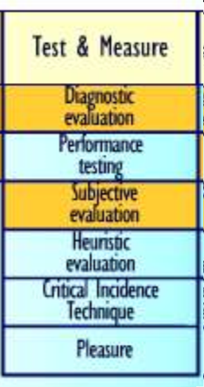

Diagnostic Evaluation- user-based evaluation of a working Human-Computer Interface.

Subjective Evaluation- focus user evaluation on user's feelings.

See the **Usability_Methods.pdf** in this folder for more info.