CSC406 Project Final Report

Carson-Newman University

**Live Weather Dashboard and SMS Feed**

Submitted by

Jack O'Hare

jmohare@cn.edu

Computer Science

Class Instructor: SeongYong Hong

**Table of Contents**

|  |  |
| --- | --- |
| Abstract……………………………………………………………………………………... | 3 |
| Introduction…………………………………………………………………………………..  Panel 1………………………………………………………………………………………..  Panel 2………………………………………………………………………………………..  Panel 3………………………………………………………………………………………..  Panel 4……………………………………………………………………………………….. | 4  4  6  8  10 |
| Results……….....…….………………………………………………………………………  Final Thoughts...…….……………………………………………………………………….  Citations.....…….……………………………………………………………….........………. | 12  13  14 |
|  |  |
|  |  |
|  |  |
|  |  |
|  |  |
|  |  |

**Abstract**

The purpose of this project is to give a group of users customized alerts to allow them to make informed decisions regarding the current weather conditions. A user will be able to decern if the weather conditions are too extreme outside and also modify these parameters to suit their needs as well. It is important to be constantly aware of the weather outside and by using this application an individual can gain knowledge using the dashboard from a pc and then add their number to be alerted if conditions turn bad

**Keywords:** Java, Weather

**Introduction.**

The program created is separated into 4 different sections to allow a user to make decisions on different aspects of their weather needs. A user can add phone numbers to the first panel, view active weather in the second panel, change SMS weather alert parameters on the third, and enable these alerts on the 4th. This was performed using a mix of different APIs and the java development platform to ensure portability on any windows device.

**Panel 1**

As seen in figure 1, a user can enter in their phone information and choose the numbers to text. The reason this was designed this way was to offer users the ability to add several numbers to the list to text in case they are in a group or a setting where multiple people need to be notified. This information when added is stored into a text file in which phone numbers can be pulled from to be displayed on the application giving the user an awareness of who they are actually texting.

**Figure 1: Panel 1 of Weather Application**

This was performed by the use of the library swing in Java. Swing is a graphical user interface that allows for several types of input methods and images to be displayed. In figure two this data is sent into the file then it is cleared from the text box to allow for more numbers to be inputted and also has a check to make sure that phone numbers are currently inputted with 10 numbers exclusively.A screenshot of a computer program

**Figure 2: Saving phone numbers from user**

**Panel 2**

In this panel, users are given a feed of current weather in the chosen area they have selected. A user is given a graphic of their current weather conditions, humidity, temperature, total precipitation, and wind speed. This combination allows a user to make guided choices due to how the current weather looks.

**Figure 3: Panel 2 from Weather Application**

In this section, weather information is pulled from a library called OpenWeatherMap. This library allows the user to gain knowledge of current weather conditions in specific areas by making calls to the website which will return data to be parsed from a Json file. This process allows us to make calls every hour to get a constant update of current weather conditions.

**Figure 4: OpenWeatherMap Data Requests**

**Panel 3**

Once a user has created a list of phone numbers to text, a user will just have to add the parameters they want to be notified on. A user can be notified of multiple subjects such as a minimum and maximum temperature, wind speed, precipitation, and natural disasters such as tornados. The benefit of using this type of panel is that users can receive customized results of weather in their area and may want to get an earlier sign of events happening so having the ability to set when an alert will occur can be extremely helpful for a user.

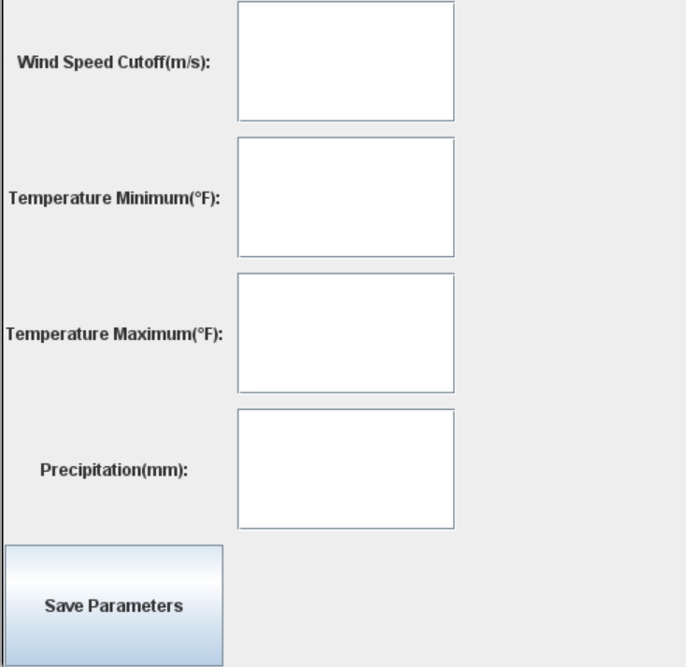

**Figure 5: Panel 3 of Weather Application**

These parameters then perform a list and prepare a message to be sent to the users. In figure 6, it is possible to see how each parameter is checked and if it returns true that alert is included on the list of events to be aware of. If a user disliked these settings they can always change them and improve to how they would like to see it

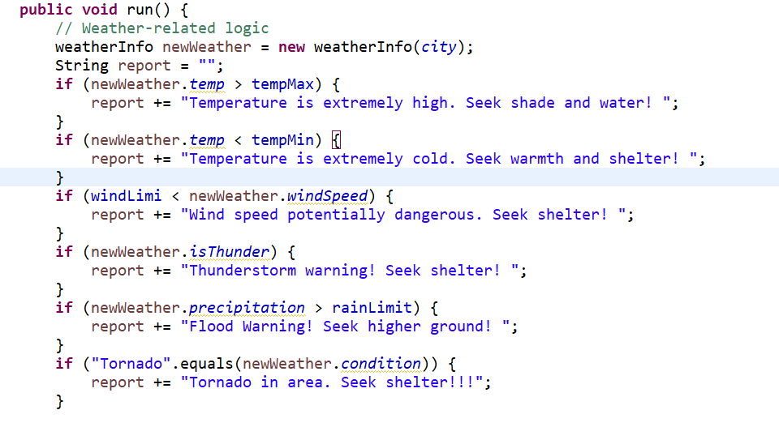**Figure 6: Message Creation Rules**

**Panel 4**

A user will then be tasked with turning on the actual SMS alert system. This is left as switch for the user to turn off and on as they like so they are not disturbed during hours they do not feel they need it such as sleeping. This was performed through the use of the messaging system Twilio which can be implemented into Java. Twilio gives us the ability to send texts to phone numbers using a predefined phone number to represent the system. It will broadcast any alerts every hour and allow a user to stay vigilant whenever they like.

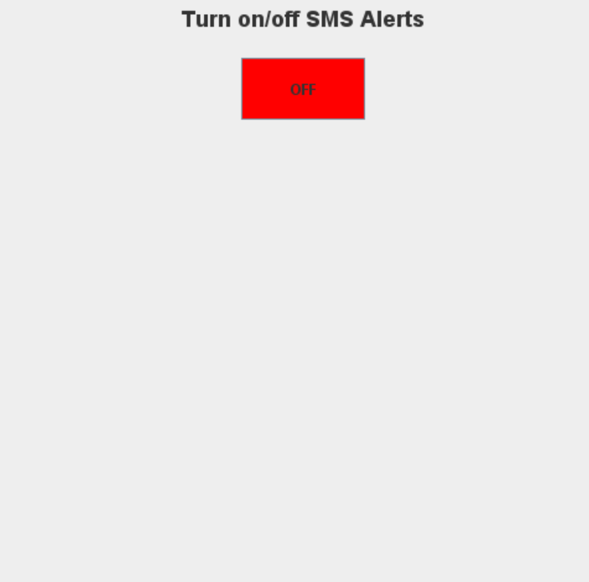

**Figure 7: Panel 4 of Weather Application**

**Figure 8: Phone Number Receipt from Alert**

**Results**

This program results in a system that allows users to see current weather conditions on their computer and also keep these notifications on the go to receive alerts when the conditions break out of the user defined alerts. With this system, a user is given complete control over their weather needs through its 4-panel based GUI.

**Figure 9: Complete Weather Alert System**

**Final Thoughts**

I believe with this project I was able to successfully make a system that was able to cover the needs of people who are looking for a weather alert system to send them SMS texts about inclement weather. I had a lot of challenges in this project I needed to fix and learning about different systems and libraries has helped improve my Java skills. GUI in java can be challenging to grasp at first and is where I spent a lot of time on this project cementing. I believe however, with the UI created and using the libraries to get weather and send alerts, this program came out in a great state to do its task.

**Citations**

OpenWeather. Weather API - OpenWeatherMap. OpenWeather, <https://openweathermap.org>. Accessed 18 Nov. 2024.

"Introduction to Java Swing." GeeksforGeeks, <https://www.geeksforgeeks.org/introduction-to-java-swing>. Accessed 18 Nov. 2024.

"Parse JSON in Java." GeeksforGeeks, <https://www.geeksforgeeks.org/parse-json-java>. Accessed 18 Nov. 2024.

Twilio. Twilio Documentation. Twilio, <https://www.twilio.com/docs>. Accessed 18 Nov. 2024.

"Java Util Timer Class in Java." GeeksforGeeks, <https://www.geeksforgeeks.org/java-util-timer-class-java/>. Accessed 18 Nov. 2024.