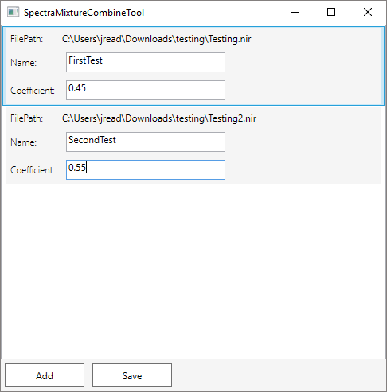

**2**

**3**

**1**

1. Click add to choose .nir files to you wish to combine
2. Constituents will appear in list box. Type in name of constituent and the weighting coefficient for this constituent in the mixture.
3. Click save. Type the name you wish your file to be saved as and save in the location you want to save it in. Program will output a .jcm file and a .txt file. The jcm can be imported into WINISI and the .txt file contains the constituents and coefficients which can then be imported in WINISI.