**Experiment2**

1.编写一个Java类和一个JSP页面，把下列信息封装到3个Student对象里，再把每一个对象放到一个ArrayList对象里，再利用ArrayList对象在JSP页面的表格中显示所示的信息，如图2-23所示。

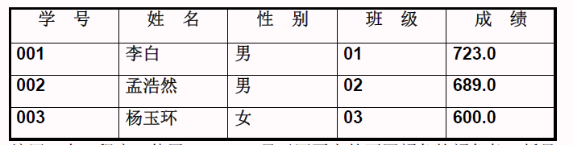

图2-23 JSP页面显示信息

//student实体

**package** com.cslg.entity;  
  
**import** java.io.Serializable;  
  
*/**  
 * 学生实体类  
 */***public class** Student **implements** Serializable {  
 **private** String **num**;  
 **private** String **name**;  
 **private** String **gender**;  
 **private** String **studentClass**;  
 **private** Double **score**;  
  
 **public** Student(String num, String name, String gender, String studentClass, Double score) {  
 **this**.**num** = num;  
 **this**.**name** = name;  
 **this**.**gender** = gender;  
 **this**.**studentClass** = studentClass;  
 **this**.**score** = score;  
 }  
  
 **public** String getNum() {  
 **return num**;  
 }  
  
 **public void** setNum(String num) {  
 **this**.**num** = num;  
 }  
  
 **public** String getName() {  
 **return name**;  
 }  
  
 **public void** setName(String name) {  
 **this**.**name** = name;  
 }  
  
 **public** String getGender() {  
 **return gender**;  
 }  
  
 **public void** setGender(String gender) {  
 **this**.**gender** = gender;  
 }  
  
 **public** String getStudentClass() {  
 **return studentClass**;  
 }  
  
 **public void** setStudentClass(String studentClass) {  
 **this**.**studentClass** = studentClass;  
 }  
  
 **public** Double getScore() {  
 **return score**;  
 }  
  
 **public void** setScore(Double score) {  
 **this**.**score** = score;  
 }  
}

//Student.jsp

<%@ **page import**="**com.cslg.entity.Student**" %>  
<%@ **page import**="**java.util.ArrayList**" %>  
<%@ **page import**="**java.util.List**" %>*<%--  
 Created by IntelliJ IDEA.  
 User: Jack  
 Date: 2019/9/6  
 Time: 11:20  
 To change this template use File | Settings | File Templates.  
--%>*<%@ **page contentType**="**text/html;charset=UTF-8**" **language**="**java**" %>  
<**html**>  
<**head**>  
 <**title**>学生信息表</**title**>  
</**head**>  
<**body**>  
 **<%** List<Student> studentList= **new** ArrayList<Student>();  
 studentList.add(**new** Student(**"001"**,**"李白"**,**"男"**,**"01"**,723.0));  
 studentList.add(**new** Student(**"002"**,**"孟浩然"**,**"男"**,**"02"**,689.0));  
 studentList.add(**new** Student(**"003"**,**"杨玉华"**,**"女"**,**"03"**,600.0));  
 **%>** <**table width="400" border="1pc" cellspacing="0" cellpadding="0" align="center"**>  
 <**caption**>学生信息表</**caption**>  
 <**tr**>  
 <**td**>学号</**td**>  
 <**td**>姓名</**td**>  
 <**td**>性别</**td**>  
 <**td**>班级</**td**>  
 <**td**>成绩</**td**>  
 </**tr**>  
 **<%  
 for**(**int** i=0;i<studentList.size();i++){  
 Student student= studentList.get(i);  
 **%>** <**tr**>  
 <**td**>  
 **<%=**student.getNum() **%>** </**td**>  
 <**td**>  
 **<%=**student.getName() **%>** </**td**>  
 <**td**>  
 **<%=**student.getGender()**%>** </**td**>  
 <**td**>  
 **<%=**student.getStudentClass() **%>** </**td**>  
 <**td**>  
 **<%=**student.getScore()**%>** </**td**>  
 </**tr**>  
 **<%** }  
 **%>** </**table**>  
</**body**>  
</**html**>

运行结果：

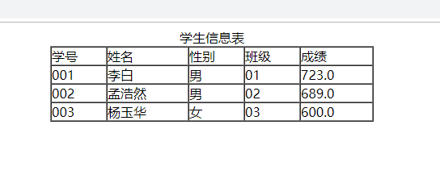

2.编写一个JSP程序，使用JSP Script显示网页上如下颜色的颜色条：绿色、蓝绿色、黑色、红色、黄色以及粉红色（对应的颜色为：Green、Cyan、Blank、Red、Yellow、Pink）。

//color.jsp

*<%--  
 Created by IntelliJ IDEA.  
 User: Jack  
 Date: 2019/9/12  
 Time: 16:57  
 To change this template use File | Settings | File Templates.  
--%>*<%@ **page contentType**="**text/html;charset=UTF-8**" **language**="**java**" %>  
<**html**>  
<**head**>  
 <**title**>颜色</**title**>  
</**head**>  
<**body**>  
 <**hr color="green"**>  
 <**hr color="cyan"**>  
 <**hr color="blank"**>  
 <**hr color="red"**>  
 <**hr color="yellow"**>  
 <**hr color="pink"**>  
</**body**>  
</**html**>

运行结果：



3.编写两个文档，一个是JSP文档命名为myJsp.jsp，另一个是普通的HTML文档，命名为myPhoto.html。

要求：在myPhoto.html插入自己的照片，在myJsp.jsp中嵌入<jsp:include>操作指令，当在浏览器中运行myJsp.jsp时能够将myPhoto.html中的照片显示出来。

//myPhoto.PNG

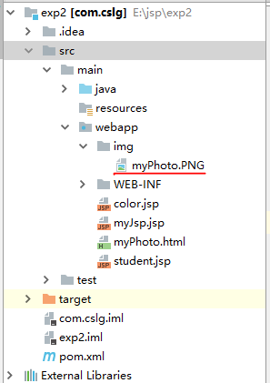

//myPhoto.html

<!DOCTYPE **html**>  
<**html lang="en"**>  
<**head**>  
 <**meta charset="UTF-8"**>  
 <**title**>我的照片</**title**>  
</**head**>  
<**body**>  
 <**img src="./img/myPhoto.PNG"**>  
</**body**>  
</**html**>

//myJsp.jsp

*<%--  
 Created by IntelliJ IDEA.  
 User: Jack  
 Date: 2019/9/12  
 Time: 17:05  
 To change this template use File | Settings | File Templates.  
--%>*<%@ **page contentType**="**text/html;charset=UTF-8**" **language**="**java**" %>  
<**html**>  
<**head**>  
 <**title**>myJsp</**title**>  
</**head**>  
<**body**>  
 <**h3**>我的照片</**h3**>  
 <**jsp:include page="myPhoto.html"**></**jsp:include**>  
</**body**>  
</**html**>

运行结果：

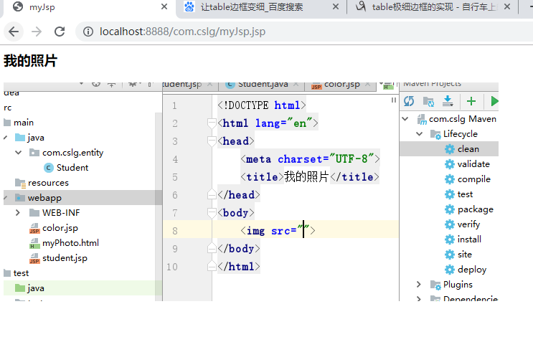

4. 编写一个JSP页面，实现根据一个人的18位身份证显示出生日的功能来，要求把表达式声明和Scriptlet全部用到，并把结果显示在表格中，如表3-2所示。

表3-2 页面上要显示的信息

|  |  |
| --- | --- |
| 身份证 | 生日 |
| 010020199601026929 | 1996-01-02 |
| 010020199711126928 | 1997-11-12 |

//cardId实体类

**package** com.cslg.entity;  
  
**public class** CardId {  
 **private** String **cardId**;  
 **private** String **birthday**;  
  
 **public** CardId(String cardId) {  
 **this**.**cardId** = cardId;  
 **this**.**birthday** = cardId.substring(6,10)+**"-"**+cardId.substring(10,12)+**"-"**+cardId.substring(12,14);  
 }  
  
 **public** String getCardId() {  
 **return cardId**;  
 }  
  
 **public void** setCardId(String cardId) {  
 **this**.**cardId** = cardId;  
 }  
  
 **public** String getBirthday() {  
 **return birthday**;  
 }  
  
 **public void** setBirthday(String birthday) {  
 **this**.**birthday** = birthday;  
 }  
}

//cardId.jsp

<%@ **page import**="**java.util.ArrayList**" %>  
<%@ **page import**="**com.cslg.entity.CardId**" %>  
<%@ **page import**="**java.util.List**" %>  
<%@ **page import**="**static sun.misc.MessageUtils.out**" %>*<%--  
 Created by IntelliJ IDEA.  
 User: Jack  
 Date: 2019/9/12  
 Time: 17:34  
 To change this template use File | Settings | File Templates.  
--%>*<%@ **page contentType**="**text/html;charset=UTF-8**" **language**="**java**" %>  
<**html**>  
<**head**>  
 <**title**>身份证-生日表</**title**>  
</**head**>  
<**body**>  
 **<%** List<CardId> cardIdList= **new** ArrayList<CardId>();  
 cardIdList.add(**new** CardId(**"010020199601026929"**));  
 cardIdList.add(**new** CardId(**"01002019971112692"**));  
 cardIdList.add(**new** CardId(**"010020199711126929"**));  
 **%>** <**table align="center" width="500px" border="1px" cellpadding="0" cellspacing="0"**>  
 <**tr**>  
 <**td**>身份证</**td**>  
 <**td**>生日</**td**>  
 </**tr**>  
 **<%  
 for**(**int** i=0;i<cardIdList.size();i++){  
 CardId cardId = cardIdList.get(i);  
 **if** (cardId.getCardId().length()!=18)  
 *//如果有身份证不等于18位则跳过此数据* **continue**;  
 **%>** <**tr**>  
 <**td**>  
 **<%=** cardId.getCardId()**%>** </**td**>  
 <**td**>  
 **<%=** cardId.getBirthday()**%>** </**td**>  
 </**tr**>  
 **<%** }  
 **%>** </**table**>  
</**body**>  
</**html**>

运行结果：

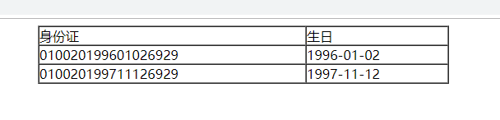

1. 编写一个JSP页面，利用Scriptlet编写一段计算代码，要求用0做除数，并使用page指令将该错误信息显示在另一个JSP页面上，产生的错误信息为“错误，不能用0做除数！”。

//Divided.jsp

*<%--  
 Created by IntelliJ IDEA.  
 User: Jack  
 Date: 2019/9/12  
 Time: 18:15  
 To change this template use File | Settings | File Templates.  
--%>*<%@ **page contentType**="**text/html;charset=UTF-8**" **language**="**java**" **errorPage**="**error.jsp**" %>  
<**html**>  
<**head**>  
 <**title**>除</**title**>  
</**head**>  
<**body**>  
 **<%  
 int** a=3/0;  
 **%>**</**body**>  
</**html**>

//Error,jsp

*<%--  
 Created by IntelliJ IDEA.  
 User: Jack  
 Date: 2019/9/12  
 Time: 18:15  
 To change this template use File | Settings | File Templates.  
--%>*<%@ **page contentType**="**text/html;charset=UTF-8**" **language**="**java**" %>  
<**html**>  
<**head**>  
 <**title**>error</**title**>  
</**head**>  
<**body**>  
 <**h3**>错误，不能用0做除数！不能用0做除数！</**h3**>  
</**body**>  
</**html**>

运行结果：

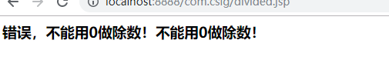

1. 网站的注册，图4-6注册信息登记页面，单击注册显示图4-7注册成功页面

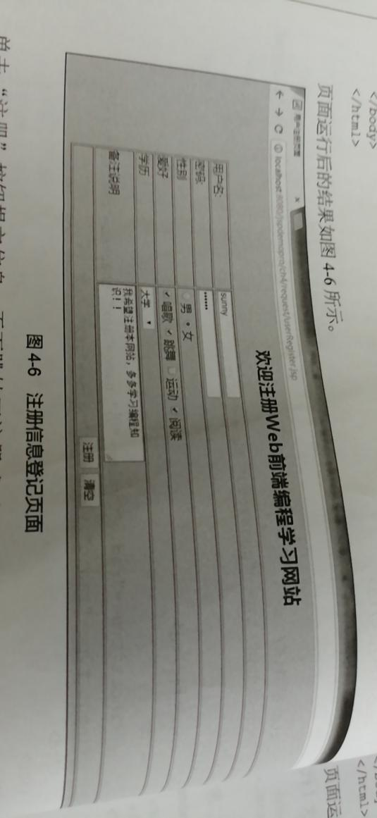

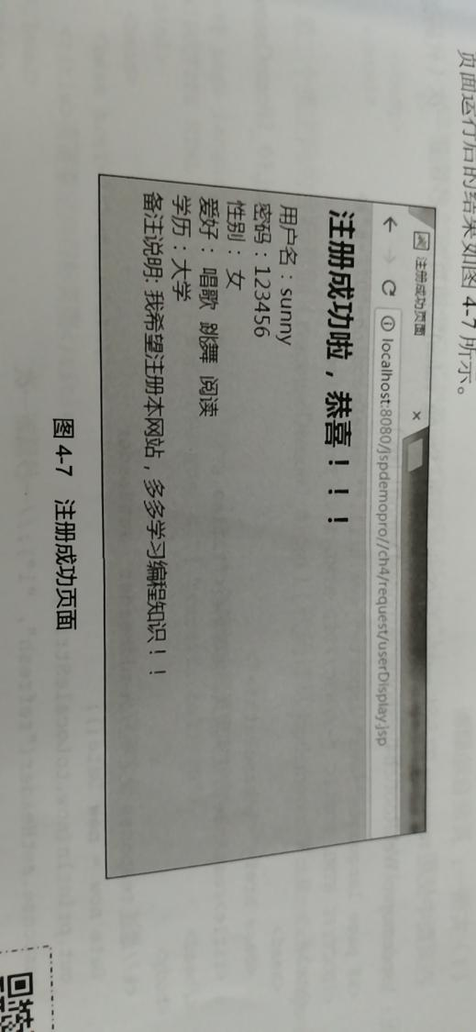

//register.jsp

*<%--  
 Created by IntelliJ IDEA.  
 User: Jack  
 Date: 2019/9/12  
 Time: 19:19  
 To change this template use File | Settings | File Templates.  
--%>*<%@ **page contentType**="**text/html;charset=UTF-8**" **language**="**java**" %>  
<**html**>  
<**head**>  
 <**title**>用户注册</**title**>  
</**head**>  
<**body**>  
 <**h2 align="center"**>欢迎注册Web前端编程学习网站</**h2**>  
 <**div align="center"**>  
 <**form action="registerInfo.jsp" method="post"**>  
 <**table width="400px" border="1px"**>  
 <**tr**>  
 <**td**>用户名</**td**>  
 <**td**><**input name="name" id="aaa"**></**td**>  
 </**tr**>  
 <**tr**>  
 <**td**>密码</**td**>  
 <**td**><**input type="password" name="password"**></**td**>  
 </**tr**>  
 <**tr**>  
 <**td**>性别</**td**>  
 <**td**>  
 <**input type="radio" value="男" name="gender"**>男**&nbsp;&nbsp;** <**input type="radio" value="女" name="gender"**>女  
 </**td**>  
 </**tr**>  
 <**tr**>  
 <**td**>爱好</**td**>  
 <**td**>  
 <**input type="checkbox" value="唱歌" name="hobby"**>唱歌  
 <**input type="checkbox" value="跳舞" name="hobby"**>跳舞  
 <**input type="checkbox" value="运动" name="hobby"**>运动  
 <**input type="checkbox" value="阅读" name="hobby"**>阅读  
 </**td**>  
 </**tr**>  
 <**tr**>  
 <**td**>学历</**td**>  
 <**td**>  
 <**select name="xueli"**>  
 <**option value=""**>--请选择--</**option**>  
 <**option value="专科以下"**>专科以下</**option**>  
 <**option value="专科"**>专科</**option**>  
 <**option value="本科"**>本科</**option**>  
 <**option value="硕士"**>硕士</**option**>  
 <**option value="博士"**>博士</**option**>  
 </**select**>  
 </**td**>  
 </**tr**>  
 <**tr**>  
 <**td**>备注说明</**td**>  
 <**td**>  
 <**textarea name="advice"**></**textarea**>  
 </**td**>  
 </**tr**>  
 <**tr align="center"**>  
 <**td colspan="2"**>  
 <**input type="submit"**>**&nbsp;&nbsp;** <**input type="reset"**>  
 </**td**>  
 </**tr**>  
 </**table**>  
 </**form**>  
 </**div**>  
</**body**>  
</**html**>

//registerInfo.jsp

*<%--  
 Created by IntelliJ IDEA.  
 User: Jack  
 Date: 2019/9/12  
 Time: 19:25  
 To change this template use File | Settings | File Templates.  
--%>*<%@ **page contentType**="**text/html;charset=UTF-8**" **language**="**java**" %>  
<**html**>  
<**head**>  
 <**title**>注册信息</**title**>  
</**head**>  
<**body**>  
 <**h1**>注册成功啦，恭喜！！！</**h1**>  
 **<%** request.setCharacterEncoding(**"UTF-8"**);  
 **%>** 用户名：**<%=** request.getParameter(**"name"**)**%>**<**br**/>  
 密码：**<%=** request.getParameter(**"password"**)**%>**<**br**/>  
 性别：**<%=** request.getParameter(**"gender"**)**%>**<**br**/>  
 **<%** String [] hobbys=request.getParameterValues(**"hobby"**);**%>** 爱好：**<%  
 for**(**int** i=0;i<hobbys.**length**;i++){  
 String hobby=hobbys[i];  
 out.print(hobby);  
 **%>  
 &nbsp;&nbsp;  
 <%** }  
 **%>**<**br**/>  
 学历：**<%=** request.getParameter(**"xueli"**)**%>**<**br**/>  
 备注说明：**<%=** request.getParameter(**"advice"**)**%>**</**body**>  
</**html**>

运行结果：

