Global Header + Footer

Wireframe documentation prepared by Jack Reis

September 24, 2012

Table of Contents

1. Global Header 3

1.1. User Interface 3

1.2. Object Table 3

1.3. Searchbar 3

1.3.1. search_bar 3

1.3.1.1. User Interface 3

1.3.1.2. Object Table 3

2. TopNav 4

2.1. User Interface 4

2.2. Object Table 4

2.3. TopNav 5

2.3.1. Home 5

2.3.1.1. User Interface 5

2.3.1.2. Object Table 5

2.3.2. Shop 6

2.3.2.1. User Interface 6

2.3.2.2. Object Table 7

2.3.3. Explore 8

2.3.3.1. User Interface 8

2.3.3.2. Object Table 9

2.3.4. Blog 10

2.3.4.1. User Interface 10

2.3.4.2. Object Table 11

3. Global Footer 13

3.1. User Interface 13

3.2. Object Table 13

Global Header

* 1. User Interface

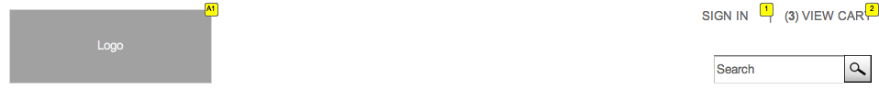

* 1. Object Table

|  |  |  |
| --- | --- | --- |
| Footnote | Label | Interactions |
| 1 |  | OnClick:  Case 1:  Takes user to sign-in page |
| 2 |  | OnClick:  Case 1:  Takes user to View Cart page |
| A1 |  | OnClick:  Case 1:  Takes User to Home Page |

* 1. Searchbar
     1. search_bar
        1. User Interface



* + - 1. Object Table

|  |  |  |
| --- | --- | --- |
| Footnote | Label | Interactions |
| 1 | Search | OnFocus:  Case 1  (If text on widget Search equals "Search"):  Set text on widget Search equal to ""  OnLostFocus:  Case 1  (If text on widget Search equals ""):  Set text on widget Search equal to "Search" |
| 3 | btn - MagnifyingGlass - Search | OnClick:  Case 1:  Searches for the query entered in the search box |

1. TopNav

OnPageLoad:  
 Home  
 (If value of variable TopNav equals "Home"):  
 Set TopNav state to Home  
 Shop  
 (If value of variable TopNav equals "Shop"):  
 Set TopNav state to Shop  
 Explore  
 (If value of variable TopNav equals "Explore"):  
 Set TopNav state to Explore  
 Blog  
 (If value of variable TopNav equals "Blog"):  
 Set TopNav state to Blog

* 1. User Interface

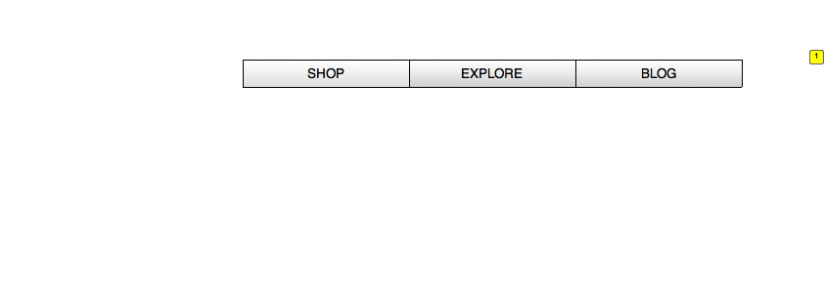

* 1. Object Table

|  |  |  |
| --- | --- | --- |
| Footnote | Label | Interactions |
| 1 | TopNav | OnPanelStateChange:  Home  (If value of variable TopNav equals "Home"):  Set TopNav state to Home  Shop  (If value of variable TopNav equals "Shop"):  Set TopNav state to Shop  Explore  (If value of variable TopNav equals "Explore"):  Set TopNav state to Explore  Blog  (If value of variable TopNav equals "Blog"):  Set TopNav state to Blog |

* 1. TopNav
     1. Home
        1. User Interface



Menu Object

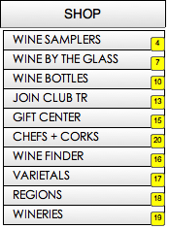 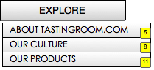 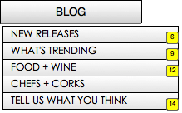

* + - 1. Object Table

|  |  |
| --- | --- |
| Footnote | Interactions |
| 1 | OnClick:  Case 1:  Set value of variable TopNav equal to "Shop"  Wait 250 ms  Open Shop in Current Window |
| 2 | OnClick:  Case 1:  Set value of variable TopNav equal to "Explore"  Set TopNav state to Explore  Wait 250 ms  Open Explore in Current Window |
| 3 | OnClick:  Case 1:  Set value of variable TopNav equal to "Blog"  Wait 250 ms  Open Blog in Current Window |
| 4 | OnClick:  Case 1:  Open Wine Samplers in Current Window |
| 5 | OnClick:  Case 1:  Open About TR.com in Current Window |
| 6 | OnClick:  Case 1:  Open New Releases in Current Window |
| 7 | OnClick:  Case 1:  Open Wine by the Glass in Current Window |
| 8 | OnClick:  Case 1:  Open Our Culture in Current Window |
| 9 | OnClick:  Case 1:  Open What's Trending in Current Window |
| 10 | OnClick:  Case 1:  Open Wine Bottles in Current Window |
| 11 | OnClick:  Case 1:  Open Our Products in Current Window |
| 12 | OnClick:  Case 1:  Open Food + Wine in Current Window |
| 13 | OnClick:  Case 1:  Open Join Club TR in Current Window |
| 14 | OnClick:  Case 1:  Open Tell us what you think in Current Window |
| 15 | OnClick:  Case 1:  Open Gift Center in Current Window |
| 16 | OnClick:  Case 1:  Open Wine Finder in Current Window |
| 17 | OnClick:  Case 1:  Open Varietals in Current Window |
| 18 | OnClick:  Case 1:  Open Regions in Current Window |
| 19 | OnClick:  Case 1:  Open Wineries in Current Window |
| 20 | OnClick:  Case 1:  Open Chefs + Corks in Current Window |

* + 1. Shop
       1. User Interface



Menu Object

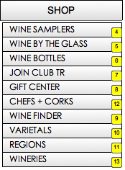 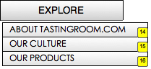 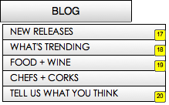

* + - 1. Object Table

|  |  |
| --- | --- |
| Footnote | Interactions |
| 1 | OnClick:  Case 1:  Set value of variable TopNav equal to "Shop"  Wait 250 ms  Open Shop in Current Window |
| 2 | OnClick:  Case 1:  Set value of variable TopNav equal to "Blog"  Wait 250 ms  Open Blog in Current Window |
| 3 | OnClick:  Case 1:  Set value of variable TopNav equal to "Explore"  Set TopNav state to Explore  Wait 250 ms  Open Explore in Current Window |
| 4 | OnClick:  Case 1:  Open Wine Samplers in Current Window |
| 5 | OnClick:  Case 1:  Open Wine by the Glass in Current Window |
| 6 | OnClick:  Case 1:  Open Wine Bottles in Current Window |
| 7 | OnClick:  Case 1:  Open Join Club TR in Current Window |
| 8 | OnClick:  Case 1:  Open Gift Center in Current Window |
| 9 | OnClick:  Case 1:  Open Wine Finder in Current Window |
| 10 | OnClick:  Case 1:  Open Varietals in Current Window |
| 11 | OnClick:  Case 1:  Open Regions in Current Window |
| 12 | OnClick:  Case 1:  Open Chefs + Corks in Current Window |
| 13 | OnClick:  Case 1:  Open Wineries in Current Window |
| 14 | OnClick:  Case 1:  Open About TR.com in Current Window |
| 15 | OnClick:  Case 1:  Open Our Culture in Current Window |
| 16 | OnClick:  Case 1:  Open Our Products in Current Window |
| 17 | OnClick:  Case 1:  Open New Releases in Current Window |
| 18 | OnClick:  Case 1:  Open What's Trending in Current Window |
| 19 | OnClick:  Case 1:  Open Food + Wine in Current Window |
| 20 | OnClick:  Case 1:  Open Tell us what you think in Current Window |

* + 1. Explore
       1. User Interface



Menu Object

  

* + - 1. Object Table

|  |  |
| --- | --- |
| Footnote | Interactions |
| 1 | OnClick:  Case 1:  Set value of variable TopNav equal to "Shop"  Wait 250 ms  Open Shop in Current Window |
| 2 | OnClick:  Case 1:  Set value of variable TopNav equal to "Blog"  Wait 250 ms  Open Blog in Current Window |
| 3 | OnClick:  Case 1:  Set value of variable TopNav equal to "Explore"  Set TopNav state to Explore  Wait 250 ms  Open Explore in Current Window |
| 4 | OnClick:  Case 1:  Open Wine Samplers in Current Window |
| 5 | OnClick:  Case 1:  Open Wine by the Glass in Current Window |
| 6 | OnClick:  Case 1:  Open Wine Bottles in Current Window |
| 7 | OnClick:  Case 1:  Open Join Club TR in Current Window |
| 8 | OnClick:  Case 1:  Open Gift Center in Current Window |
| 9 | OnClick:  Case 1:  Open Wine Finder in Current Window |
| 10 | OnClick:  Case 1:  Open Varietals in Current Window |
| 11 | OnClick:  Case 1:  Open Regions in Current Window |
| 12 | OnClick:  Case 1:  Open Chefs + Corks in Current Window |
| 13 | OnClick:  Case 1:  Open Wineries in Current Window |
| 14 | OnClick:  Case 1:  Open About TR.com in Current Window |
| 15 | OnClick:  Case 1:  Open Our Culture in Current Window |
| 16 | OnClick:  Case 1:  Open Our Products in Current Window |
| 17 | OnClick:  Case 1:  Open New Releases in Current Window |
| 18 | OnClick:  Case 1:  Open What's Trending in Current Window |
| 19 | OnClick:  Case 1:  Open Food + Wine in Current Window |
| 20 | OnClick:  Case 1:  Open Tell us what you think in Current Window |

* + 1. Blog
       1. User Interface



Menu Object

  

* + - 1. Object Table

|  |  |
| --- | --- |
| Footnote | Interactions |
| 1 | OnClick:  Case 1:  Set value of variable TopNav equal to "Shop"  Wait 250 ms  Open Shop in Current Window |
| 2 | OnClick:  Case 1:  Set value of variable TopNav equal to "Blog"  Wait 250 ms  Open Blog in Current Window |
| 3 | OnClick:  Case 1:  Set value of variable TopNav equal to "Explore"  Set TopNav state to Explore  Wait 250 ms  Open Explore in Current Window |
| 4 | OnClick:  Case 1:  Open Wine Samplers in Current Window |
| 5 | OnClick:  Case 1:  Open Wine by the Glass in Current Window |
| 6 | OnClick:  Case 1:  Open Wine Bottles in Current Window |
| 7 | OnClick:  Case 1:  Open Join Club TR in Current Window |
| 8 | OnClick:  Case 1:  Open Gift Center in Current Window |
| 9 | OnClick:  Case 1:  Open Wine Finder in Current Window |
| 10 | OnClick:  Case 1:  Open Varietals in Current Window |
| 11 | OnClick:  Case 1:  Open Regions in Current Window |
| 12 | OnClick:  Case 1:  Open Chefs + Corks in Current Window |
| 13 | OnClick:  Case 1:  Open Wineries in Current Window |
| 14 | OnClick:  Case 1:  Open About TR.com in Current Window |
| 15 | OnClick:  Case 1:  Open Our Culture in Current Window |
| 16 | OnClick:  Case 1:  Open Our Products in Current Window |
| 17 | OnClick:  Case 1:  Open New Releases in Current Window |
| 18 | OnClick:  Case 1:  Open What's Trending in Current Window |
| 19 | OnClick:  Case 1:  Open Food + Wine in Current Window |
| 20 | OnClick:  Case 1:  Open Tell us what you think in Current Window |

1. Global Footer
   1. User Interface

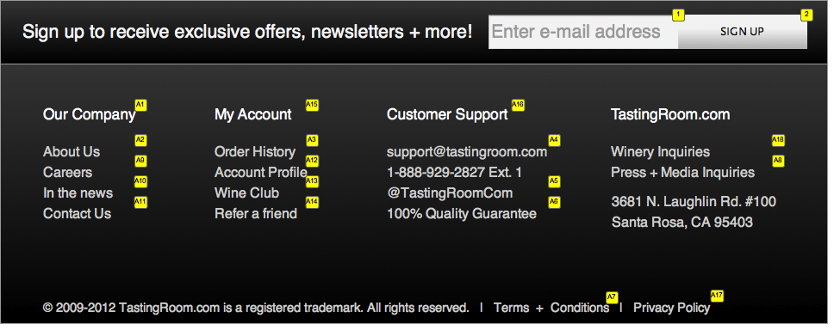

* 1. Object Table

|  |  |  |
| --- | --- | --- |
| Footnote | Label | Interactions |
| 1 | textfield | OnFocus:  clear and store label  (If text on widget label storage (ignore) equals ""):  Set text on widget label storage (ignore) equal to text on widget textfield, and  text on widget textfield equal to ""  OnLostFocus:  replace label  (If text on widget textfield equals ""):  Set text on widget textfield equal to text on widget label storage (ignore), and  text on widget label storage (ignore) equal to "" |
| 2 | btn - SignUp - GlobalFooter | OnClick:  Case 1:  Takes user to quick sign-up link with email address pre-populated |
| A1 |  | OnClick:  Case 1:  Links to page listed in text of footer item |
| A2 |  | OnClick:  Case 1:  Links to page listed in text of footer item |
| A3 |  | OnClick:  Case 1:  Links to page listed in text of footer item |
| A4 |  | OnClick:  Case 1:  Emails support@tastingroom.com (mailto link?) |
| A5 |  | OnClick:  Case 1:  Links to twitter page |
| A6 |  | OnClick:  Case 1:  Links to page listed in text of footer item |
| A7 |  | OnClick:  Case 1:  Links to page listed in text of footer item |
| A8 |  | OnClick:  Case 1:  Links to Press + Media Inquiries (Mailto to Press + Media alias?) |
| A9 |  | OnClick:  Case 1:  Links to page listed in text of footer item |
| A10 |  | OnClick:  Case 1:  Links to page listed in text of footer item |
| A11 |  | OnClick:  Case 1:  Links to page listed in text of footer item |
| A12 |  | OnClick:  Case 1:  Links to page listed in text of footer item |
| A13 |  | OnClick:  Case 1:  Links to page listed in text of footer item |
| A14 |  | OnClick:  Case 1:  Links to page listed in text of footer item |
| A15 |  | OnClick:  Case 1:  Links to page listed in text of footer item |
| A16 |  | OnClick:  Case 1:  Links to page listed in text of footer item… do we have a central Customer Support page? |
| A17 |  | OnClick:  Case 1:  Links to page listed in text of footer item |
| A18 |  | OnClick:  Case 1:  Links to Winery Inquiries (Winery.TastingRoom.com?) |