FSM CODE
`timescale 1ns / 1ps

module FSM(emerg_in, g_f,f_f,s_f,emerg_out,reset,clk,Disp_1,Disp_2);
input emerg_in, g_f,f_f,s_f,reset,clk;
output reg emerg_out;
//output reg [3:0] c_state;
output reg [3:0] Disp_1;
output reg [3:0] Disp_2;

always@(posedge clk)
begin
if(reset)
begin
//c_state <= 4'b0000;
//n_f <= 4'b0000;
emerg_out <= 0;
Disp_1 <= 4'b0000;
Disp_2 <= 4'b0000;
end
else
begin
if(emerg_in || emerg_out)
begin
emerg_out <= 1;
Disp_2 <= Disp_1;
end

else if (g_f && ~f_f && ~s_f)
begin
Disp_2 <= 4'b0000;
//c_state = Disp_2;
Disp_1 = Disp_2;
//c_state = Disp_2;
end
else if(~g_f && f_f && ~s_f)
begin
Disp_2 <= 4'b0001;
Disp_1 = Disp_2;
//c_state = Disp_2;
end
else if(~g_f && ~f_f && s_f)
begin
Disp_2 <= 4'b0010;
// c_state = Disp_2;
Disp_1 = Disp_2;
//c_state = Disp_2;
end
else
begin
Disp_1 = Disp_2;
end
end
end
endmodule

TEST BECHES
Good inputs
`timescale 1ns / 1ps

module tb_FSM();
reg emerg_in, g_f,f_f,s_f,reset,clk;
wire emerg_out;
wire [3:0] Disp_1;
wire [3:0] Disp_2;

FSM uut (.emerg_in(emerg_in), .g_f(g_f),.f_f(f_f),.s_f(s_f),.emerg_out(emerg_out),.reset(reset),.clk(clk),.Disp_1(Disp_1),.Disp_2(Disp_2));
initial begin//good inputs only
emerg_in = 0; g_f = 0; f_f = 0; s_f = 0; reset = 0; clk = 0;#10;
emerg_in = 0; g_f = 0; f_f = 0; s_f = 0; reset = 1; clk = 1;#10;
emerg_in = 0; g_f = 1; f_f = 0; s_f = 0; reset = 0; clk = 0;#10;
emerg_in = 0; g_f = 1; f_f = 0; s_f = 0; reset = 0; clk = 1;#10;
emerg_in = 0; g_f = 0; f_f = 0; s_f = 0; reset = 0; clk = 0;#10;
emerg_in = 0; g_f = 0; f_f = 0; s_f = 0; reset = 0; clk = 1;#10;
emerg_in = 0; g_f = 0; f_f = 1; s_f = 0; reset = 0; clk = 0;#10;
emerg_in = 0; g_f = 0; f_f = 1; s_f = 0; reset = 0; clk = 1;#10;
emerg_in = 0; g_f = 0; f_f = 0; s_f = 0; reset = 0; clk = 0;#10;
emerg_in = 0; g_f = 0; f_f = 0; s_f = 0; reset = 0; clk = 1;#10;
emerg_in = 0; g_f = 0; f_f = 0; s_f = 1; reset = 0; clk = 0;#10;
emerg_in = 0; g_f = 0; f_f = 0; s_f = 1; reset = 0; clk = 1;#10;
emerg_in = 0; g_f = 0; f_f = 0; s_f = 0; reset = 0; clk = 0;#10;
emerg_in = 0; g_f = 0; f_f = 0; s_f = 0; reset = 0; clk = 1;#10;
emerg_in = 0; g_f = 1; f_f = 0; s_f = 0; reset = 0; clk = 0;#10;
emerg_in = 0; g_f = 1; f_f = 0; s_f = 0; reset = 0; clk = 1;#10;
emerg_in = 0; g_f = 0; f_f = 0; s_f = 1; reset = 0; clk = 0;#10;
emerg_in = 0; g_f = 0; f_f = 0; s_f = 1; reset = 0; clk = 1;#10;
emerg_in = 0; g_f = 0; f_f = 0; s_f = 0; reset = 0; clk = 0;#10;
$finish;
end
endmodule
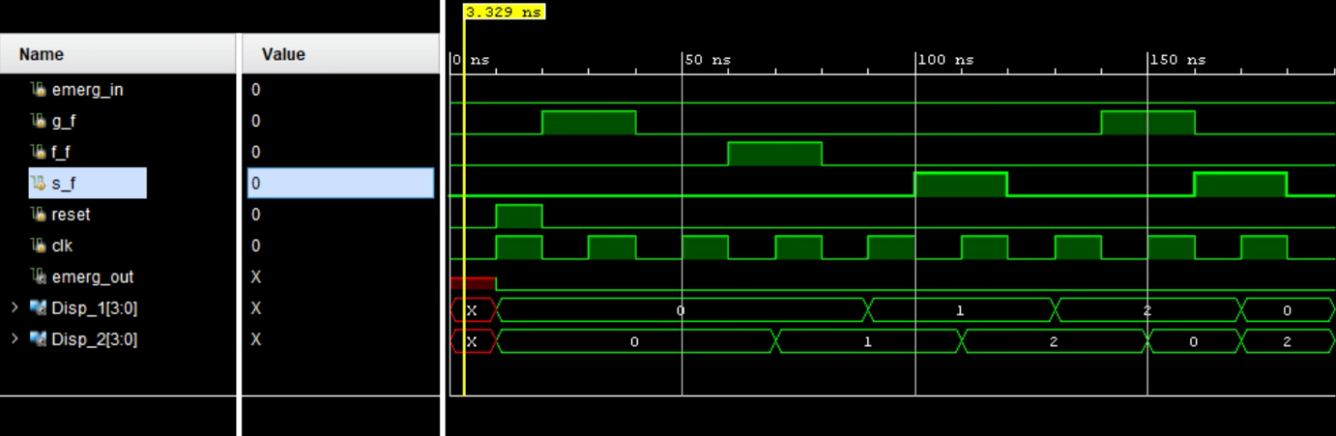
Bad/emergency outputs
`timescale 1ns / 1ps

module tb_FSM();
reg emerg_in, g_f,f_f,s_f,reset,clk;
wire emerg_out;
wire [3:0] Disp_1;
wire [3:0] Disp_2;

FSM uut (.emerg_in(emerg_in), .g_f(g_f),.f_f(f_f),.s_f(s_f),.emerg_out(emerg_out),.reset(reset),.clk(clk),.Disp_1(Disp_1),.Disp_2(Disp_2));
initial begin//bad/emerge inputs only
emerg_in = 0; g_f = 0; f_f = 0; s_f = 0; reset = 0; clk = 0;#10;
emerg_in = 0; g_f = 1; f_f = 1; s_f = 1; reset = 1; clk = 1;#10;
emerg_in = 0; g_f = 0; f_f = 1; s_f = 1; reset = 0; clk = 0;#10;
emerg_in = 0; g_f = 1; f_f = 0; s_f = 1; reset = 0; clk = 1;#10;
emerg_in = 0; g_f = 0; f_f = 0; s_f = 1; reset = 0; clk = 0;#10;
emerg_in = 0; g_f = 0; f_f = 0; s_f = 1; reset = 0; clk = 1;#10;
emerg_in = 0; g_f = 1; f_f = 1; s_f = 0; reset = 0; clk = 0;#10;
emerg_in = 0; g_f = 1; f_f = 1; s_f = 0; reset = 0; clk = 1;#10;
emerg_in = 0; g_f = 1; f_f = 1; s_f = 0; reset = 0; clk = 0;#10;
emerg_in = 1; g_f = 0; f_f = 0; s_f = 0; reset = 0; clk = 1;#10;
emerg_in = 0; g_f = 1; f_f = 0; s_f = 0; reset = 0; clk = 0;#10;
emerg_in = 0; g_f = 1; f_f = 0; s_f = 0; reset = 0; clk = 1;#10;
emerg_in = 0; g_f = 0; f_f = 1; s_f = 0; reset = 0; clk = 0;#10;
emerg_in = 0; g_f = 0; f_f = 1; s_f = 0; reset = 0; clk = 1;#10;
emerg_in = 0; g_f = 1; f_f = 0; s_f = 1; reset = 0; clk = 0;#10;
emerg_in = 0; g_f = 1; f_f = 0; s_f = 1; reset = 0; clk = 1;#10;
emerg_in = 0; g_f = 0; f_f = 0; s_f = 0; reset = 1; clk = 0;#10;
emerg_in = 0; g_f = 0; f_f = 0; s_f = 0; reset = 1; clk = 1;#10;
emerg_in = 0; g_f = 0; f_f = 0; s_f = 0; reset = 0; clk = 0;#10;
emerg_in = 0; g_f = 0; f_f = 1; s_f = 0; reset = 0; clk = 1;#10;
$finish;
end
endmodule
