# eretrwtwtwtAbstract:

An inventory management system is a computer based software for recording and tracking sales, orders and deliveries. It is used in most of the industries to create bill of orders, materials and other related documents. The user logins to the inventory system and processes the contents and information. It makes us clear that the data is managed by a particular database in inventory system and therefore it is a responsibility to manage data. It is the most important part of an organization or industries. This project is based on the research and comparison between two database system i.e. Oracle and Microsoft SQL. The investigation and research focuses on critically valuing the features and functionality of these two (DBMS) Database Management System, which finally helps to decide the most proper database amongst Oracle and MS SQL for the inventory system described above.

# Overview of the chapters:

* **Chapter 1 – Introduction:** This chapter describes the initial description about the project and the related fields. How the introduction of Information technology changed the traditional way of doing works. It provides justification, aim and objectives of the project and system.
* **Chapter 2 – Research:** It shows the research on database management systems (Oracle and MS SQL) and their technologies used in the inventory management system. It examines the differences and similarities amongst them, and their performance on the system.
* **Chapter 3 – Analysis:** This chapter contains the requirement of the system along with the use case diagrams. It shows the functional and non-functional requirements of an inventory system. The process of prioritization is done using MoSCow technique which is also covered in this section.
* **Chapter 4 –** **Design:** This chapter covers the activities involved in the designing of system. Different design approaches are shown and explained for their selection. It covers GUI design, Class diagram, Activity diagram etc.
* **Chapter 5 –** **Development & Implementation:** This chapter gives information about the programming language, database, platforms, other tools and technologies used during the advancement of system. It shows methodology used for the project development and issues during the implementation process. Implementation and errors are demonstrated in proper series of screenshots.
* **Chapter 6 –** **Testing & Results:** This chapter illustrates the result of the final system. It contains the result of various inputs and are shown in series of screenshots. It shows all kind of results performed on the system.
* **Chapter 7 –** **Conclusions and future works:** This section provides the overall conclusion of project. If it fulfilled the proposed objectives and aims which was supposed to be achieved.

# Chapter 1 – Introduction

## Background:

With the introduction of Information Technology it has influenced a broad grouping of people in their common traditions, institutions and collective activities. The development of information technology is improvement in traditional mechanism used to store, manipulate, distribute or create information. Now it has become an important aspect for every business processes and is used in almost every area: businesses, educational system, governmental operations, entertainments and many more. The use of ICT to access information plays a dominant role in the growth of industries today. The greatest impact of ICT is that it allows the people to get access to services that has accompanied the growth of the internet. (<http://article.sapub.org/10.5923.j.ac.20140401.07.html>)

This project shows the implementation of database like Oracle and MS SQL into an inventory system. It is also called as modern inventory system. Using this system comparison and similarities between two databases is shown. Todays computerized inventory management system enhances the business processes in many ways. It reduces the excess or incorrect Inventory: Due to the physical work in traditional systems, the worst case scenario was sometimes wrong product may be ordered which was not needed instead of those which was actually in demand. But computerized inventory management system keeps a track of demands as well as provides detail status of the inventory in warehouse. It was hard to maintain the customer satisfaction with no system to optimize the inventory in traditional ways, which leads to the loss of sales because of unavailability of definite products. Instead the computerized inventory management system bound to tracks all the customer buying habits and purchases then accordingly products can be ordered for the upcoming season. (<https://salvagespace.com/blog/moving-from-traditional-to-modern-inventory-systems/>)

## Justification:

Traditional method of using inventory is been for a long time but in today’s competitive industry most of the organization and businesses implement the use of computerized inventory management system. ICT technology is growing rapidly which creates another requirement to build the centralized online platform (IAAS – Infrastructure as a service) for better organized and more effective to what it’s been using already.

An inventory management system is used in controlling and overseeing of the storage, ordering and the components that company will use for the production of the item which it will sale or to save the records of the products which have been sold. Traditional inventory management system can get messy over time, it can be confusing to other users. Traditional could be suitable for a small sized business, where it is no problem if a sent message arrives late to the intended person. But this kind of performance is not very reliable and efficient for a large business. Paper work becomes messy and confusing as the business grows.

Though, computerized inventory management system, offers their user to store and manipulate the data electronically from anywhere. It is speed and efficient compared to the traditional system. Doing a hand count of inventory system can take several days but with a computerized inventory management system, same process can be done in couple of hours. Handwritten contents can be ambiguous, instead computer generated values are distinct and accurate to understand. It makes sure of delivering accurate value than traditional way. Which makes it more reliable than traditional inventory system. (<http://smallbusiness.chron.com/advantages-disadvantages-computerized-inventory-management-system-22513.html>)

It becomes more available to the users creating it more transparent and thus making more profit from the business and user satisfaction. Computerized inventory system always provide well organized data which helps organization to create better decision and other market strategy rather than focusing on physical structure. By focusing on actual business process it indirectly increases the ROI (Return on investment) along with aiding in detecting the weaknesses in the business flow. (<http://www.inboundlogistics.com/cms/article/top-five-ways-warehouse-management-systems-deliver-roi/>)

## Aim:

The aim of this project is to produce an inventory management system and implementing two different database for the comparison. It aims to produce a reliable, easy, efficient inventory management system for a company or organization tested on different database which helps user to decide on the selection of database (Oracle & MS SQL).

## Objectives:

Most of the objectives of this project are listed below:

* Documentation review: documentation provides a brief understanding of whole project. It is useful for future references.
* Analysis phase: This is the phase where we find all the requirements of the planned project. It is one of the essential part in the initiation of the project. It analyses the requirements and need of the user from the system. Requirements are usually captured by various techniques like questionnaires, interviews, facilitated workshops and many others.
* Design phase: It includes designing part like: GUI designing, architectural designing and designing of database.
* Implementation: This phase covers the coding of the system as well as development of the system.
* Testing: This is another important part of the project, which defines the end result of project. It checks whether system meet the proposed requirement or not.
* Finally evaluation of final product.

# Chapter 2 – Research:

Database is nothing but an organized collection of information that exists over a long period of time, often many years. It facilitates the system to find the information more efficiently and all of these data are managed by a DBMS. It consists of organized set of tables, schemas, records, views, indexes, metadata, log records, and many more other similar objects. In database each data is in relation in the table. ER (Entity Relationship) diagram helps to facilitate when designing the database, it is used to confirm the requirements and provide direction to design and architecture as we process with physical database design.

Database system has significantly changed over the progression of time. Ted Codd in 1970 of IBM's San Jose Research Laboratory proposed the relational database system which present the user with a view of data organized as tables called ***relations***. A relational database stores data in a set of simple relation. A relation is a set of tuples. This ability to use related data from table put it name to relational database. It simply stores and view the data in sequence of organized tables.

A relational database management system (RDMS) is used to organize data into related rows and columns. It assists in storing, retrieving, accessing and managing data. Various database are available in industries but RDMS is one of the dominating and mostly used DBMS. This project covers the comparison between these two RDMS (Oracle and MS SQL) to their details along with features nearly in all levels. And finally it helps us to decide upon the selection of database for the proposed system we are developing.

Both of the systems is concisely described below:

## Features:

### Oracle:

In 1977, Oracle database was originally created, and the current version of the oracle is the result of over 30 years of advanced development. Oracle database is the first commercially available RDMS. In 1979, Relational software, Inc. (RSI) introduced Oracle Version 2 which was SQL-based RDBMS, and available commercially for the first time. Which created the history of relational databases. Later version 3 of oracle was released in 1983, which was the first relational database capable to run on minicomputers, mainframes and PCs. The updated version of oracle enhanced the data distribution, scalability and concurrency control. The incremental development of oracle now brought it to the first position, which has a commercial license but is also available as a free version over the internet. We are using oracle 11g (released in 2007) in this project and it is available freely on the internet. But freely version has some restrictions over the commercial products. (<http://www.oracle.com/technetwork/issue-archive/2007/07-jul/o4730-090772.html>)

Features of Oracle 11g are shown in the list below:

One of the important feature of RDMS is that the logical data structure is not dependent on the physical data storage.

* Application Development: Oracle 11g comes with new feature of APIs and Precompilers. With this feature, scalability and performance of the oracle client-side stack is improved.
* Client-Side Query Cache: In this feature query result ever performed is saved in client’s memory as cache. Any changes on server side does not alter the saved cache. Using the cache service it avoid the time consumption of trip from the server to get the results, which results in less CPU power consumption.
* Application Express: This features provide application development tools which is installed and build in database. Like Drag and Drop Item Layout, Flash Charts etc.
* Globalization and Unicode: It includes more Unicode support and globalization features for Oracle Database.
* Java Integration: New JIT compiler is introduced which enhance the performance of Java runtime. Tooling and command-line interface makes it easy to understand.
* SQLJ and JDBC: SQLJ and JDBC APIs is enhanced with some new feature for developers. New support for advanced security and XA support.

## Oracle architecture:

Storing and retrieving of the data is main objective of the oracle database. It is a collection of data for a unit and is treated equally. Therefore a ***database server*** plays an important role in the information management. Database is accessed by a multi user at same time and it is where ***server*** plays a significant role by managing a large amount of data, which facilitate users to concurrently access the same data in same environment. Unauthorized access is also handled by the database server with some failure recovery solutions if any in need.

For grid computing the first database designed was by the oracle database management system. It is cheap and flexible way of organizing application and managing systems. Modular storage servers and other industry standards is a substantial pool of grid computing.

A database consists of both logical and physical view. Physical and logical structure are both separate, the logical storage structure is not affected by alteration of any kind of physical storage data. Physical data is such kind of data which can be viewable in Operating system while Logical data are tables created in a database.

***Client/Server*** and ***Multitier*** architecture are the two most common architecture:

## Client/Server Architecture:

In this type of architecture the database consists of two parts: front end which is also called as client end, and the back end which is also known as server end. It means database application and database are installed in different systems. It is a kind of computing environment where oracle database is connected to an application.

Client application requests for the operations and other processing power from the database server. All of the request are processed and managed by server. Such type of setup is also known as two-tier architecture. During the communication between client and server both system uses common communication protocol

Oracle software is installed on server-side computer. It responds to all the request made from the client-side computer in SQL (Structured Query Language) and PL/SQL statements. (<http://www.webopedia.com/TERM/C/client_server_architecture.html>)

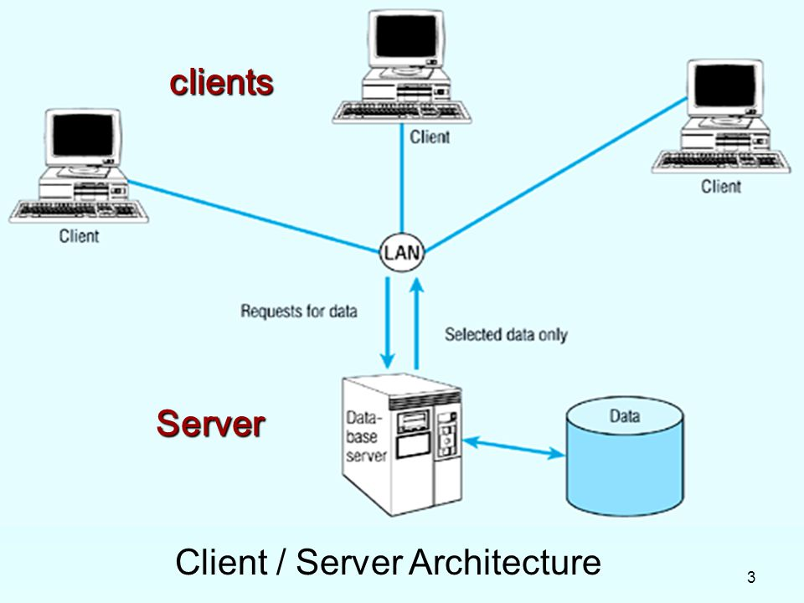

## Multitier architecture:

Clients are the always initiator of operation and database server stores data used in operations. But in multitier architecture, operation is performed by one or more than one application server. This architecture helps to reduce the burden on the database because some query processing is also done in application server as it holds a large amount of application logic. It delivers an extra level of security because it can function as an interface between multiple databases and clients. Here application server connects to database server along with validating client’s credential data.