4.7

10.

# 加载必要的库

library(ISLR)  # 提供Weekly数据集

library(MASS)   # 用于LDA和QDA

library(class)  # 用于KNN

# 加载Weekly数据集

data(Weekly)

# 查看数据集结构，确保数据加载正确

str(Weekly)

summary(Weekly)

# (a) 对Weekly数据进行数值和图像描述统计，检查是否存在模式

print("描述统计结果：")

print(summary(Weekly))

# 图像描述统计：绘制相关图表

par(mfrow = c(2, 3)) # 设置多图布局

plot(Weekly$Year, Weekly$Today, main = "Today vs Year", xlab = "Year", ylab = "Today") # 时间序列图

hist(Weekly$Volume, main = "Histogram of Volume", xlab = "Volume") # Volume直方图

boxplot(Weekly$Lag1, main = "Boxplot of Lag1") # Lag1箱线图

plot(Weekly$Lag2, Weekly$Direction, main = "Lag2 vs Direction") # 散点图

barplot(table(Weekly$Direction), main = "Barplot of Direction")

# 重置图形参数

par(mfrow = c(1, 1))

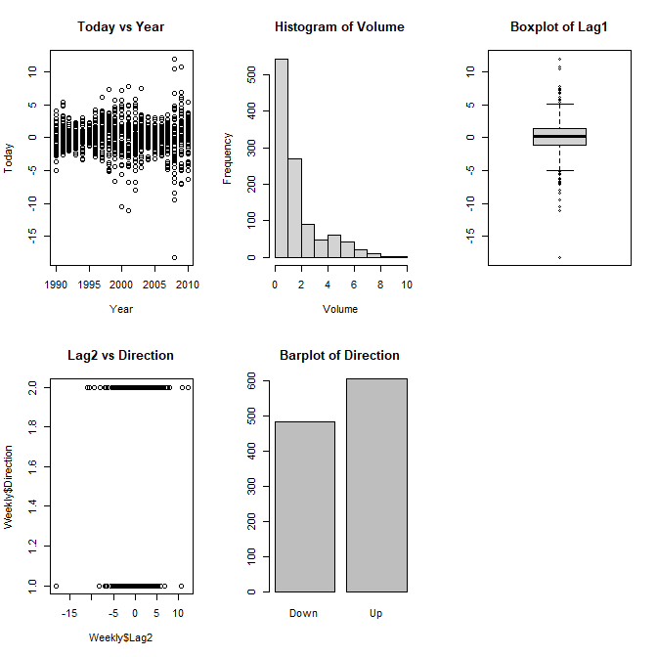

从1990到2010年，收益率没有持续上升或下降的趋势

# (b) 用整个数据集建立逻辑斯谛回归模型，使用Lag1-Lag5和Volume作为预测变量，Direction作为响应变量

model_b <- glm(Direction ~Lag1 + Lag2 + Lag3 + Lag4 + Lag5 + Volume, data = Weekly, family = binomial) # 逻辑斯谛回归模型

print(summary(model_b))

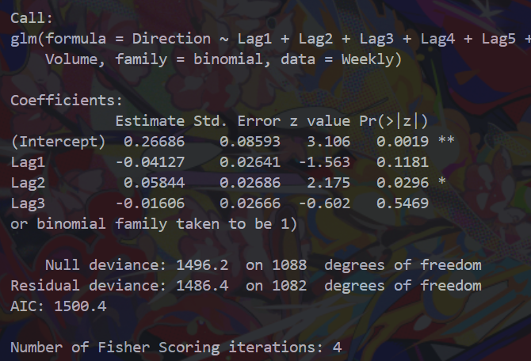

只有Lag2是显著变量

# (c) 计算混淆矩阵和整体预测准确率，解释错误类型

pred_b <- predict(model_b, type = "response")  # 获取预测概率

pred_class_b <- ifelse(pred_b > 0.5, "Up", "Down")  # 以0.5为阈值分类

conf_matrix_b <- table(Predicted = pred_class_b, Actual = Weekly$Direction)  # 混淆矩阵

accuracy_b <- sum(diag(conf_matrix_b)) / sum(conf_matrix_b)  # 准确率

cat("混淆矩阵:\n")

print(conf_matrix_b)

cat("整体预测准确率:", accuracy_b, "\n")

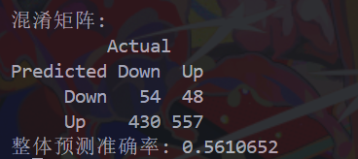

将实际是down的预测为up的有430，将实际是up的预测为down的有48，主要犯了前者的错误

# (d) 使用1990-2008年数据训练逻辑回归模型，仅用Lag2预测，测试2009-2010年数据

train <- subset(Weekly, Year >= 1990 & Year <= 2008)  # 训练集：1990-2008

test <- subset(Weekly, Year >= 2009 & Year <= 2010)   # 测试集：2009-2010

model_d <- glm(Direction ~ Lag2, data = train, family = binomial)  # 仅用Lag2拟合

pred_d <- predict(model_d, newdata = test, type = "response")

pred_class_d <- ifelse(pred_d > 0.5, "Up", "Down")

conf_matrix_d <- table(Predicted = pred_class_d, Actual = test$Direction)

accuracy_d <- sum(diag(conf_matrix_d)) / sum(conf_matrix_d)

cat("(d) 逻辑回归测试准确率:", accuracy_d, "\n")

print(conf_matrix_d)



# (e) 应用LDA重复(d)的过程

model_e <- lda(Direction ~ Lag2, data = train)

pred_e <- predict(model_e, newdata = test)

conf_matrix_e <- table(Predicted = pred_e$class, Actual = test$Direction)

accuracy_e <- sum(diag(conf_matrix_e)) / sum(conf_matrix_e)

cat("(e) LDA测试准确率:", accuracy_e, "\n")

print(conf_matrix_e)

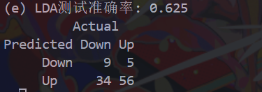

# (f) 应用QDA重复(d)的过程

model_f <- qda(Direction ~ Lag2, data = train)

pred_f <- predict(model_f, newdata = test)

conf_matrix_f <- table(Predicted = pred_f$class, Actual = test$Direction)

accuracy_f <- sum(diag(conf_matrix_f)) / sum(conf_matrix_f)

cat("(f) QDA测试准确率:", accuracy_f, "\n")

print(conf_matrix_f)



# (g) 应用K=1的KNN重复(d)的过程

train_X <- as.matrix(train$Lag2)  # 预测变量矩阵

test_X <- as.matrix(test$Lag2)

train_Y <- train$Direction

set.seed(123)  # 设置随机种子以确保可重复性

pred_g <- knn(train_X, test_X, train_Y, k = 1)

conf_matrix_g <- table(Predicted = pred_g, Actual = test$Direction)

accuracy_g <- sum(diag(conf_matrix_g)) / sum(conf_matrix_g)

cat("(g) KNN (K=1) 测试准确率:", accuracy_g, "\n")

print(conf_matrix_g)

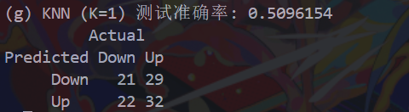

(h) LDA 和逻辑斯蒂回归最好，KNN最差

# (i) 探索不同预测变量组合、变换和交互作用，找出最佳组合

# 示例1: 逻辑回归带交互项

model_i1 <- glm(Direction ~ Lag2 * Volume, data = train, family = binomial)

pred_i1 <- predict(model_i1, newdata = test, type = "response")

pred_class_i1 <- ifelse(pred_i1 > 0.5, "Up", "Down")

acc_i1 <- mean(pred_class_i1 == test$Direction)

# 示例2: 使用多个变量

model_i2 <- glm(Direction ~ Lag1 + Lag2, data = train, family = binomial)

pred_i2 <- predict(model_i2, newdata = test, type = "response")

pred_class_i2 <- ifelse(pred_i2 > 0.5, "Up", "Down")

acc_i2 <- mean(pred_class_i2 == test$Direction)

# 示例3: 尝试KNN with K=5（优化K值）

pred_i3 <- knn(train_X, test_X, train_Y, k = 5)

acc_i3 <- mean(pred_i3 == test$Direction)

# 比较准确率

acc_i <- c(Interaction = acc_i1, MultiVar = acc_i2, KNN5 = acc_i3)

best_i <- names(which.max(acc_i))

cat("(i) 探索性结果准确率:", acc_i, "\n")

cat("最佳组合:", best_i, "with accuracy", max(acc_i), "\n")

# 分析：最佳组合可能涉及Lag2和Volume的交互，或优化K值；需通过交叉验证确认。

# 输出最佳混淆矩阵（以示例model_i1为例）

conf_matrix_i <- table(Predicted = pred_class_i1, Actual = test$Direction)

cat("最佳混淆矩阵（示例）:\n")

print(conf_matrix_i)

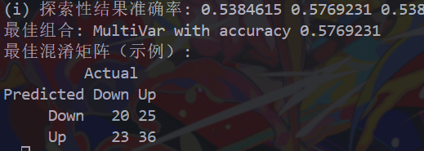

11.

# 加载必要的库

library(ISLR)  # 提供Auto数据集

library(MASS)   # 用于LDA和QDA

library(class)  # 用于KNN

# (a) 建立二元变量mpg01

data(Auto)

median_mpg <- median(Auto$mpg, na.rm = TRUE)

mpg01 <- ifelse(Auto$mpg > median_mpg, 1, 0)

Auto_df <- data.frame(mpg01, Auto)

# (b) 探索mpg01与其他特征的关系

par(mfrow = c(2, 3))

plot(Auto_df$mpg01, Auto_df$displacement, main = "mpg01 vs displacement")

plot(Auto_df$mpg01, Auto_df$horsepower, main = "mpg01 vs horsepower")

plot(Auto_df$mpg01, Auto_df$weight, main = "mpg01 vs weight")

plot(Auto_df$mpg01, Auto_df$acceleration, main = "mpg01 vs acceleration")

boxplot(displacement ~ mpg01, data = Auto_df, main = "Boxplot: displacement by mpg01")

boxplot(horsepower ~ mpg01, data = Auto_df, main = "Boxplot: horsepower by mpg01")

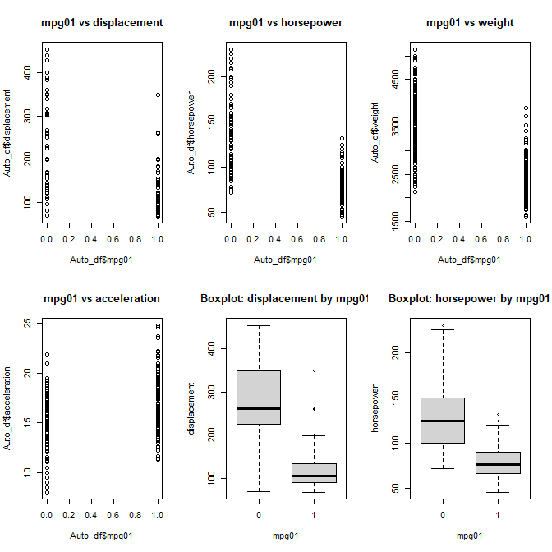

变量关系分析

displacement：与mpg01 呈负相关，高排量汽车更可能油耗较高（mpg01=0）

horsepower：与mpg01 呈负相关，高马力汽车更可能油耗较高

weight：与mpg01 呈负相关，重汽车更可能油耗较高

acceleration：与mpg01 关系不明显

箱线图分析

displacement by mpg01：mpg01=0的汽车排量明显高于mpg01=1的汽车

horsepower by mpg01：mpg01=0的汽车马力明显高于mpg01=1的汽车

# (c) 分割训练集和测试集

set.seed(1)

train_index <- sample(1:nrow(Auto_df), 0.7 * nrow(Auto_df))

train_data <- Auto_df[train_index, ]

test_data <- Auto_df[-train_index, ]

# (d) LDA模型

lda_model <- lda(mpg01 ~ displacement + horsepower + weight + acceleration, data = train_data)

lda_pred <- predict(lda_model, test_data)

lda_error <- mean(lda_pred$class != test_data$mpg01)

cat("LDA测试误差:", lda_error, "\n")



# (e) QDA模型

qda_model <- qda(mpg01 ~ displacement + horsepower + weight + acceleration, data = train_data)

qda_pred <- predict(qda_model, test_data)

qda_error <- mean(qda_pred$class != test_data$mpg01)

cat("QDA测试误差:", qda_error, "\n")



# (f) 逻辑斯谛回归

logit_model <- glm(mpg01 ~ displacement + horsepower + weight + acceleration, data = train_data, family = binomial)

logit_pred <- predict(logit_model, test_data, type = "response")

logit_pred_class <- ifelse(logit_pred > 0.5, 1, 0)

logit_error <- mean(logit_pred_class != test_data$mpg01)

cat("逻辑斯谛回归测试误差:", logit_error, "\n")



# (g) KNN模型

k_values <- seq(1, 10, by = 2)

knn_errors <- numeric(length(k_values))

for(i in 1:length(k_values)) {

  knn_pred <- knn(train = train_data[, c("displacement", "horsepower", "weight", "acceleration")],

                  test = test_data[, c("displacement", "horsepower", "weight", "acceleration")],

                  cl = train_data$mpg01, k = k_values[i])

  knn_errors[i] <- mean(knn_pred != test_data$mpg01)

}

best_k <- k_values[which.min(knn_errors)]

cat("最佳K值:", best_k, "\n")

cat("KNN最小测试误差:", min(knn_errors), "\n")



12.

# (a) 编写Power()函数，计算2的3次方

Power <- function() {

  result <- 2^3

  print(result)

}

Power()



# (b) 创建Power2()函数，计算x的a次方

Power2 <- function(x, a) {

  result <- x^a

  print(result)

}

# (c) 使用Power2()计算10^3, 8^7, 131^3

Power2(10, 3)

Power2(8, 7)

Power2(131, 3)

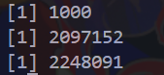

# (d) 创建Power3()函数，返回计算结果

Power3 <- function(x, a) {

  result <- x^a

  return(result)

}

# (e) 使用Power3()绘制f(x)=x^2的图像

x_values <- 1:10

y_values <- Power3(x_values, 2)

plot(x_values, y_values, type = "b", main = "f(x) = x^2", xlab = "x", ylab = "x^2")

# (f) 创建PlotPower()函数，绘制x与x^a的关系图像

PlotPower <- function(x_range, a) {

  x_values <- x_range

  y_values <- Power3(x_values, a)

  plot(x_values, y_values, type = "b", main = paste("x vs x^", a), xlab = "x", ylab = paste("x^", a))

}

# 调用PlotPower函数

PlotPower(1:10, 3)

