**EXP#6: PWM by using TL494 & 556 Timer**

**Objective:**

Understanding the function and operation of tl494 and 555-Timer to generate the PWM.

**TASK-1:**

Consult the data sheet of TLP494 and design the circuit to generate 1 kHz, 4 kHz, 10 kHz and 20 kHz frequencies with 50% duty cycle. There are two variable resistances used in the circuit, one is to adjust the frequency and other one is to adjust the duty cycle. The required variation of duty cycle is from 5% to 95% with all the selected frequencies.

* Observe the saw tooth waveform on the Multisim scope, measure feed-back voltage and verify the generation of duty cycle.
* Observe the variation of frequency by changing the resistance in your oscillator circuit.
* Observe the variation of duty cycle by varying feed-back voltage.

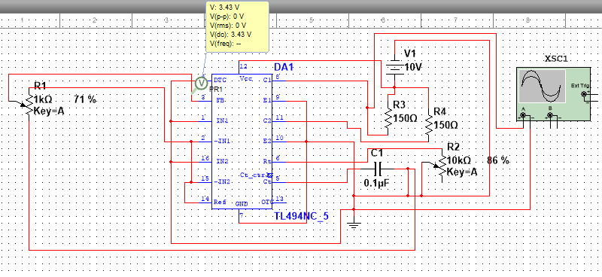**TL494-Circuit:**

**Waveforms:**

**Sawtooth waveform of oscillator**

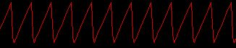

**Frequency variation:**

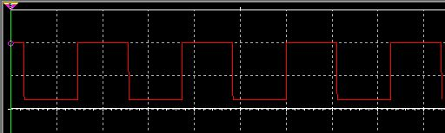

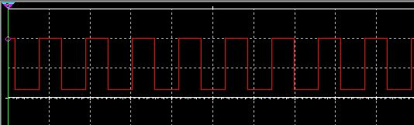

**Duty cycle variation**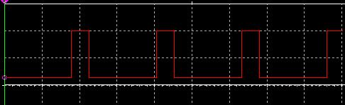

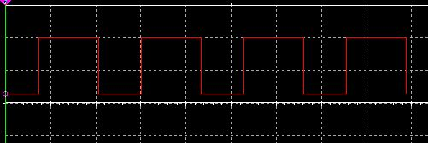

By observing the Circuit diagram we observe that feedback voltage is:

***Feedback voltage=3.43V***

**Waveforms of variation of frequency at fix 50% duty cycle:**

 **Frequency=1KHz:**

**Frequency=4KHz:**

**Frequency=10KHz:**

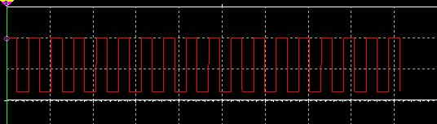

**Frequency=20KHz:**

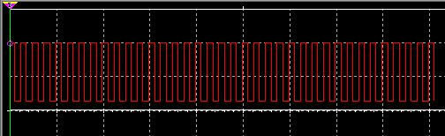

**Waveforms of different duty cycle at different frequencies:**

**At frequency=1KHz:**

**20% DutyCycle**

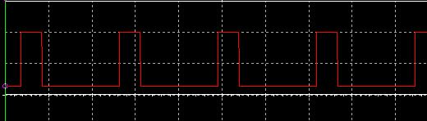

**40% DutyCycle**

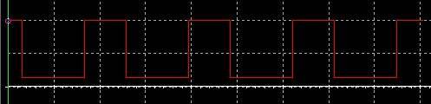

**60%DutyCycle**

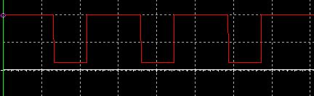

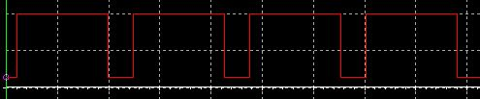 **80% DutyCycle**

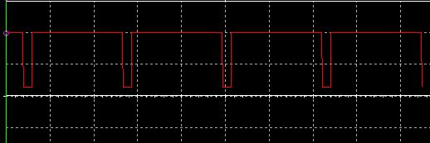 **90% DutyCycle**

**At frequency=4KHz:**

 **20% DutyCycle**

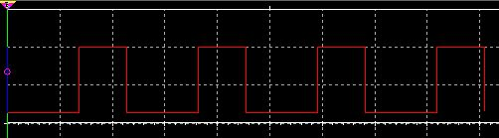 **40% DutyCycle**

 **60% DutyCycle**

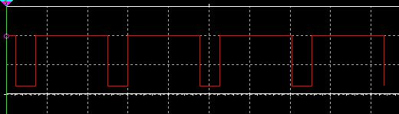 **80% DutyCycle**

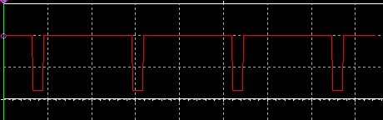 **90% DutyCycle**

**At frequency=10KHz:**

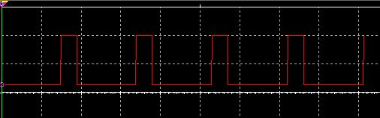 **20% DutyCycle**

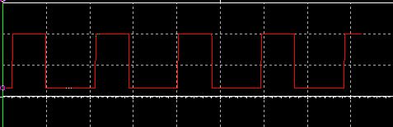 **40% DutyCycle**

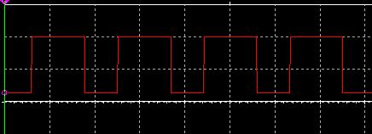 **60% DutyCycle**

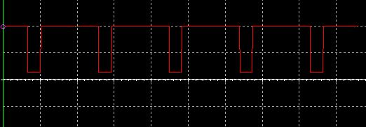 **80% DutyCycle**

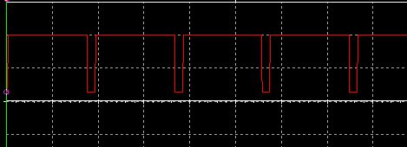 **90% DutyCycle**

**At frequency=20KHz:**

**20% DutyCycle**

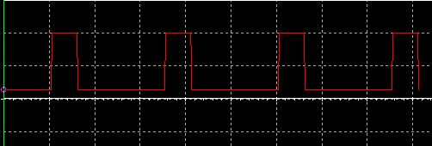

**40% DutyCycle**

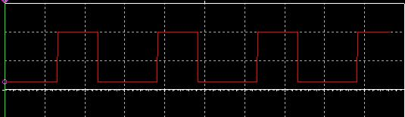

**60% DutyCycle**

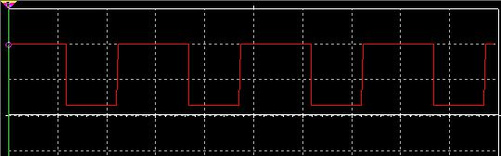

**80% DutyCycle**

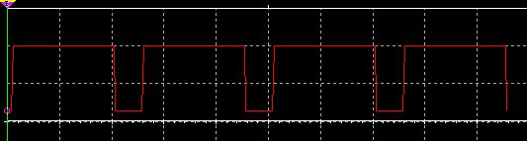

**90% DutyCycle**

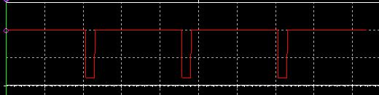

**TASK-2:**

Consult the data sheet of 555 Timer circuit and implement the astable mode of operation for all the frequencies selected in the case of TLP494 for the duty cycle of 50% and repeat all the steps followed in Task-1.

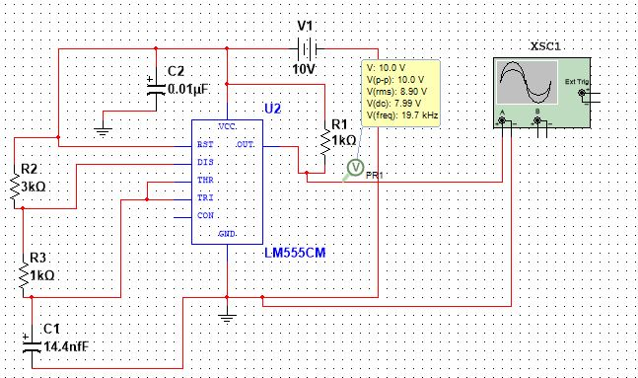**555-Timer Circuit:**

**Waveforms of Circuit:**

**Frequency variation**

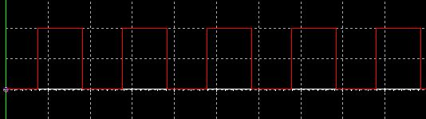

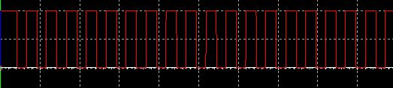

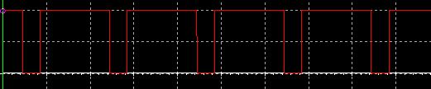 **DutyCyle variation**

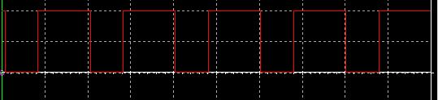

**Waveforms of variation of frequency at fix 50% duty cycle:**

**Frequency=1KHz:**



 **Frequency=4KHz:**

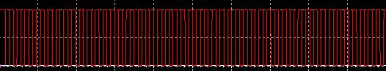 **Frequency=10KHz:**

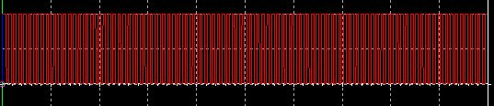 **Frequency=20KHz:**

**Waveforms of different duty cycle at different frequencies:**

**At frequency=1KHz:**

 **60% DutyCycle**

 **80% DutyCycle**

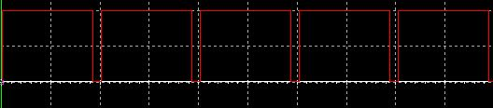 **90% DutyCycle**

**At frequency=4KHz:**

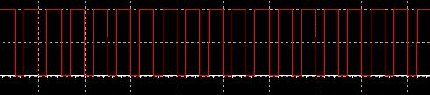 **60% DutyCycle**

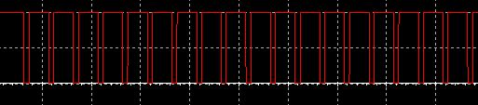 **80% DutyCycle**

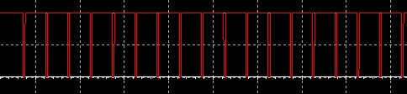 **90% DutyCycle**

**At frequency=10KHz:**

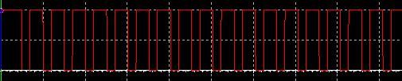 **60% DutyCycle**

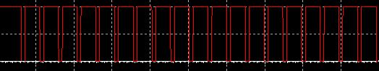 **80% DutyCycle**

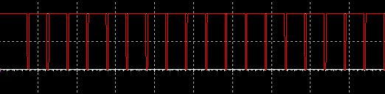 **90% DutyCycle**

**At frequency=20KHz:**

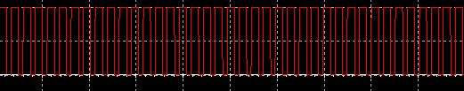 **60% DutyCycle**

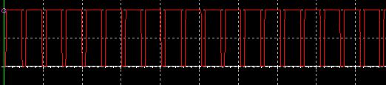 **80% DutyCycle**

**90% DutyCycle**

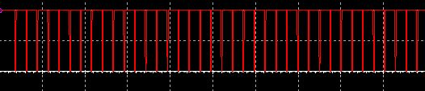

**Answers of the required questions:**

Now following is the answers of those questions that are required in our lab manual.

* For tl494 we adjust the frequency by using formula related with RT and CT:

***f = 1/(RT x CT)***

we fix CT=0.1uF and we change RT value, by using the variable resistor, according to the required frequency so we have CT and frequency value and we get that value from that formula. So CT is fix for all frequencies so we show only RT value.

**RT=10Kohms & f=1KHz**

**RT=2.5Kohms & f=4Khz**

**RT=1Kohms & f=10KHz**

 **RT=500ohms & f=20KHz**

For 555-Timer circuit we use this formula to adjust frequency:

***f = 1.44/(Ra+2Rb)C***

Now again we again fix our parameter like we fix Ra=1Kohms & Rb=10Kohms. So now changing capacitor value the desire frequency is achieved.

**C=35.12nF & f=1KHz**

**C=8.7nF & f=4KHz**



**C=3.5nF & f=10KHz**



**C=1.7nF & f=20KHz**



* The voltage we observe across oscillator capacitor is equal to **1.7V** and following is the snapshot of the oscillator waveform:



* The waveforms at 20%, 40%, 60%, 80% and 90% is shown above in section of different duty cycles at different frequencies.
* The function of DTC (dead-time-control) pin is to regulates the minimum dead time. when voltage on the DTC pin exceeds the ramp voltage from the oscillator, forces the output comparator to switch OFF the transistors Q1 and Q2. Applying a voltage to the dead-time control input can impose additional dead time. This provides a linear control of the dead time from its minimum of 3% to 100% as the input voltage is varied from 0 V to 3.3 V,  
  respectively, so by applying voltages at Pin-4 we can control dead time. When Pin-4 is grounded then we have minimum about **3%** dead time.

Here, a minute nearly 110mV offset is shown because Pin-4 is grounded.

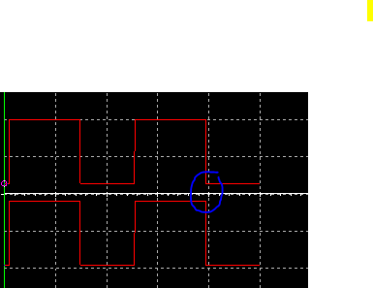

* The output-control input determines whether the output transistors operate in single ended operation or in push-pull operation.

For single ended operation:

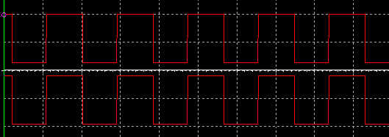

For Push-pull operation:

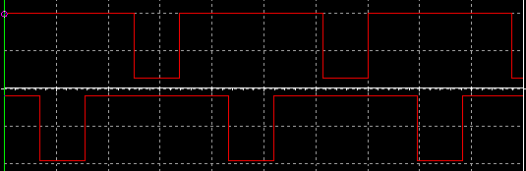

* By using error amplifier to generate PWM we have following design:

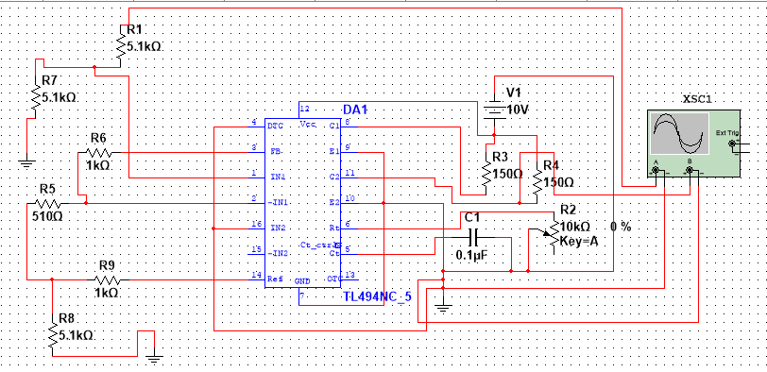

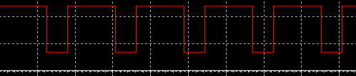

**Conclusion:**

The experiment concluded that by using different operations of PWM like error amplifier, current amplifier and push-pull operation we can control our output PWM waveform. Similarly, we can also use 555-Timer to generate PWM but it is hard task for us to maintain duty cycle and frequency at desire value due to Ra & Rb resistance relation with duty cycle as well as with frequency.