 My website was created to be a portfolio for the fictional company of Broken Infinity Game, showing off all of their projects, as well as providing more information about team members and links to social media for further contact. To do this, I planned on creating a website with several different pages for each of these aspects. This consisted of creating an initial landing page that would give a brief overview of the website and company as a whole, as well as a slideshow showing some work created by the company. Another page would be things such as a list with all past and present projects. This page would display a brief overview of what each project is about, with a small image or gif. Clicking on this image/gif would take you to a separate page where there is more in-depth information about the game, as well as more images, or perhaps some form of interactive media such as a 3D model view for the user to engage with. Adding this connects the user to my website and allows it to be much more interesting and interactive for them. Adding a profile page takes the spot of a “meet the team” page, like the one shown[1]. This page provides more info about me as well as including a button to allow you to download my CV. This again would add more interactivity, while also providing a way for the user to have additional information stored directly on their computer for later viewing. The last page filled with links to social media, as well as an email form for contacting the company. This page can be accessed through the link in the footer or though a hyperlink provided on the profile page. 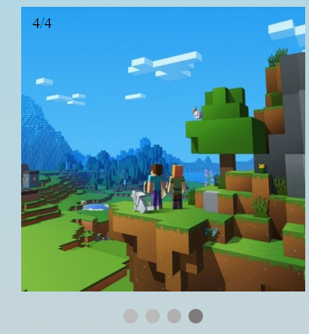

Creating the slideshow for the landing page, I followed along with a tutorial created by a member of the course, James[2]. The slide show slowly transitions through several images (all which are currently placeholders, hence the type of images and the sizing of them), using both a number and coloured dot indicator to know what image you are on in the series, circled in the image. On the same page, I wanted to create a floating header and footer that would stay in place on all pages using a tutorial provided by w3shools [3]. This, however, did not work, so I created one using HTML and CSS instead of Javascript. I was able to create a header and footer that more or less changes size with the webpage, as well as being able to display all of the relevant data while staying on top and bottom of the webpage. It does scale slightly if the user has the scroll bar visible, but this was intentional. Some fixes to keep things from initially loading underneath it had to be done, such as adding a div above the content used for padding to stop content from going behind the header. I also added a dropdown menu[4] to the final option on the header, “Projects”. This was to allow the user to have an easier way to navigate to each of the individual project pages. This was not initially part of the header and was done later in development as I realised it was difficult for the user to quickly navigate to the individual project pages.

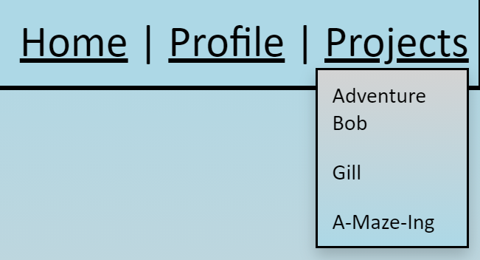As you can see, it projects directly out from underneath the projects tab. I chose to add a gradient to it in opposite colour to the rest of the website to allow it to stand out from the page while keeping with the theming of the site. As the code from the tutorial turned “Projects” into a button, I used CSS to make it look more like a link, like the rest of my header

On the ”Projects” page and the drop-down, are links to 3 separate pages, one for each of the projects that I have decided to include. I have used these pages to individually showcase some of the requirements for the website, whilst also tying into the portfolio aspect. On the “Adventure Bob” page, you will see an animation created using a sprite sheet and canvas. This animation loops every 4 frames for a gif like an effect on the page to show off Bob's idle animation. Centred on the page above the descriptive text for him matches the formatting of the rest of the website, and allows the canvas animation to be show off to the user.

On the “Gill” page, I included a 3d model viewer, following a tutorial by Peter Allen, and using a tool created by Poly, from the website found in the footer[5]. This script, shown below, allows the model viewer to appear in a div on my website, with the user being able to interact with it at will with their mouse, being able to move it as well as zoom in and out.

Finally, I added the “A-Maze-Ing” page, which includes a playable video directly in the browser, as well as a hyperlink attached to and image that when you click on it, it downloads the .apk file for the game to your computer. The video does not have sound, which is not an error of the site, but of the program used to record it. This video was added in after I did some research and found it was similar to adding in an image but changing the type of the file to .mp4[6]. The download link is attached to a custom logo for the game, again adding interactivity to the website.

The “Designer Profile” page is just to show a profile can be created. The page itself is pretty barebones, but it is mainly there to provide a download link to my CV[7], as well as another way to gain access to the companies social media pages through the image links provided, as well as another way to access the email form through a hyperlink in the text.

The email form is a proof of concept. It was created following another tutorial created by w3schools[8]. The form does allow you to fill it in, but at the moment, the data is simply cleared when you press the submit button and you are sent to the successful submission page. All of the logos shown on this page are working links to social media pages for the company. I wanted this to be similar to what you'll find on other websites, like the example shown[9].

Overall, I feel like my website fulfils most of the specification. It is a fully working website that could be used as someone’s basic portfolio. For its strengths, the user can engage with it easily, it loads quickly, and is interactive. There are some formatting issues when it tries to work on a tablet or mobile devices, which could be fixed by changing the sizing of the webpage and how the header and footer change size when the screen changes. In the future, some additions to the site would be more interactive elements. These would be changed by adding an interactive demo of a game playable in the browser, instead of having to rely on the user downloading the file and then installing it on their device. I feel like I have created a strong website, but improvements could be made to make it even stronger and more professional.

1. https://www.atlassian.com/company/people
2. James Webb (2020). *HTML slideshow* Available at: https://youtu.be/TveZCzSG8xs (Accessed: 21 November 2020).
3. W3schools, 2020. How TO - On Scroll Header [online]. Available from: https://www.w3schools.com/howto/howto_js_sticky_header.asp [Accessed 16 November 2020].
4. W3schools, 2020. How TO - Hoverable Dropdown[online]. Available from: https://www.w3schools.com/howto/howto_css_dropdown.asp [Accessed 16 December 2020].
5. https://modelviewer.dev/
6. W3schools, 2020. HTML Video [online]. Available from: https://www.w3schools.com/html/html5_video.asp [Accessed 25 November 2020].
7. Plus2Net, 2020. Linking pages using buttons click event [online]. Available from: https://www.plus2net.com/html_tutorial/button-linking.php [Accessed 25 November 2020].
8. W3schools, 2020. How TO - Contact Form [online]. Available from: https://www.w3schools.com/howto/howto_css_contact_form.asp [Accessed 25 November 2020].
9. Image shown is from <https://kotaku.com>