DelPhiForce Manual

DelPhiForce is a tool to calculate electric field, forces, energy for a two molecule system. The electrostatic forces can be visualized in VMD. In the ***DelPhiForce/bin*** folder, there are several files:

**DelPhiForce.sh**

**ForceGen.sh**

**draw_arrow.tcl**

The usage of DelPhiForce is:

./DelPhiForce.sh -1 file1 -2 file2 -e absolute_path_to/delphicpp -o output_name

Where file1 is the reference molecule, file2 is the probe molecule, output_name is the output file name.

Tutorial on an example

Here is an example of using DelPhiForce on a dynein-tubulin complex on Linux or Mac system.

Once DelPhiForce.tar.gz is downloaded, the example can be found in the *DelPhiForce/example*/ folder. This example is the dynein MTBD (microtubule binding domain) and tubulin complex. The dynein MTBD is detached from tubulin and rotated in 90 degrees. The goal is to calculate and visualize the electrostatic forces on all the residues of dynein MTBD.

To run the example, go to the example folder, copy all files from the *DelPhiForce/bin/* folder to *DelPhiForce/example/* folder, then run DelPhiForce by the command:

./DelPhiForce.sh -1 test_complex.pqr -2 test_frc.pqr -e absolute_path_to_delphicpp -o out

After the run, you will get such files:

**out.residue**

out.residue is the result for electrostatic forces on all the residues of dynein MTBD;

**out.atom**

out.atom is the result for electrostatic forces on all the atoms of dynein MTBD;

**out_residue.tcl**

out_residue.tcl is generated for visualization of electrostatic forces on residues of dynein MTBD in VMD.

**out.tcl**

out.tcl is generated for visualization of the total electrostatic force of dynein MTBD in VMD.

In order to visualize the forces, first launch VMD, open the molecules of test_frc.pqr.

In the VMD TkConsole, run the commands:

source draw_arrow.tcl

source out_residue.tcl

source out.tcl

Then open the molecule test_complex.pqr in VMD.

The electrostatic forces are displayed as shown in figure 1. Each arrow illustrates an electrostatic force on a residue of dynein MTBD. The tail of an arrow is the mass center of the corresponding residue. The length of an arrow indicates the magnitude of the force.

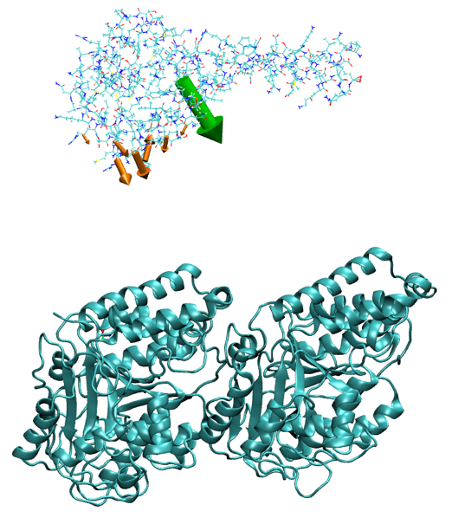

Figure 1. Electrostatic forces generated by tubulin dimer (cyan colored cartoon representation) onto kinesin microtubule binding domain (line representation), placed 15 Å away from its bound position. Orange arrows represent forces acting on each residue, while the green arrow is the total resultant force. The length of the arrow reflects calculated magnitude of the force.

**Reference:**

*Li, Lin, Arghya Chakravorty, and Emil Alexov. "DelPhiForce, a tool for electrostatic force calculations: Applications to macromolecular binding." Journal of Computational Chemistry 38.9 (2017): 584-593.*