**HIT Manual**

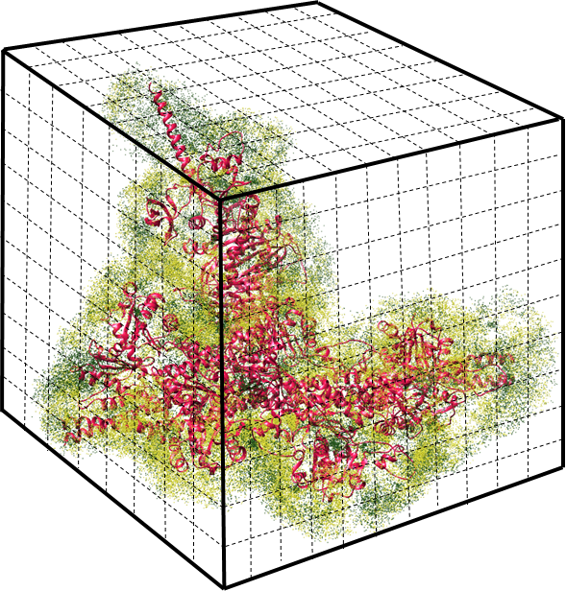

The HIT is a tool to calculate the position of trapped ions for highly charged biomolecule system. The result can be output in PDB format. In DFT/bin folder, there are several files:

HIT

merge.tcl

run_HIT.sh

The usage of HIT is:

Step 1. Make sure you have your psf file, dcd file, HIT, merge.tcl, run_HIT.sh are in the same folder.

Step 2. merge.pdb file preparation:

Open vmd

Open Extension -- Tk Console

Input: “source merge.tcl” and then follow the instruction to input your psf name and dcd file name.

After a few minutes, you will get a file, named “merge.pdb”

Step 3. run “run_HIT.sh” in the terminal.

“./run_HIT -f merge.pdb -i [ion_name] -n [number of ions]”

NOTE: If you want to set the cubesize, please use -s [cubesize]. For more information about the cubesize, please read the article

” Sun, S., Karki, C., Xie, Y., Xian, Y., Guo, W., Gao, B.Z. and Li, L., 2021. Hybrid method for representing ions in implicit solvation calculations. Computational and structural biotechnology journal, 19, pp.801-811.”

Where merge.pdb is the ions coordinate in PDB format (here is the *merge.pdb*) saved from NAMD simulation by VMD. ion_name is the target ion you want to add (it can be found in your pdb file, for example, sodium is SOD and chloride is CLA), number of ions is an integer that how many target ions you want to add in your biomolecule model to compensate your system. cube size is 3.3, if you want to use other cube size just use another one.

**Tutorial on an example**

Here is an example of using HIT on a kinesin-tubulin complex on Linux system.

Once HIT.zip is downloaded, the example can be found in the HIT/example/ folder.

This example is the kinesin-tubulin complex. To run the example, go to the example folder and run the following commands.

1. in vmd Tk Console

Input: source merge.tcl

And input the ionized.psf and eq.dcd following the instructions.

After that, you will get the file named after “merge.pdb”.

(Warning: this dcd file only contains 20 frames, which is only for guidance. In your real cases, the frames should be over 1000. The bigger, the better)

2. Open terminal and run the following command:

./run_HIT.sh -f merge.pdb -i SOD -n 36

After the run, you will get such files:

SOD.pdb

SOD.txt

The SOD.pdb is the file of trapped sodium in pdb file which could be visualized in Chimera. It is better to visualize it with biomolecule. The SOD.txt is the centroid of all clusters with frequency.

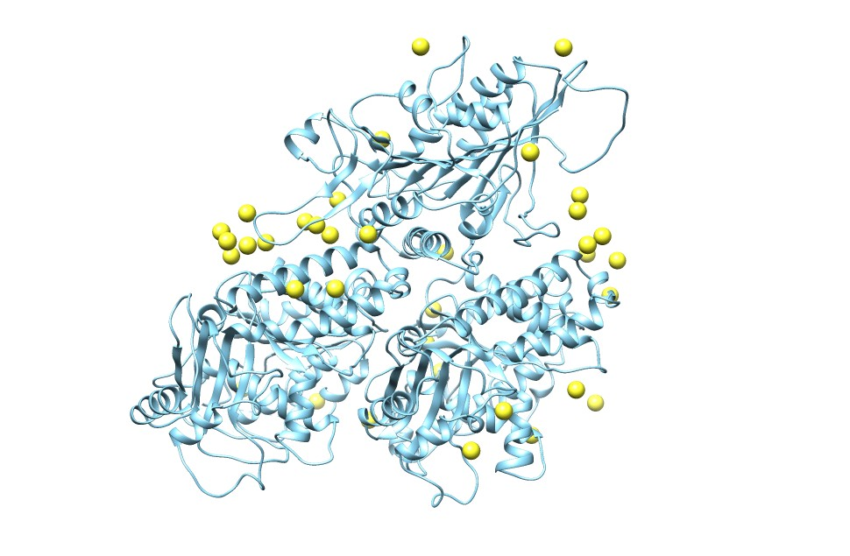

Figure 1. trapped sodium (yellow balls) with kinesin-tubulin complex (this is from a 10ns MD simulation with 2000 frames).

Reference:

Sun, S., Karki, C., Xie, Y., Xian, Y., Guo, W., Gao, B.Z. and Li, L., 2021. Hybrid method for representing ions in implicit solvation calculations. Computational and structural biotechnology journal, 19, pp.801-811.