**Analysis:**

Intro:

In this coursework, I plan to create a system which aims to function like a fitness companion, which involves exercise tracking and food tracking along with calculating bmi, counting calories and macronutrients/micronutrients, appointment booking for personal training, target setters and % progress the user has made.

I want to make this system because it will be useful in order to help the user track their targets and set new ones, this should hopefully better encourage and motivate the user and therefore will be more likely to reach their fitness targets. I plan on providing a range of tools and resources that can support their journey to better health.

I plan on targeting this system towards anyone who needs help losing or gaining weight and individuals who are looking to improve their health and fitness. This can include people of all ages and fitness levels, from beginners to experienced athletes. The system will be tailored to meet the needs of different users through customised targets and a clear and an easy-to-follow GUI.

However, one of the key constraints of my system is the user's ICT skill level. Not all users will be tech-savvy or familiar with using systems such as this. So, it’s important for my system to be user-friendly and easy to navigate, with clear instructions and support available to help users get started.

In addition, some users may have different accessibility needs, and I want the system to be accessible to everyone not dependent on how much knowledge they have in this area, so I will use larger text, clear font, beginner friendly GUI etc to try and make the system as accessible as possible.

Legal issues concerning Data Protection can also be a concern, as my system will collect and store personal data such as user's health information, exercise routines and other sensitive information. So it's important for me to comply with data protection regulations and ensure that user data is kept secure and private. I will make use of a secure database in MySQL which holds the information of the user to keep data secure and protected.

By addressing these issues, I can hopefully create a more effective and user-friendly system that meets the needs of a diverse user base, and help users track their progress, set goals, and stay motivated.

Similar Systems:

One similar system which exists is the FitBit app which includes some of the same features which I plan on implementing:

The Fitbit app collects a range of inputs from the user, including data on their activity levels, sleep patterns, heart rate, and weight, once the data is collected, the Fitbit app processes this information to provide users with meaningful insights and recommendations. The data collected by the Fitbit app is stored in the cloud or another database, this allows users to access their information from multiple devices. The data is stored securely and is protected by encryption to ensure user privacy. The Fitbit app provides a range of outputs to users, including visualisations of their data, daily activity summaries, and personalised insights and recommendations. The app also allows users to set goals and track their progress. When creating my system I might include similar inputs, processes, storage, and outputs as the Fitbit app. As shown by the screenshot I could implement a goal tracking system to show the user how much progress they have made which could motivate them; taking this into account I may need to create a database table for the users targets so they can easily be updated and displayed. However, it's important to avoid features that can negatively impact the user experience. For example, the system should be designed with simplicity and ease of use in mind, avoiding overly complex or confusing interfaces.

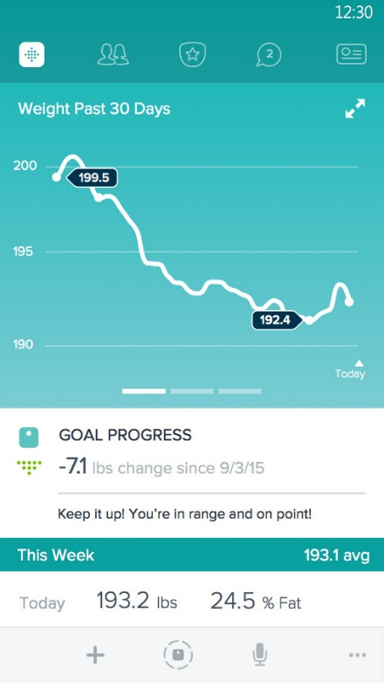

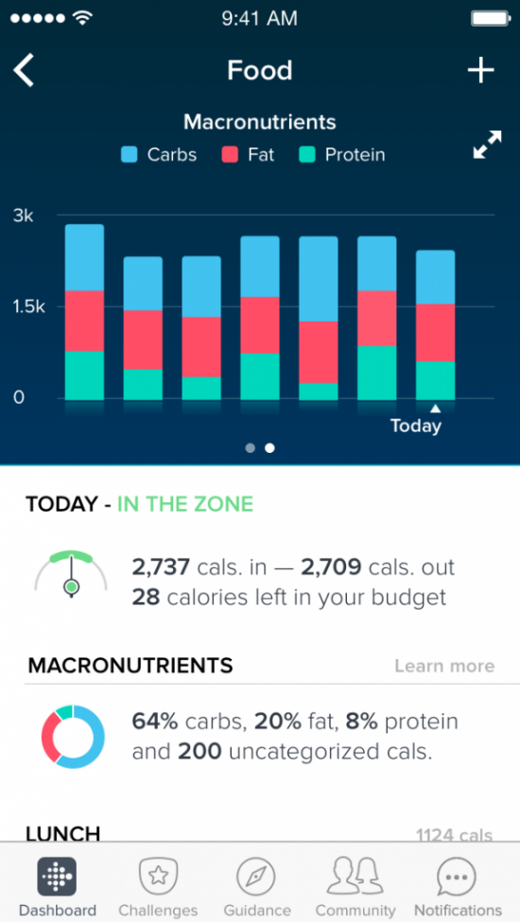

This feature displayed on the right allows the user to enter information about the food that they have consumed and displays through a graph the number of calories a day and the % of macronutrients that the user has had.

* I might take inspiration from this feature as the way that the user’s information is displayed on a graph is nice and it also links to the users inputted target.
* However, there are still problems with this system as those who do not know much about fitness may not need macronutrients being displayed and this may overcomplicate the system.
* By storing all this information, it emphasizes the use of a database to hold all these values and will make it a lot easier.
* These features may also require a lot of inputs from the user however so this may not be a desirable feature, since the system still needs to be easy to use.

Google Fit:

Another similar system which I will take inspiration from is the MyFitnessPal app which is screenshotted below:

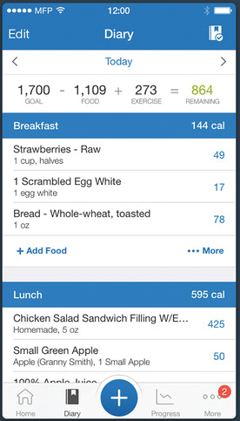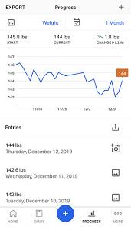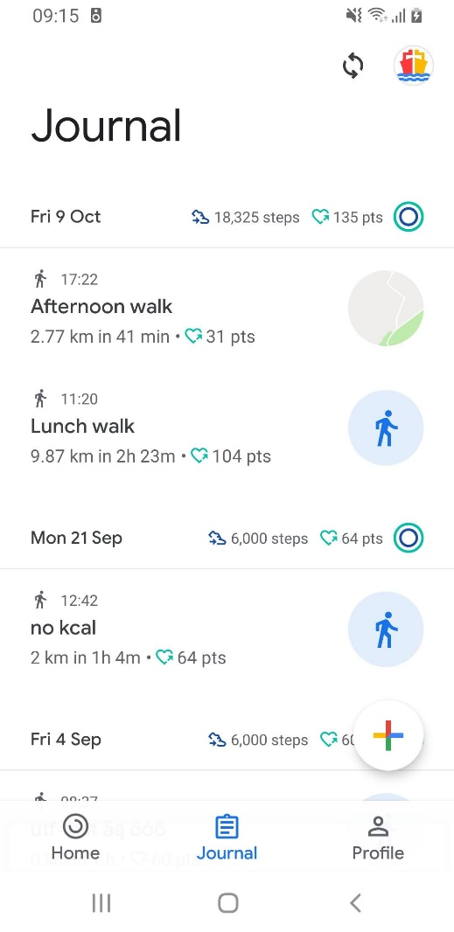Another system which I will take inspiration from is Google Fit:

As shown on the right the MyFitnessPal app collects a range of inputs from the user, including data on their daily calorie intake, macronutrient ratios, and physical activity levels. These inputs are collected manually by the user, who enters information about the foods they eat and their exercise routines into the app. Once the data is collected the app might use the user's nutrition data to suggest ways to balance their macronutrient intake or adjust their caloric intake to reach their weight loss goals. The app also allows users to set goals and track their progress which is something I plan on adding too. When creating my system I will try to prioritise user privacy and data protection, ensuring that sensitive information is stored securely on the MySQL database and may use encryption algorithms such as hashing.

* This feature allows the user to enter the food that they have eaten into a diary which will also show the calories and show the user exactly how many calories they have had and how many they have left over in the day.
* I may try implementing this into my system as it provides a lot of information in the GUI and tells the user exactly how many calories they have left.
* This can be gathered by more user inputs which could be a disadvantage to this system as it will take more time to carry out.
* Other problems related to this system include calories do not show all information related to losing/gaining weight, not enough features implemented.
* However, the calorie feature showing exactly how many remaining and where the calories come from could be very useful and I plan on implementing something similar.
* This feature displays a GUI which in detail shows the users average calories burnt/goal and shows the user how many to go to reach this value.
* I plan on implementing a target tracking system which displays the % the user is towards their target in a similar way the circle works in this feature.
* There are still flaws in this feature however such as the user not being able to input their own goal and instead it uses an average number of calories burnt which may be inaccurate due to the user potentially having a different lifestyle which means the average is never a target.
* This system features an exercise log which details the duration, calories burnt, and name of the exercise participated in.
* I plan on implementing something similar to this in my systems exercise log by adding a system as to where the user can input their exercise participated for that day.
* However there are still flaws in this system such as it not linking with a food log/calorie tracker which will be helpful for the user as they can then track at real time whether eating will be ok for achieving their goal.

Survey Reviews:

* From these responses it can be concluded that 64% of users are experienced in using similar systems which makes the responses more accurate due to the majority of users already having knowledge in this area, this also puts less emphasis on making the system simpler instead of including some complex features.
* However, I will still take into account that 36% of users are inexperienced which is still a large percentage therefore I will have to make the system both user friendly and include features which will keep the majority of users interested in the system.

* For this first response to the question the user has suggested many features and recommendations which I will consider when creating this system, I will likely implement the goal setting system with progress tracking, I also plan on making a lot of customisations as the user has stated.



* I do plan on adding a food tracker with food details, including calories, protein gs and fat%. This will also link to the target setting that I also plan on adding to this system, I think these are essential features which add a lot of value to this system.



* I do plan on adding this alongside a goal setting system with % progress involved. So that the user can predict when and how they are going to achieve their goal.



* Whilst most users responded with N/A due to their response to the last question the other responses to this question mostly consist of the user not being interested which there is not much I can do. However, user 14s comment on the accessibility is useful since I plan on targeting my system to all ages and to have a easy to follow GUI.

* This question was mainly to test how effective similar systems are at helping the user achieve their goals and with an average rating of 6.5 it can be concluded that there is a large room to improve. This means there is a further need to motivate the user so I will try to implement features which track progress such the % progress they have made.

* The results from this question can conclude that the most essential/desirable feature is target setting and tracking progress, therefore this will be a key area of my system and I will try to implement it using a variety of algorithms.

* Although most responses for this question were N/A some answers were useful such as including a bmi calculator and a calorie counter which are 2 features I am planning on adding, the large number of features and data being collected emphasises the use of many classes and OOP along with a connected database to hold this data.

**Modelling:**

Smart objectives:

1. Develop a login/signup system that allows users to create an account or log in with an existing account using secure authentication methods, saving the result to a database.
2. Implement a BMI calculator that calculates a user's BMI accurately based on their height and weight data input.
3. Create a dashboard that displays users' fitness goals, progress, and other relevant information, providing a comprehensive overview of their fitness journey.
4. Develop a target setter and changer that allows users to set and change their fitness goals easily and accurately, saving them to a database.
5. Implement a calorie logger that allows users to log their daily food intake, including a database of foods and their associated caloric content.
6. Develop an exercise logger that allows users to log their daily exercise routines, including the type of exercise, duration, and calories burnt.
7. Create a booking system that allows users to book workout classes or sessions with a personal trainer through the system.
8. Develop a feature that provides users with a progress tracker, allowing them to see their progress over time and stay motivated.
9. The exercises and food valid options will be sorted via a merge sort and allows the user to input their own.
10. The username set by the user will be unique and the primary key in the database.
11. The database will have multiple tables linked in MySQL and will contain the user’s personal data.
12. The username will be the foreign key for the other tables in the database.
13. The user will be able to see the % progress they have made compared to their set targets.
14. The user will be able to change their targets and upload them to the database.
15. Implement a sorting algorithm so users can find and add new exercises and foods to their log, easier.
16. I will use fxml files and the use of scene switching to output the GUI for the user.
17. If there is an invalid data type entered for entering inputs, there will be an error alert.
18. If the user inputs a string which is not a food/exercise stored, then an error message will be shown and they will be prompted to either add their own or use the displayed foods/exercises.
19. If the exit button is pressed on the main menu the entire application will close.
20. All the scene switching methods will specify if the scene is full screen or not and if it is it will not display the full screen message that comes up when an application is placed in full screen mode.
21. Once logged in the username entered will be stored as a public variable so that for later use the program knows the current user.
22. There will be hints/prompts throughout the system so that the GUI is easy to use and accessible for a larger number of people.