Detailed Design

Member
CS Senior: Chi Thanh Tran
EECE Senior: Luke Grochocki, Hebron Mekuria, Kian Palmer

Title, Goal, and Convention
- D1: A low-cost sensor system that include:
- Sensor Hub: Control sensors that collect field data, read data using sensors, transmit it (using radio, or maybe another method) to a central receiver.
- Central Application: Central Program connected to the central receiver that receive sensors data from Sensor Hub and decompress/decrypt said data. This program also hold the machine learning model and training data needed to check for disease.
- Network: Deferred to D2
- GUI: Deferred to D2

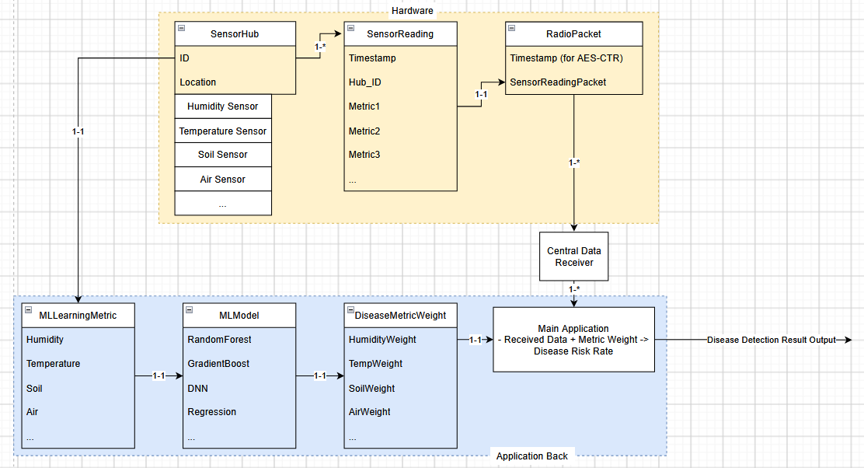
D1 Diagram

Structural Decisions
Decision | Choice | Reason
SensorHub | Entity | Main component that control/collect other sensor data
SensorReading | Entity | Every reading is unique in data and timestamp, and will need to be saved and used for ML
RadioPacket | Entity | Similar to above. Separated specifically for future potential choice of wireless communication model, but core aspect of packet will remain the same
MLLearningMetric, MLModel, and DiseaseMetricWeight | Entity | Each of these component of the ML model for disease detection represent a ML step associate with each other
SensorHub -> SensorReading | 1 to many | A hub will create multiple reading over time
SensorReading -> RadioPacket | 1 to 1 | Each RadioPacket contain one SensorReading
RadioPacket -> CentralDataReceiver -> MainApp | 1 to many | MainApplication will receive multiple RadioPacket containing Reading over time
CentralDataReceiver | Entity | Entity in charge of receiving data. Separated for similar reason to RadioPacket
MainApp | Entity | Entity in charge of getting Disease Detection Result from SensorReading with MetricWeight. Despite being called MainApp, this Entity act more like a bridge between these two entities

Core Algorithms
DecryptData(bytes encrypted, bytes decrypted, int size)
What it is: Function from MainApp that recrypted received DataSensor
Input: Encrypted DataSensor (bytes)
Output: Decrypted DataSensor (bytes)
Complexity: Use AES-128-CTR, O(size) with key
Reason: Simple and popular encryption choice
Edge Case: Will need to be detected outside of function, such as decrypted size too small compared to encrypted, wrong input size, wrong password, wrong nonce, etc.

Build-versus-reuse decisions
Majority of hardware (Each Sensor on Hub, Microcontroller, Wireless communication model, etc.) will be reused due to build complexity
Software (Code) will use given library from associated hardware
Components | Choice | Reason
ML Model | Reuse - Library | Too time-consuming to build one for little reason
ML Model Metric | Build | The main part of the project that need to be done manually to choose data to detect disease
Encryption | Reuse - Idea | No need for custom encryption/decryption when most publicly available choice already have highest security possible
Hardware Setup | Build | Will need to manually configurate depend on our own research environment

API contract: None

Technology Choices:
- Python was chosen for the ML part of the project due to its ease of use, and overall proficiency by members in the group (as well as being easy to get good at even without proficiency). It also have a large community library support, basically free of cost. The only trade back is a possibly lower performance compared to some other language (C++, JS, etc.), but since the computation part of the project will be done at the Central Application where power usage and speed is not as important (compared to being done at the Sensor Hub), we have decided that it is a winning trade.

