Design Diagrams
Member
CS Senior: Chi Thanh Tran
EECE Senior: Luke Grochocki, Hebron Mekuria, Kian Palmer
Title, Goal, and Convention
- Project: A low-cost sensor system that include:
  - Sensor Hub: Control sensors that collect field data, read data using sensors, transmit it (using radio, or maybe another method) to a central receiver.
  - Central Application: Central Program connected to the central receiver that receive sensors data from Sensor Hub and decompress/decrypt said data. This program also hold the machine learning model and training data needed to check for disease.
  - Networking: Central Program, after doing its work, need to send data to “client application” to allow Farmer to access and check. In case where important information is needed to be shown (disease risk high, malfunction hardware, etc.), Central Program will also need to send these data to client application.
    - NOTE: Despite being “Network”, our system are not planned to need a database/API, and in case needed, will be more decentralized, since this fit more to what a Farm/farmer usually set up
  - GUI: While farmer can check data on Central Application, a GUI for portable system like phone is likely preferred when they are far from the Farm. GUI receive data and information from Network to show said data to the farmer in a clean and interactive way that is easy to work with.

D0 Diagram
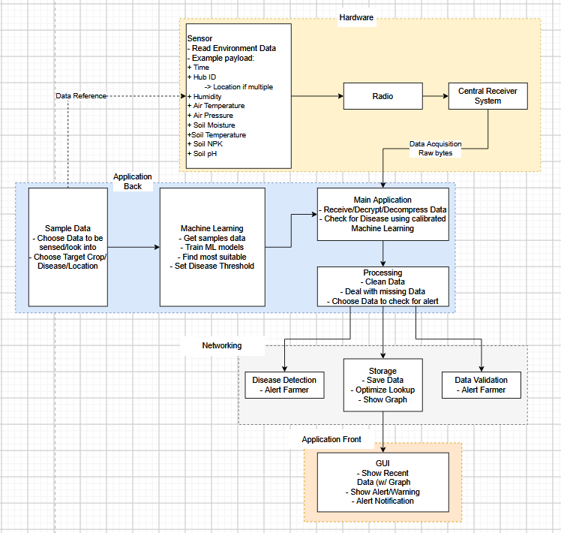

Data Flow
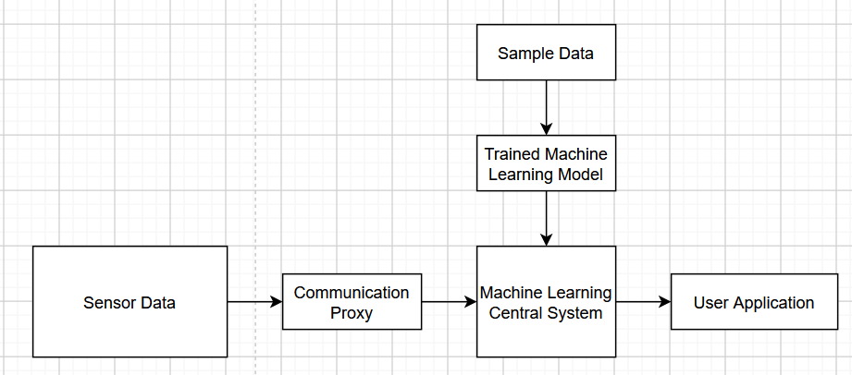
Pipeline / Data-Flow Pattern: Due to the high-hardware-focused aspect of the system, the software part of the system doesn’t need to follow complicated flow or Client-Server Pattern. A Pipeline Pattern show clear structure of the system and step-by-step on how sensor data turn into final disease detection decision.
- An extra pipeline pattern is used for the machine learning process, which fit the basic of Machine Learning
Alternative Consideration:
- N-Tier Pattern: Close to Pipeline Architecture, but lack a bit of flexibility that might be needed for the future where more interaction with other module. (automatic irrigation, pest control, etc.)
- Client-Server: The application/project is planned to be more of a local project with no heavy internet/server structure, and so this wasn’t chosen. However, there is a high chance of a similar architecture being used if we plan on a multi-hub extension, in which case a Client-Server architecture might fit well with the idea of multiple hub communicating with 1 central receiver
- Microservices: As mention above, the project is not a server-type application
- Sensor-Actuator Pattern: Is a more suitable pattern if we are planning on a full farm support cycle, however we are currently planning on narrowing down our scope to just the disease detection due to its likely difficulty, and will not be touching actual actuator for farm support for now

