1. Download Visual Studio Code IDE from <https://code.visualstudio.com/>.

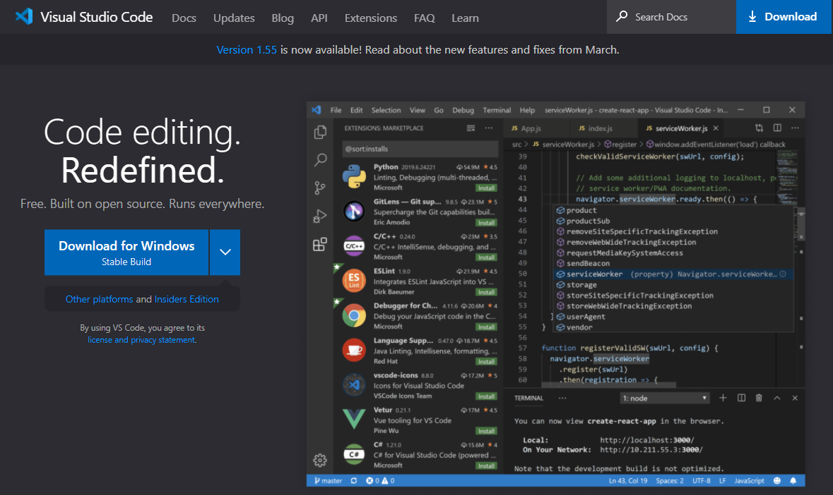

1. Follow the installation steps to install VS Code on your local machine.
2. Prepare a simple test scenario: Create a folder somewhere on your machine (e.g. C:/Users/you/Desktop/stne) and create a .stne file. You can simply use a text editor like notepad or wordpad to create a .txt file and change the file extension to .stne.

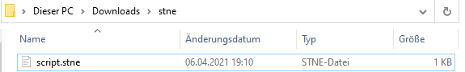

1. 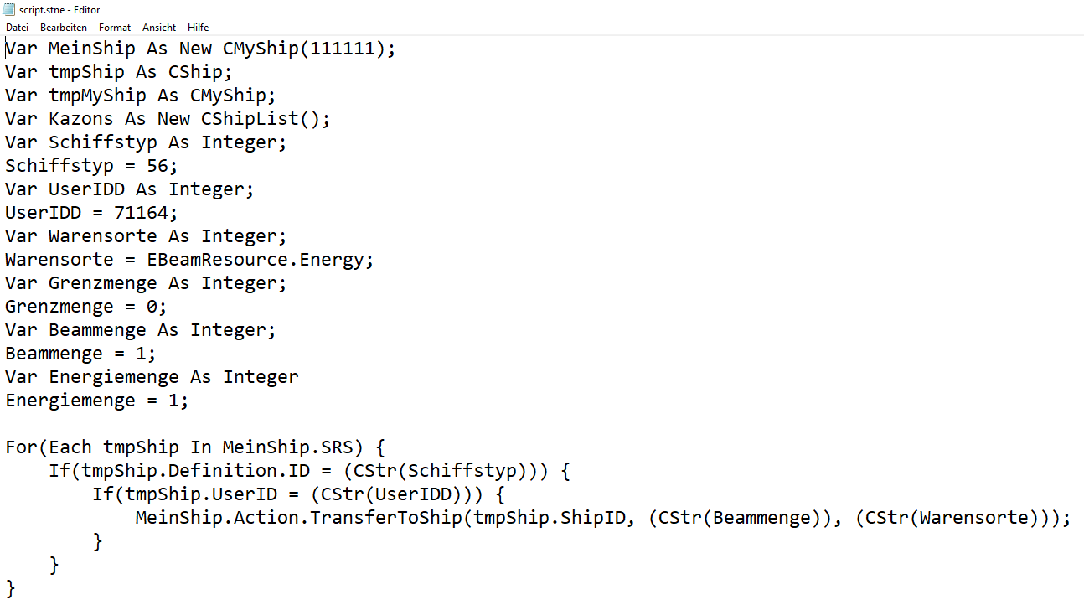Paste some Code from a STNE Script into the file.
2. 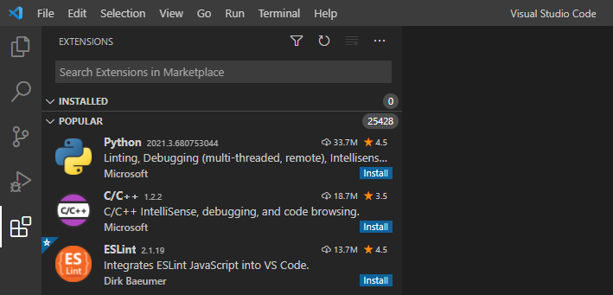Now, open your Visual Studio IDE and go to the Marketplace. You can use the Icon in the left menu bar or go to View 🡪 Extensions
3. Search for “STNE” and install the extension. Alternatively, you could go to the store and download the extension from <https://marketplace.visualstudio.com/items?itemName=STNE.stnescript-support>
4. After installing the extension, use the “Set File Icon Theme” button and select the STNE theme. You can also do so by going to the VS Code settings or using the Command Palette. Note that this step is not required to get the extension running on only provides visuals.

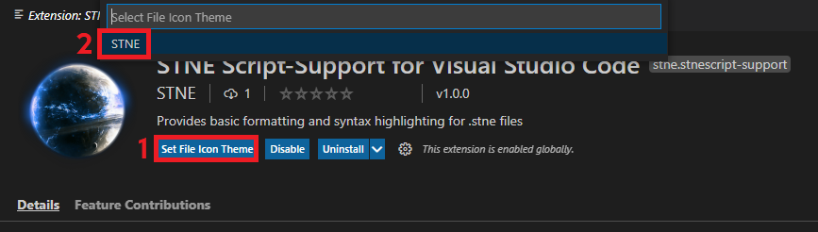

1. Now use VS Code to open the folder that contains the .stne file. The .stne file is shown with its own icon. The bottom bar shows that the file content is detected as “STNE Script”.

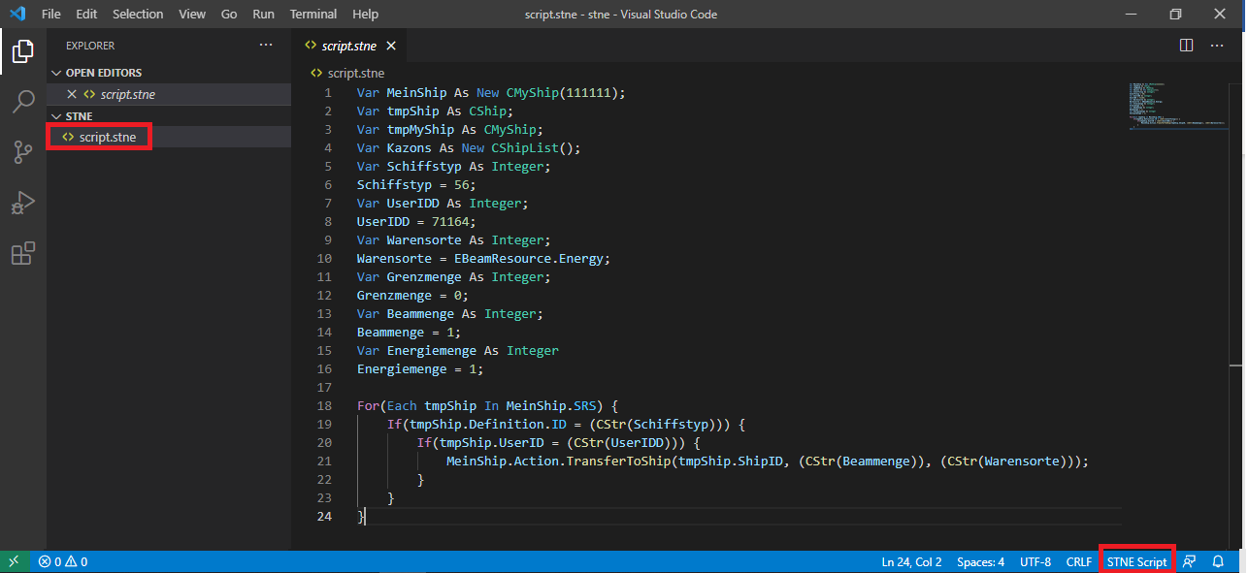

**What do you get?**

The extension provides syntax highlighting in files containing STNE script code. The syntax highlighting might not be perfect and there are probably still some bugs that will break the highlighting in some files. But the foundation is set.

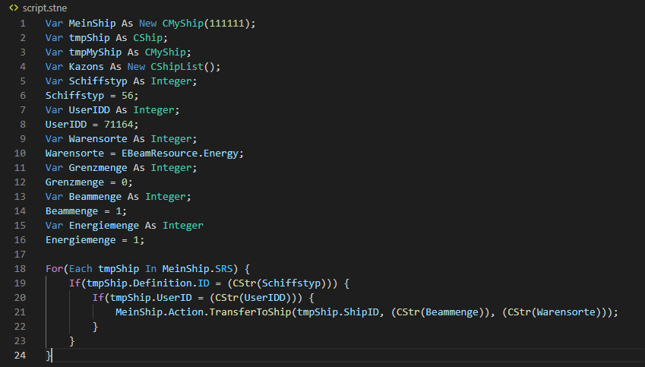

The extension also provides basic formatting for stne script files. Use the VS Code command **ALT + SHIFT + F** to format the document and remove whitespaces and fix the indentation.

Before:

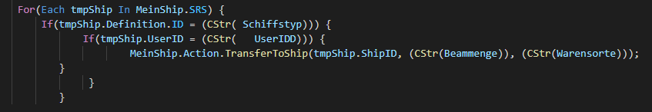

After formatting:

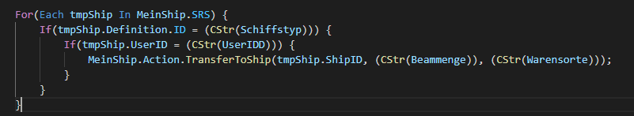

Also, the extension provides some basic autocompletion:

Of course, the IDE will give you suggestions for already written words:



But the extension will also give you suggestions for members (attributes and methods):

