BigfootTrackers.com

# 

# Site Description

BigfootTracker.com is a website for tracking and reporting sightings of Bigfoot. The site provides a news feed for relevant news for the bigfoot community. It also has a system for viewing, adding, and editing bigfoot sightings. Users will also have the option of sighting up for email alerts that trigger when a sighting is added. The site will have a green woodlands aesthetic and possess bigfoot paraphernalia in the form of various media decorating the pages. The look of the site is inspired by <https://www.bfro.net/> with a green theme instead of black. The site will be built using Html and css. With most application features built with php.

## Site Target Audience

* Bigfoot believers
* Conspiracy Theorists
* Cryptozoologists

## Site Purpose

* Provide news for the target audience
* Record sightings of Bigfoot
* Keep target audience informed of new sightings

## Site Functions

* Bigfoot Sightings Database
  + Add to database
  + Edit database
  + Delete data from database
  + Validation for data added to database
* Email alert system
  + Mail() function sending emails when called
  + Database of emails
  + Add to email database

## Tools used

* Visual Studio Code
* MYSQL Workbench 8.0 CE
* XAMMP Control Panel v3.3.0
* Apache NetBeans IDE 15
* MYSQL80
* Apache
* PHP
* HTML

# Navigation Diagram

The user will land on the index page. From there they can move to the sightings and alerts pages. The sightings page contains the buttons to take you to the add and delete/edit pages which are separated for aesthetics.

# Pages

## Index Page

* Landing page
* Home page
* Possesses news feed

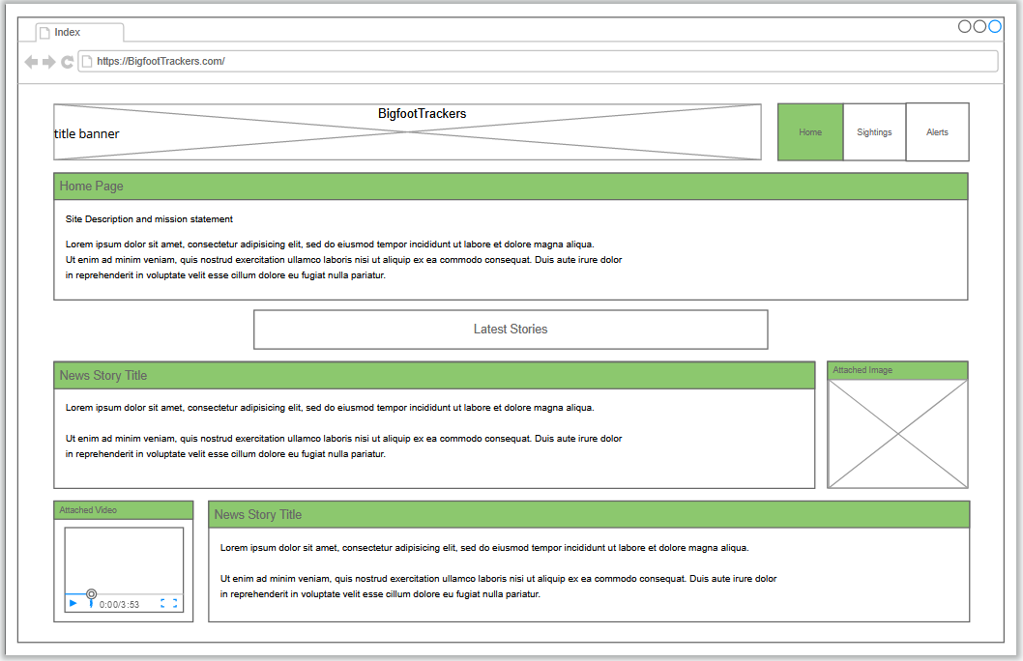

The index page is the landing page for the site. At the top of the page will be the website’s banner and the navigation banner to get to the 3 main pages. Below this is the sites and pages description. This will contain the site’s purpose and features, as well as telling of the news feed on the current page. The news feed will be segmented articles with media on the left or right to accompany the piece. Size is subject to change based on the size of elements and articles. This page can be entirely made through html and css.

## Alerts Page

* Add email to email alerts mail list
  + Mail list is a database added to by the form

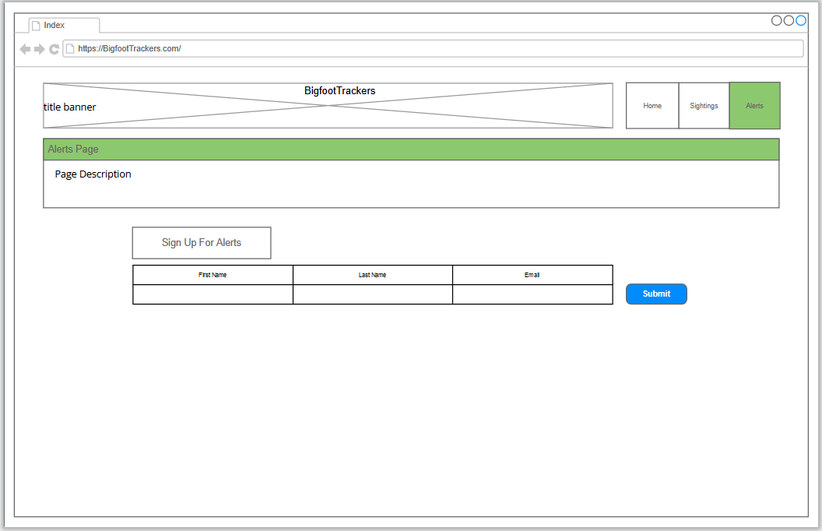

The alerts page is where the user goes if they wish to sigh up for email alerts. At the top of the page will be the website’s banner and the navigation banner to get to the 3 main pages. Below this is the page description. This page will simply posses a form where the user can enter some basic information and have their name added to a database of other emails that will be sent a basic message when a sighting is added. The form will have its input data checked to ensure integrity. When a sighting is added, a loop will be run that feed database of user info into a mail() php function.

## Sightings Page

* Primary feature of site
* Displays contents of sightings database
* Buttons that lead to other pages

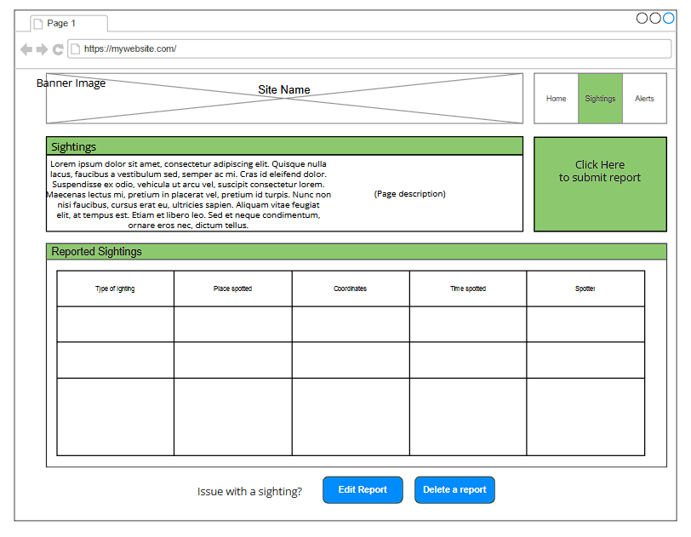

The sightings page is the main feature of the site. At the top of the page will be the website’s banner and the navigation banner to get to the 3 main pages. Below this is the page description. To the right of the description is a graphic that will act as a button. This button takes the user to the add page. In the center of the page will be the sightings table. This table will posses the contents of the sightings database. The table will be updated as the database is. Below this table is two buttons that take the user to the edit/delete page in case there is an error with a sighting. These buttons are separated for user clarity. Edit, delete, and add functions are on separate pages for readability and aesthetics. The primary build of the page will be made using html and css. Php will be used for the database table.

## Add Page

* Form for adding entry to sightings database
* Trigger for email alerts

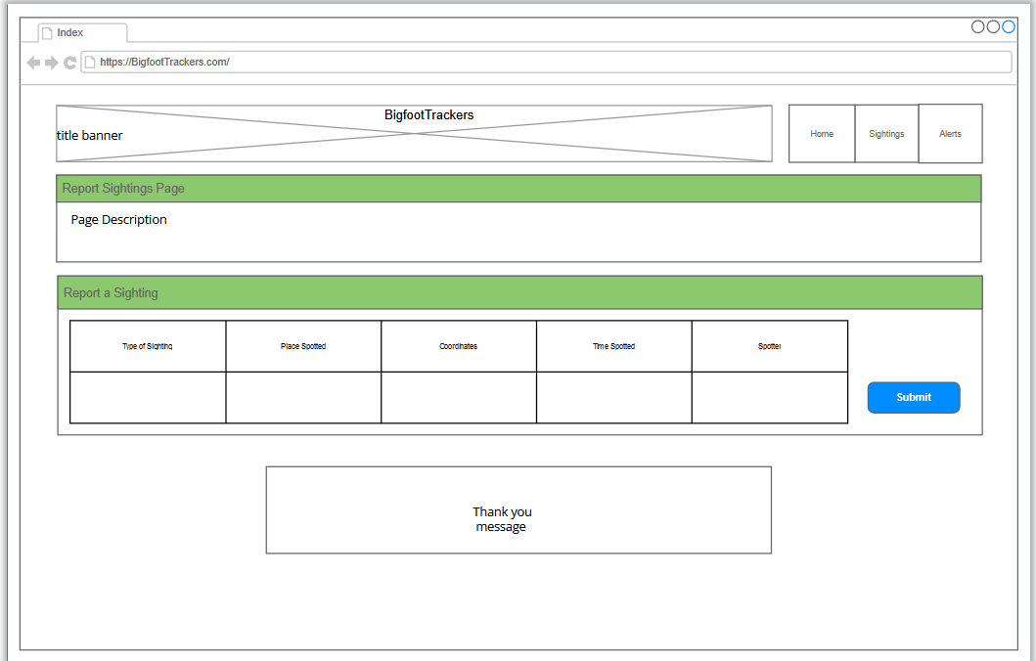

The add page is where the sightings database is added too. At the top of the page will be the website’s banner and the navigation banner to get to the 3 main pages. Below this is the page description. The center of page will have a form which the user can submit to add to the sightings database. The form will have its input data checked to ensure integrity. Once the user hits submit the email alert function is called. Below the form will be a thank you message to thank the user for reporting. The build of the page will be html and css. Php will be used to program the database manipulation in the background.

## Edit/Delete Page

* Sightings database but with buttons to manipulate data

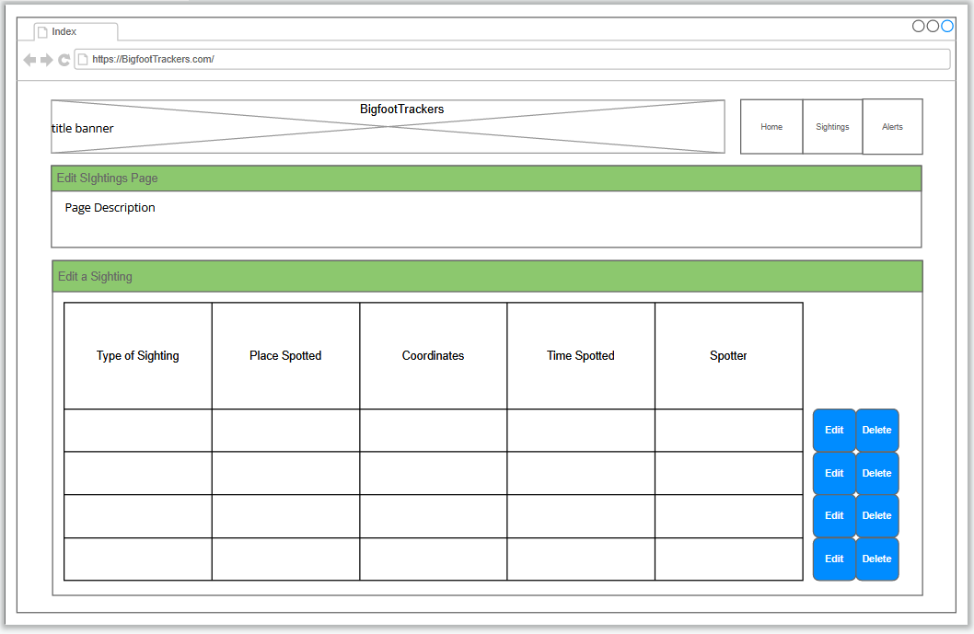

If the user has a problem with a sighting they can come to this page. At the top of the page will be the website’s banner and the navigation banner to get to the 3 main pages. Below this is the page description. This page will posses the sightings database but will have added buttons to edit and delete entries. If the delete button is pressed that entry will disappear from the table and database. If the edit button is pressed a text prompt will appear for the user to edit that entry. The build of the page will be html and css. Php will be used to program the database and manipulation in the background.

# Storyboards

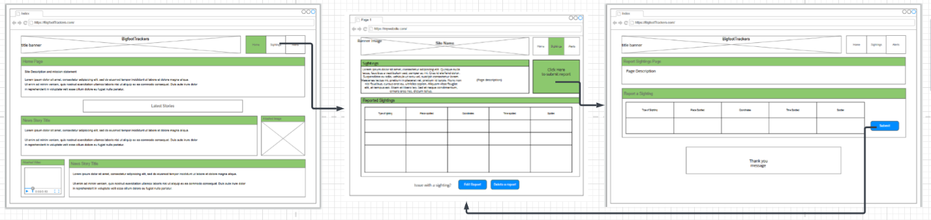

In this storyboard a user adds a sighting:

1. User lands at the index page
   1. Navigation buttons are clearly visible
   2. News feed is visible and enticing with images
2. User uses the navigation bar to click sightings page option
3. Enter the sightings page
   1. All of the sightings page functions stand out
4. The user clicks the graphic to report a sighting
5. Enter the add page
6. User fills out form
7. User submits form
8. Submit button takes user back to sightings page.

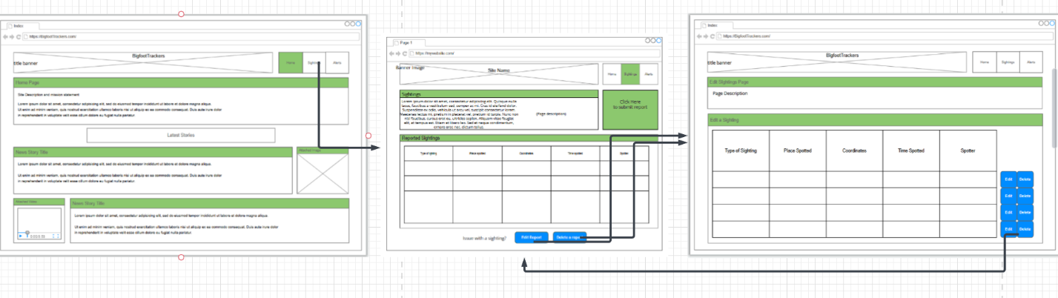

In this storyboard the user notices a problem and makes an edit to the database:

1. User lands on the index page
2. User clicks navigation button for sightings page
3. User arrives on navigation page
4. User then notices issue with database
5. User clicks edit or delete button to enter edit/delete page
6. User arrives at the edit/delete page
7. User uses buttons to manipulate the database
8. User is then taken back to the sightings page

References:

https://www.bfro.net/