Hybrid Centralized Voting System

Reg. no: 20584

M. Fawad

Abasyn University, Peshawar

Friday, 15 December 2023

Table of Contents

Software Architecture & Design 3

1. System Models 3

Voter & candidate: 3

EDA: 3

System Admin: 4

2. Dynamic model 4

Voter module: 4

Candidate module: 5

EDA module: 5

System Admin: 5

Database Design 6

Tools and Technologies Used 6

Dart: 6

Node js: 6

Truffle (node library): 6

Truffle Ganache (a local blockchain): 6

VSCode: 6

Solidity 0.8.19: 6

Sepolia Ethereum Faucet: 6

Sepolia Ethereum Test-net: 7

Remix IDE 7

Metamask (A crypto wallet): 7

Firebase: 7

Wondershare EdrawMax: 7

# Software Architecture & Design

## 1. System Models

### Voter & candidate:

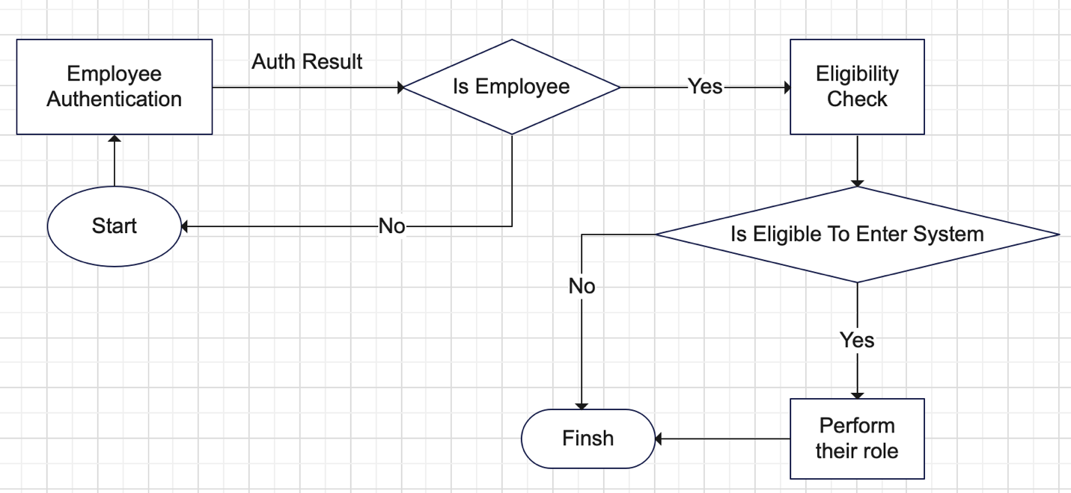

### EDA:

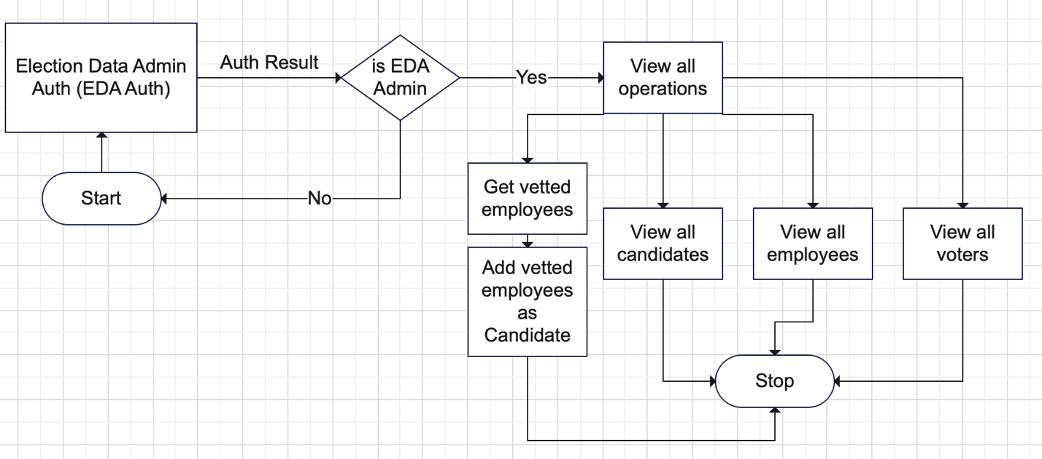

### System Admin:

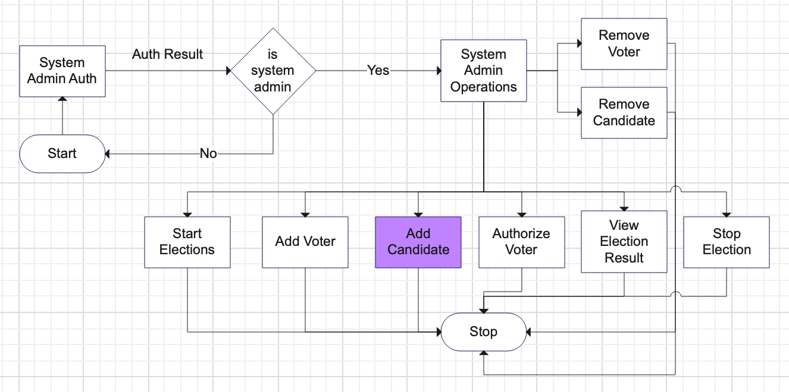

## 2. Dynamic model

In dynamic model, the changes which comes w.r.t time or event are to be modelled. So for this purpose, DFDs are used because they show the exact data flow at each process within each system’s modules.

### Voter module:

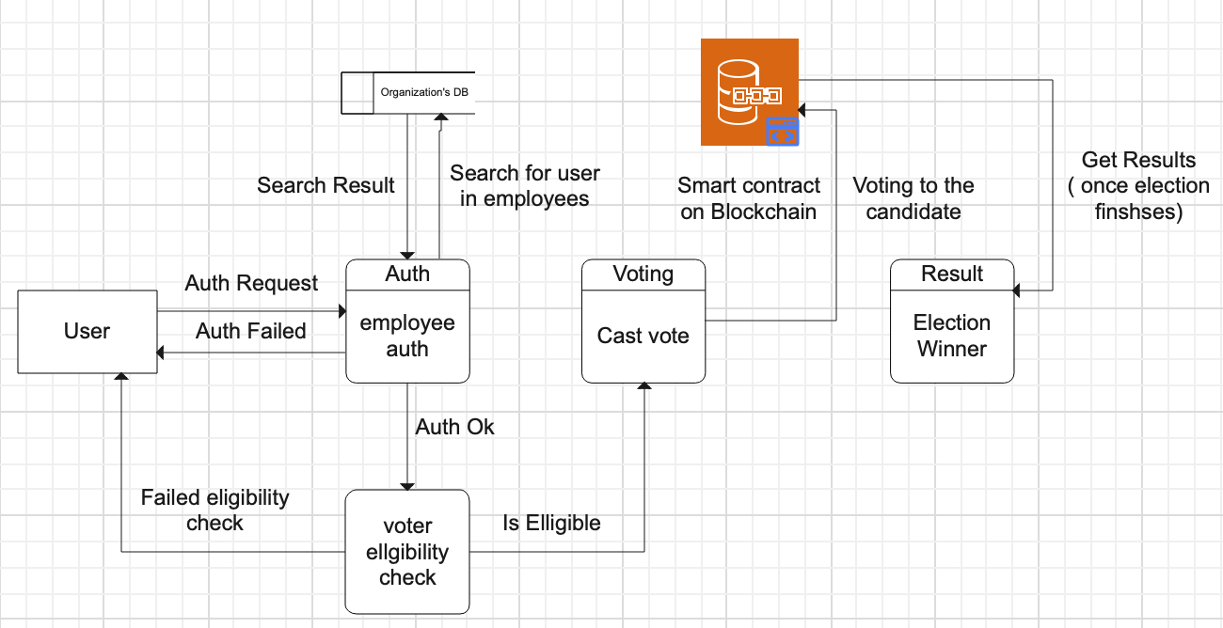

### Candidate module:

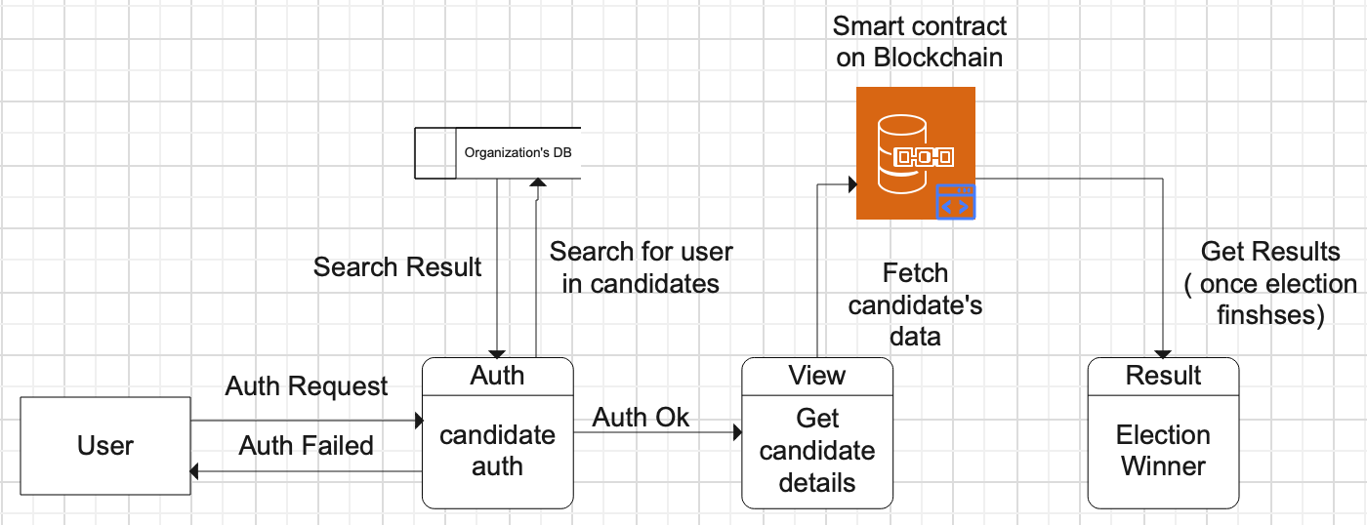

### EDA module:

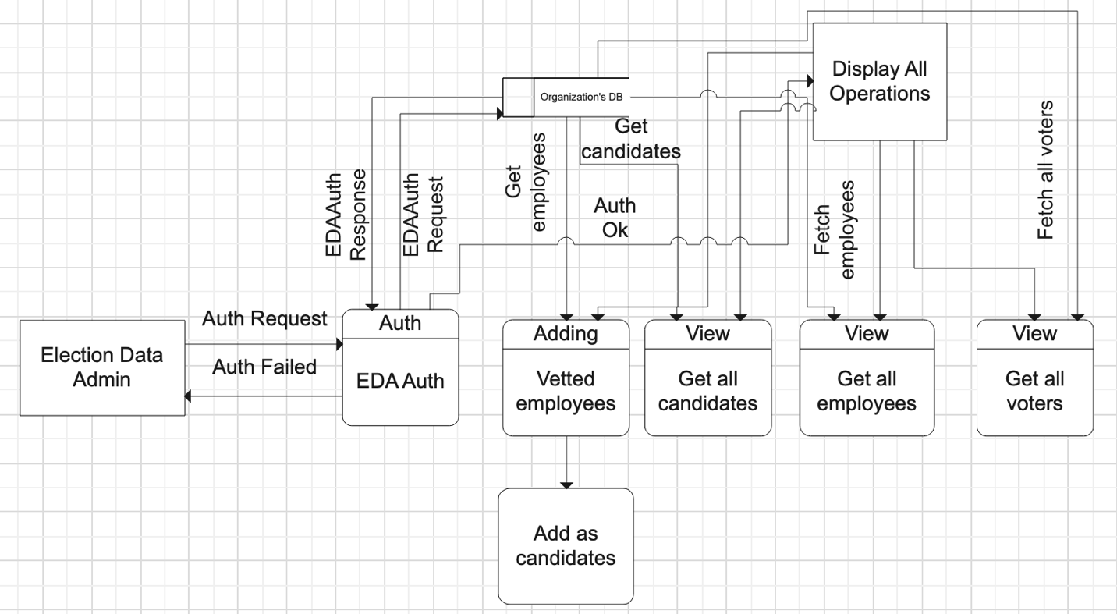

### System Admin:

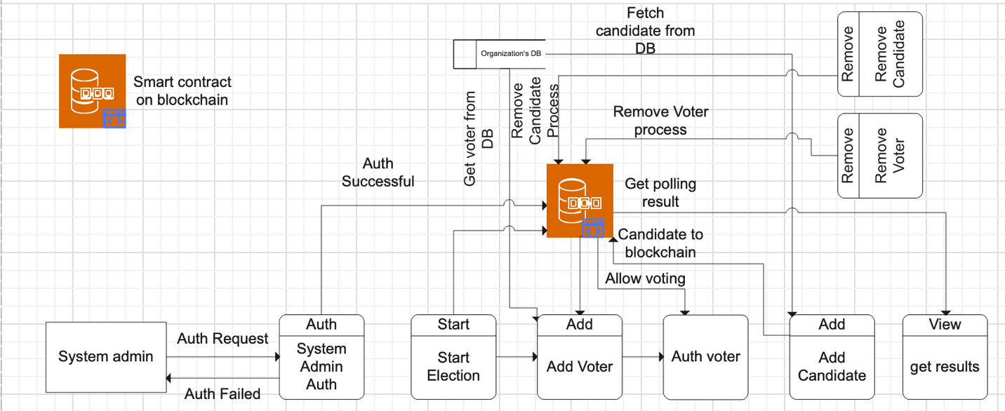

# Database Design

The ERD to show the relationship among the entities of the system proposed is as under:

**NOTE:** The crow’s foot notation of ERD is now only in premium version of Edraw max, that’s why I draw with this method.

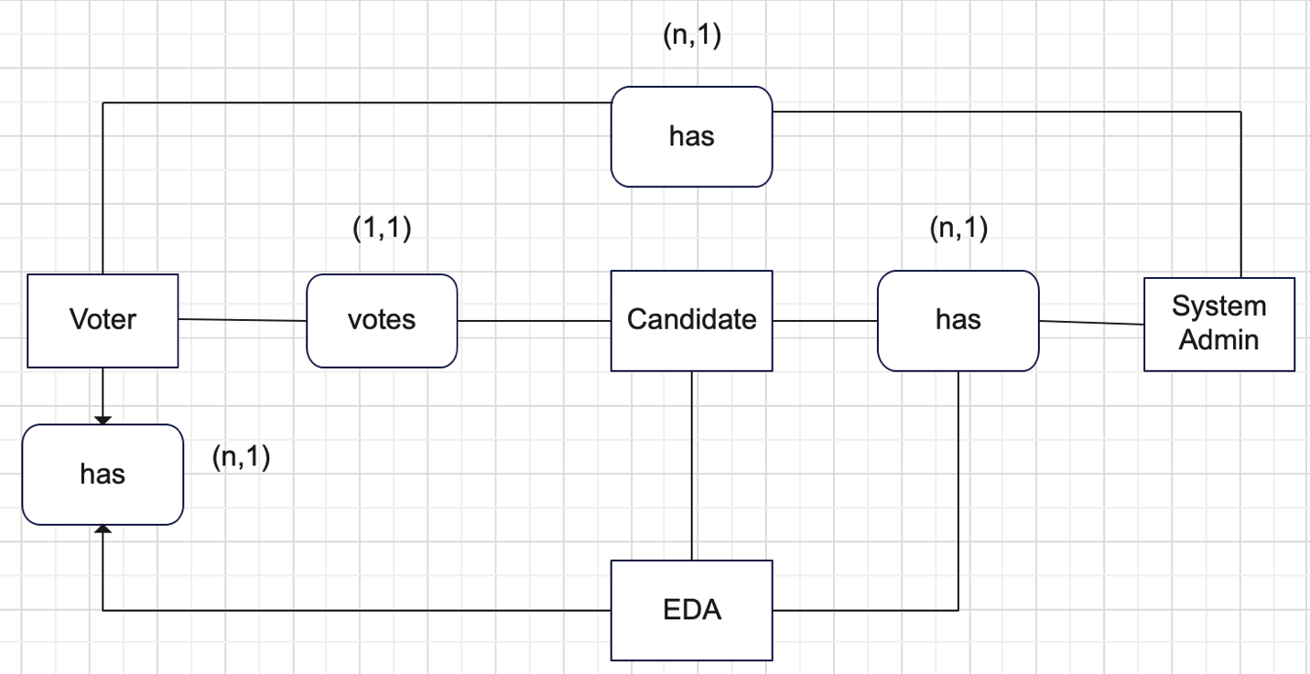

* A voter votes for a candidate.
* Many candidates and voters have a system admin
* Many candidates and voters have an EDA (Election Data Admin).

# Tools and Technologies Used

The system is a set of 4 mobile applications and will be build using flutter framework primarily, the other required technologies are:

Dart: Flutter’s default programming language.

Node js: For writing the migrations to deploy the smart contract on local blockchain of Ethereum, provided by the Truffle Ganache.

Truffle (node library): A node library installed globally, to facilitate web3 development and providing local solidity compiler to write the solidity smart contracts.

Truffle Ganache (a local blockchain): A local ethereum blockchain to deploy and test the solidity smart contracts before deploying them in a production level blockchain(s).

VSCode: For flutter app development, developing local smart contract using solidity

Solidity 0.8.19: The version of solidity, which is used in smart contract’s developing which is deployed on the sepolia test net. Solidity is the programming language with which you can interact with the ethereum based blockchains.

Sepolia Ethereum Faucet: To get test ethers, which’ve no market value, are not actual ethers, can be acquired free of cost, and are to be used as gas fee of the smart contract deployment over the sepolia blockchain.

Sepolia Ethereum Test-net: A sandbox blockchain made for testing of a smart contract, created by Ethereum, where contract deployment occurs, without the actual ethereum(s) deduction as gas fee from your crypto-wallet

Remix IDE: For solidity compiling and smart contract deploying over sepolia test-net.

Metamask (A crypto wallet): For storing sepolia test ethers and to deploy the smart contract over the sepolia testnet, by adding it to the remix IDE as an ether wallet

Firebase: As a central database for the non-existing organization’s data storage.

Wondershare EdrawMax: For UML diagrams creation.