# Graph brief description

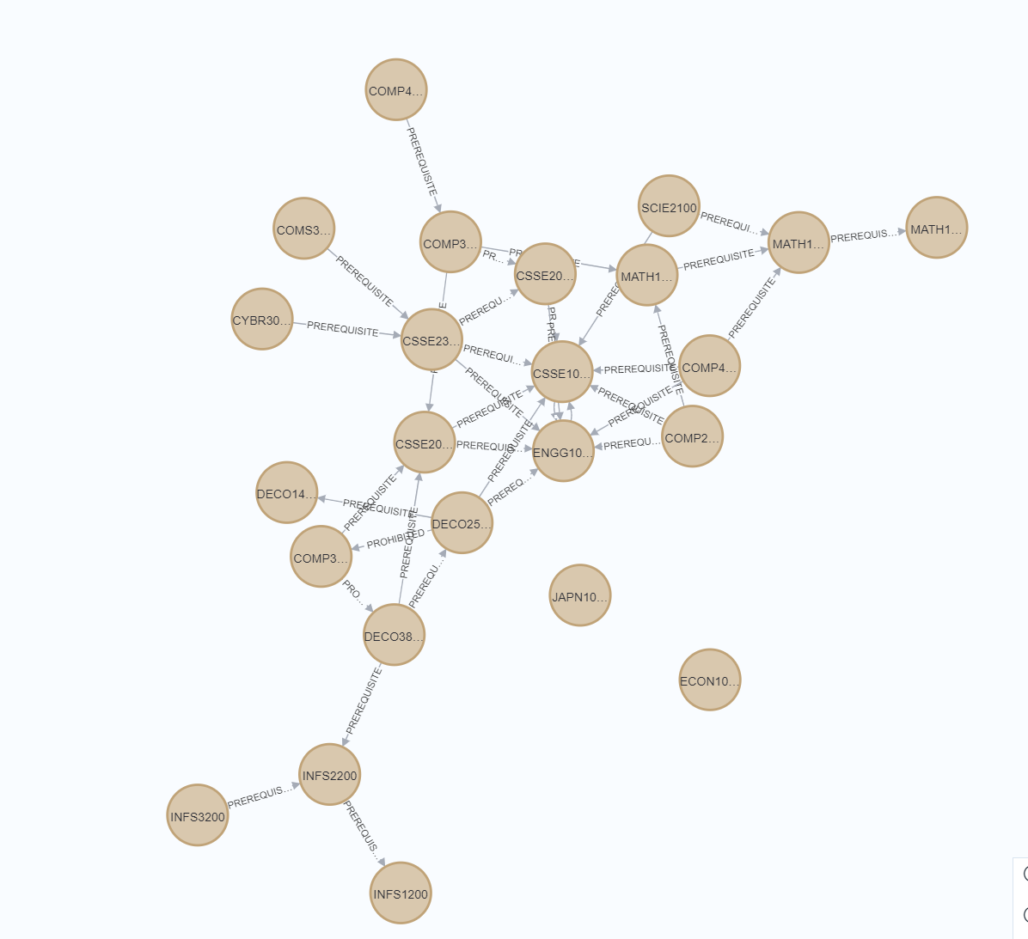The graph contains 24 unites node and 2 different relationships PREREQUISITE and PROHIBITED between each node. Relationship (n1) – [:PREREQUISITE] -> (n2) means n2 is the prerequisite course for n1. Relationship (n1) – [:PROHIBITED] -> (n2) means n2 is prohibited to choose if you choose n1.

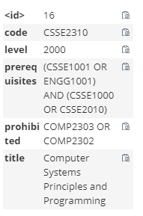Each unite node contains at most 5 information: code, level, prerequisites, prohibited and title like the picture on the left.

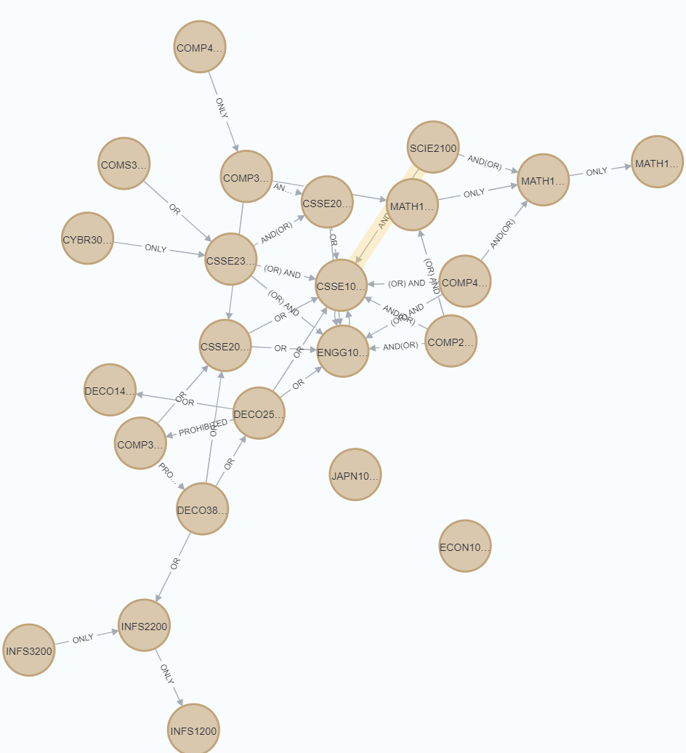In relationships PREREQUISITE, there are also 4 different type “OR”, “(OR) AND”, “AND(OR)”, “ONLY”. “OR” represents the prerequisites only has OR operation. “(OR) AND”, “AND(OR)” both represents (u1 OR u2 OR u3 ...) AND (u4 OR u5) situation, “(OR) AND” represents left OR operation, and “AND(OR)” represents right OR operation. “ONLY” represents this is only one prerequisites course.