CONCURRENCY ASSESSED COURSEWORK 1
Jack Thorp

1.
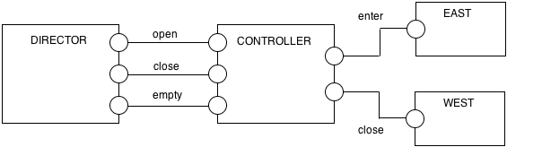
2.
EAST = (enter -> EAST).

WEST = (exit -> WEST).

CONTROL (N=3) = (open -> OPEN[0]),

OPEN[i:0..N] = ( when(i<N) enter -> OPEN[i+1]
| when(i>0) exit -> OPEN[i-1]
| close -> CLOSE[i]),

CLOSE[i:0..N] = (when(i>0) exit -> CLOSE[i-1]
|when(i==0) empty -> CONTROL).

DIRECTOR = (open -> close -> empty -> DIRECTOR).

||MUSEUM = (DIRECTOR || CONTROL || EAST || WEST).

3.
CLOSE_ENTER_T = (open -> ENTER_T),

ENTER_T = (enter -> ENTER_T
| exit -> ENTER_T
| close -> CLOSE_T),

CLOSE_T = (enter -> ERROR
| exit -> CLOSE_T
| empty -> CLOSE_ENTER_T).

4.
Trace to DEADLOCK:
open
enter
close

