Swarm-PI System Overview

Stephen Majercik, Frank Mauceri, Grace Handler, Jack Truskowski

Updated 5/1/16

**Overview**:

I. Directory Structure

II. Jitter External Data Structures

III. General Code Structure

IV. Max Parameters

V. External Outlets

**I. Directory Structure**

**Max Patch Files:**

*ControlPanel_XX-XX.maxpat* - This is the max file that the simulation and contains everything related to the simulation including the external jitter object that is used in the simulation. Instructions on running the simulation can be found in this file in Presentation Mode.

*FlockParamUI_XX-XX.maxpat* - This is a max patch that is embedded in the *ControlPanel* patch. Contains the number fields for all the parameters of a flock and packages when a parameter is changed in the Control Panel, this file packages a message that will be sent to the external object.

ie) Changing the speed of the first flock to 5.0 would produce the message: 'speed 5.0 1', where 5.0 is the new speed for this flock, and 1 is the flock whose speed will be updated

**Code:**

*XX-XX_Code* - This directory contains the code for the jitter external, *jit.boids3d.mxo*, which performs updates to the boids. Opening *jit.boids3d.xcodeproj* will allow you to make changes to the code which can then be compiled into a new external (For compilation instructions, refer to the User Manual in the *Help/* directory)

*Dependencies* - This directory contains various Jitter and Max header files that are required to compile the external. This directory should remain unchanged.

**Help Files:**

*Help ­-* Contains various instructions and help files that are useful for running and understanding the simulation and external object.

*README.md* - A markdown file for GitHub containing general information about anticipated future work.

**Other:**

*jit.boids3d.mxo* - The compiled jitter external object from the code in the *XX-XX_Code* directory. This file is used in the Control Panel to perform updates on the boids.

*paramPreset.json* - A JSON object containing preset flock behaviors. Interacting with this file is not necessary, it is automatically loaded into the presets section of the Control Panel upon startup and presets can be saved within the Control Panel.

**II. Jitter External Data Structures**

This section contains info about the data structures used in the *jit.boids3d.mxo* object. This code can be found in the XCode project in the *XX-XX_Code/* directory.

**Flock Parameters:**

The flock-specific parameters for the flocks are stored in arrays of size 6 (an index for each flock) in the jitter object struct.

Example Code:

typedef struct _jit_boids3d

{

double minspeed[MAX_FLOCKS]

double maxspeed[MAX_FLOCKS]

...

}

Note: the constant MAX_FLOCKS is set to 6

**Boids:**

Boids are individual structs that are stored in a linked list for each flock. A linked list was used because this allows boids to be added and deleted quickly without the overhead of creating a new array of appropriate size and copying the boids over every time the count changes.

The linked lists for each flock are stored in an array of size 6 (an index for each flock). Refer to Fig. 1 for the organization of flocks/boids.

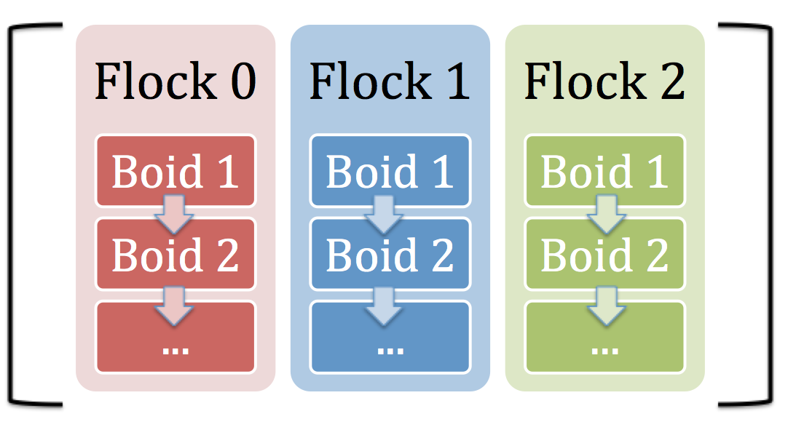

**flockPtr flockLL[MAX_FLOCKS] =**

**Fig. 1: Organization of the boids linked lists**

The boids struct contains the following data about a boid:

- Flock ID (which flock this boid is a part of)

- Age (int, in timesteps)

- Old Position (double[3], xyz)

- New Position (double[3], xyz)

- Old Direction (double[3], xyz)

- New Direction (double[3], xyz)

- Speed (double)

- Neighbors (long[kMaxNeighbors])

- Neighbor Distance Squared (double[kMaxNeighbors])

- Pointer to the next boid in the flock

**Attractors:**

Attractors are also structs which are stored in a linked list (called attractorLL) in the _jit_boid3d object. The attractor struct contains the following:

- Attractor ID (int)

- Location of the attractor (double[3], xyz)

- Radius of the attractor (note: this is called attractorWeight)

- Pointer to the next attractor in the LL

**Neighborhood Lines:**

All of the neighborhood lines (a maximum of kMaxNeighborLines lines) are stored in the array:

NeighborLinePtr neighborhoodConnections[kMaxNeighborLines];

Each neighbor line in this array is a struct that contains the following data:

- Position of the first boid (float[3], xyz) - this is an endpoint of the line

- Position of the second boid (float[3], xyz) - this is the other endpoint

- Flock ID - neighborhood lines are only drawn between boids of same flock

**Other:**

- Birth location is stored in an array - double birthLoc[3]

- The center point of the current flock being updated is stored in an array - double tempCenterPt[3]

- The boundaries of the simulation are stored in an array - double flyrect[6]

**III. General Code Structure**

**1. Lines 0-375: Global variables, structs, and function definitions**

This section contains code for the above components. It also contains the initializer for the _jit_boids3d object which is called on startup and initializes all of its attribute methods

**2. Lines 375-725: Boids attribute methods**

This section contains all the attribute methods for the external. When a message is passed to the external to change a parameter, the cooresponding attribute method in this section is called, which then updates the global variable for this parameter stored in Section 1.

**3. Lines 725-990: Matrix output methods**

After every timestep, these methods are called to prepare the matricies that will be outputted in the 4 outlets of the external object back to the Max Patch.

jit_boids3d_matrix_calc(): Prepares the matricies, populates matricies 2-4 with data, and outputs all of them to the max patch.

jit_boids3d_calculate_ndim(): Called by the matrix_calc method, populates the 1st matrix with data

For more information on the contents of each matrix going back to the Max Patch, refer to *Help/Swarm-PI_Parameters.docx*

**4. Lines 990-1445: Boid update methods**

These lines contain all the functions that are used to update each boids direction and position every timestep.

FlightStep(): Calculates the new velocity and position of each boid. Calls the other methods in this section to get each component of the boids new velocity

**5. Lines 1445-end: Memory management methods**

Methods in this section are intializers for the various structs and objects in the external. Allocation and freeing of memory for all of these objects occurs in this section.

**IV. Max Parameters**

**Population:**

Number of boids in the flock

-> total number across all flocks must be < 1000

**Speed:**

Multiplier on the final speed (magnitude) after all velocity components are added. (Note: This allows boids to travel faster than the max speed- why? Do we want that?)

Range: 1.0 - 8.0

**Max:**

Upper bound on boid speed (except for speed parameter)

Range: 3.0 - 10.0

**Min:**

Lower bound on boid speed (except for speed parameter)

Range: 0.5 - 5

**Inertia:**

The resistance of boids to change speed and direction. ~Mass of the boids

->Calculated by multiplying the old direction by the inertia, and dividing all the other components by the inertia.

->Inertia seems related to acceleration

Range: 6-15

**Accel (not currently used):**

Acceleration is based on neighbor positions only (not attractors). Is related to the speed of the. How to incorporate this?

-> Should this be used to somehow limit the magnitude at each timestep?

**Center:**

Component of velocity -- Boids feel attraction to the average position of their neighbors.

Range: 0-15

**Attract:**

Component of velocity -- Boids feel attraction to the closest attractor (based on flocks)

->Possible future work would be to have attraction level based on the attractor, not the flock or some combination.

Range: 0-15

**Match:**

Component of velocity -- Boids feel attraction to the average direction of their neighbors. Same as center but with direction instead of position

Range: 0-15

**Separation Dist:**

Closest boids can be to their neighbors (if they are less than this, a separation component of velocity will kick in)

Ranges: (World is 10x10x10)

Close cohesion with flock = 0.05 - 0.2

Far cohesion with flock = 0.2-0.5

Avoidance of other boids = >4

**Separation Wt:**

Component of velocity -- How much boids will try to maintain the specified Separation Dist

Range: 0-15

**NRadius:**

How far away from themselves in the simulation boids will have neighbors

Range: 0-25 (World is 10x10x10)

**Age:**

Number of timesteps boids in this flock will stay alive

->Live forever = -1

**\*\*\***NOTE: For the parameters that are components of velocity, the absolute value does not seem to matter so much as its relationship to the other components of velocity. **\*\*\***

**V. External Outlets**

**Outlet #1 - Boid Info Matrix**

Note: The dimensions of this matrix and its contents depend on the mode, which is documented in the max patch. This is what the planes are for Mode 0:

Plane 0 - X position

Plane 1 - Y position

Plane 2 - Z position

Plane 3 - Flock ID

**Outlet #2: Boid Counts**

Outputs the number of boids in each flock (one per plane)

**Outlet #3: Attractor Info**

Format:

Plane 0 - X position

Plane 1 - Y position

Plane 2 - Z position

Plane 3 - Attractor ID

Plane 4 - Attractor Strength

**Outlet #4: Matrix with lines connecting neighboring boids**

Format:

Plane 0 - boid1, X position

Plane 1 - boid1, Y position

Plane 2 - boid1, Z position

Plane 3 - boid2, X position

Plane 4 - boid2, Y position

Plane 5 - boid2, Z position

Plane 6 - Flock ID

Note: connecting lines are only drawn between boids of the same flock