- Install Ubuntu or any Linux distribution in a virtual machine. Document the installation steps.
Step 1 Download Oracle VirtualBox from virtualbox.org and install it on your host machine.
Step 2 Download the 24.04.4 LTS ISO from https://lubuntu.me/downloads/.
Step 3 Open VirtualBox → Click New → Name it lubuntu_base.
Step 4 Allocate RAM: Set memory to 8192 MB (8 GB).
Step 5 Create a Virtual Hard Disk: Choose VDI → Dynamically Allocated → 25 GB.
Step 6 Attach ISO: Go to Settings → Storage → IDE Controller (Empty) → select the downloaded Lubuntu .iso file.
Step 7 Start the VM. At the boot menu, select Try or Install Lubuntu.
Step 8 Choose language (English) → Click Install Lubuntu.
Step 9 Select keyboard layout → Choose Normal Installation → check Download updates while installing.
Step 10 Installation type → Select Erase disk and install Ubuntu (safe inside VM) → Click Install Now.
Step 11 Set your time zone, create a username and password → Click Continue.
Step 12 Wait for installation to complete → Click Restart Now.
Step 13 Open a terminal and run system updates commands.
Lubuntu is now installed and ready to use inside the virtual machine

- Log in to the Linux system and display the current username using a command.
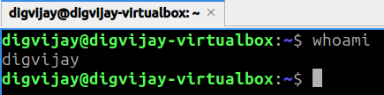
- Display the current working directory using a command.
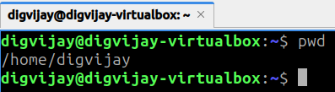

- List all files in the current directory using ls.
- List files along with permissions, owner, and size using an appropriate ls option.
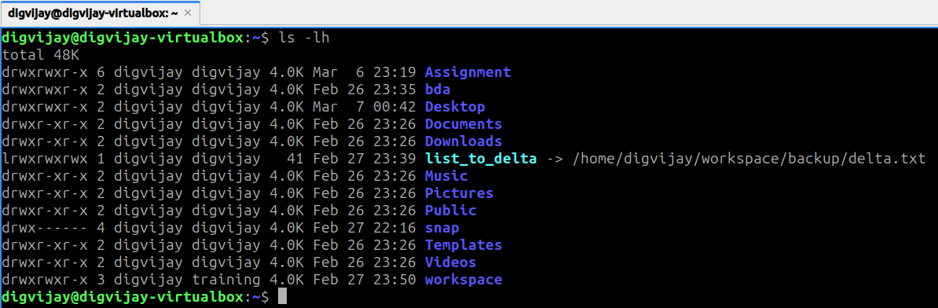
- Create a directory named practice.
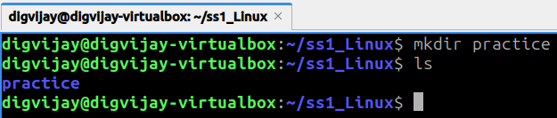
- Navigate into the practice directory.
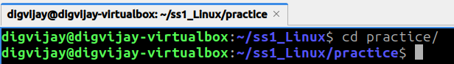
- Create three files named file1.txt, file2.txt, and file3.txt.
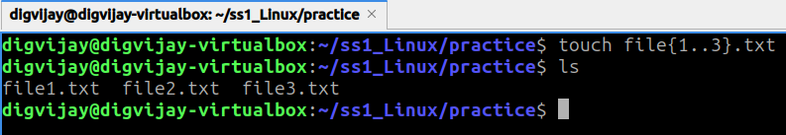
- Display the contents of file1.txt using the cat command.
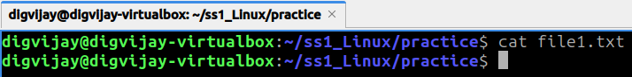
- Create a file and write text into it using the echo command.
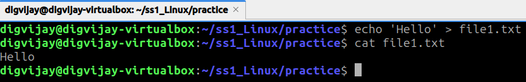

- Copy file1.txt to backup.txt.
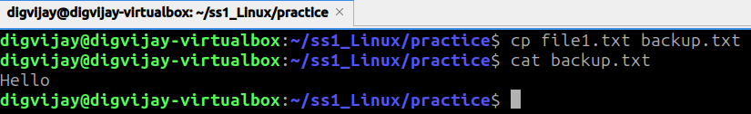
- Move backup.txt to a new directory called backup.
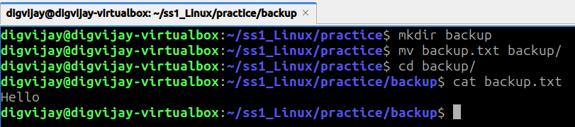
- Rename file2.txt to data.txt.
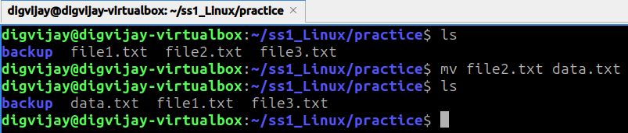
- Remove a file using the rm command.
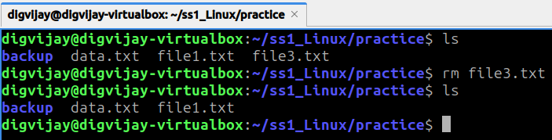
- Remove an empty directory using rmdir.
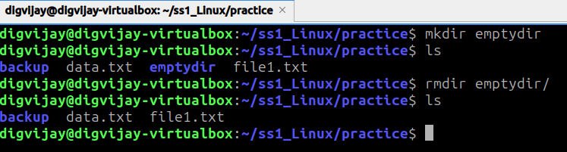

- Create a directory tree project/data/logs.
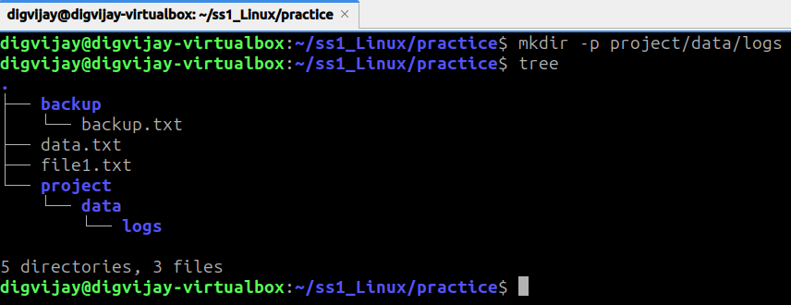
- Display the first 5 lines of a file using head.
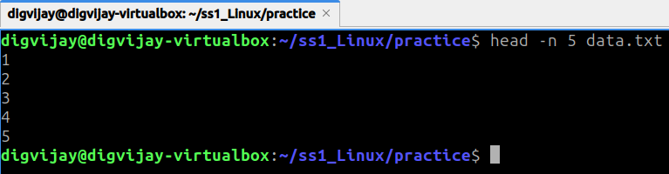
- Display the last 5 lines of a file using tail.
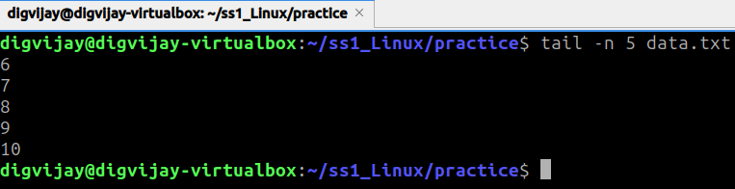
- Sort the contents of a text file using the sort command.
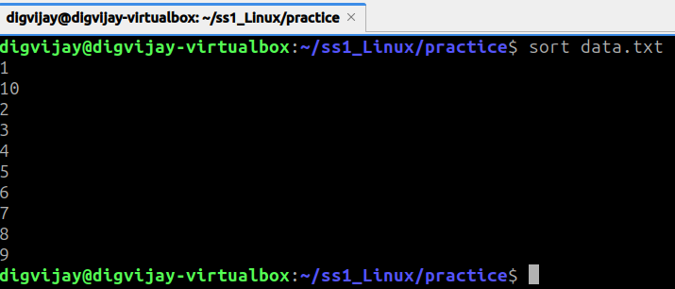

- Search for the word "Linux" in a file using grep.
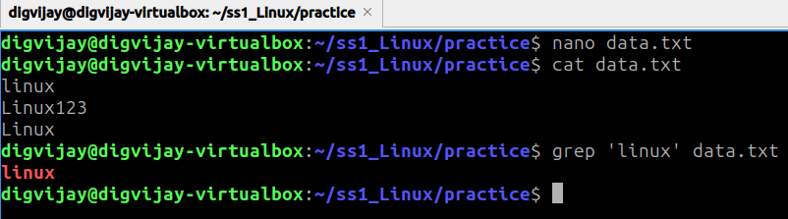
- Use grep with the -i option to search ignoring case.
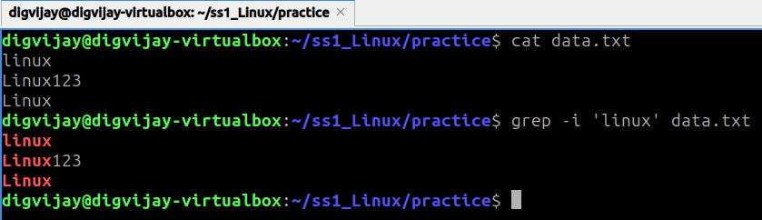
- Use grep to count the number of matching lines in a file.
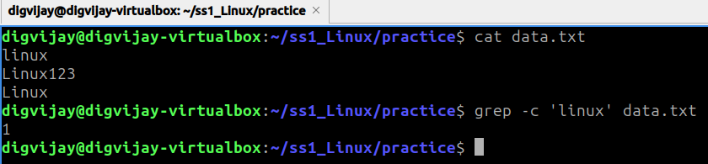

- Display the manual page of the ls command.
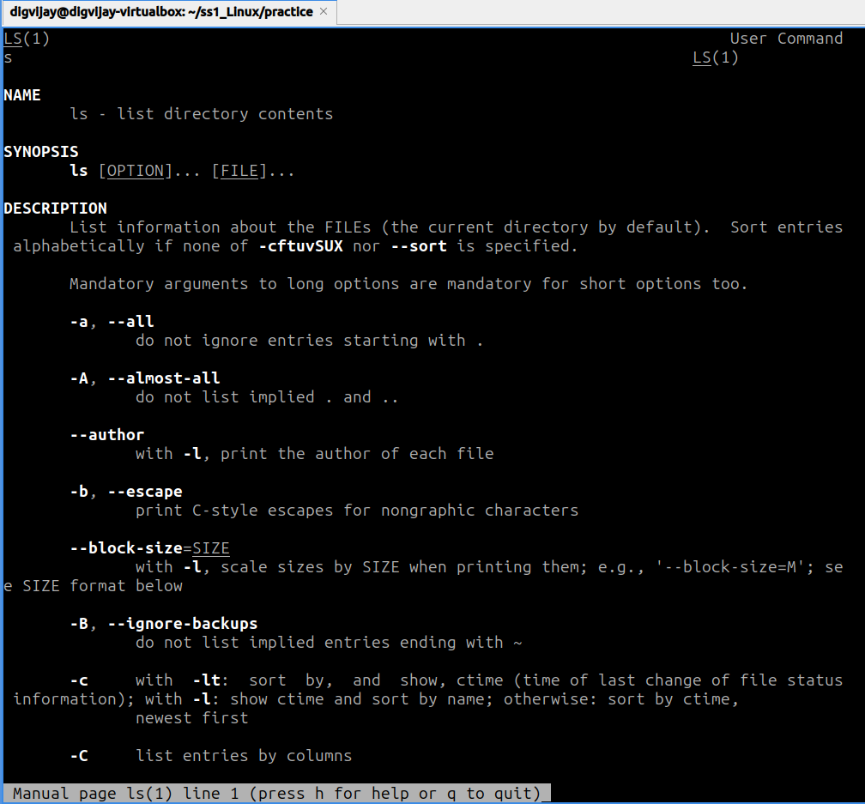
- Find the location of the grep command using which.
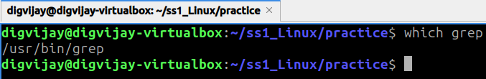
- Locate a file using the locate command.
