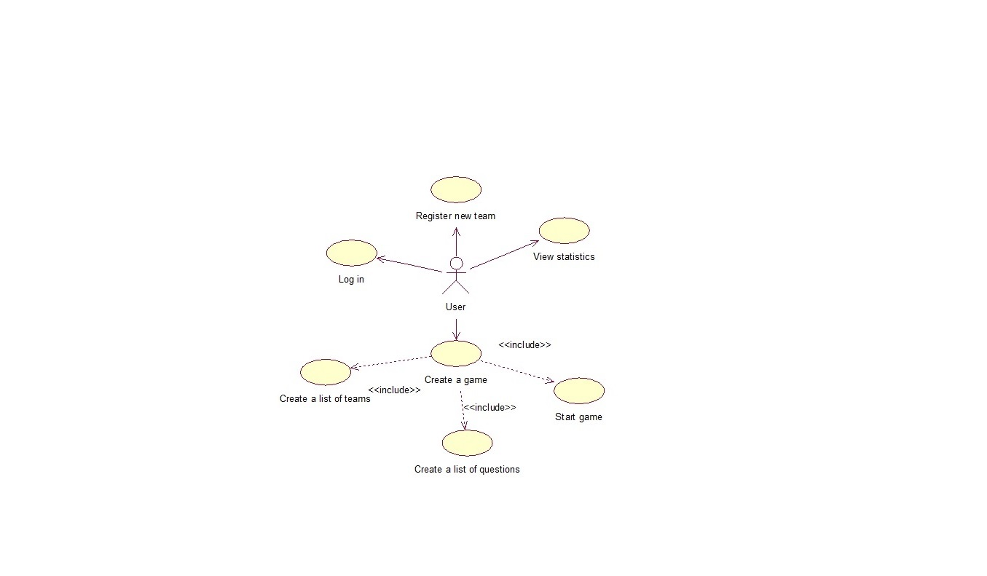

**Events flow for use case “Log in”**

Short description:

Event for signing a game creators in.

Preconditions:

1. User should be registered.

Main events flow:

1. User fill the fields of “login” and “password” in.
2. If user not signed up or input data is incorrect, performed an alternative flow *A1*.

Alternative events flow:

*A1*. System suggest user to register or edit form.

Post conditions:

1. User are logged into the system at a given login.

**Events flow for use case “Register new team”**

Short description:

This use case is for registering new teams in the system.

Preconditions:

1. User should be signed in.

Main events flow:

1. User tap a special button for team registering.
2. Feel in the fields.
3. If there is a team with duplicate data in DB, suggestion to retry input.

Post conditions:

1. New team are registered in the system.

**Events flow for use case “View statistics”**

Short description:

Event for showing a teams statistics for the current gaming season.

Preconditions:

1. User should be signed in.

Main events flow:

1. User tap a special button for statistics viewing.

Post conditions:

1. Demonstrated statistical table.

**Events flow for use case “Create a game”**

Short description:

Use case for creating a new game.

Preconditions:

1. User should be signed in.
2. There should be more than one team in list.

Main events flow:

1. Standings creating starts. User can choose teams from global list.
2. If there is less then 2 teams in global list, suggestion to create new teams, transition to new team creating item.
3. Creating of list of questions.
4. Start game. There a certain period of time to answer each question and statistics recording after chosen number of questions.

Post conditions:

1. Every team’s result record.
2. Creating of rating table.