Jack Wilburn
Test 2: Take-home

- Relational Schema Attached Below:
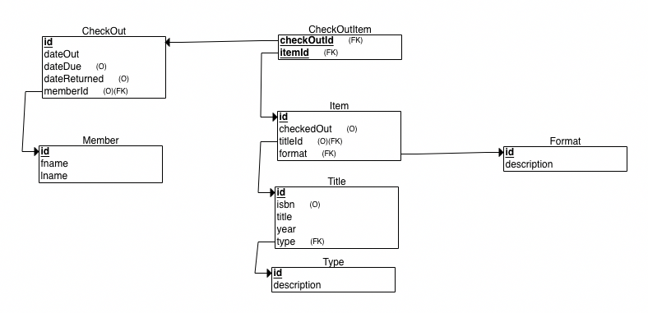
- Queries with joins
  - SELECT COUNT(*) FROM Title
JOIN Type ON Title.type = Type.id
WHERE description = 'Book';
+----------+
| COUNT(*) |
+----------+
| 24 |
+----------+
  - SELECT COUNT(*) FROM Item
JOIN Title ON Item.titleId = Title.id
JOIN Type ON Title.type = Type.id
WHERE description = 'Book';
+----------+
| COUNT(*) |
+----------+
| 136 |
+----------+
  - SELECT COUNT(*) FROM Item
JOIN Title ON Item.titleId = Title.id
JOIN Type ON Title.type = Type.id
WHERE description = 'Book' AND format = 'cdsc';

+----------+
| COUNT(*) |
+----------+
| 34 |
+----------+
  - SELECT DISTINCT fname, lname FROM CheckOut
JOIN Member ON CheckOut.memberId = Member.id
WHERE dateReturned > dateDue AND lname LIKE 'Z%';
+---------+--------+
| fname | lname |
+---------+--------+
| Corene | Zeller |
+---------+--------+
  - SELECT isbn FROM CheckOutItem
JOIN Item ON CheckOutItem.itemId = Item.id
JOIN Title ON Item.titleId = Title.id
GROUP BY isbn
ORDER BY COUNT(*) DESC
LIMIT 1;
+---------------+
| isbn |
+---------------+
| 9782519046816 |
+---------------+
- Queries with aggregation
  - SELECT fname, lname, COUNT(itemId) FROM CheckOutItem
JOIN CheckOut ON CheckOutItem.checkOutId = CheckOut.id
JOIN Member ON CheckOut.memberId = Member.id
GROUP BY Member.id
ORDER BY COUNT(itemId) DESC
LIMIT 3;
+---------+---------+---------------+
| fname | lname | COUNT(itemId) |
+---------+---------+---------------+
| Quincy | Crowley | 215 |
| Nilsa | Catron | 187 |
| Britt | Solis | 168 |
+---------+---------+---------------+
  - SELECT isbn, title, COUNT(*) FROM CheckOutItem
JOIN Item ON CheckOutItem.itemId = Item.id
JOIN Title ON Item.titleId = Title.id
GROUP BY isbn, title
ORDER BY COUNT(*) DESC
LIMIT 1;
+---------------+--------------------------------+----------+
| isbn | title | COUNT(*) |
+---------------+--------------------------------+----------+
| 9782519046816 | Merry Scroobers: Crown of Evil | 522 |
+---------------+--------------------------------+----------+
  - SELECT description, COUNT(*) FROM CheckOutItem
JOIN Item ON CheckOutItem.itemId = Item.id
JOIN Title ON Item.titleId = Title.id
JOIN Type ON Title.type = Type.id
GROUP BY type
ORDER BY COUNT(*) DESC;
+-------------+----------+
| description | COUNT(*) |
+-------------+----------+
| Music | 7073 |
| Book | 6428 |
| Game | 5475 |
| Movie | 3884 |
+-------------+----------+

