Jack Wilburn
Assignment 4

- [1NF] Identify the primary key of the MOVIE_STAR table. You may assume that no two stars (or directors) have the same first & last name, but you may not assume that every movie has a different title (remakes, for example). You should also not assume that the database contains only one movie per year!
  - The primary key is: (STAR_FNAME, STAR_LNAME, MOVIE_TITLE, MOVIE_YEAR).
- Identify all partial dependencies and write in determinant → dependent form.
  - (STAR_FNAME, STAR_LNAME) → STAR_DOB
  - (MOVIE_TITLE, MOVIE_YEAR) → (MOVIE_RATING, DIR_FNAME, DIR_LNAME, DIR_DOB)
- Identify all transitive dependencies and write in determinant → dependent form.
  - (DIR_FNAME, DIR_LNAME) → DIR_DOB
- Draw a dependency diagram for this table (as in the book Figure 6.3). You need include only partial and transitive dependencies; dependencies on the primary key are implied.
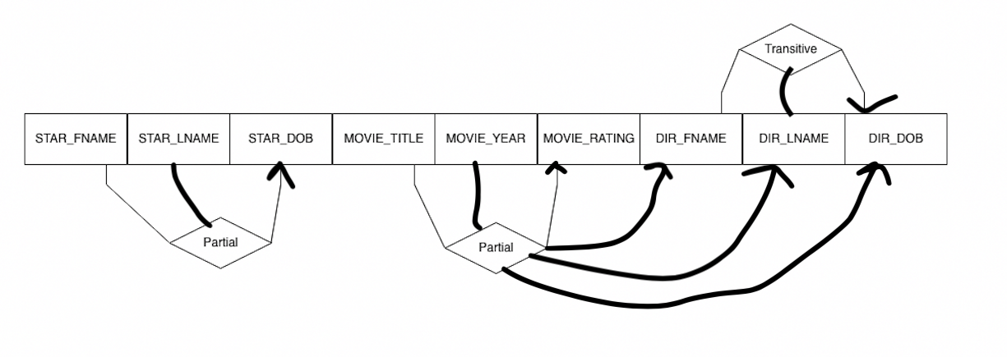
- [2NF] Put the database schema in second normal form. Specifically, write down a list of all the tables, what attribute each has, and clearly label primary and foreign keys.
  - STAR
    - STAR_NUM(PK), STAR_FNAME, STAR_LNAME, STAR_DOB
  - MOVIE
    - MOVIE_NUM(PK), MOVIE_TITLE, MOVIE_RATING, MOVIE_YEAR, DIR_FNAME, DIR_LNAME, DIR_DOB
  - STAR_MOVIE
    - STAR_NUM(FK), MOVIE_NUM(FK)
    - PK: (STAR_NUM, MOVIE_NUM)
- [3NF] Put the database schema in third normal form. Again, write down a list of all tables, their attributes, and primary and foreign keys.
  - STAR
    - STAR_NUM(PK), STAR_FNAME, STAR_LNAME, STAR_DOB
  - MOVIE
    - MOVIE_NUM(PK), MOVIE_TITLE, MOVIE_RATING, MOVIE_YEAR, DIR_NUM(FK)
  - STAR_MOVIE
    - STAR_NUM(FK), MOVIE_NUM(FK)
    - PK: (STAR_NUM, MOVIE_NUM)
  - DIRECTOR
    - DIR_NUM(PK), DIR_FNAME, DIR_LNAME, DIR_DOB
- Notice that some directors are also stars. Is there any redundancy in your 3NF design as a result? Explain. If there is, update your design to eliminate this redundancy.
  - There is redundancy in this design because the people who are directors and stars would appear at 2 points in the table. To rectify this we could combine director and star into a table called personnel. Then we could just have 2 FKs from the personnel table in one linking table to track stars and directors and their role. The personnel table would be almost a union of star and director where PERS_LNAME is a union of STAR_LNAME and DIR_LNAME, and so on. Now the names of the personnel are not redundant
  - PERSONNEL
    - PERS_NUM(PK), PERS_FNAME, PERS_LNAME, PERS_DOB
  - MOVIE
    - MOVIE_NUM(PK), MOVIE_TITLE, MOVIE_RATING, MOVIE_YEAR,
  - PERS_MOVIE
    - PERS_NUM(FK), MOVIE_NUM(FK), PERS_MOVIE_ROLE
    - PK: (STAR_NUM, MOVIE_NUM, PERS_MOVIE_ROLE)
- Use ERDPlus or similar to draw a relational schema for your final database design.
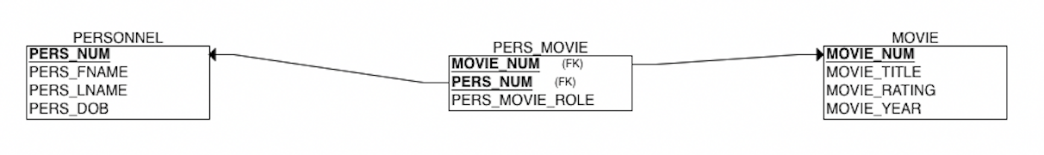
- Identify the primary key of the REGISTRATION table.
  - The primary key is: (CRS_TITLE, SEMESTER, SEC_NUM, STU_NUM)
- [1NF] The CLS_FLAGS column is problematic. Why? Adjust the design of this schema to eliminate the issue.
  - The CLS_FLAGS column breaks the fundamental definition of being a table because it stores multiple values in once cell which is not allowed; the book calls this situation a repeating group. To rectify this, we should add more row to the table so that the CLS_FLAGS only have one entry per row. This means we would need to add some repeated rows where the CLS_FLAGS column is separated out. Also, CLS_FLAGS would now need to be part of the PK so we need it to not be null so every empty CLS_FLAGS cell would have to be filled with “none”.
- Identify all partial dependencies and write in determinant → dependent form.
  - CRS_TITLE → (CRS-PREFIX, CRS_NUM, CRS_HRS)
  - STU_NUM → (STU_FNAME, STU_LNAME)
- Identify all transitive dependencies and write in determinant → dependent form.
  - There are no transitive dependencies.
- Draw a dependency diagram for this table (as in the book Figure 6.3). You need include only partial and transitive dependencies; dependencies on the primary key are implied.
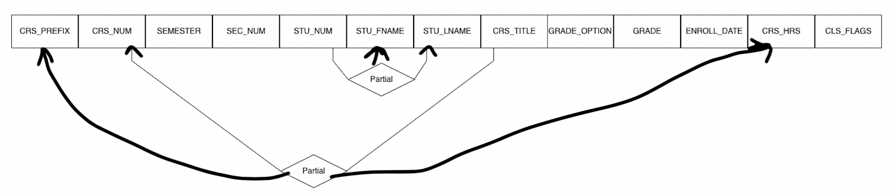
- [2NF] Put the database schema in second normal form. Specifically, write down a list of all the tables, what attribute each has, and clearly label primary and foreign keys.
  - STUDENT
    - STU_NUM(PK), STU_FNAME, STU_LNAME
  - COURSE
    - CRS_TITLE(PK), CRS_NUM, CRS_PREFIX, CRS_HOURS
  - GRADE
    - STU_NUM(FK), CRS_TITLE(FK), SEMESTER, SEC_NUM, GRADE_OPTION, GRADE
    - PK: (STU_NUM, CRS_TITLE, SEMESTER, SEC_NUM)
  - FLAGS
    - FLAG_NUM(PK), FLAG_NAME
  - CLASS_FLAGS
    - CRS_TITLE(FK), SEMESTER, SEC_NUM, FLAG_NUM(FK)
    - PK : (CRS_TITLE, SEMESTER, SEC_NUM, FLAG_NUM)
- [3NF] Put the database schema in third normal form. Again, write down a list of all tables, their attributes, and primary and foreign keys.
  - Nothing to change so it’s the same as before:
  - STUDENT
    - STU_NUM(PK), STU_FNAME, STU_LNAME
  - COURSE
    - CRS_TITLE(PK), CRS_NUM, CRS_PREFIX, CRS_HOURS
  - GRADE
    - STU_NUM(FK), CRS_TITLE(FK), SEMESTER, SEC_NUM, GRADE_OPTION, GRADE
    - PK: (STU_NUM, CRS_TITLE, SEMESTER, SEC_NUM)
  - FLAGS
    - FLAG_NUM(PK), FLAG_NAME
  - CLASS_FLAGS
    - CRS_TITLE(FK), SEMESTER, SEC_NUM, FLAG_NUM(FK)
    - PK : (CRS_TITLE, SEMESTER, SEC_NUM, FLAG_NUM)
- Use ERDPlus or similar to draw a relational schema for your new and improved database design.
